THE STATE OF LOCAL GOVERNMENT AND SERVICE DELIVERY IN SOUTH AFRICA: ISSUES, CHALLENGES AND SOLUTIONS

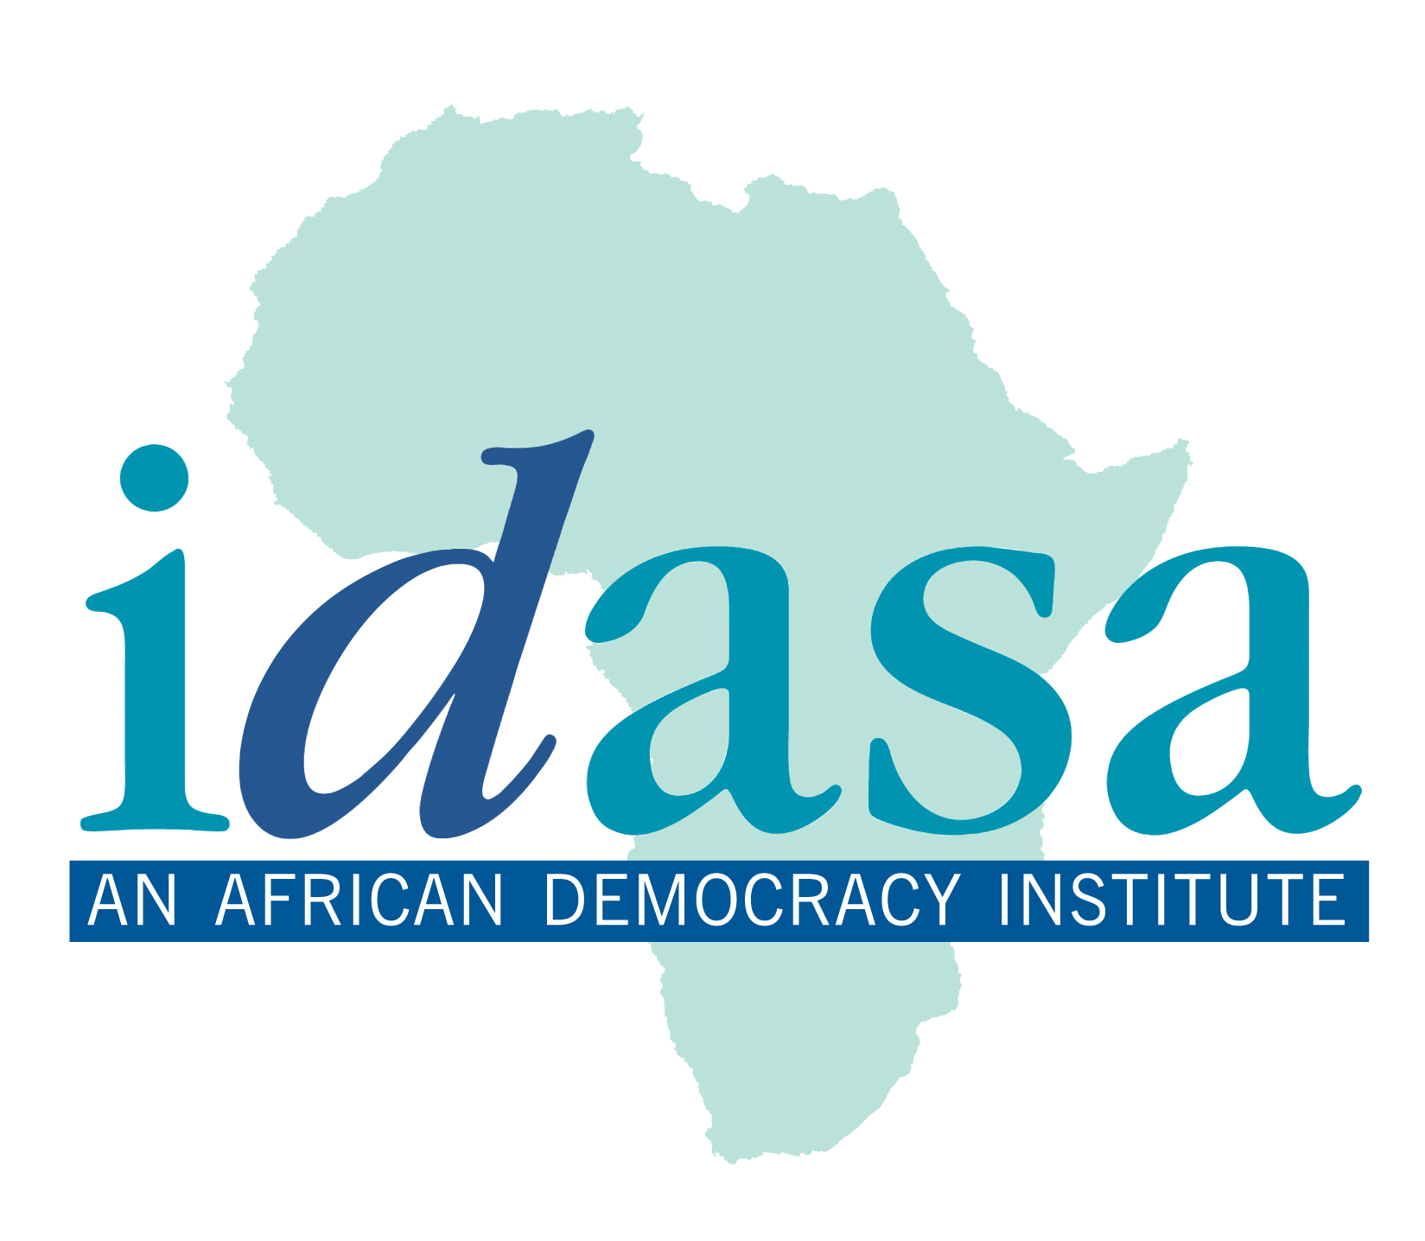

SUBMITTED TO THE PORTFOLIO COMMITTEE ON CO-OPERATIVE GOVERNANCE AND TRADITIONAL AFFAIRS
(COGTA)
FOR PUBLIC HEARINGS: CO-ORDINATED SERVICE DELIVERY

BY IDASA,
LOCAL GOVERNANCE UNIT
(LGU)

22 JANUARY 2010

THE STATE OF LOCAL GOVERNMENT AND SERVICE DELIVERY IN SOUTH AFRICA: ISSUES, CHALLENGES AND SOLUTIONS

INTRODUCTION

The South African legislation on local government emphasizes that municipalities have a pivotal role of democratizing society and fulfilling a developmental role within the new dispensation. This implies that municipalities must have policies and institutional frameworks that support and sustain the development of local people. Such plans must be geared towards achieving and progressive realization of the Millennium Development Goals (MDGs) and fundamental rights of the people. Moreover, local government must promote good governance.

Developmental local government is intended to have a major impact on the daily lives of South Africans and should seek a new focus on improving the standard of living and quality of life of the people. Thus, in short, developmental local government means strong leadership and clear vision for local government. This requires municipal officials to discharge their responsibilities with prudence and in an efficient, transparent, and accountable manner thus promoting good governance. Good governance entails the existence of efficient and accountable institutions and systems and entrenched rules that promote development and ensure that people are free to participate in, and be heard on, decisions and implementation thereof that directly affect their lives. For democracy to materialize at the municipal level, citizens have to be given some role in these processes. This will lead to more accountability and responsiveness, and therefore the level of democracy will improve.

It should be noted that the fundamental goal of a democratic system is citizen satisfaction. Therefore, the effectiveness of good local governance needs to be judged by the capacity of local government structures to provide an integrated development approach to social and economic development issues and to supply essential services congruent with the needs and desires of the local communities. In this regard, municipalities should be able to identify and prioritize local needs, determine adequate levels of services, allocate necessary resources to the public.

From the foregoing this presentation reflects the public perceptions on the state of local government and service delivery following the recent delivery protests around the country. This is based on Idasa recent survey which it undertook within the affected municipalities to solicit issues and challenges that resulted to these protests. Finally, the presentation will present some possible solutions for improving the current status of local government and service delivery.

THE STATE OF LOCAL GOVERNMENT AND SERVICE DELIVERY: SOME REFLECTIONS ON THE EXISTING CHALLENGES

South Africa has taken a significant and positive stride towards the promise of developmental local government. However, most municipalities are still plagued by significant challenges.

The enduring facts of poverty, inequality and underdevelopment underscore the need for government to address issues of social and economic development. The imperative for development in local government are articulated in the legislative framework governing local government. This includes the Bill of Rights and the Millennium Development Goals (MDGs).

The Bill of Rights provides the communities with fundamental rights to access social services. In same token the MDGs are emphatic that local government should work towards the realization of basic socio-economic rights that contribute to human development. The argument advanced is that the contemporary focus on attainment of the MDGs constitutes a major shift in development thinking because it places improvement of the human conditions at the centre of world progress.

In this regards local government has an obligation to work towards the realization of these goals. These goals are:

- Eradication of extreme poverty and hunger;
- Achieving universal primary education;
- Promoting gender equality and empower women;
- Reducing child mortality;
- Improving maternal health;
- Combating HIV/AIDS, malaria and other diseases;
- Ensuring environmental sustainability; and
- Developing a global partnership for development.

The delivery of social and economic development requires concerted effort and a more coordinated approach from local government.

CRISIS OF LOCAL DEMOCRACY

Since 2004 an unprecedented wave of popular and violent protests has flowed across the country. With the recent service delivery protests the protesters explain that they took to the streets because there was no way for them to get to speak to government, let alone to get government to listen to them. Powell argue that government’s faith in local government as the sphere that is closest to people and the delivery arm of the state is not shared by citizens. Local government is the least trusted of all public institutions in the country and that has been the case since the first elections in 2000. This is evidenced by the study undertaken by the Human Sciences Research Council’s Social Attitude Survey for 2003 which shows that only 43% of South Africans actually trust local government. This shows that while the new system of local government has been established with genuine intentions to positively affect democracy and to bring about social and economic delivery to the people, the system has not live up to expectations.

The general feeling in the hotspots is that political leadership lack responsiveness to issues raised by communities, incompetent, prone to corruption and with high degree of disregard for the communities.

The other contributing factor is that ward communities are not fully operational, resulting in poor communication with communities. Ward committees have been the focus of considerable attention by government as well civil society, with substantial investment already made in an attempt to ensure that these structures have the necessary capacity and resources required for them to fulfill their envisaged roles as the voices of communities. At the same time, questions that are often asked is how effective these institutions; whether they are useful conduits for community involvement in local governance; whether, as created space for public participation, they are inherently capable of playing the critical role expected of them; and whether they create opportunities for real power-sharing between municipalities and citizen.

The mention of ward committees typically solicits quite negative views. Communities appear to be critical of ward committees, arguing that ward committees are not functioning as intended. Moreover, ward committees are usually viewed as highly partisan structures aligned to party political agendas.

These protests mirror the crisis of local democracy. It is the nature of local democracy that needs to change. There is a strong view that “in a democracy, the government should listen to the people, do what the majority asks, if that is possible, and, where it is not, to work with citizens to ensure that what is done is as close to what they want as it can be. It stems from the core democratic idea that government works for citizens and that it cannot do this unless it listens to them”.

The present developmental local government model is premised on recognition of the primacy of linkages between development, service delivery and local citizen participation, defined as the organized effort to increase control over resources and regulative institutions by groups and movements excluded from such control.

The White Paper on Local Government urges: “building local democracy is a central role of local government, and municipalities should develop strategies and mechanisms to continuously engage with citizens. Participation is mandated in four major senses:
- as voters to ensure democratic accountability;
- as citizens who through a variety of stakeholder organisations can contribute to policy processes;
- as consumer and end users who expert value for money and affordable services; and
- as organised partners engaged I resource mobilisation for development objectives.

Brynard outlines the following as the objectives of citizen participation:
- provide information to citizens;
- get information from the citizens;
- improve public decisions, programmes, projects, and services; and
- protect individual and minority group rights and interests.

It should be noted that while the causes of the protests differ from one province to the other and from one municipality to the other, in all instances people want to be heard and to be taken seriously. The protesters are aware that they are citizens with rights and that they should be treated accordingly.

It is widely felt that the decisions in South Africa do not respond adequately to the needs and values of the communities, especially the poor and disadvantaged sectors of the community. As a result, planning including the budgets and IDPs has not sufficiently been reflective of the needs of the community. This is a contradiction to local government legislative framework underpinning local governance and popular belief that some form of stakeholder involvement in decision-making is necessary in planning on issues that affect people’s lives.

Protesters are adamant that for as long as government officials continue to assume that mandate at the polls gives them a mandate to act in a unilateral and top-down manner these protests will continue. This approach undermines public participation which is intrinsic to the core meaning of democracy. According to Powell it is estimated that only 3% of the national population has actually participated in IDP processes.

The Municipal Finance Management Act requires municipalities to “take reasonable steps to ensure that the resources of the municipality are used effectively, efficiently and economically”. Good financial management is the key to local delivery. It is quite disturbing to note that most municipalities are generally associated with the worst form of financial management. Corruption, financial mismanagement and non-compliance with financial legislation are common in most municipalities. Consequently, this result to poor performance thus the delivery of social services is compromised.

In his 2003/04 report for Local Government financing published in March 2004 the Auditor-General of South Africa noted that:
“the basis of income generation might not provide sufficient funds for delivering the services expected of municipalities. This means that sustainability of service provision by local government has to be called into question.”

In this regard, the financial viability of the impoverished municipalities needs some consideration. These municipalities can not perform their functions due to fiscal distress. These municipalities do not have extensive powers to raise their own revues through property and business taxes and to impose fees for services. Furthermore such municipalities are overburdened to deliver. The State of Local Government in South Africa Report, 2009 admits that “the national government may have created expectations that local government cannot fulfill, or placed a burden on municipalities that perhaps only the strongest amongst them can carry”. This is the reality for local and district municipalities which largely depend on municipal grants and equitable share.

Municipalities with weak revenue base can not survive on the current municipal infrastructure grant and equitable share funding allocations to fulfill their mandate. Such allocations are insufficient to ensure universal access to adequate services and will not enable poor and small municipalities to eradicate backlogs. Thus municipalities with financial limitations can not translate their IDPs to workable socioeconomic programmes. The State of Local Government in South Africa Report further notes that the “distribution of the equitable share always favoures metros over local municipalities and that the national government has failed to devised a sustainable strategy for supporting municipalities that are inherently different and confronting unique problems that are linked to their location in a distorted spatial economy”.

Finally, the other factor that undermines the performance of municipalities is the availability and shortage of the required skills. The State of Local Government in South Africa Report 2009, points that skills deficit within municipalities remains a major challenge. A significant number of municipalities do not have the managerial, administrative, financial and institutional capacity to meet the rising needs of local people. This situation is exacerbated by the decline of municipal professional and poor linkages between local government and tertiary education sector. As a result these municipalities can not meet their required performance standards hence impacting adversely on the delivery of services.

RECOMMENDATIONS

To address these formidable governance challenges the following recommendations should be considered:

- PUBLIC PARTICIPATION

Improving and encouraging the culture of public participation that will promote inclusive participation and actively incorporate public inputs on vital governance issues remains vital in this democratic era. It should be stressed that public participation is a key tenet of democratic governance. Municipalities should engage and consult civil society more frequently in policy formulation and implementation and incorporate them in governance structures.

In fact, the process to ensure community participation is a core principle of legislation. There is a wide consensus that ‘local democracy entails participatory and inclusive decision-making processes in which the beneficiaries have a substantial say in determining local government developmental agendas. To achieve this, it is essential that community awareness of rights and obligations should be enhanced so that citizens can play an instrumental role in municipal affairs and in implementation of MDG-related activities in their localities. For local government to live up to its potential, it depends not only on availability of skilled personnel and financial resources but also on the role played by communities in the structures.

- CURBING CORRUPTION AND PROMOTING FINANCIAL COMPLIANCE

There is an urgent need to rethink the innovative ways of curbing corruption and some other administrative malpractices within municipalities. Local government transformation in South Africa has exerted considerable pressure on municipalities to manage their financial resources effectively, economically and efficiently in order to meet their developmental mandate. Therefore, municipalities need to improve sound financial management requirements as envisaged in the statutory framework by appointing qualified and capable officials, including chief financial officers and internal auditors, with right and appropriate skills. Importantly, municipal officials must accounts for results, not only for budget spending and as more resources are transferred to local government there is a need to strengthen the institutions that enforce accountability of public resources.

To fight the scourge of maladministration, mismanagement of municipal finances, fraud and corruption, municipalities need to strengthen and review their existing internal control systems that detect the above-mentioned deficiencies. These include verifying the quality and appropriateness of internal audit and audit committees. Therefore, this requires effective monitoring by the officials in managerial positions.

- OPEN LOCAL GOVERNMENT

Open government should be emphasized in the management of local affairs. Local government should be accountable, transparent and open to public scrutiny.

- BUDGET AND IDP’S

The effectiveness of municipalities to deliver on their mandate is largely dependent on their ability to plan and allocate public resources in a developmental and sustainable manner. Therefore, it is significant that municipalities carefully integrate community needs in their development plans and when allocating budget. It is essential to note that the IDP is informed by the resources which can be afforded and allocated through the budget process. Therefore, the budget must, in turn be aligned with the IDP and its objectives and strategies. The processes are, therefore, not separate and distinct; they are integrally linked and are symbiotic. Furthermore, municipalities must ensure that the budget supports the achievement of the objectives set in the IDP and the attainment of the overall vision of the council. This again requires high leveled community participating in the formulation of IDP’s and budget allocations. After all, the content of the IDP must represent consensus reached with the community through various community participation processes. The significance of this is clear in that it enables the community to hold the council accountable for the attainment of the goals and targets set in the IDP.

- POLITICAL AND ADMINISTRATIVE TENSIONS

It is crucial that current prevailing political and administrative tensions are resolved in order to enhance and deepen local democracy. The relationship between politics and administration should ensure that partisan concerns do not compromise the management of the administration which is the core element of ensuring delivery. For instance, this relationship should guarantee that councilors do not exert pressure on officials to act in the interest of particular constituencies.

- INTERGOVERNMENTAL FISCAL RELATIONS:

The magnitude and urgency of the fiscal problems within municipalities is a cause for concern. The current intergovernmental fiscal system and the equitable distribution of the national revenue should significantly consider the differing challenges, among other things, the relation to rural and urban environments, availability of human resource capacity, degree of economic activity and overall institutional strength. These differing municipal realities show the anomaly of the distribution of resources uniformly to municipalities when in reality there are very different in their economic capabilities. The unintended consequence of such approach is that the economically distressed municipalities (local and district) are seriously challenged to fulfill their constitutional obligations. Therefore, the country’s current intergovernmental fiscal relations (IGFR) system is certainly open to question and should consider the fiscal capacity of municipalities.

Rethinking fiscal allocations holds great promise for improving the socioeconomic conditions. Central to this promise is how best the national government redistributes national revenues with a view to equity and poverty alleviation. It is primarily the task of the national government to ensure that it builds the financial and development capacity of local government to effectively discharge their constitutional mandate.
- CAPACITY BUILDING

Building capacities of municipal officials becomes essential in order for municipalities to fulfill and optimally achieve their obligations envisaged in the constitution and in other national policies. Capacity building is one of the most essential tools available to local government in bridging the gaps in what is expected of municipal officials and what they can deliver. In the context of overall transformation of local government skills development is critical as it lays basis for more people-oriented local government system, able to meet the demands of the people for democracy, reconstruction and development. For local government to work there is a need for investment in capacity building of councilors and officials. Stakeholders involved in such capacity building initiatives need to organize their programs for greater impact and to link it more accurately to the national democratic transition.

CONCLUSIONS

Poor service delivery and governance remains an overwhelming challenge in most municipalities. Of major concern is the degree of corruption, institutional capacity constraints relating to appropriate skills and staff, lack of transparency, dysfunctional of ward committees, lack of accountability by councilors and municipal officials, lack of public participation in issues of governance, failure to comply with municipal legislation and other by-laws, failure to prioritize community needs and IDP and budgeting processes not aligned, tensions between the political and administrative sections of the municipalities and weak financial viability of the municipalities. These are factors affect the functioning of municipalities tremendously. As a result this has led to the protests and disgruntlements at local government level. These governance challenges require robust interventions by the national government to expedite local government transformation. Municipalities have a legal obligation to provide basic services to their communities in an adequate and timely fashion. The failure of municipalities to deliver basic services not only causes immense hardship to the residents of municipalities, but can have a detrimental impact on the social and economic development.

See Chapter 3 of the Constitution of the Republic of South Africa, Act 106 of 1996
Kiyaga-Nsubuga, Local Democracy, Good Governance and Delivering the MDGs in Africa, 2007
Powell, D, 2009. What is wrong with local government? The magazine of local government. October 2009.
Steven Friedman – Business Day, 29/07/2009
Stiefel, M. & Wolfe, M. 1994. A voice for the excluded: Popular participation in development; Utopia or Necessity. London: ZED Books.
Mogale in Mhone, G. and Edigheji, O. (2004) Governance in the new South Africa: The challenge of globalisation. South Africa: University of Cape Town Press
Brynard (1996:44) in Kakumba and Nsingo, Journal of Public Administration, Vol 43. Number 2, June 2008
Powell, D, 2009. What is wrong with local government? The magazine of local government. October 2009.
Act No.56 of 2003
The State of Local Government Report in South Africa, 2009

