Presentation by the Bank Supervision Department of the South African Reserve Bank to the Portfolio Committee on Finance

September 2006


This presentation provides an executive summary and abridged version of the 2005 Annual Report of the Bank Supervision Department of the South African Reserve Bank. The presentation does not replace the 2005 Annual Report and should, in fact, be read in conjunction with the report.

Contents

Page

A. Executive Summary 3
B. Slides
- Salient information on the South African banking system 14
- Trends in South African banks
1. Balance sheet structure 17
2. Capital adequacy 22
3. Profitability 25
4. Liquidity risk 31
5. Market risk 34
6. Credit risk 36
7. Currency risk 42

- Current issues in banking supervision (see section C for text) 44
- Developments related to banking legislation (see section C
for text) 58

C. Text for:
- Current issues in banking supervision 62
- Developments related to banking legislation 77

EXECUTIVE SUMMARY OF THE 2005 ANNUAL REPORT OF
THE BANK SUPERVISION DEPARTMENT

As is well known, the use of information and communication technology systems by banks has increased dramatically in the past number of years, a trend that is likely not only to continue, but to grow. Therefore, some thoughts on the importance of such systems for the future viability and sustainability of banks are highlighted on the verso of the title page.

In chapter 1 of the report, the issues discussed include the following:
- Overview of trends in the South African banking sector

During 2005, the South African banking system remained stable, and, in general, banks were sound and continued to benefit from South Africa’s economic health. Banks were well capitalised, and the average risk-weighted capital-adequacy ratio for the banking system as a whole was 13,3 per cent at the end of December 2005.

Growth in the total balance sheet remained strong throughout 2005. By the end of December 2005, the total assets of banks – comprising, amongst other things, money, loans and advances, investment and trading position and non-financial assets – had increased by 12 per cent (measured over a period of twelve months), to a level of R1 677,5 billion (December 2004: R1 489,4 billion). Mortgage advances showed the strongest growth of the various types of credit. At the end of 2005, the five largest banks (one of which is internationally owned) represented about 89,6 per cent of the total banking sector, whereas small local banks constituted 2,2 per cent of total banking-sector assets, and other international banks constituted 8,6 per cent of the banking sector.

Total non-bank deposits increased by 21,1 per cent over the 12-month period ended 31 December 2005 (December 2004: 20,5 per cent). The composition of non-bank deposits remained largely unchanged during 2005.

Profitability indicators, however, declined somewhat during 2005. By the end of December 2005, the average return on net qualifying capital and reserves (smoothed) was 14,4 per cent, down from 14,7 per cent in December 2004, whereas the return on assets (smoothed) decreased from 1,2 per cent in December 2004 to 1,1 per cent in December 2005. The efficiency of the banking sector also started showing signs of a decline during the year under review, weakening from 63,9 per cent in December 2004 to 66,3 per cent in December 2005.

Throughout 2005, South African banks maintained adequate levels of liquidity. In December 2005, banks’ liquid assets amounted to 119,7 per cent of the liquid assets required to be held, compared to a level of 116,8 per cent in December 2004. Besides banks experiencing strong asset growth in their core products, gross amounts overdue also improved during 2005, from 1,8 per cent in December 2004 to 1,5 per cent in December 2005. Banks’ provisioning against these non-performing loans was adequate.

- Progress with implementation of Financial Sector Charter

During 2005, the Charter Council envisaged by the Financial Sector Charter set up offices in Johannesburg, and the Charter Council Principal Officer, Mr Enoch Godongwana, was appointed in October 2005. The ten Charter Council committees tasked with addressing the challenges of implementing the principal commitments made in terms of the Charter met regularly throughout 2005, and most committees completed their work.

Access standards for entry-level products across all financial industries were finalised and approved by the Charter Council. Key indicators include physical access, appropriateness, affordability, fair value, simplicity and non-discrimination. Almost two million Mzansi accounts had been opened since the launch of the product by the four major banks and the Post Bank in November 2004, and a money-transfer facility was launched in September 2005. Banks will, however, be required to enhance the Mzansi offering with affordable debit-order facilities.

As regards definitions, measurements and targets, agreement had largely been reached by December 2005. The Charter may, however, have to be aligned in this regard to the Codes of Good Practice published by the Department of Trade and Industry.

All five big banks entered into black economic-empowerment (BEE) shareholding transactions, funded by structured finance and various hedging transactions. The debt incurred by the BEE participants in the transactions is to be repaid primarily from the share-dividend flow. Since the banks are adequately capitalised to absorb any potential loss, default by any party would have only a limited effect on a bank’s capital-adequacy ratio.

- Barclays/ABSA transaction

A majority shareholding in ABSA Group Limited (ABSA), a controlling company, was acquired by Barclays Bank plc (UK) (Barclays) in 2005. The transaction resulted not only resulted in the first international ownership of one of the larger South African banks, but also in the receipt of the largest single foreign direct investment in South Africa to date. The transaction also affirmed South Africa’s position as an attractive and stable financial centre.

In view of the importance of the transaction to the South African financial system, the Bank Supervision Department made a recommendation in terms of the Banks Act to the Minister of Finance only after extensive consultation with local and international stakeholders and after consideration of a multitude of aspects. Of particular importance in the latter regard were the implications for the economy of South Africa and its banking system, the implications of, as well as arguments for and against, international ownership of a domestic bank and considerations relating to the existing four-pillar policy.

- Evaluation of progress with South Africa’s economic–policy framework by the International Monetary Fund

During May 2005, the International Monetary Fund evaluated the progress made with various aspects of South Africa’s economic-policy framework. The IMF directors noted that indicators of the South African banking system's health were favourable and sound. In particular, it was noted that most of the recommendations of the IMF/World Bank Financial Sector Assessment Program, including legislation on anti-money laundering and countering of terrorist financing, had been implemented and that enhancements to the regulatory and supervisory framework would further strengthen the financial sector's resilience to adverse shocks. The South African authorities were encouraged to facilitate access to banking services for the whole population and to speed up implementation of the Financial Sector Charter, as well as the introduction of a regulatory framework for institutions providing basic banking services.

- Succession planning for senior executives and training of directors

In the report, banks are urged to take note of the need for proper succession planning and ongoing training of directors, particularly non-executive directors. In line with the recommendation of the 2003 Myburgh Report on the Standard of Corporate Governance in the Five Largest Banks, the Banks Act was amended to incorporate a requirement that banks establish a directors’ affairs committee, consisting of non-executive directors only and with responsibility for corporate governance and succession planning. Although succession planning by banks has become more formalised, banks have to focus on updating the succession plans for all senior executives. Banks also have to pay increased attention to relevant training to equip newly appointed non-executive directors properly to discharge their duties and responsibilities.

Chapter two focuses on important regulatory and supervisory developments, both locally and abroad. These include the following:

- New Basel Capital Accord (Basel II)

Good progress was made during 2005 with preparations for the implementation of Basel II on 1 January 2008. The Bank Supervision Department established a dedicated project team, which includes quantitative analysts and risk specialists, to drive the implementation of Basel II. Each risk specialist has been assigned dedicated responsibility for a specific risk area or aspect of a particular risk area. These responsibilities include, amongst other things, provision of technical guidance on model validation and minimum criteria for the use of more advanced approaches by banks. The risk specialists will also lead onsite visits to banks to assess the quality of banks’ risk management and, in the case of banks intending to use an advanced approach, the models, methodologies and related controls used by such banks.

The previously established Accord Implementation Forum met on a regular basis during 2005, resulting in a substantial increase in the number of position papers issued. Proposed amendments to both the Banks Act and the Regulations relating to Banks necessitated by Basel II were also circulated for comment.

In order to assess banks’ readiness for Basel II, the Bank Supervision Department analysed the results of the gap analyses and self-assessments performed by banks, as well as the results of the fourth quantitative impact study, aimed at assessing the possible impact of Basel II on the level of banking capital. Problems identified are receiving ongoing attention, and substantial progress was made during 2005. From a supervisory perspective, a major challenge will be to balance the supervisory requirements of Basel II with the available resources.

- Review of corporate governance in South African banks

Following the review of corporate governance in the five largest South African banks in 2003, the Bank Supervision Department undertook a similar review of 14 other South African banks, including two mutual banks. The general findings were similar to those of the 2003 review, but a number of concerns were highlighted in the final report. These concerns related to the compliance function, director selection, training, board monitoring of management and unresolved issues, transformation within boards, effectiveness of directors’ affairs committees and segregation of duties. The Department is engaging with the banks to ensure that these areas of concern are addressed.

- Interaction with other supervisors

The Bank Supervision Department continued to interact with other supervisors, both locally and abroad, in fulfilling its regulatory and supervisory responsibilities. Interaction with the Basel Committee on Banking Supervision continued to be of particular importance at the international level, and, at the regional level, the Department continued to participate in the activities of the SADC (Southern African Development Community) Subcommittee of Bank Supervisors. Attendance of courses on bank supervision and training of staff received particular attention so as to ensure that the Department’s skills base is constantly improved.

- Alignment of South African Accounting Statements with International Financial Reporting Standards

For financial years commencing on or after 1 January 2005, listed banks have to prepare their consolidated financial statements in accordance with International Financial Reporting Standards (IFRS), which also includes International Accounting Standards. Although conversion to IFRS is compulsory for the consolidated financial statements of listed banks, the statements of other banks may continue to be prepared in accordance with South African Statements of Generally Accepted Accounting Practice (SA GAAP). As part of the process of bringing SA GAAP in line with IFRS, the Accounting Practices Board in South Africa has reissued all SA GAAP statements and interpretations when there were differences between these standards and those issued by the International Accounting Standards Board (IASB). Consequently, all differences in wording between the affected statements and interpretations were removed, except when effective dates differed.

All listed banks in South Africa have spent a substantial amount of time and effort on ensuring that their figures accord with IFRS and have reported the effect of conversion from “old” GAAP in their opening balance sheet.

- Monitoring of banks’ compliance with anti-money-laundering legislation

At a meeting during the earlier part of 2005, all banks had to give feedback to the Bank Supervision Department on their progress with the further implementation of know-your-client (KYC) procedures and the verification of clients, consistent with the deadlines of the conditions of exemption from the provisions of section 21(2) of the Financial Intelligence Centre Act, 2001 (FICA).

The Registrar of Banks also requested the five big banks to call for an independent auditing firm to undertake physical verification of the client-verification data that the banks had submitted in terms of Banks Act Circular 10/2004. This verification was intended to give the Director of the Financial Intelligence Centre (FIC) and the Minister of Finance comfort from an external source that all data that had been submitted to the Department were reliable. Further guidance on compliance with FICA by banks was subsequently issued by the FIC. A subsequent verification review in October 2005 showed that substantial improvements had been made.

- Combating of illegal deposit-taking

The Bank Supervision Department is responsible for the administration of the Banks Act, 1990, in terms of which the Registrar of Banks is tasked with, amongst other things, controlling deposit-taking of persons not registered as banks or mutual banks. During 2005, three new inspections of unregistered deposit-takers, together with 30 inspections carried over from 2004, were undertaken. The Department also forwarded information to other regulatory bodies to ensure that they were informed of possible contraventions by unregistered persons.

- Deposit insurance

South Africa does not have an explicit deposit-insurance scheme (DIS) at present. During 2000, the Minister of Finance requested the Bank Supervision Department to participate in a joint project with the National Treasury to investigate the requirements necessary to implement a South African DIS (SADIS). A work group, consisting of members of the National Treasury, the Department, the Banking Association of South Africa and others, was established in order to research the issues and to make proposals on the establishment of SADIS.

The Work Group has held numerous meetings and developed a number of discussion and position papers over the years. The Work Group has also done comprehensive research on DISs in other jurisdictions and has come to the conclusion that each DIS was designed and implemented according to the specific needs and requirements of the particular jurisdiction. Proposals on SADIS, therefore, are being developed to serve the purposes and interests of South Africa, as well as to incorporate the international best-practice principles and procedures available in order to attain that goal.

Issues requiring final resolution before a proposal is made to the Minister relate to, amongst others, the legal nature of a possible SADIS, its functions, roles and responsibilities, its funding and governance, basis of participation in and membership of SADIS, reimbursement of depositors and failure resolution, claims and recoveries.

- Liquidity-risk and market-risk management by South African banks

During 2005, the Bank Supervision Department undertook targeted reviews of banks’ management of liquidity risk. Generally, the banks had liquidity strategies, policies and procedures, standards and limits in place. The Department communicated identified weaknesses or concerns to the banks concerned and is monitoring progress with the rectification of deficiencies on an ongoing basis.

The Regulations relating to Capital Adequacy Requirements (“CAR”) for Banks’ Trading Activities in Financial Instruments require banks to report their market-risk exposure and to determine their capital adequacy using one of a number of methods, which vary in complexity. The simplified method is suited to banks with “vanilla-type” trading books and few systems supporting their trades. The building-block method is suited to banks with significant exposures and which manage their risk internally with relatively manual processes and systems. The internal model (IM) approach permits banks that are using sophisticated risk-management systems not only to manage their risk and report their exposure, but also to calculate their capital adequacy.

In order to assess the operational risks associated with the IM approach and to review the multiplication factor used to determine a bank’s capital charge more regularly, the Department is increasing the frequency of its onsite reviews of trading banks. This will enable the Department more rapidly to adjust the capital-charge requirements of banks using the IM approach via the multiplication factor under both adverse and favourable results.

- Growth in mortgage loans

By the end of December 2005, South Africa had recorded mortgage-lending growth of 28,6 per cent (measured over a period of 12 months), compared to growth of 25,6 per cent in December 2004. Factors leading to this growth included, amongst other things, lower and variable mortgage-interest rates, a lower level of inflation, lower income-tax rates and an increase in the real disposable income of households, as well as in increase in speculative buying, also known as the buy-to-let boom. As the regulator of banks, the Bank Supervision Department will continue to ensure that banks’ risk-management processes are appropriate for the high growth in mortgages.

- Supervision of representative offices

The Bank Supervision Department undertakes both onsite and offsite oversight, in order to establish whether a representative office (RO) of a foreign banking institution adheres to the applicable legislation. The onsite supervisory function entails annual visits to all registered ROs operating in the Republic, whereas the offsite supervisory function includes analysis of the quarterly returns submitted by ROs and evaluation of the annual internal control reports submitted by the ROs’ chief representative officers. During 2005, advisory services to network customers, advice on offshore private-banking investment and correspondent banking were the main areas business of the ROs operating in South Africa.

- Information and communication systems

The information and communication systems used by the Bank Supervision Department have evolved into sophisticated and efficient analytical tools over the years. A number of controls are in place when the Department captures and processes the DI returns submitted by banks, and the Department has developed approximately 1 000 reports and graphs, for use in the analysis of banks. Additional analytical requirements, resulting partly from the impending implementation of the new Basel Capital Accord, however, have necessitated upgrading of the Department’s database and technology.

Chapter 3 highlights developments in the South African bank-regulatory framework, as follows:

- Proposed amendments to the Banks Act, 1990, and the Regulations thereto

A first draft of proposed amendments was approved by the Standing Committee for the Revision of the Banks Act, 1990, during November 2005 and was circulated to all banks, for comment, and a second draft was circulated at the end of January 2006. The proposed amendments to the Banks Act are aimed mainly at addressing the prescriptions of the new Capital Accord (Basel II), although some other necessary amendments are also proposed. The prescriptions contained in Basel II have also necessitated a complete revision of the Regulations relating to Banks.

- Other legislation likely to affect the banking industry

Other pieces of draft legislation likely to affect the banking industry, as well as the ongoing regulation and supervision of banks by the Bank Supervision Department, include the National Credit Bill, 2005 (which will regulate all credit extension), proposed legislation relating to the establishment of second-tier and third-tier banks (namely, the Dedicated Banks Bill, 2004, and the Co-operative Banks Bill, 2004) and a proposed section in the Companies Amendment Bill, 2005, requiring audit committees for public-interest companies.

In chapter 4 and appendix 6 of the report, trends in the South African banking sector, based on risk-based information submitted by banks during 2005, are outlined under the following headings:

- Balance-sheet structure

The aggregated balance sheet of the banking sector in South Africa equalled R1 677,5 billion as at 31 December 2005, as opposed to R1 498,4 billion as at 31 December 2004 and R1 379,8 billion as at 31 December 2003. During 2005, growth in the aggregated balance sheet accelerated until June 2005 (15,8 per cent), but moderated to 15,3 per cent in September 2005. By the end of 2005, a growth rate of 12 per cent had been recorded. Domestic deposits from the public, in the amount of R1 101,5 billion, remained the main source of funding for the banking sector and constituted 65,7 per cent of total liabilities in December 2005, compared to 60,7 per cent in December 2004. Short-term deposits remained the largest component of total non-bank funding and accounted for 66,2 per cent of total non-bank funding as at 31 December 2005. The sharp increase of R116,2 billion in mortgage loans, to a level of R522,4 billion, representing an increase of 28,6 per cent, during 2005 was due, amongst other things, to South Africa having experienced a lower interest-rate environment from June 2003, as well increased demand for housing by the previously disadvantaged sector of the population.

- Capital adequacy

For 2005, the average capital and reserves held by the banking sector amounted to R130,7 billion (R116,5 billion in December 2004), and R122,5 billion (R107,5 billion in December 2004) thereof constituted qualifying capital and reserves for purposes of assessing capital adequacy. The capital-adequacy ratio for the banking sector in total as at the end of December 2005 was 13,3 per cent (2004: 12,7 per cent).

- Profitability

During 2005, there was a gradual decline in both the return on equity and the return on assets, owing to a decline in net income after tax, resulting mainly from higher operating expenses. For 2005, an after-tax return of approximately 1,1 per cent on total assets (1,2 per cent for 2004) was reported, whereas an after-tax return of approximately 14,5 per cent was reported on net qualifying capital and reserves (14,7 per cent for 2004).
- Liquidity risk

The average daily amount of liquid assets held by banks exceeded the statutory liquid-asset requirement throughout 2005. For the month of December 2005, the average daily amount of liquid assets held represented 119,7 per cent of the statutory liquid-asset requirement, compared to 116,8 per cent for December 2004.

- Market risk

Turnover in derivatives, excluding forward contracts, generally fluctuated during 2005. Total turnover in derivative contracts, excluding forward contracts, increased from R475,8 billion in January 2005 to R840,7 billion in August 2005, before declining to R728,9 billion in December 2005. Forward contracts contributed to the largest portion of total turnover in derivative instruments and increased from R1 442,5 billion in January 2005 to R2 172,5 billion in August 2005, but decreased to R1 346 billion in December 2005.

- Credit risk

Banks experienced enhanced asset growth in their core products during 2005, the main products being mortgages, instalments and overdrafts, owing mainly to favourable economic conditions. These growing credit portfolios were generally well managed by banks, as evidenced by the level of total overdues, which continued to decrease, from R20,4 billion in December 2004 to R20,1 billion in December 2005.

- Currency risk

From December 2004 to December 2005, the maximum net open position in foreign currency after hedging increased from 0,83 per cent to 1,7 per cent, but remained well within the limit of 10 per cent of net qualifying capital and reserves.

Appendices 1 to 5 and 7 to 9 of the report contain useful administrative information.

Salient information on the South African banking system

Salient information as at 30 June 2006

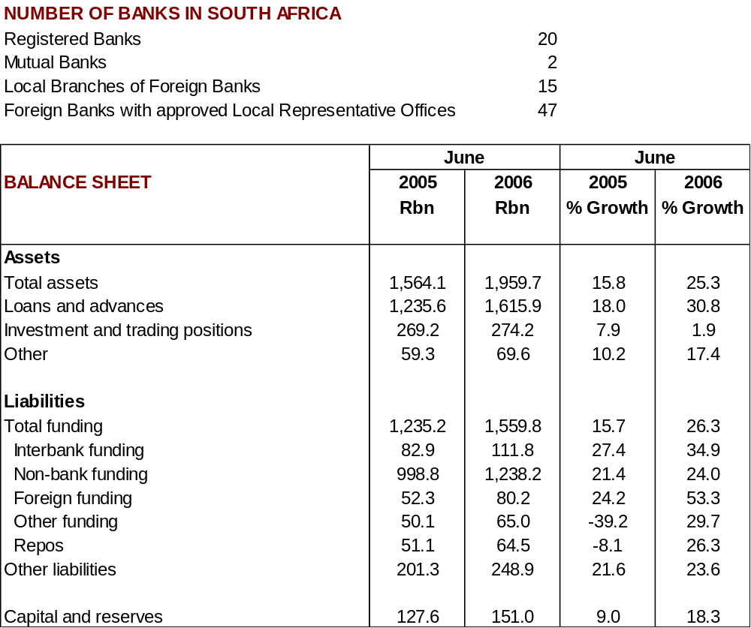

Trends in South African banks

1. Balance-sheet structure - R1 677,5 billion

1.1 Aggregated balance sheet

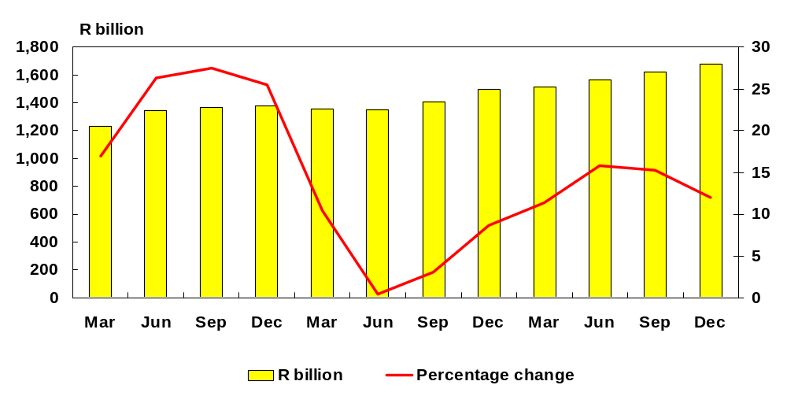

The banking sector is affected largely by the position of the “big four” banks, which constituted 83,8 per cent of the banking sector in December 2005 (December 2004: 83,6 per cent). The aggregated balance sheet of the banking sector in South Africa equalled R1 677,5 billion as at 31 December 2005, as opposed to R1 498,4 billion as at 31 December 2004 and R1 379,8 billion as at 31 December 2003.

The sharp decrease in total assets during the first two quarters of 2004 was due mainly to the deregistration of two A-2 rated banks (being banks other than the five largest banks) and a decrease in the total assets of some local branches of international banks. The increase during the first two quarters of 2005 relates to generally strong growth in the core products of A1-rated banks (that is, the five largest banks), the main products being mortgages, instalments and overdrafts. The moderation from the third quarter of 2005 until the end of the year was due mainly to a decrease in derivative activities.
1.2 Composition of non-bank deposits - R1 101,5 billion
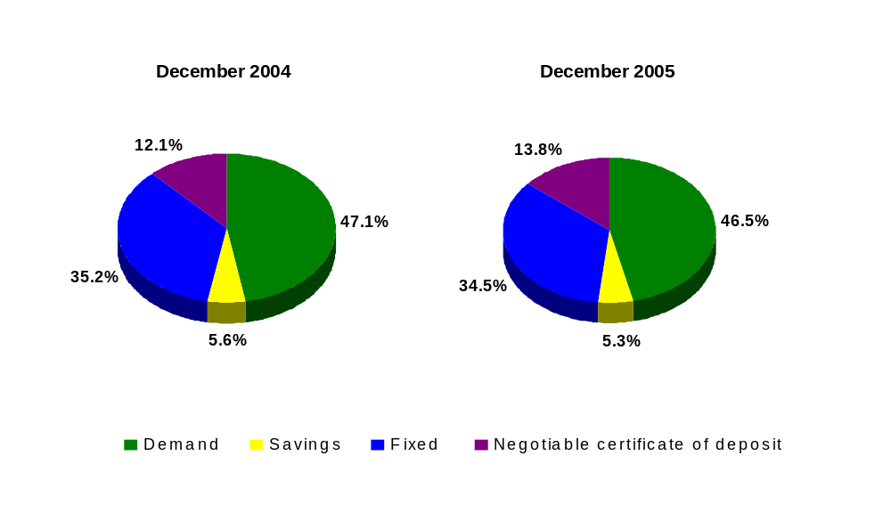

Domestic deposits from the public remained the main source of funding for the banking sector and constituted 65,7 per cent of total liabilities in December 2005, compared to 60,7 per cent in December 2004. Share capital and reserves and other liabilities as a percentage of total liabilities, on the other hand, decreased from 8,3 per cent and 19,5 per cent, respectively, in December 2004 to 8,0 per cent and 14,6 per cent, respectively, in December 2005.

Total non-banks deposits as at the end of December 2005 equalled R1 101,5 billion, as opposed to R909,9 billion as at the end of December 2004. Demand deposits and fixed and notice deposits as a percentage of total non-bank deposits constituted the largest portion of total non-bank deposits, followed by negotiable certificates of deposit (NCDs). Demand deposits and fixed and notice deposits as a percentage of total non-bank deposits decreased from 47,1 per cent and 35,2 per cent, respectively, in December 2004 to 46,5 per cent and 34,5 per cent, respectively, in December 2005. The share of non-bank deposits represented by NCDs increased from 12,1 per cent at the end of December 2004 to 13,8 per cent at the end of December 2005. The growth in NCDs during the past two years was due to the removal of stamp duties on NCDs in the 2004 budget speech, consequently decreasing the cost of NCDs.
1.3 Composition of non-bank deposits - R1 101,5 billion
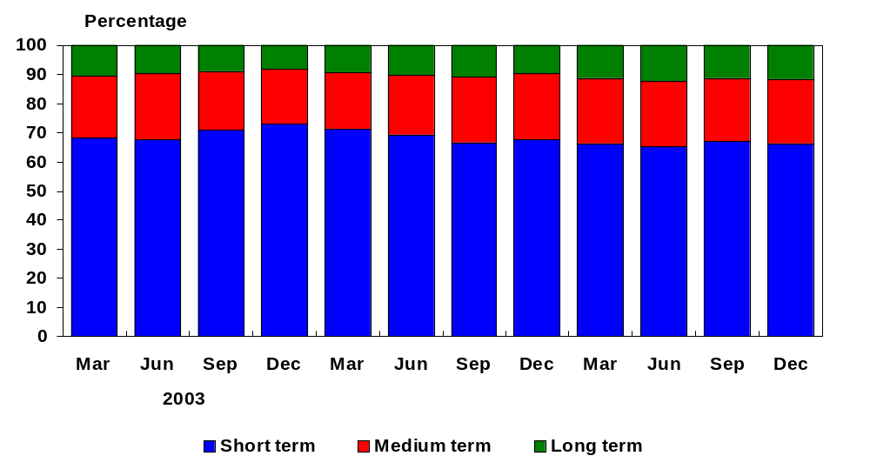

Short-term deposits remained the largest component of total non-bank funding and accounted for 66,2 per cent of total non-bank funding as at 31 December 2005, compared to 67,4 per cent as at the end of December 2004 and 73 per cent as at the end of December 2003. Medium-term deposits accounted for 22 per cent as at 31 December 2005, compared to 22,9 per cent and 18,7 per cent as at the end of December 2004 and the end of December 2003, respectively. Although long-term deposits remained the smallest component of total non-bank funding and accounted for 11,9 per cent of total non-bank funding as at 31 December 2005, they showed some steady growth when compared to 9,7 per cent and 8,3 per cent as at the end of December 2004 and the end of December 2003, respectively.

The high percentage of 66,2 per cent represented by short-term deposits during 2005 was due mainly to a combination of banks’ pricing policy and depositors’ view on interest rates. Although the aforementioned percentage appears to be high, it has proved to be stable over the past number of years.
  - Total loans and advances - R1 353,6 billion

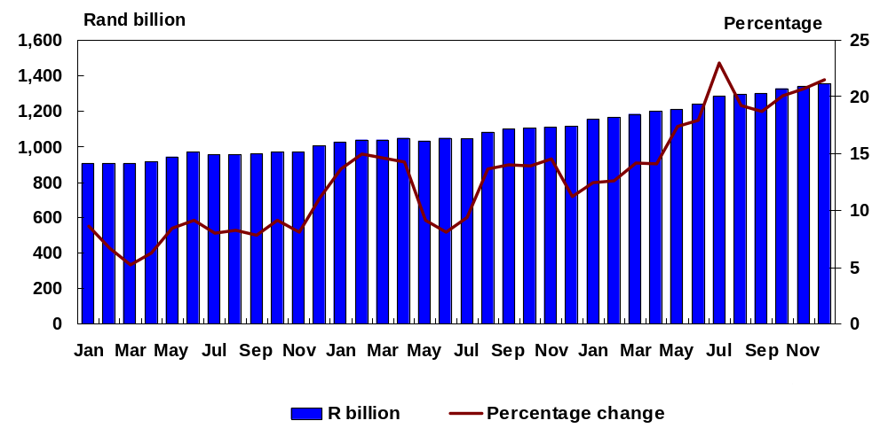

Total loans and advances as at the end of December 2005 equalled R1 353,6 billion, as opposed to R1 114,13 billion as at the end of December 2004. During 2005, growth in total loans and advances increased strongly, from 12,5 per cent in January 2005 to 23 per cent in July 2005, before decreasing slightly, to 18,8 per cent in September 2005. The strong growth in total loans and advances during the first seven months of 2005 was due mainly to growth in mortgage loans, followed by growth in overdrafts and loans and instalment debtors, the peak in July 2005 being due to an increase in the interbank advances, mortgage loans and foreign-currency loans of two A1-rated banks. By the end of 2005, a growth rate of 21,5 per cent had been recorded.
  - Composition of loans and advances - R1 353,6 billion

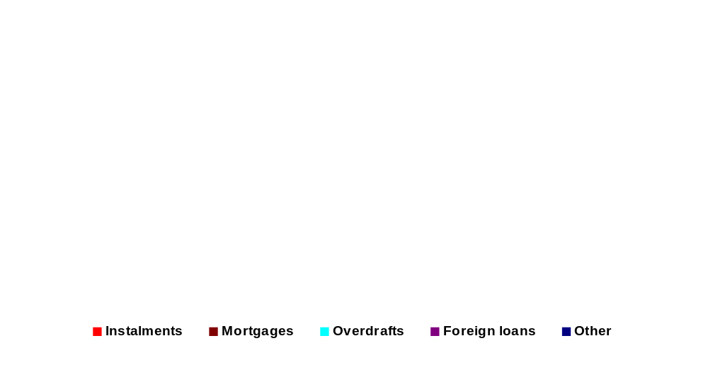
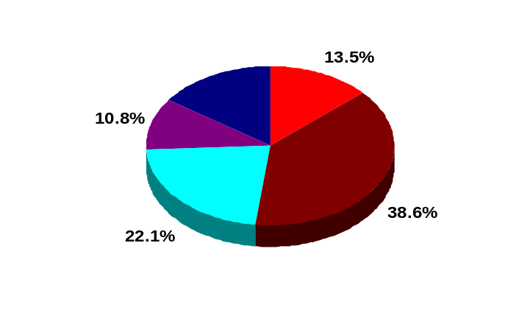

Non-bank loans and advances constituted 73,4 per cent (December 2004: 67,7 per cent) of the banking sector's assets and, thus, represented the main area of focus for the management of on-balance-sheet credit risk. The increase of R217,3 billion, representing a growth rate of 21,4 per cent, achieved in respect of non-bank advances during 2005 can be attributed to the following areas:

- Mortgage loans increased by R116,2 billion, to a level of R522,4 billion, representing an increase of 28,6 per cent as a result of South Africa having experienced a lower interest-rate environment from June 2003, as well as increased demand for housing by the previously disadvantaged sector of the population.
- Overdrafts and loans increased by R19,6 billion, to a level of R298,5 billion, representing a growth rate of 7 per cent.
- Instalment debtors increased by R29,8 billion, to a level of R182,2 billion, representing an increase of 19,5 per cent due mainly to lower interest rates.
- Foreign-currency loans and advances increased by R28,8 billion, to a level of R145,5 billion, representing an increase of 24,7 per cent due, amongst other things, to an increased flow of funds between South Africa and foreign centres and factors such as fluctuating and more volatile market conditions.
2. Capital adequacy

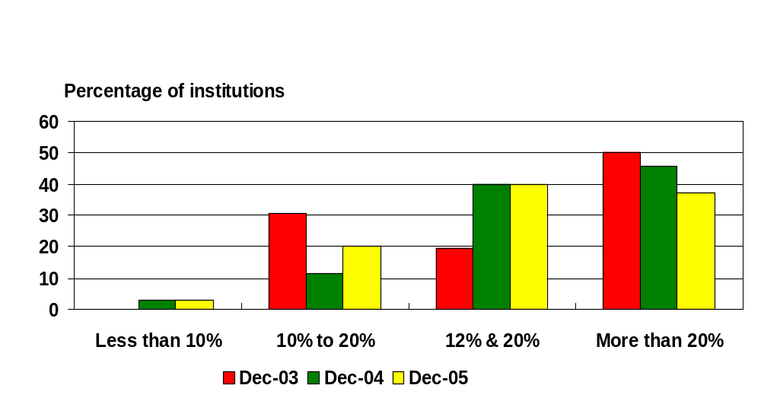
2.1 Distribution of banks in terms of capital adequacy

dISTIBUTIONM

Only 2,9 per cent (2004: 2,9 per cent) of the total number of banking institutions – in fact, only one bank – did not meet the minimum capital-adequacy ratio of 10 per cent, whereas 37,1 per cent of banking institutions (2004: 45,7 per cent) had capital-adequacy ratios that exceeded 20 per cent.

Banking institutions that reported capital-adequacy ratios of above 20 per cent represented only 3,3 per cent of total banking-sector assets. Banking institutions with a capital-adequacy ratio of between 12 per cent and 20 per cent (40 per cent of banking institutions) represented 29 per cent of total banking sector assets, whereas banking institutions with a capital-adequacy ratio of between 10 per cent and 12 per cent (20 per cent of banking institutions) represented the largest portion of total banking sector assets, namely 67,7 per cent.
  - Qualifying capital and reserves - R126,5 billion

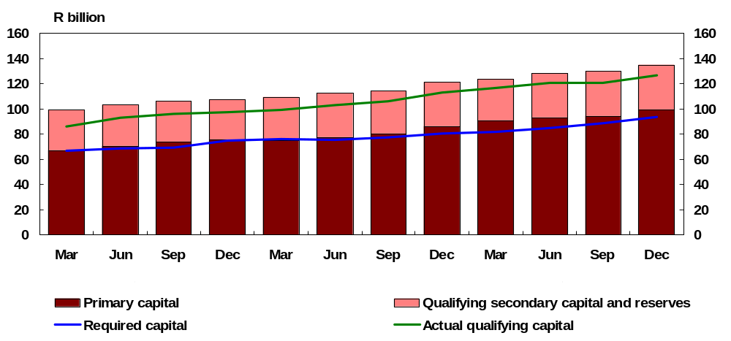

At the end of December 2005, primary capital and reserves constituted 73,4 per cent (2004: 71,2 per cent) of qualifying capital and reserves before deduction of impairments amounting to R8,7 billion (2004: R8,0 billion). Primary capital and reserves grew by 9,8 per cent (2004: 23,9 per cent) during 2005, to R99,2 billion as at the end of December 2005. The increase in the growth of primary capital and reserves was due to the issue of non-redeemable non-cumulative preference shares and the appropriation of profits by some banks. Secondary capital and reserves increased by 1,4 per cent (2004: 3,3 per cent), to R36 billion as at the end of December 2005. Banks continued to hold a buffer in excess of the required capital during 2005.
  - Risk profile of on- and off-balance sheet items
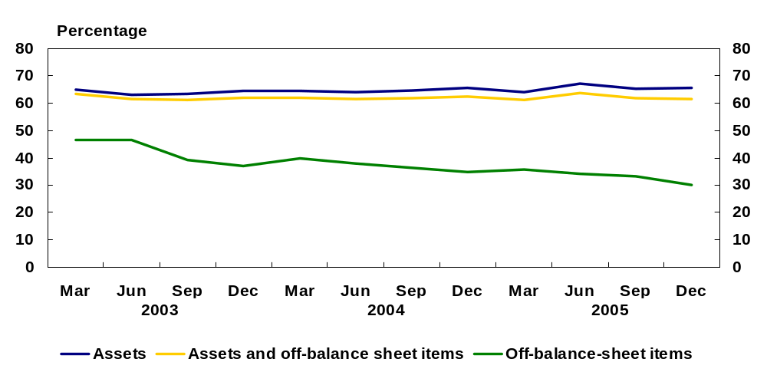

The risk weighting of the banking sector’s assets decreased slightly, from 65,49 per cent as at the end of December 2004 to 65,45 per cent as at the end of December 2005. The risk weighting of off-balance-sheet items decreased from 34,9 per cent as at the end of December 2004 to 30,1 per cent as at the end of December 2005, owing to strong growth in indemnities and guarantees, together with unutilised facilities, which were assigned to a lower risk-weighting category. As a result of the change in the composition of off-balance-sheet-items, the combined risk weighting of assets and off-balance-sheet items decreased slightly, from 62,6 per cent in 2004 to 61,4 per cent in 2005.
3. Profitability

3.1 Composition of the income statement

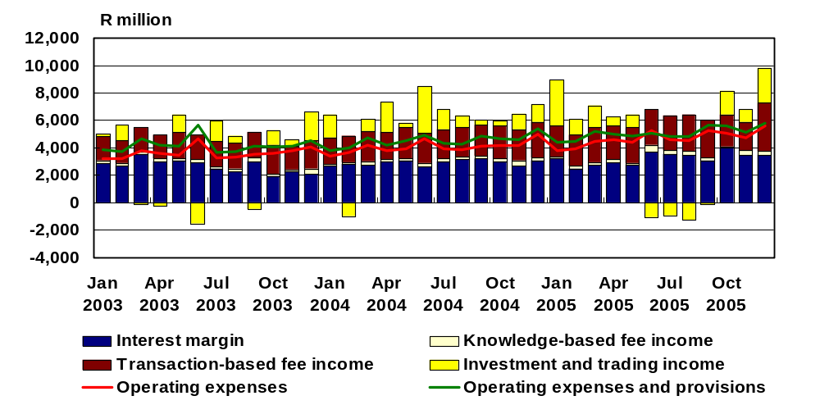

The total income, that is, net interest turn (that is, interest income less interest expense) plus non-interest income, of the banking sector amounted to R84,4 billion at the end of December 2005, as opposed to R76,6 billion at the end of December 2004. The intermediation function generates interest margin and transaction-based fee income. The income of R69,1 billion derived from the intermediation function during 2005 was generally sufficient to cover the sum of operating expenses and provisions, which amounted to R60,7 billion. The generation of additional income from investments, including Government stock and Treasury bonds, knowledge-based fee income and income derived from trading and advisory activities, also contributed to the continued profitability of banks.

For the year 2005, interest expense increased by about 9,8 per cent, whereas interest income increased by 10,1 per cent. The net result thereof was that the interest margin increased by 10,6 per cent, whereas it increased by 9,1 per cent in 2004. The main components of interest expense were interest in respect of demand deposits at 27,4 per cent of the total interest expense (2004: 28,2 per cent) and interest in respect of fixed and notice deposits at 31,7 per cent of the total interest expense (2004: 34 per cent). Interest derived from mortgage bonds and overdrafts and loans constituted 36,5 per cent and 25,1 per cent, respectively, of total interest income during 2005, as opposed to 35,4 per cent and 26,5 per cent, respectively, during 2004.
  - Interest margin - 3,1%
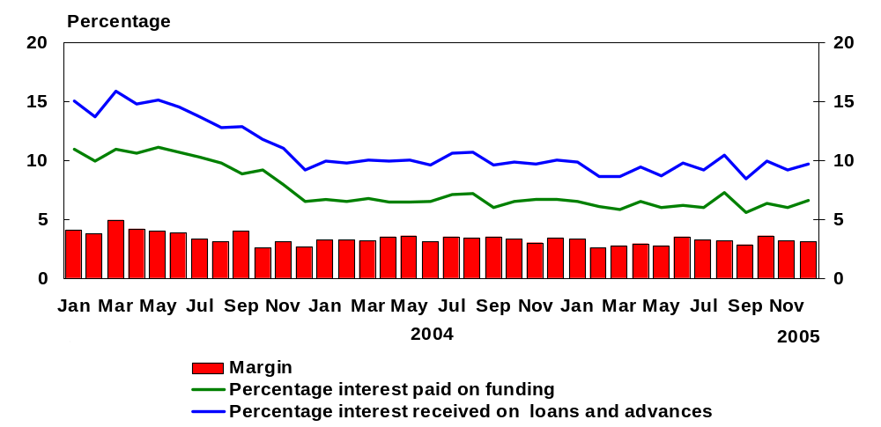

The interest margin for the year was on average lower in 2005 than in 2004. By the end of December 2005, the interest margin was 3,1 per cent, compared to 3,4 per cent in 2004 and 2,7 per cent in 2003. The margin of 2,6 per cent at the end of February 2005 was affected mainly by February being a short month. The margin of 2,8 per cent at the end of September 2005 was affected by the refinement of reporting by an A1-rated bank.
  - Growth in staff expenses, number of employees and number of branches
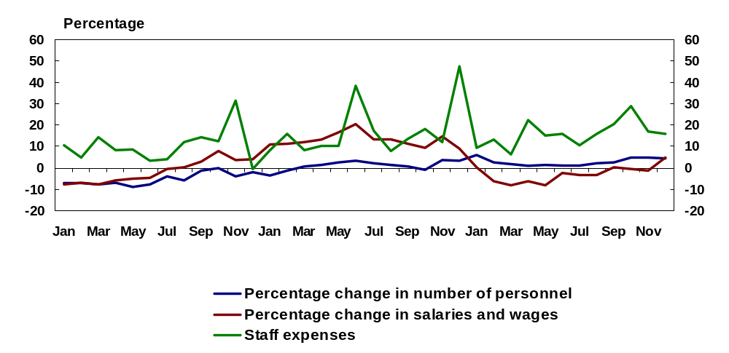

The operating expenses of the total banking sector increased by 14,6 per cent in 2005 (12,5 per cent in 2004), mainly as a result of an increase of 16 per cent in total staff expenses, which accounted for about 57,1 per cent (2004: 55,4 per cent) of total operating expenses. The increase in staff expenses was due mainly to, amongst other things, bonuses paid out during the year and an increase in the number of specialised personnel in some banks. During 2005, the number of employees in the banking sector increased by 2,7 per cent, whereas the number of branches decreased by 2,8 per cent, as opposed to an increase of 1,1 per cent in the number of employees and an increase of 12,8 per cent in the number of branches during 2004. An increase in administrative expenses also contributed to the growth in operating expenses. In 2005, administrative expenses increased by 14,1 per cent and accounted for 40,4 per cent (2004: 40,6 per cent) of total operating expenses.
  - Efficiency ratio of South African banking sector - 66,3%
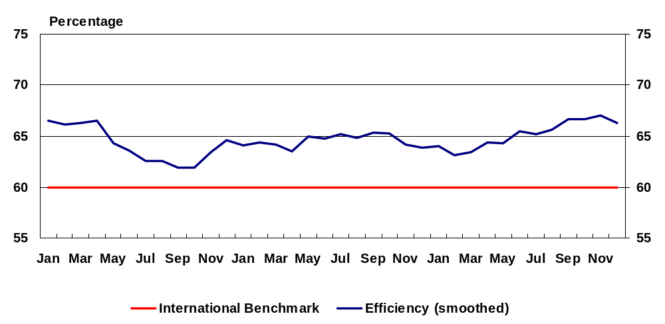

A widely used indicator of the efficiency of the banking sector is the ratio, expressed as a percentage, of operating expenses to total income. The lower the ratio is, the more efficient a bank is considered to be. Currently, it is considered desirable for the ratio to be 60 per cent, and a ratio of below 50 per cent is considered to indicate a highly efficient institution.

Smoothed over a 12-month period, the efficiency ratio of the banking sector deteriorated from 63,9 per cent in December 2004 to 66,3 per cent in December 2005. The deterioration in the efficiency ratio in December 2005, compared to December 2004, can be attributed to the increased operating expenses of some banks relating to, amongst other things, information-technology system changes and personnel costs. Operating expenses increased from R5 billion at the end of December 2004 to R5,6 billion at the end of December 2005.
3.5 Efficiency ratio of banking institutions according to asset size – December 2005
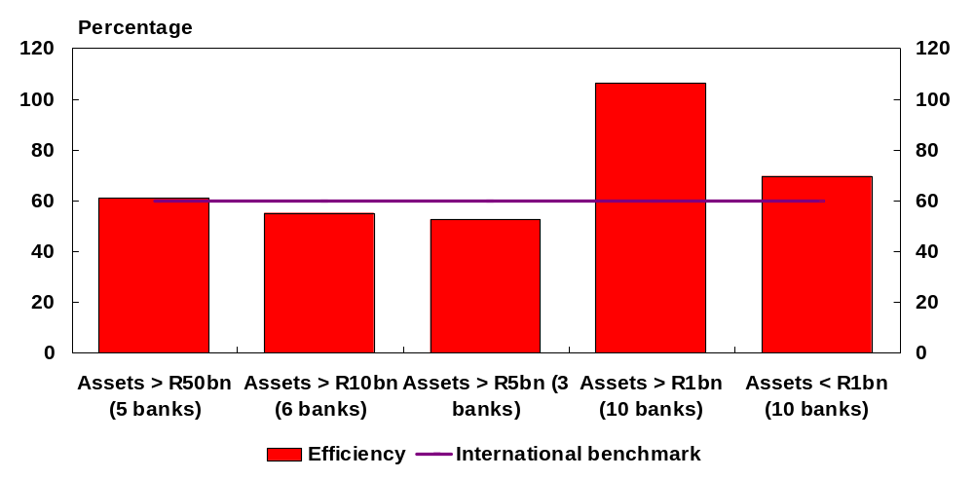

In December 2005, banks with assets of above R5 billion, but below R10 billion, were the most efficient, with an efficiency ratio of 52,7 per cent, followed by banks with assets above R10 billion, but below R50 billion (55,2 per cent). The least efficient were banks with asset values of above R1 billion, but below R5 billion (106,4 per cent), mainly as a result of continuing high costs relating to start-up operations having been reported by some banks. It should be borne in mind, however, that these figures are compiled for one month at a time. Because operating expenses and total-income components can fluctuate drastically from one month to another, the average efficiency ratios of different banks will fluctuate accordingly.
3.6 Profitability (12-month smoothed average)
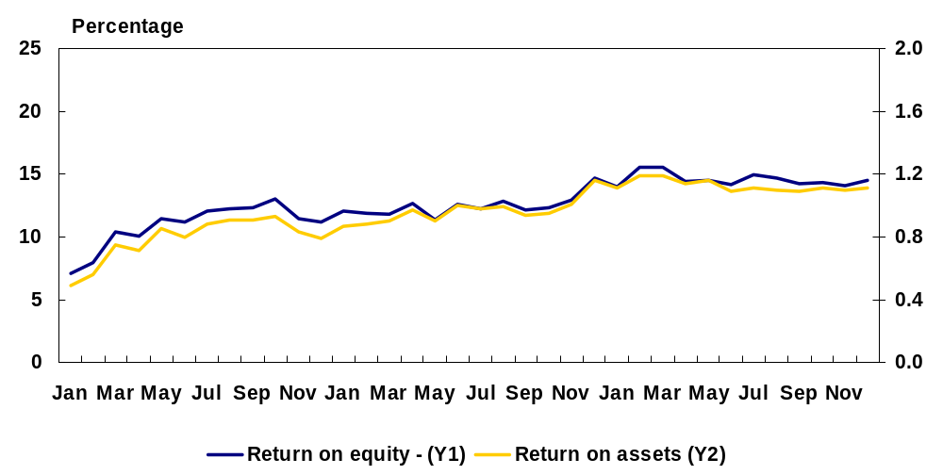

The gradual decrease in both the return on equity (ROE) and the return on assets (ROA) during 2005 resulted from a decrease in net income after tax having been recorded during 2005. The said decrease resulted mainly from higher operating expenses having been recorded during 2005, as mentioned earlier. For 2005, an after-tax return of approximately 1,1 per cent on total assets (2004: 1,2 per cent) was reported, whereas an after-tax return of approximately 14,5 per cent on net qualifying capital and reserves (2004: 14,7 per cent) was reported. The banking sector achieved a before-tax return of approximately 1,48 per cent on total assets (2004: 1,5 per cent).
4. Liquidity risk
4.1 Statutory liquid assets – actual versus required
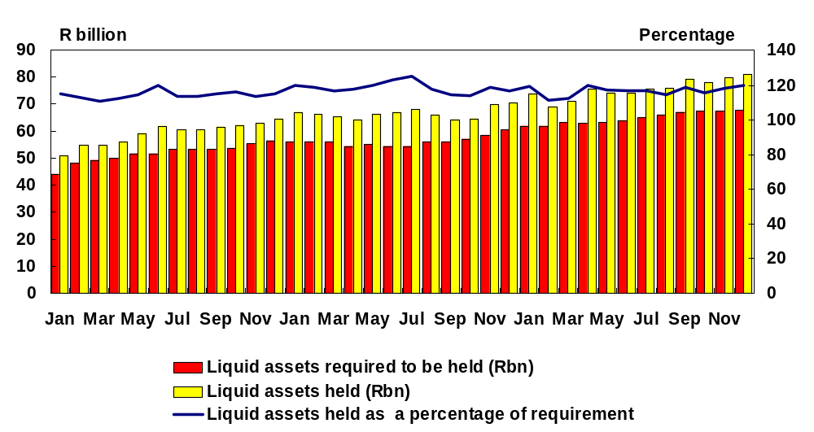

For the month of December 2005, the average daily amount of liquid assets held represented 119,7 per cent of the statutory liquid-asset requirement, compared to 116,8 per cent for December 2004.

Approximately 46,8 per cent (2004: 54,4 per cent) of the average daily amount of liquid assets held during December 2005 consisted of securities issued by virtue of section 66 of the Public Finance Management Act, 1999, whereas 32,3 per cent (2004: 28,4 per cent) consisted of Treasury bills of the Republic of South Africa, and 1 per cent (2004: 1,1 per cent) consisted of short-term bills issued by the Land Bank.
4.2 Wholesale depositors shorter than three months and large depositors

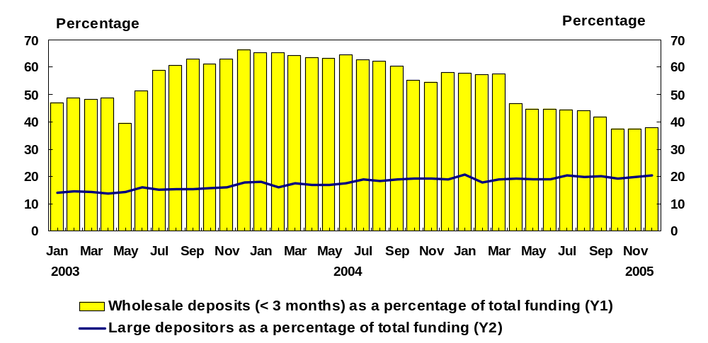

As at 31 December 2005, total wholesale deposits constituted 93,2 per cent (2004: 94,8 per cent) of total wholesale and retail deposits. Wholesale deposits shorter than three months as a percentage of total funding decreased substantially, from 57,5 per cent in March 2005 to 46,8 per cent in April 2005 and from 41,7 per cent in September 2005 to 37,4 per cent in October 2005. The decreases were due mainly to a change in the reporting of wholesale deposits from a contractual to an anticipated basis, in line with the regulatory requirements, by two A1-rated banks. By the end of December 2005, wholesale deposits shorter than three months represented 37,8 per cent of total funding.

During 2005, the aggregate amount of the funding provided by the 10 largest depositors of individual banks averaged R244,5 billion (2004: R194,2 billion). The 10 large depositors constituted 18 per cent (2004: 17,1 per cent) of the aggregate amount of total funding-related liabilities to the public at the end of December 2005.
  - Short-term wholesale deposits
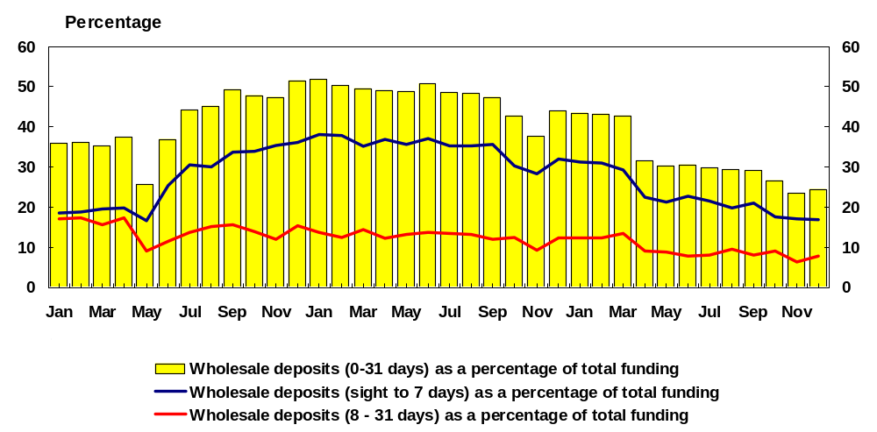

Short-term wholesale deposits (nil to 31 days) represented 24,5 per cent of total funding in December 2005, as opposed to 43,9 per cent for December 2004. As at the end of December 2005, wholesale deposits shorter than seven days and wholesale deposits between eight and 31 days represented 16,8 per cent and 7,7 per cent, respectively, of total funding. As can be seen in figure 26, wholesale deposits shorter than three months, categorised according to sight to seven days, eight to 31 days and nil to 31 days as a percentage of total funding decreased substantially in April 2005 and October 2005. The decreases were due mainly to a change in reporting from a contractual to an anticipated basis by two A1-rated banks, as mentioned previously.

5. Market risk
5.1 Turnover in derivative contracts
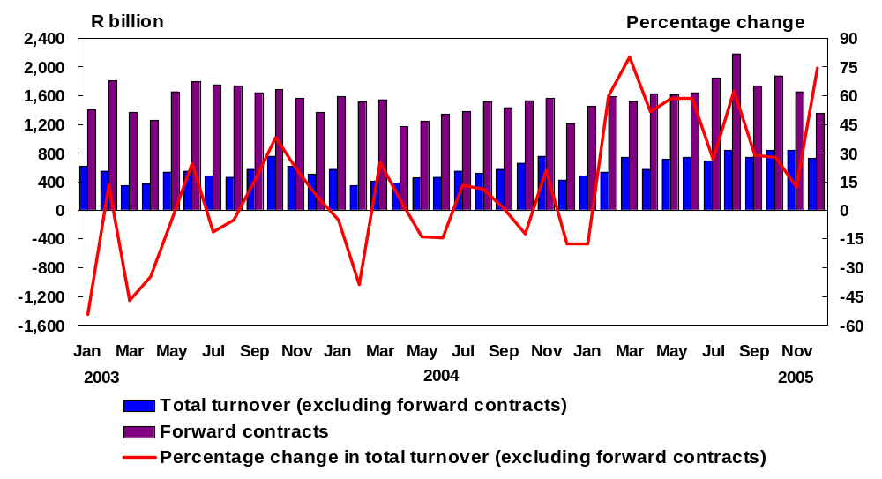

Turnover in derivatives, excluding forward contracts, generally fluctuated during 2005. Total actual turnover in derivative contracts, excluding forward contracts, increased from R475,8 billion for the month of January 2005 to R840,7 billion for the month of August 2005, before declining to R728,9 billion for the month of December 2005. The increase in August 2005 was mainly driven by, amongst other things, high market expectations of a rate increase, market opportunities and increased customer flows. The decrease in December 2005 was due largely to the general year-end slowdown in activity in the derivative markets.

Forward contracts contributed to the largest portion of total turnover in derivative instruments and increased from R1 442,5 billion in January 2005 to R2 172,5 billion in August 2005, but decreased to R1 346 billion in December 2005.
  - Total unexpired derivative contracts
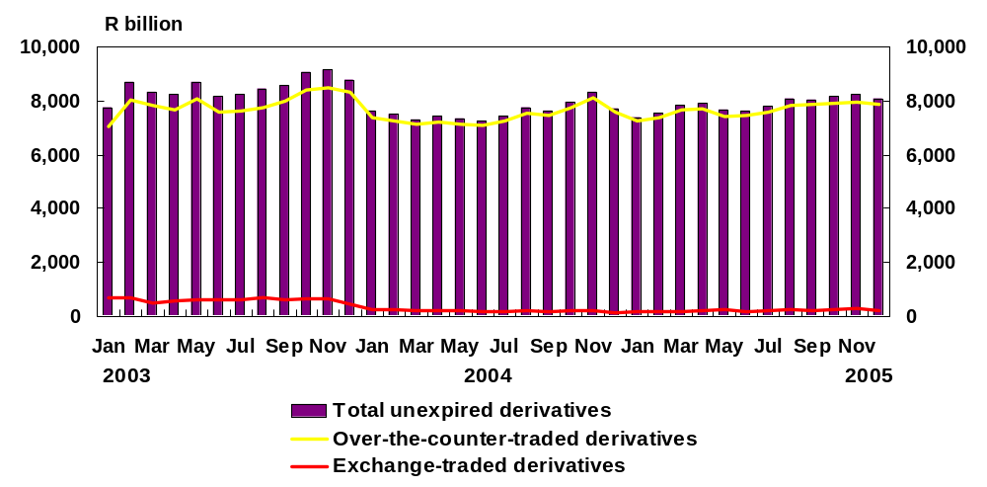

Total unexpired contracts consist mainly of over-the-counter (OTC)-traded derivative contracts and a small amount of exchange-traded derivative contracts. During 2005, total unexpired derivative contacts increased from R7 383,3 billion in January 2005 to R8 086 billion in December 2005, as a direct result of the growth in unexpired OTC-traded derivative contracts, which increased from R7 237,8 billion in January 2005 to R7 873,4 billion in December 2005. Unexpired exchange-traded derivative contracts increased from R145,5 billion in January 2005 to R212,6 billion in December 2005.

As at the end of December 2005, unexpired OTC-traded derivative contracts accounted for 97,4 per cent (2004: 98,4 per cent) of total unexpired derivative contracts, whereas unexpired exchange-traded contracts accounted for 2,6 per cent (2004: 1,6 per cent) of total unexpired derivative contracts. The total value of unexpired derivative contracts represented 482 per cent of total assets as at the end of December 2005 (December 2004: 514,7 per cent).
6. Credit risk
6.1 Total banking-sector overdues - R20,1 billion
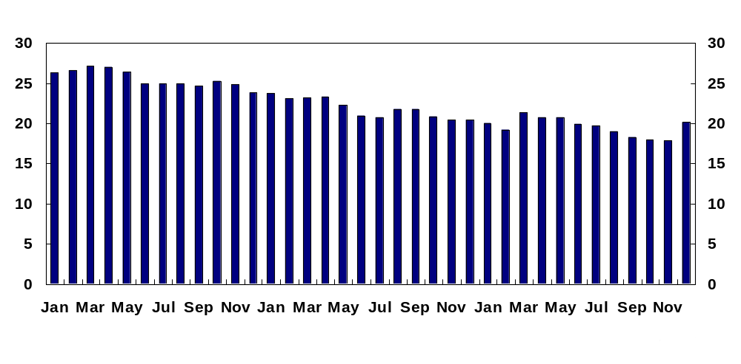

During 2005, total gross overdues continued to decrease, from R20,4 billion in December 2004 to R20,1 billion in December 2005, although total gross overdues increased noticeably during March 2005 and December 2005. The increase in March 2005 was due to a reporting correction by a large bank, whereas the increase in December 2005 was due mainly to a change in reporting, resulting from system developments to reflect a consolidated “per person” classification of credit risk, replacing “per account” reporting, in line with the requirements of regulation 28 of the Regulations relating to Banks.
  - Net overdues as a percentage of net qualifying capital and reserves

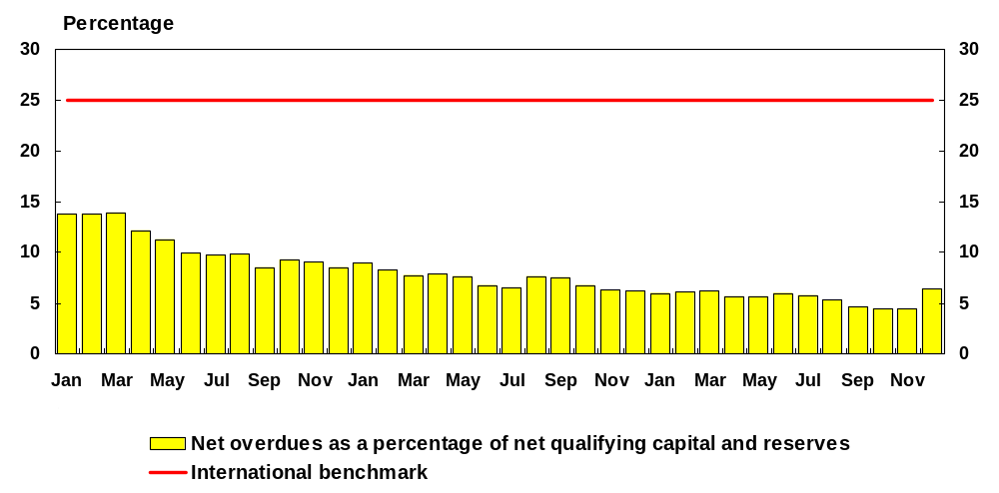

The ratio of net overdues (that is, gross overdues less specific provisions) to net qualifying capital and reserves is an indicator of the extent to which credit risk has materialised. As at the end of December 2005, net overdues amounted to R8,2 billion (2004: R7,3 billion), and specific provisions amounted to R11,9 billion (2004: R13,1 billion).

Net overdues as a percentage of net qualifying capital and reserves decreased from 6,2 per cent in December 2004 to 4,4 per cent in November 2005. By the end of December 2005, however, this ratio had increased to 6,4 per cent, owing to the above-mentioned increase in total overdues in that month resulting from the change in reporting to reflect the regulatory “per person” credit-risk classification.
6.3 Composition of overdues (as a percentage of loans and advances)
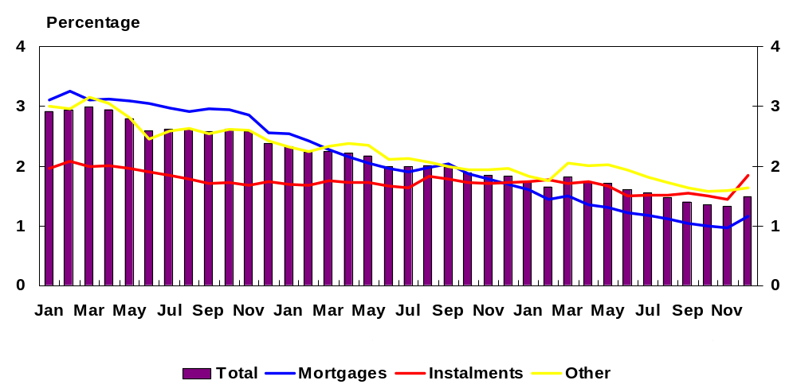

Expressed as a percentage of total loans and advances, gross amounts overdue improved from 1,8 per cent in December 2004 to 1,3 per cent in November 2005, before increasing to 1,5 per cent in December 2005 as a result of the previously mentioned change in reporting to reflect the regulatory “per person” credit-risk classification. The increase in March 2005 (1,8 per cent) was due to a reporting correction by a large bank.

From December 2004 to November 2005, mortgage loans overdue (as a percentage of total mortgage loans) improved substantially, from 1,7 per cent to 1 per cent. During March 2005 and December 2005, however, mortgage loans overdue (as a percentage of total mortgage loans) increased to 1,5 per cent and 1,2 per cent, respectively, for the reasons mentioned previously.

Other loans and advances overdue (as a percentage of total other loans and advances) increased from 2 per cent in December 2004 to 2,1 per cent in March 2005, before decreasing to 1,6 per cent in December 2005. The sharp increase in March 2005 was due to a reporting correction by a large bank.

Instalment sales overdue (as a percentage of total instalment sales) improved from 1,7 per cent in December 2004 to 1,4 per cent in November 2005, before increasing significantly to 1,9 per cent in December 2005. The sharp increase during December 2005 was due to the previously mentioned change in reporting to reflect the regulatory “per person” credit-risk classification.
6.4 Adequacy of provisions
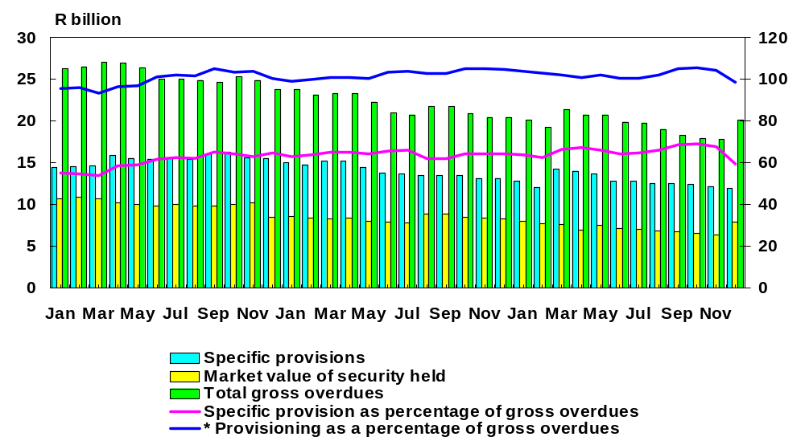

* Provisioning equals the sum of specific provisions and the market value of security.

Provisions by banks remained adequate throughout 2005. By the end of December 2005, specific provisions amounted to 59,4 per cent of all overdues (December 2004: 64,3 per cent). Total specific provisions and the market value of security held as a percentage of total overdues decreased from 104,9 per cent in December 2004 to 98,9 per cent in December 2005. The decrease in December 2005 was due to an increase in total overdues in December 2005, resulting from a change in reporting, as explained previously, which ultimately resulted in the ratio decreasing.

As at the end of December 2005, specific provisions per asset class, expressed as a percentage of overdue amounts, were as follows:
- Mortgages - 31,5 per cent (36 per cent on 31 December 2004).
- Instalment sales - 56,8 per cent (56,8 per cent on 31 December 2004).
- Other loans and advances - 76,1 per cent (83,7 per cent on 31 December 2004).
6.5 Large exposures granted and utilised as a percentage of capital
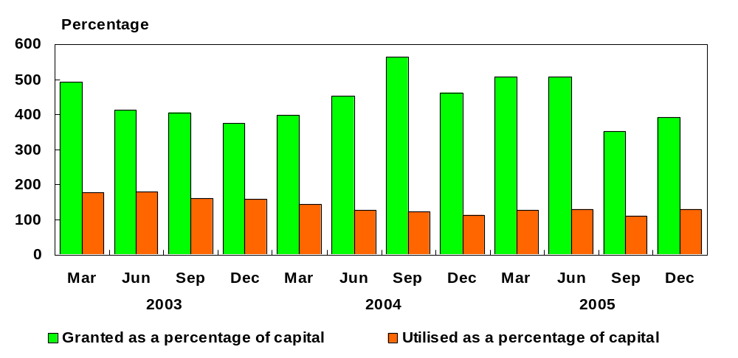

In terms of section 73(1)(b) of the Banks Act, 1990, exposures granted that exceed 10 per cent of capital and reserves (referred to as large exposures) should not exceed, in total, 800 per cent of net qualifying capital and reserves, and any single exposure granted and exceeding 25 per cent should be an impairment against the capital of the bank. This refers only to large exposures to private-sector non-bank borrowers and that the total of the large exposures analysed in this annual report includes, amongst other things, exposures to Government and other banks.

Large exposures granted decreased from 461,8 per cent of net qualifying capital and reserves in December 2004 to 391,7 per cent in December 2005. The decrease in large exposures granted from June 2005 to September 2005 was due mainly to banks aligning unutilised facilities with utilised facilities. Large exposures utilised increased from 113 per cent of net qualifying capital and reserves in December 2004 to 128,8 per cent in December 2005.
6.6 Asset performance
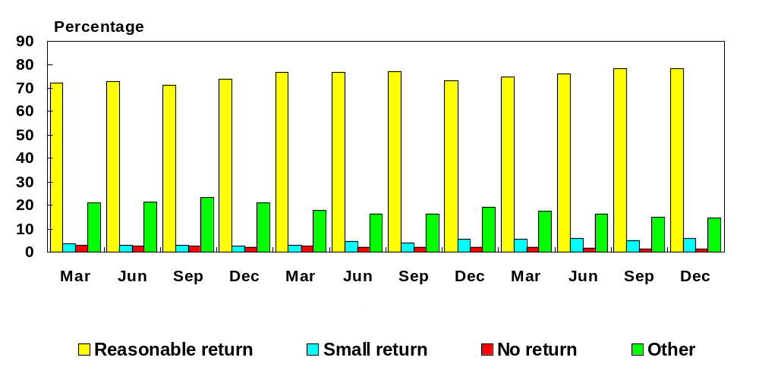

Reasonable return: This includes the assets that would contribute to continued profitable operation of the bank. In the absence of more accurate methods, all relevant assets on which a return in excess of the average cost of funds plus (operational expenses x 100)/total assets is being earned shall be included.

Small return: This includes the assets on which the profit margins are so low that they would not allow continued profitable operation of the bank. In the absence of more accurate methods, all relevant assets on which a return in excess of the average cost of funds, but below a reasonable return, is being earned shall be included.

No return: This includes the assets on which no income is earned and those discounts, as well as loans and advances, that are non-performing debts, as defined and net of specific provisions, including when the return being earned is less than the average cost of funds.

Other: This includes non-financial assets and other assets.

About 78,2 per cent of the banking sector’s assets (December 2004: 73,3 per cent) earned a reasonable return, whereas 5,8 per cent (December 2004: 5,3 per cent) earned a small return, and the remaining 16 per cent (December 2004: 21,4 per cent) earned no return. The increase in the reasonable-return category and the decrease in the no-return category were due mainly to a general improvement in credit-risk ratios during 2005. Although favourable economic conditions, such as lower interest rates and improved economic growth, will impact positively on asset quality, the challenge remains to maintain asset quality when economic conditions deteriorate.

7. Currency risk
7.1 Maximum effective net open foreign-currency position as a percentage of net qualifying capital and reserves (compliance with limit of 10 per cent)
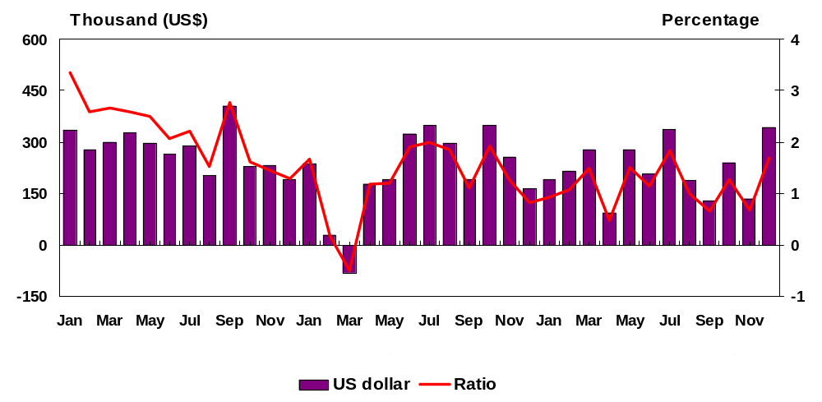

From December 2004 to December 2005, the maximum net open position in foreign currency after hedging increased from 0,8 per cent to 1,7 per cent, but remained well within the statutory limit of 10 per cent of net qualifying capital and reserves.
7.2 Position in foreign currency instruments

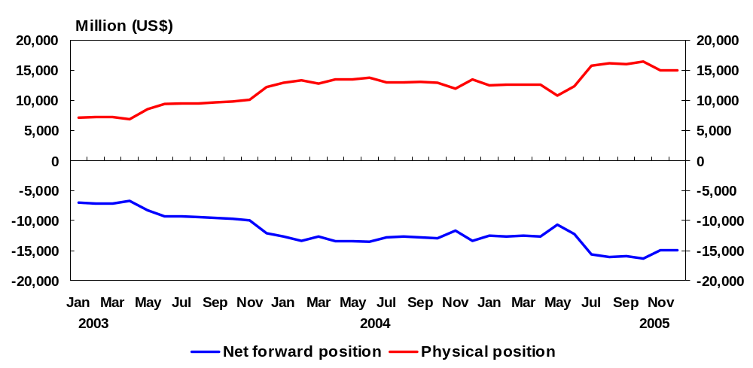

The physical position in foreign currency instruments equals the difference between the foreign assets and foreign liabilities, whereas the net forward position is the difference between commitments to sell foreign currency and commitments to purchase foreign currency. The physical position increased from US$13,5 billion in December 2004 to US$15,1 billion in December 2005, whereas the net forward position increased from -US$13,4 billion in December 2004 to -US$14,9 billion in December 2005. The increase in the physical position mirrored the widening forward position in order to maintain the overall net open position within the regulatory limit of 10 per cent of qualifying capital.

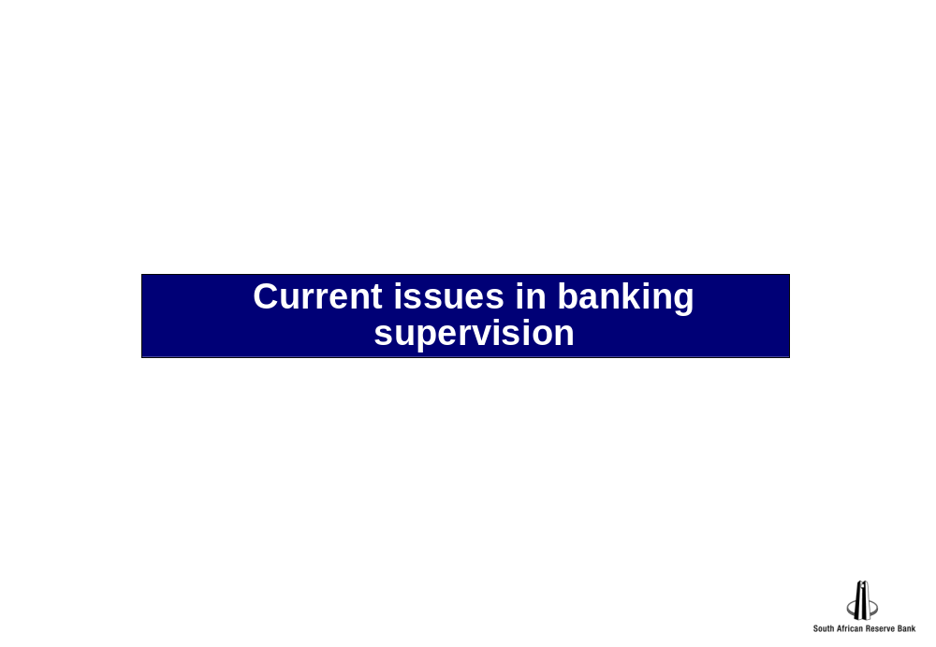

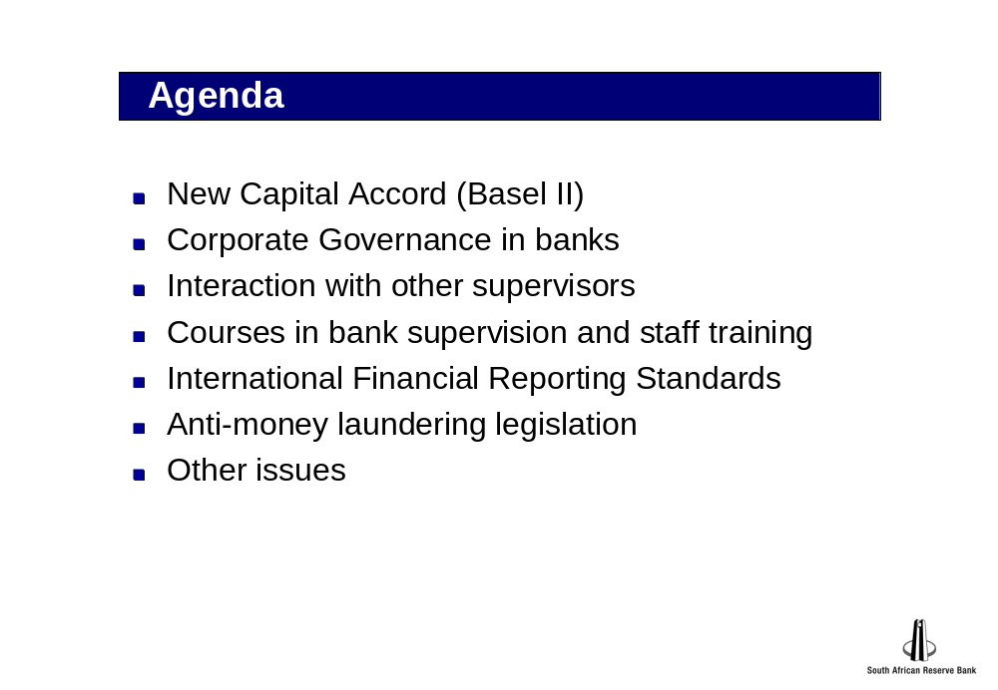



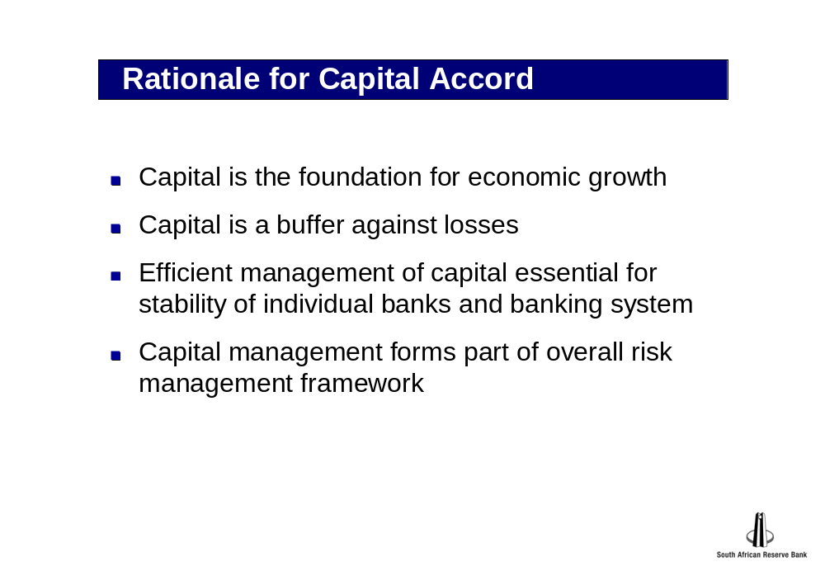

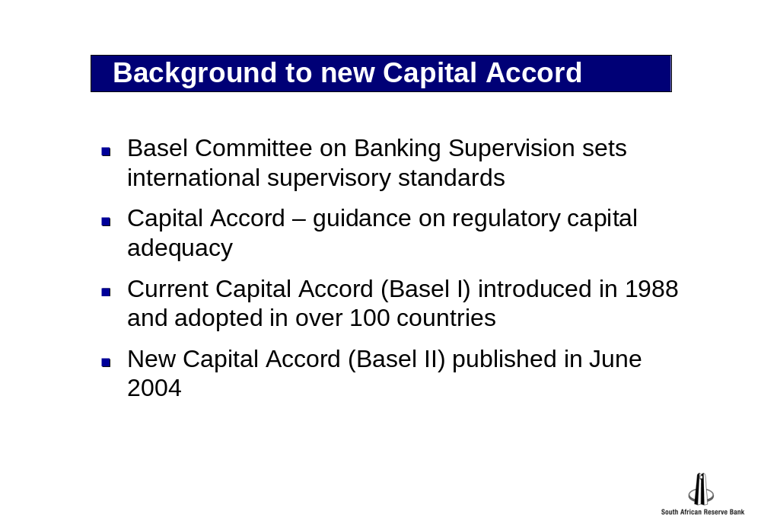

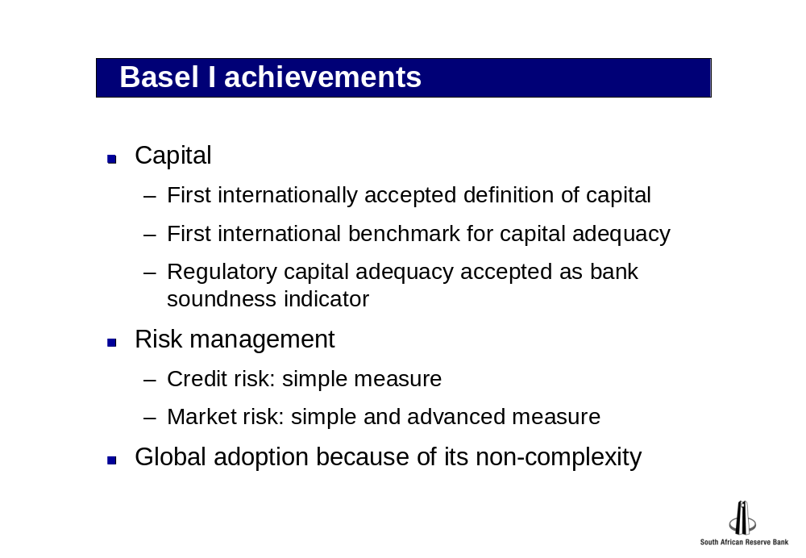

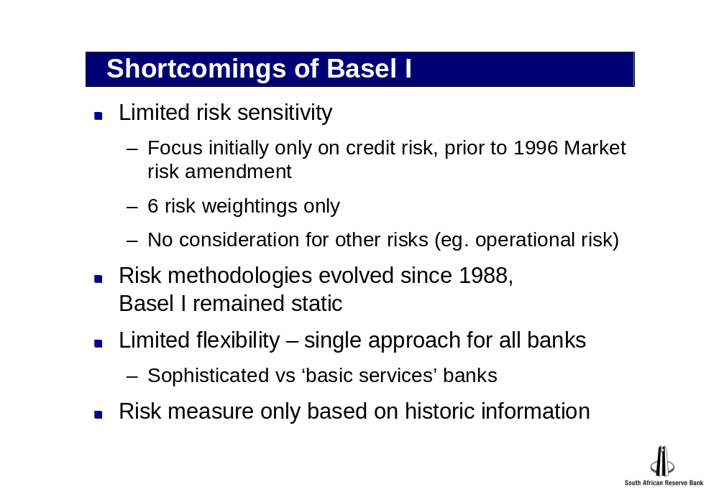

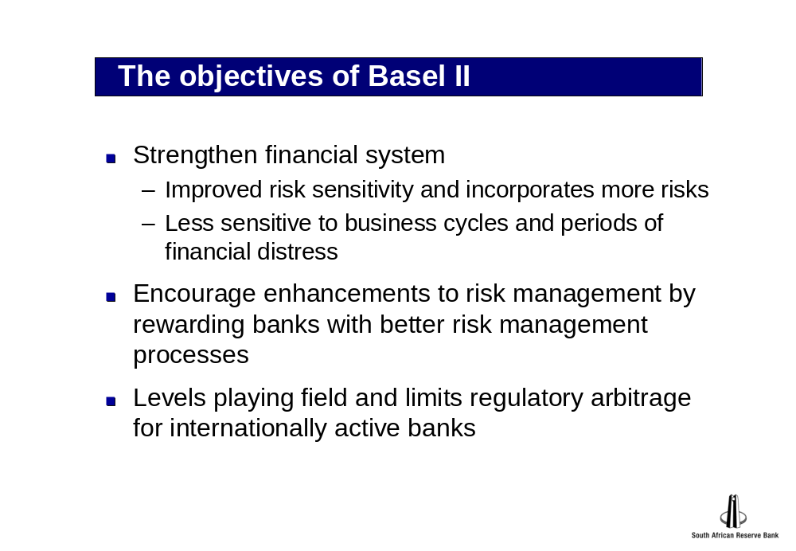

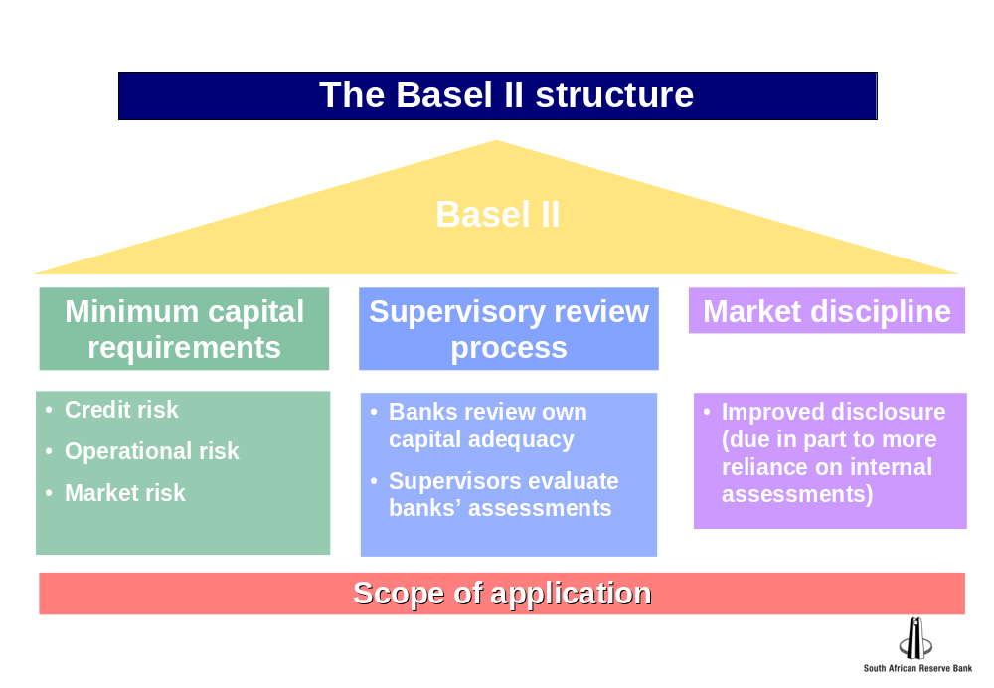

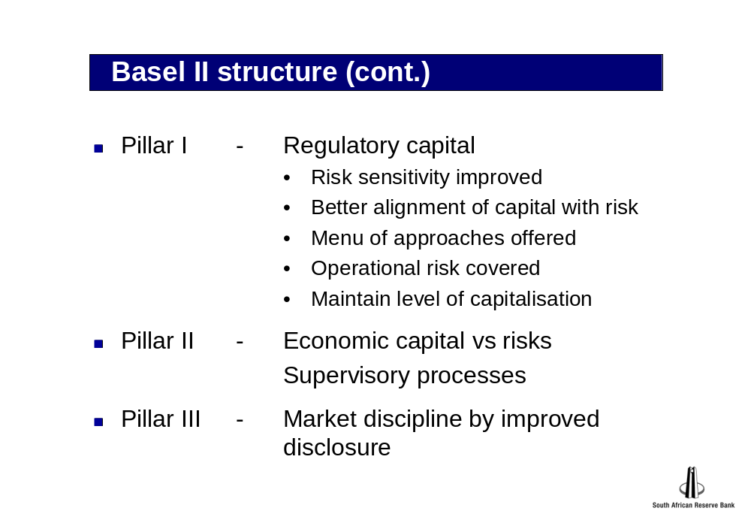

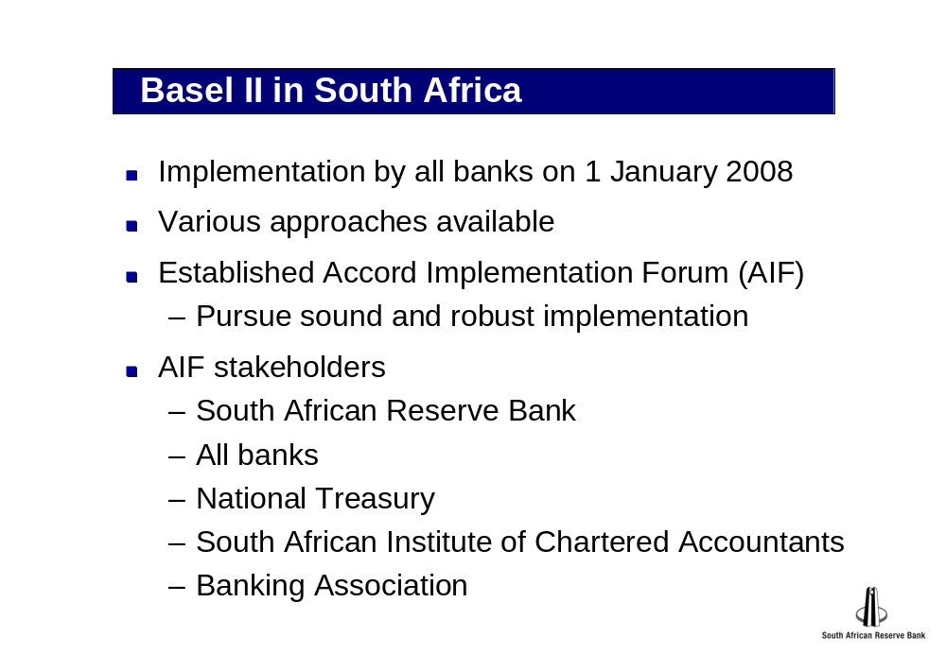

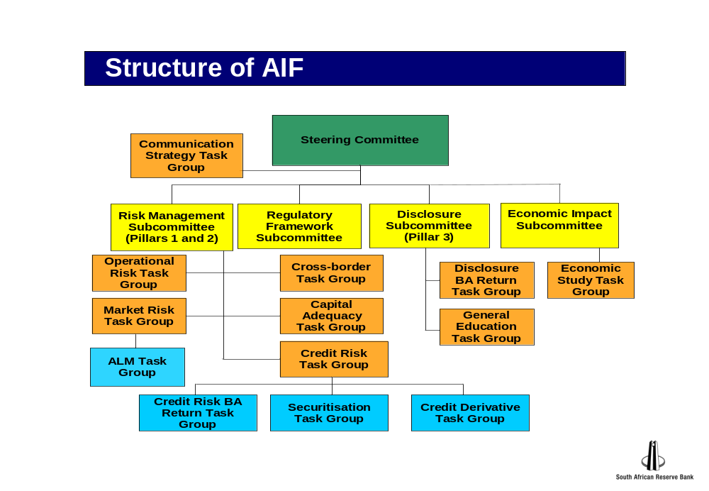

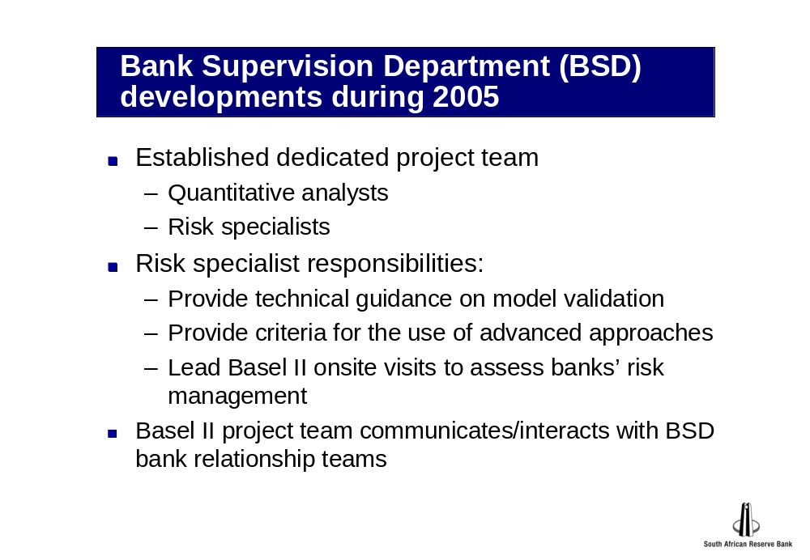

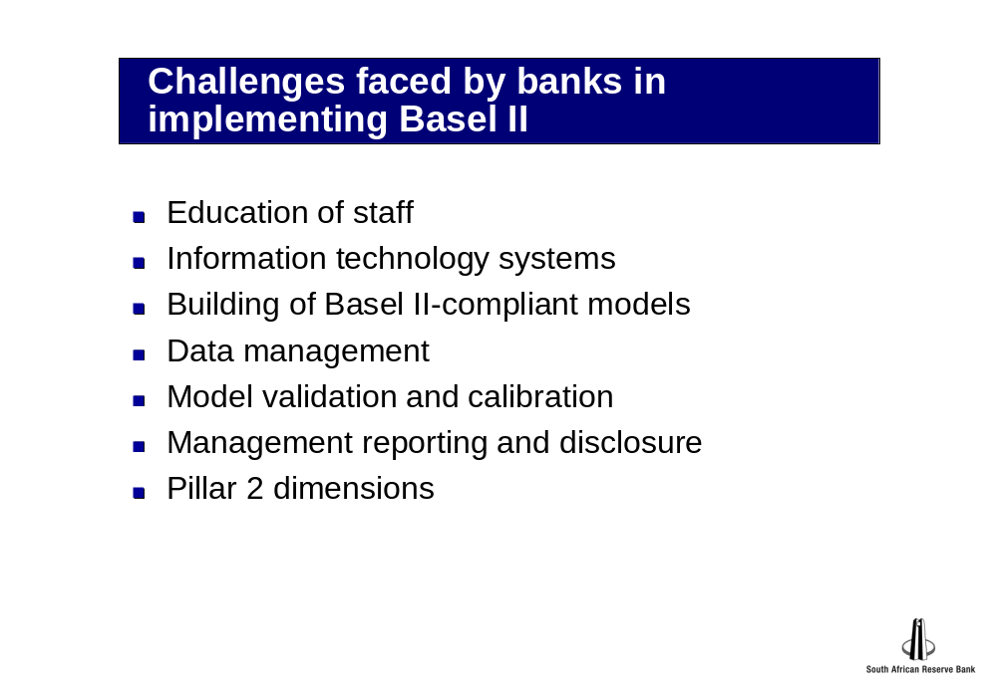

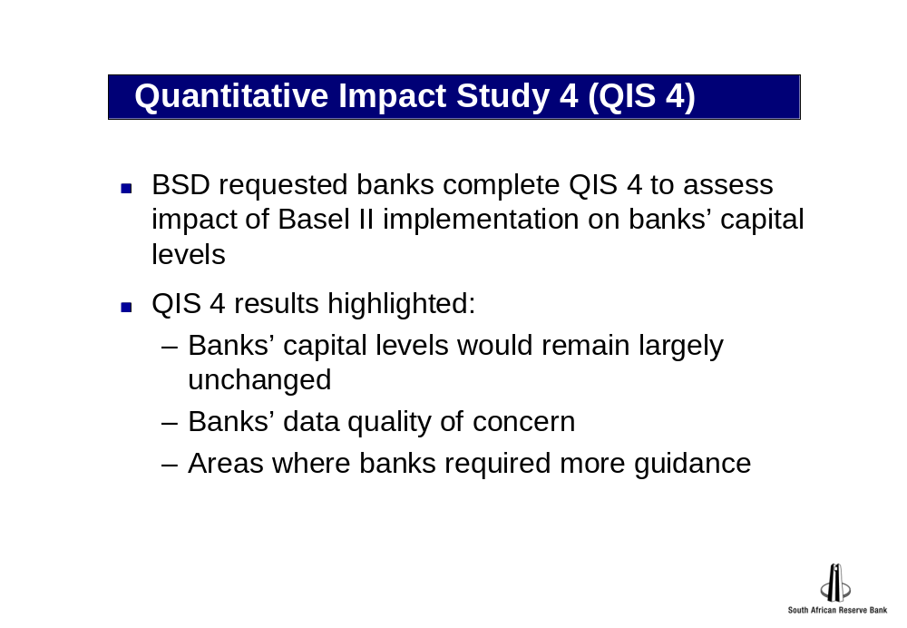

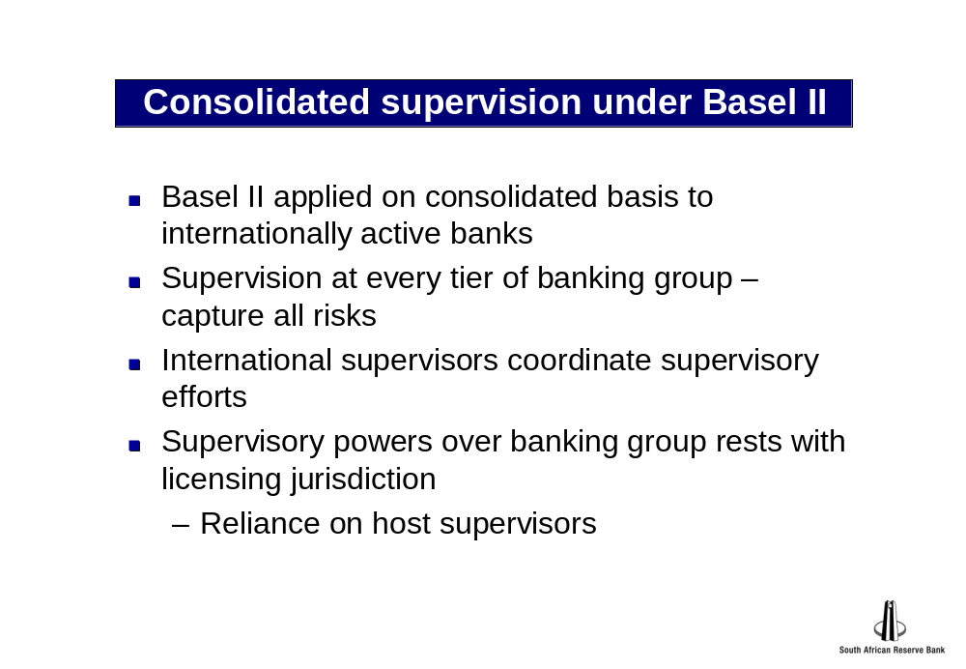

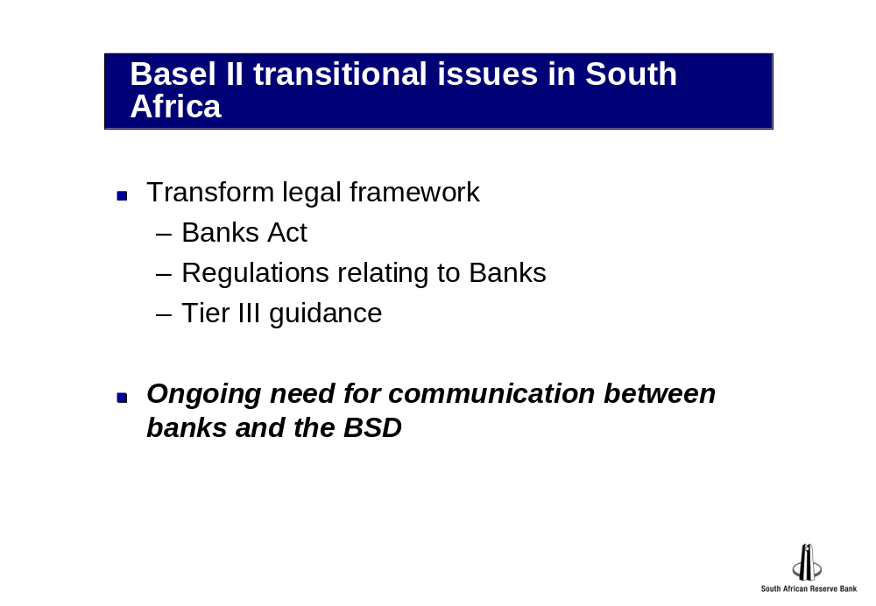



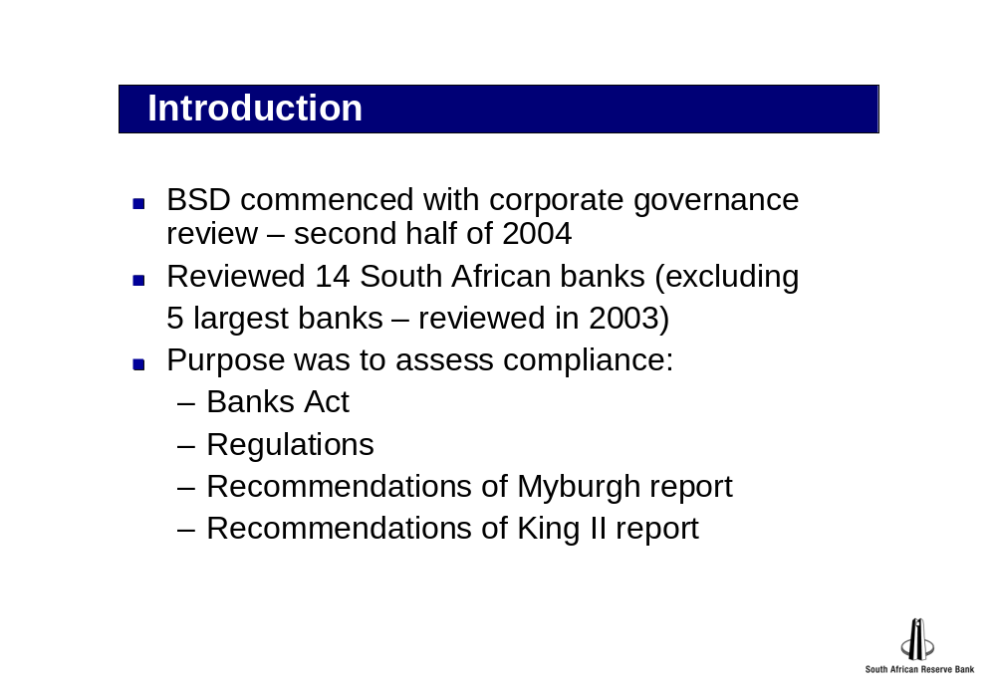

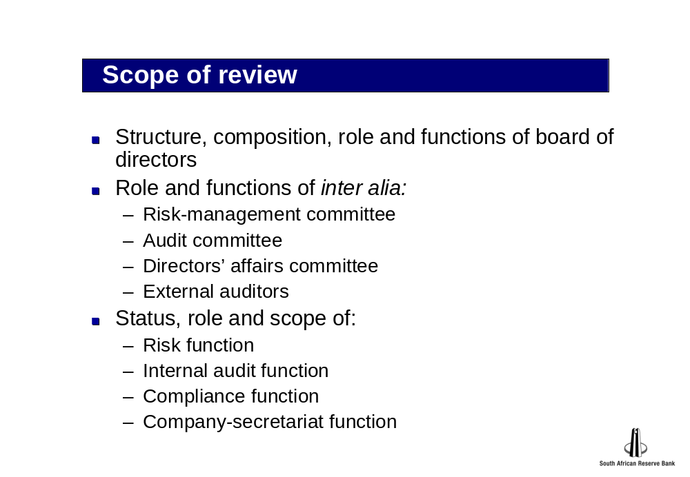

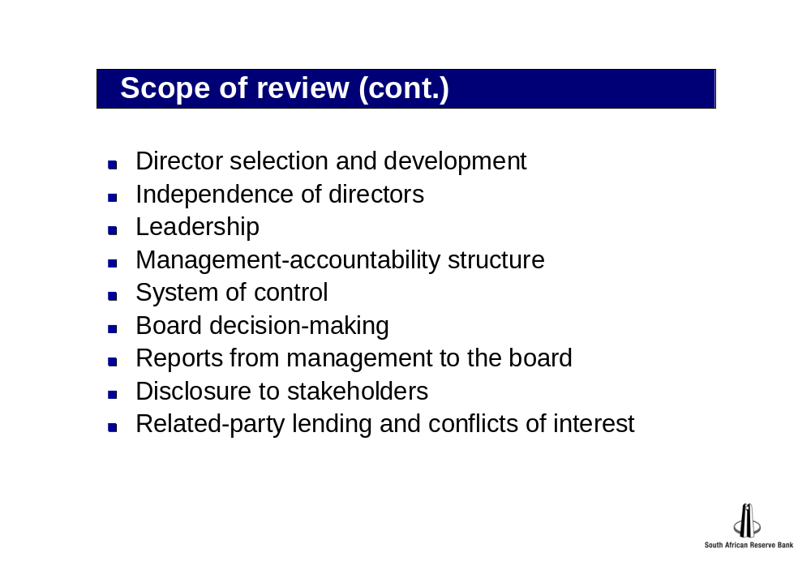

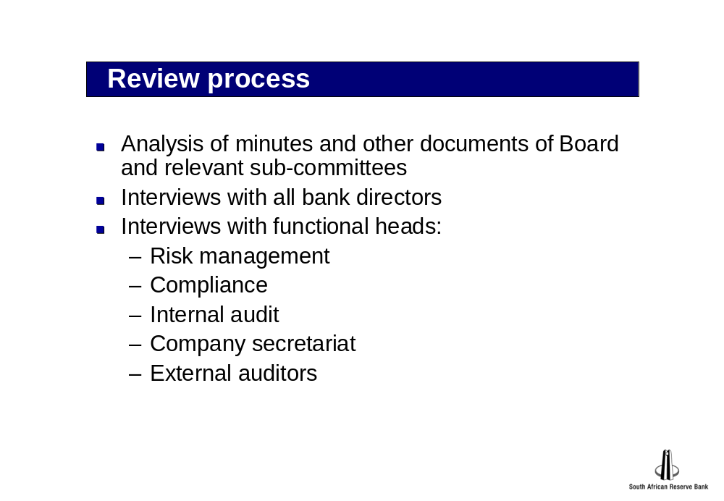

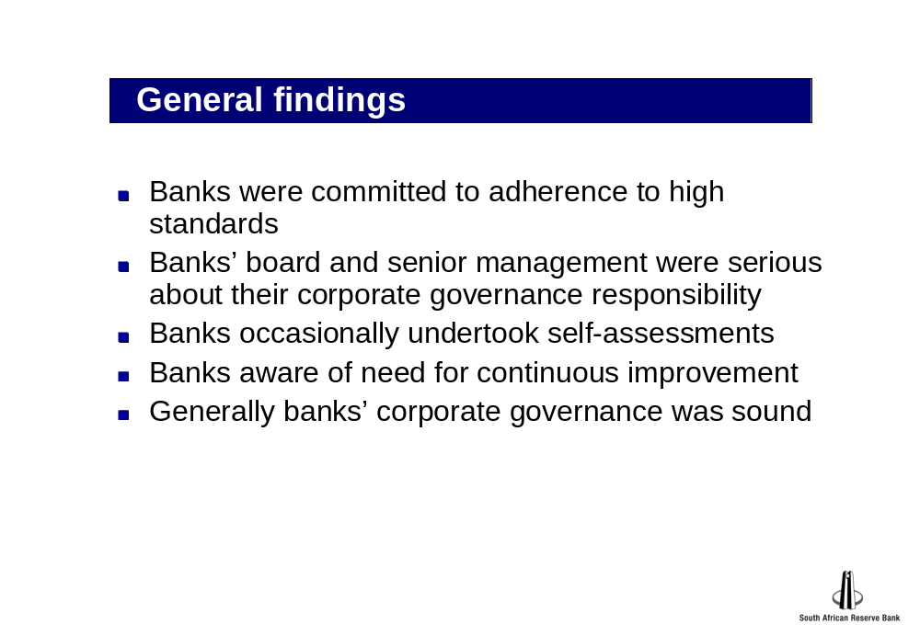

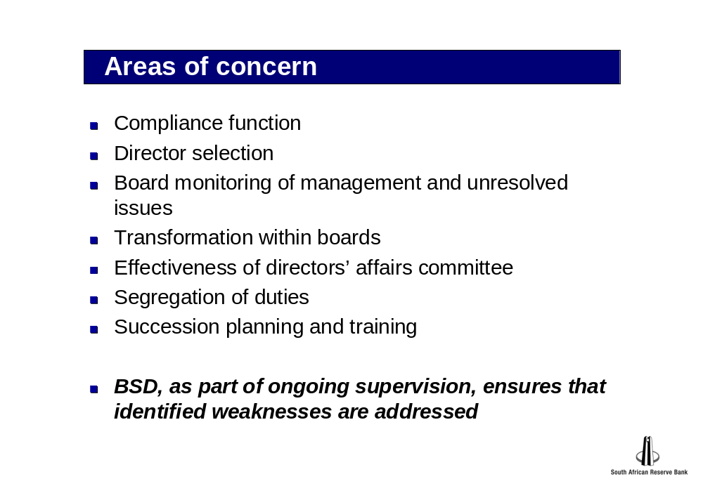

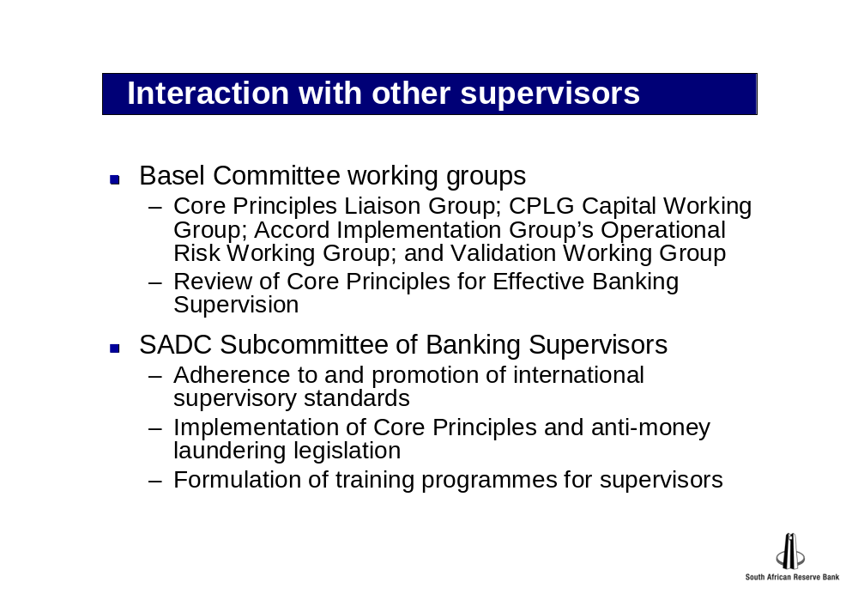

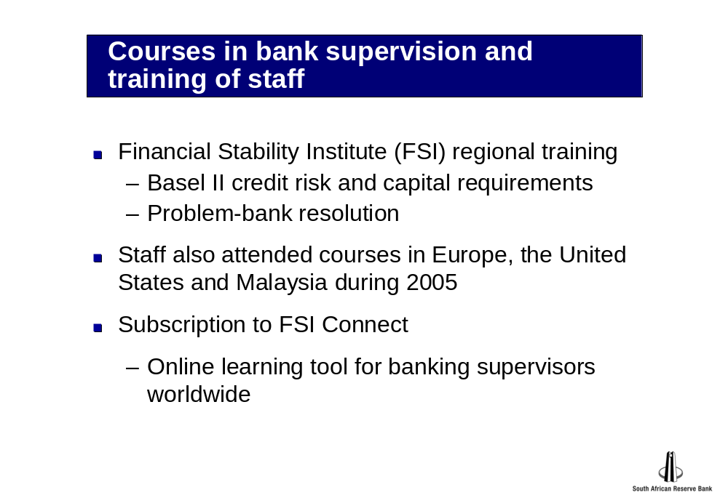

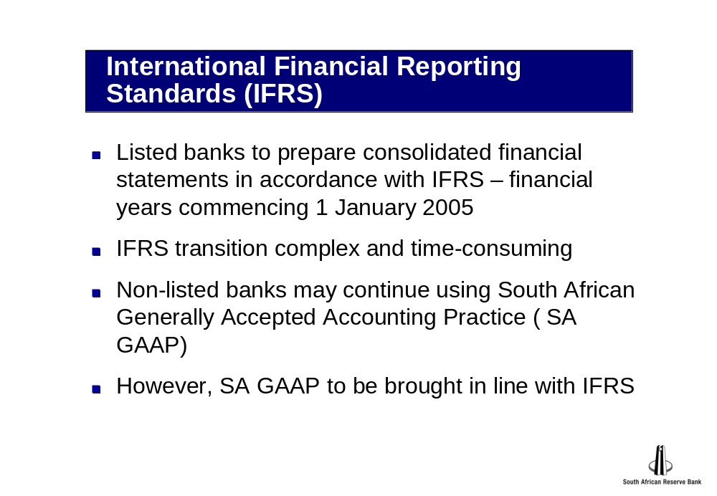

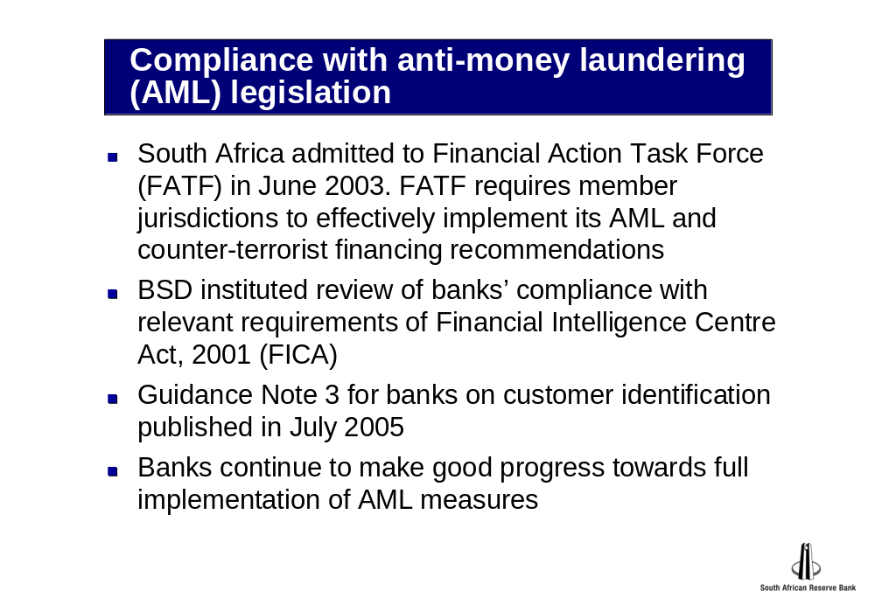

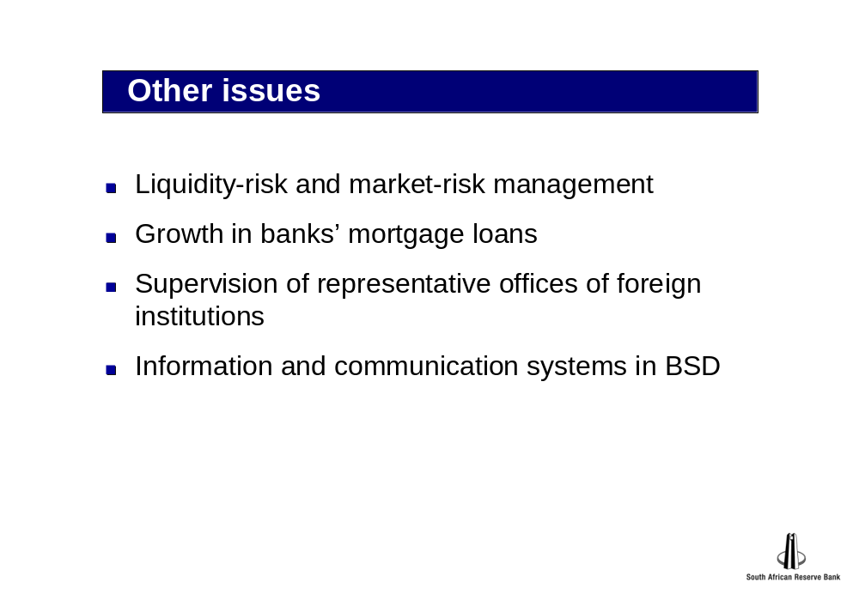

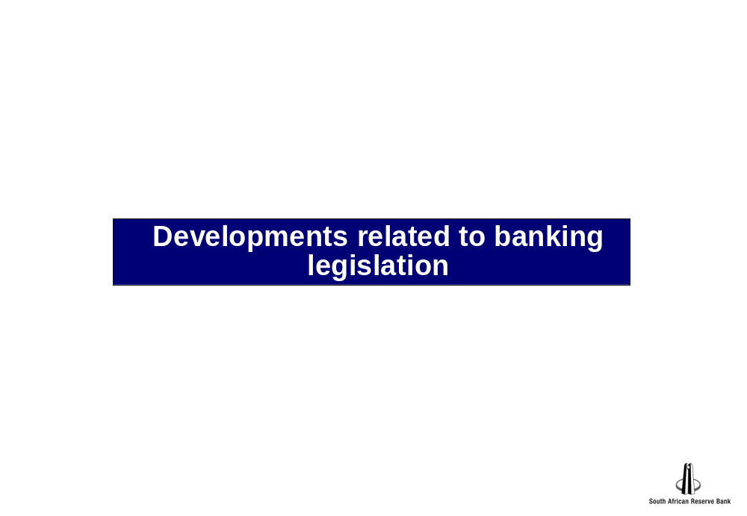

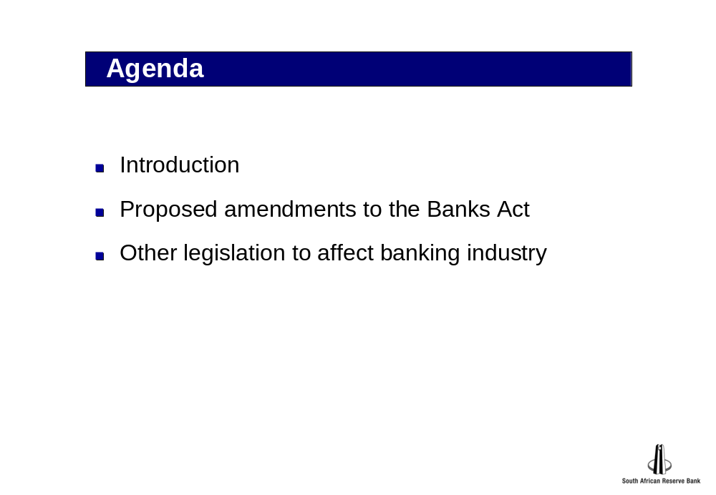

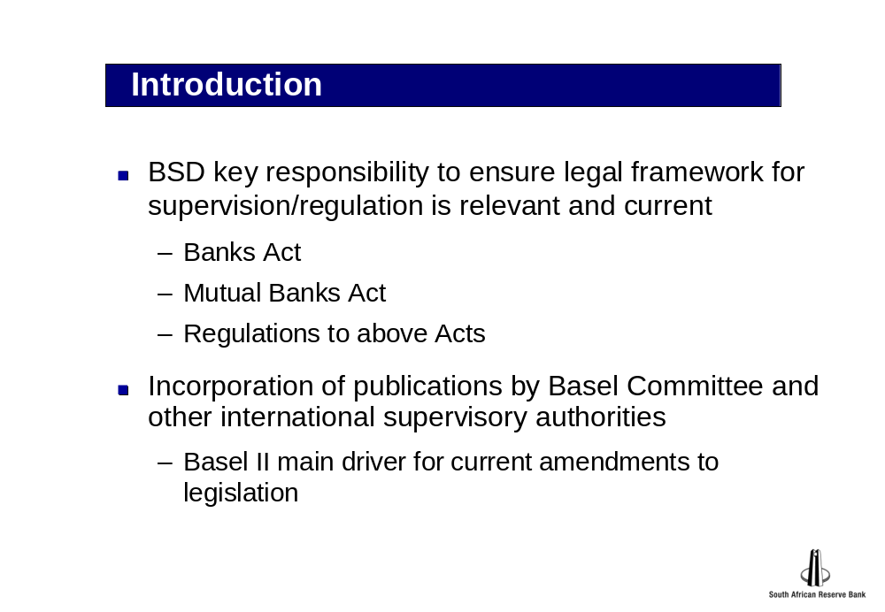

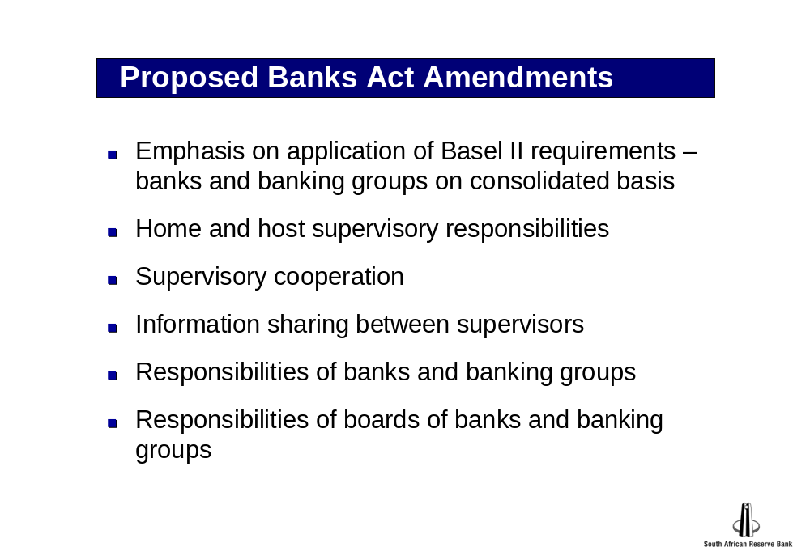

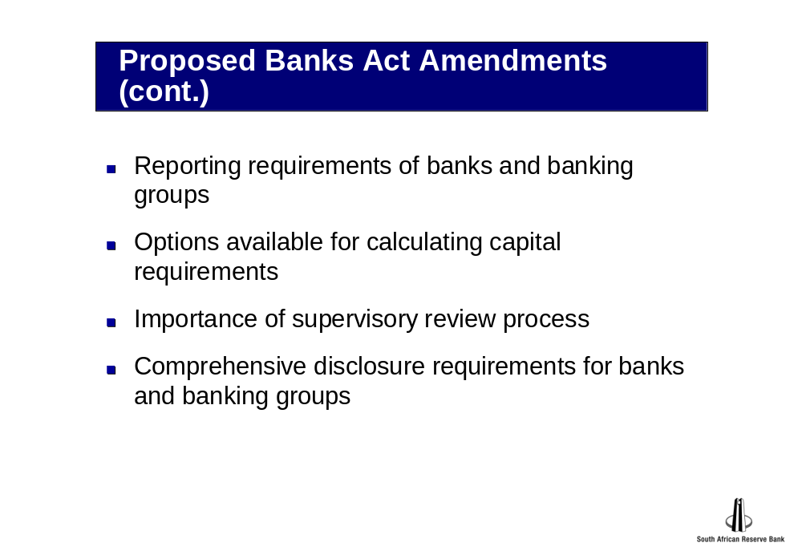

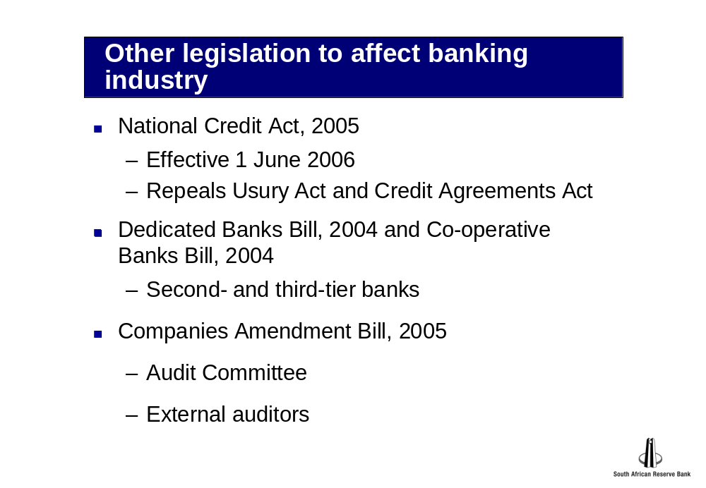

Current issues in banking supervision

1. The new Capital Accord

Good progress was made during 2005 with preparations for the implementation of the new Capital Accord (Basel II) on 1 January 2008.

During November 2005, the Basel Committee on Banking Supervision issued an updated version of the revised capital framework, incorporating the additional guidelines contained in the Committee’s paper titled “The application of Basel II to trading activities and the treatment of double default effects”. The changes introduced by the revised framework and the aforementioned document also resulted in the “Amendment to the Capital Accord to incorporate markets risks”, originally issued in January 1996, being updated.

Basel II Project Team

During 2005, the Department established a dedicated project team, which includes quantitative analysts and risk specialists, to drive the implementation of Basel II. Each risk specialist has been assigned dedicated responsibility for a specific risk area or aspect of a particular risk area. These responsibilities include, amongst other things, provision of technical guidance on model validation and minimum criteria for the use of more advanced approaches by banks. The risk specialists will also lead onsite visits to banks to assess the quality of banks’ risk management and, in the case of banks intending to use an advanced approach, the models, methodologies and related controls used by such banks.

The Department’s analysts are kept informed of the Basel II Project Team’s work on an ongoing basis and, when possible, the relevant team of analysts accompanies the risk specialists during the above-mentioned visits to banks. In the case of banks that are intending to apply to use an advanced approach for capital-adequacy purposes, the lead analyst of each particular bank has a dedicated primary responsibility for Basel II implementation. This entails, amongst other things, ongoing monitoring of the particular bank’s Basel II implementation plans and state of readiness.

The Basel II Project Team’s work will result in, amongst other things, input into an updated supervisory process.

Accord Implementation Forum

The Bank Supervision Department previously reported on the establishment and work of the Accord Implementation Forum (AIF) in pursuit of sound and robust implementation of Basel II and the significant contribution by banks that the structure facilitated. During 2005, the AIF met on a regular basis, and the extensive deliberations resulted in a substantial increase in the number of position papers issued. New task groups were created on an ad hoc basis when deemed necessary, and when the work allocated to a task group had been completed, the group was disbanded. The AIF structure is depicted in figure 1 below.

Figure 1: Structure of Accord Implementation Forum

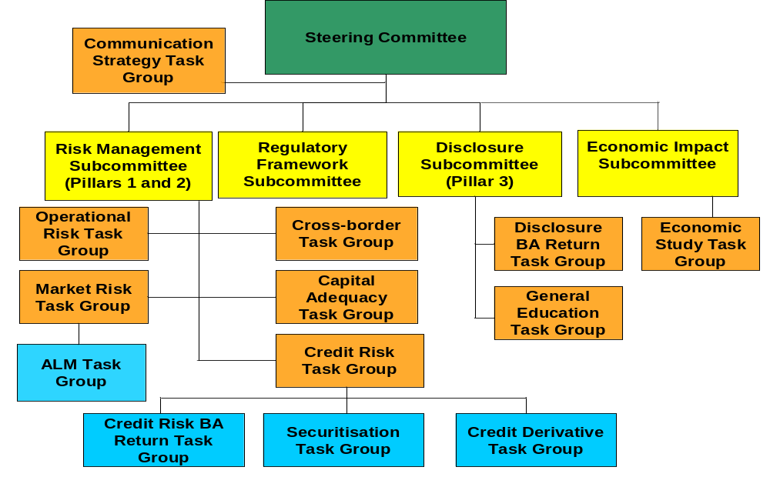

Challenges that banks face in implementing Basel II are the following:

- Basel II education of staff.
- Information technology systems.
- Building of Basel II-compliant models.
- Data management.
- Model validation and calibration.
- Management reporting and disclosure.
- Pillar 2 dimensions.

Quantitative Impact Study 4

In Banks Act Circular 2/2005, released early in January 2005, banks were requested to complete Quantitative Impact Study 4 (QIS 4). The aim of QIS 4 was to assess the possible impact of the implementation of Basel II on the level of capital in the banking industry.

The results of QIS 4 raised concerns about the quality of data, the dispersion of results and certain international issues. Accordingly, QIS 4 highlighted areas on which additional guidance is required to ensure consistent application of the Basel II framework by South African banks.

The QIS 4 results indicated that the level of capital that the banking industry would be required to hold in terms of Basel II would not differ significantly from the level that the banking industry was currently required to hold. In this regard, however, the benign economic conditions of the recent past have to be borne in mind. The QIS4 results further indicated that the composition of the capital requirements would change, owing to the introduction of a new capital charge for operational risk and a decrease in the credit-risk capital requirement

The QIS 4 results were based on models in use at the time of the study. Since these models are expected to evolve over time, future results may differ from the QIS 4 results.

Consolidated supervision under Basel II

Basel II will be applied on a consolidated basis to internationally active banks, in order to capture the risks faced by an entire banking group. In practice, supervisors have to perform supervision at every tier within a banking group, starting with the banking entity and progressing to the holding company of the particular banking group, including banking operations in all jurisdictions in which the group is active.

Basel II provides a menu of options for banks and makes provision for various items of national discretion. Furthermore, different jurisdictions are following timetables suited to their local conditions. It is widely recognised that this type of customisation between different jurisdictions may result in inconsistencies in the implementation of Basel II. The onus is on international regulators to coordinate their supervisory efforts, specifically when they have to supervise internationally active banks that operate in a number of jurisdictions, so as to promote the principles underpinning Basel II.

The responsibilities of the consolidating supervisor will encompass the supervision of the group-wide functions and the overall solvency of a consolidated group. Supervisory powers thus rest substantially with the authorities that license individual institutions, and consolidating supervisors will have to rely on their host peers for effective intervention at the level of a banking subsidiary, in many areas.

This may be illustrated as set out in figure 2.

Figure 2: Consolidated supervision

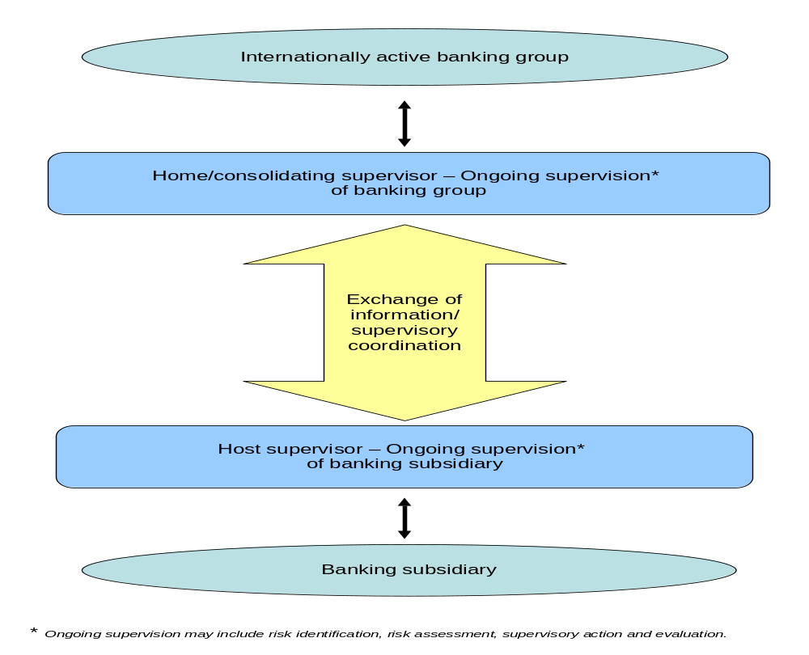

Practical concerns include:

- The need for increased supervisory transparency.
- Convergence of supervisory practices around common principles.
- Effective home/host coordination in respect of qualification and model validation.
- Avoidance of duplication of efforts or increasing regulatory burdens.
- Fostering commonality of pillar 2 approaches.

Internationally, consolidated supervision remains an area of ongoing research and debate. The Bank Supervision Department will continue to liaise with its international counterparts to assist internationally active banks in its jurisdiction.

Supervisory challenge

Migration from the existing Capital Accord to Basel II has necessitated significant amendments and refinements to the legal framework and supervisory review process followed by the Department. A major challenge will be to balance the supervisory requirements with the available resources.

The progress made thus far with the process of planning for and gearing up to the implementation of Basel II has benefited greatly from the active and enthusiastic involvement of the banking sector in the AIF fora. Personnel from the Banking Association South Africa who are dedicated to the Basel II planning and implementation process also continue to play a most valuable and an indispensable role.

The combined efforts of all participants have contributed to an efficient, effective and robust process, from which the banking sector and the country as a whole is bound to benefit. This is in line with the Basel Committee on Banking Supervision’s objective to strengthen the soundness and stability of the international banking system, whilst maintaining sufficient consistency to promote level playing-fields among banking institutions.

The Bank Supervision Department is of the view that Basel II is an interim point in striving towards the attainment of best practice.

2. Review of corporate governance in South African banks

In the second half of 2004, a four-person team of the Bank Supervision Department commenced with a corporate-governance review of 14 South African banks, including two mutual banks, but excluding the five big banks, which had been reviewed in 2003. The purpose was to assess these banks’ compliance with sound corporate-governance practices, as laid down in the Banks Act, 1990, the Mutual Banks Act, 1993, the Regulations to these Acts, the recommendations of the Myburgh Report on the Standard of Corporate Governance in the Five Largest Banks and of the second King Committee on Corporate Governance. As in the case of the review of the five big banks undertaken by the Myburgh Working Group in 2003, the particular objective of the second review was to establish to which extent an adequate and effective process of corporate governance had been established and maintained within each bank and banking group, where applicable, and the extent to which the overall effectiveness of the process could be improved and enhanced.

Scope of the review

The scope of the review, which was similar to that of the Myburgh Working Group’s review, was to establish, describe and express an opinion on the adequacy of the following areas in the 14 banks reviewed:

- Structure, composition, role and functions of the board of directors.
- Role and functions of the:
  - Risk-management committee.
  - Audit committee.
  - Remuneration committee.
  - Directors’ affairs committee.
  - Chief executive officer.
  - External auditors.
- Status, role and scope of the:
  - Risk function.
  - Internal audit function.
  - Compliance function.
  - Company-secretariat function.
- Director selection, career pathing and development.
- Independence of directors.
- Leadership.
- Management-accountability structure.
- Systems of control.
- Decision-making process and decision-making capability of the board.
- Reports from management to the board.
- Board monitoring of management activities reported to the board.
- Disclosure to stakeholders.
- Related-party lending, conflicts of interest and related matters.

Review process

The review process was very similar to that followed by the Myburgh Working Group and included the following:

- Analysis of various documents, including minutes of meetings of the following bodies:
- Board of directors.
  - Audit committee.
  - Risk committee.
  - Remuneration committee.
  - Directors’ affairs committee.

- Interviews, 191 in total, with the following:
- All directors of the banks under review.
- Heads of the following functions:
- Risk management.
- Compliance.
- Internal audit.
- Company secretariat.
- External auditors of the banks under review.

- Consolidation of the information received and report writing.

The review was concluded by the release of a report titled “General report on the standard of corporate governance in South African registered banks and mutual banks (excluding the five major banking institutions and foreign branches)” on 1 September 2005. The report was distributed to all banking institutions under cover of Banks Act Circular 5/2005 of 7 September 2005.

General findings

The following general findings arose from the review:

- The banks reviewed were committed to adherence to and application of high standards of corporate governance.
- The banks’ senior management and boards of directors were inclined to take seriously their responsibilities for ensuring effective corporate governance.
- The banks from time to time, at their own initiative, reviewed their corporate governance to ensure compliance with accepted corporate-governance principles.
- In general, the banks’ corporate governance was sound.
- The banks reviewed were mindful of the need to improve continuously, especially in the light of ever evolving governance standards in South Africa and internationally.
Areas of concern

Certain areas of concern, however, were highlighted in the general report, as follows:

- Compliance function
- Director selection
- Training of directors
- Board monitoring of management and unresolved issues
- Transformation within boards
- Effectiveness of directors’ affairs committees
- Segregation of duties
- Succession planning and training

The Department, as part of its ongoing supervision of the banking sector’s commitment to sound corporate governance, will engage with the banks reviewed, in order to ensure that weaknesses identified in the review are addressed.
3. Interaction with other supervisors

As in the past, the Bank Supervision Department continued to interact with other supervisors, both locally and abroad, in fulfilling its regulatory and supervisory responsibilities. In view of the importance of the Basel Committee on Banking Supervision in the supervisory arena, coupled with the impending implementation of the new Capital Accord, interaction with the Basel Committee continued to be of particular importance.

Bank-supervisory activities at regional level

The Bank Supervision Department continued to participate in the activities of the SADC (Southern African Development Community) Subcommittee of Bank Supervisors (SSBS). The SSBS is the forum for bringing together the views of regional bank-supervisory bodies, the objective being to promote the overall standard of bank supervision in SADC member countries, in line with best international practice. The SSBS - through its Steering Committee, established to run day-to-day activities - actively promotes the harmonisation of bank-supervisory philosophies and practices in the SADC region.

The objectives of the SSBS include:

- Enhancement of bank supervision, through adherence to and promotion of international supervisory standards.
- Harmonisation of banking legislation and supervisory systems and practices.
- Implementation of the Basel Core Principles for Effective Banking Supervision.
- Anti-money-laundering compliance and combating of terrorist financing.
- Formulation of training programmes in conjunction with regional and international bodies.

Projects of the SSBS Steering Committee include:

- Compliance with the Basel Core Principles.
- Financial-soundness indicators.
- Report on aggregated financial information.
- Bank-supervision information-technology application project.

During 2005, members of the Department attended two meetings of the SSBS Steering Committee to finalise a memorandum of understanding.

4. Courses in bank supervision and training of staff

The Financial Stability Institute of the Bank for International Settlements presented two regionally focused seminars during 2005. The first seminar, which covered credit-risk management and the measurement of capital requirements for credit risk in the new Capital Accord (Basel II), was held at Victoria Falls, Zimbabwe, and was attended by 46 participants from 17 countries. The second seminar, which covered problem-bank resolution, was held in Maputo, Mozambique, and was attended by 34 participants from 11 countries. Both seminars were attended by staff members of the Bank Supervision Department.

The objectives of the seminars were to:

- Provide an overview of the latest developments with Basel II.
- Update participants on current best practices in risk management and problem-bank resolution.
- Provide a forum for the exchange of ideas on common problems and the implementation of best supervisory practices, such as improving corporate governance in banks.
- Provide the Financial Stability Institute with useful information on the most important needs in the SADC region.

The Bank Supervision Department successfully hosted an intermediate course in banking supervision, attended by 25 participants from 10 SADC member countries.

To ensure that the skills base of the Bank Supervision Department is constantly improved, considerable resources are allocated to training. The objective is to enable staff to:

- Implement sound global supervisory standards and practices.
- Share supervisory practices and experiences.
- Promote cross-sectoral and cross-border supervisory contacts and co-operation.

During 2005, staff members of the Department attended seminars and courses on banking supervision and financial topics not only in South Africa, but also in Austria, Hungary, Lesotho, Malaysia, Mozambique, Switzerland, the United Kingdom, the United States of America and Zimbabwe.

In order to overcome the Basel II skills shortage, the Department has subscribed to FSI Connect, a web-based information resource and learning tool for bank supervisors worldwide, developed by the Financial Stability Institute. FSI Connect offers a comprehensive set of online tutorials directly related to banking and bank supervision. The tutorials reflect the most up-to-date information and cover capital adequacy and important risk-management topics, such as credit-risk, market-risk and operational-risk management.

5. Alignment of South African Accounting Statements with International Financial Reporting Standards

For financial years commencing on or after 1 January 2005, listed banks have to prepare their consolidated financial statements in accordance with International Financial Reporting Standards (IFRS), which also includes International Accounting Standards. These financial statements also have to include comparative figures for 2004 prepared on an IFRS basis. Therefore, companies with a December year-end have an IFRS transition date of 1 January 2004 assuming the companies have only one year of comparative figures. The comparative figures are likely to differ from those published previously.

Since all European listed companies are required to prepare financial statements in terms of IFRS for years ending on or after 31 December 2005, the International Accounting Standards Board (IASB) revised many of its standards and interpretations and also issued a number of new standards. Although conversion to IFRS is compulsory for the consolidated financial statements of listed South African banks, the statements of other banks may continue to be prepared in accordance with South African Statements of Generally Accepted Accounting Practice (SA GAAP). As part of the process of bringing SA GAAP in line with IFRS, however, the Accounting Practices Board, which issues accounting standards in South Africa, has reissued all SA GAAP statements and interpretations when there were differences between these standards and those issued by the IASB. Consequently, all differences in wording between the affected statements and interpretations were removed, except when effective dates differed.

The IFRS transition process is both complex and time consuming. The process, therefore, places significant demands on banks in areas such as staff training, data collection, and new or modified information system requirements. In order to compile the transition-date balance sheet to take into account both the optional and mandatory conversion exceptions of IFRS 1, companies have to make judgments and decisions about which options to apply in their first set of IFRS financial statements. IFRS 1 allows or requires companies to use options that might not be possible to use if companies continue to apply SA GAAP. Adaptations to existing accounting systems are required in order to produce and report financial information in terms of IFRS.

In South Africa, companies that continue to use SA GAAP and those that have changed to IFRS are required to apply the new and revised standards and interpretations. Most of the changes will affect years ending on or after 31 December 2005 year-ends. Because of the effect of different effective dates and the application of IFRS 1, the results of a bank that continues to apply SA GAAP are likely to differ from the results that would be obtained if the bank were to change to IFRS.

All listed banks in South Africa have spent a substantial amount of time and effort on ensuring that their figures accord with IFRS and have reported on the effect of conversion from “old” GAAP on their opening balance sheet.

6. Monitoring of banks’ compliance with anti-money-laundering legislation
In June 2003, South Africa was admitted as a member of the Financial Action Task Force (FATF), established by the Group-of-seven summit in June 1989 to examine measures to combat money laundering, and retention of South Africa’s membership will probably be assessed in the latter part of 2007. In terms of the FATF 40+9 Recommendations, countries are required to ensure that financial institutions in their jurisdictions are subject to adequate regulation and supervision and are effectively implementing the FATF Recommendations. Compliance with the FATF Recommendations on an ongoing basis is essential in order for a country to retain its FATF membership.
In an attempt to ensure not only that banks complied with the FATF 40+9 Recommendations, but also that South Africa would retain its FATF membership, the Registrar of Banks instituted a review, in terms of section 7 of the Banks Act, of banks’ compliance with section 21 of the Financial Intelligence Centre Act, 2001 (FICA), and the related exemptions, as outlined below.
The Bank Supervision Department also held a meeting with all banks during the earlier part of 2005 in order to obtain an update on their progress with the further implementation of know-your-client (KYC) procedures and the verification of clients. In particular, the banks gave feedback on their ability to comply with the 31 May 2005 deadline of the conditions of exemption from the provisions of section 21(2) of FICA, in terms of which the identity of 50 per cent of medium-risk clients had to be verified by 31 May 2005. All high-risk clients had to have been verified by 31 December 2004.

Review of the big banks in terms of section 7 of the Banks Act, 1990

The Registrar requested the five big banks to appoint an independent auditing firm to undertake physical verification of the client-verification data that the banks had submitted in terms of Banks Act Circular 10/2004. The auditors’ terms of reference were to evaluate the banks’ level of compliance with the requirements of the aforementioned circular. The Registrar wished to give the Director: Financial Intelligence Centre, Mr Murray Michell, and, thereafter, the Minister of Finance comfort from an external source that all data that had been submitted to the Bank Supervision Department in fulfilment of the requirements of Banks Act Circular 10/2004 were reliable.

In order to ensure a uniform view, a single firm of auditors was engaged in January 2005. The auditors had to evaluate and express an opinion on the banks’ board-approved internal KYC policies and procedures. The auditors also had to evaluate and express an opinion on the capabilities of the banks’ information systems to generate exception reports automatically, so as to identify non-cooperating client accounts and unauthorised unfreezing of accounts.

Upon conclusion of the review, the Department drew up a matrix of issues that were of concern to all five big banks. Many of the issues in the auditors’ report were unresolved issues that had previously been referred to the Money Laundering Advisory Council.

Guidance provided by the Financial Intelligence Centre

Following the above-mentioned review, the Financial Intelligence Centre (FIC) provided guidance on a number of matters relating to compliance with the requirements of FICA. Guidance Note 3 for banks on customer identification and verification and related matters was published on 18 July 2005, in Government Gazette No. 27803.

Supervisory process

The Department continued to supervise banks’ compliance with the deadlines stipulated in the exemption from section 21(2) of FICA. Since the Department had observed that banks had encountered major difficulties in the re-identification of high-risk clients, as defined in the risk categories that banks had put in place, regular meetings were held with the FIC. There was also a concern that the number of clients in the high-risk categories would be far smaller than the number of clients in the medium-risk category.

In October 2005, a different firm of auditors was engaged to verify the big five banks’ compliance with the next deadline of 30 September 2005, by which all medium-risk clients had to be re-identified. The specific terms of reference of the auditing firm were an expansion of the previous firm’s terms of reference, and the improvement in findings was substantial. The Department is of the opinion that banks have made good progress with the implementation of anti-money-laundering measures and will continue to monitor and supervise banks’ progress in this regard.
7. Other issues

The Bank Supervision Department focussed its attention on several other issues during 2005 inter alia the following:

- Liquidity-risk and market-risk management in banks (Annual Report 2005, page 33)
- Growth in banks’ mortgage loans (Annual Report 2005, page 34)
- Supervision of representative offices of foreign institutions (Annual Report 2005, page 35)
- Information and communication systems in the Bank Supervision Department (Annual Report 2005, page 37)

Developments related to banking legislation

Introduction

A key responsibility of the Bank Supervision Department is to ensure that the legal framework for the regulation and supervision of banks and banking groups in South Africa remains relevant and current. The legal framework pertaining to banking regulation, therefore, has to take account of local and international developments in the markets and the regulatory standards applicable thereto. Consequently, the Department has to review the banking legislation – that is, the Banks Act, 1990, the Mutual Banks Act, 1993, the Regulations thereto and other pieces of related banking legislation – on an ongoing basis and make the necessary amendments.

During the past number of years, the Basel Committee on Banking Supervision and several international supervisory authorities published various documents that, amongst other things, address various cross-border matters, including matters relating to the roles and responsibilities of home and host supervisors and other relevant matters relating to the supervision of a bank or banking group on a solo basis and on a consolidated basis. Of particular importance to supervisors and the banking industry is the new Capital Accord, generally known as Basel II, which is to be implemented on 1 January 2008, in South Africa.

It is therefore imperative for the legal framework to be, amongst other things, sufficiently robust to enable the Registrar of Banks properly to discharge his/her role and responsibilities in respect of banks, controlling companies of banks and banking groups on a solo, consolidated and cross-border basis.

Based on the mission and philosophy of the Bank Supervision Department and in order to implement Basel II successfully in South Africa, in accordance with the latest international regulatory, supervisory and market best practices and standards, it has become necessary to make amendments to, amongst other things, the Banks Act, the regulatory framework (the Regulations), the supervisory process and related policies.

In particular, the legal framework pertaining to the supervision of banks requires amendment as regards the following aspects:

- Increased emphasis on the application of the Basel II requirements to all relevant banks and banking groups on a consolidated basis.
- Roles and responsibilities of home and host supervisors, respectively.
- Cooperation between supervisors.
- Sharing of information between supervisors.
- Responsibilities of banks and banking groups.
- Responsibilities of the management and boards of directors of banks and banking groups.
- Reporting requirements of banks and banking groups.
- Various options available to banks and banking groups in the calculation of minimum capital requirements in respect of credit-risk, market-risk and operational-risk exposures.
- Importance of the supervisory review process in order, amongst other things, to assess the capital adequacy and control environment of banks and banking groups.
- Comprehensive disclosure requirements for banks and banking groups.

Besides addressing proposed amendments to the Banks Act and the Regulations, this chapter also contains some comments on other legislation and draft legislation likely to affect the banking industry.

1. Proposed amendments to the Banks Act

The process of drafting amendments to the Banks Act in order to comply with the principles and standards outlined earlier in this chapter was developed further during the year under review. The first draft of the proposed amendments was approved by the Standing Committee for the Revision of the Banks Act, 1990, during November 2005 and was circulated to all banks, for comment. The second draft of the proposed amendments to the Banks Act was circulated at the end of January 2006. The proposed amendments to the Banks Act are the product of an assessment of the various prescriptions contained in Basel II, inputs received from the various subcommittees of the Basel II Accord Implementation Forum (AIF) and a number of discussions and debates on issues raised during meetings of the regulatory subcommittee of the AIF.

Although the proposed amendments to the Banks Act are aimed mainly at addressing the prescriptions of Basel II, other necessary amendments are also proposed.

The proposed amendments to the Banks Act are to be affected to the following sections:

  - Chapter I – Definitions

  - Chapter II – Administration of Act

- Section 4 – Registrar and Deputy Registrar of Banks
    - Written arrangements relating to the respective roles and responsibilities, as well as cooperation between, consolidating and host supervisors
    - Sharing of information
    - Supervisory review process
    - Mapping of external ratings
    - National discretion
    - Disclosure of information

- Section 6 (4) – Powers of inspection of, and guidelines by, Registrar
    - Circulars, guidance notes and directives

    - Section 7 – Furnishing of information by banks

1.3 Chapter III – Authorization to establish, and registration and cancellation of registration of, banks

    - Section 30 – Publication of information relating to banks, branches, controlling companies and representative offices of foreign institutions

1.4 Chapter IV – Shareholding in, and registration of controlling companies in respect of, banks
    - Section 37 – Permission for acquisition of shares in bank or controlling company of a bank

    - Section 43 – Application for registration as controlling company
    - Registration of controlling companies of banks

    - Section 50 – Investments by controlling companies
    - Investments in controlling companies of banks

1.5 Chapter V – Functioning of banks and controlling companies with reference to the Companies Act
    - Section 52 – Subsidiaries, branch offices, other interests and
representative offices of banks and controlling companies
    - Section 54 – Compromises, amalgamations, arrangements and
affected transactions
    - Section 59 – Returns regarding shareholders
    - Section 60 – Directors of bank or controlling company
    - Sections 64, 64A, and 64B – Audit, risk and directors’ affairs committee

1.6 Chapter VI – Prudential requirements
- Section 70 – Minimum share capital and unimpaired reserve funds
- Section 70A – Minimum capital and reserve funds in respect of a
controlling company of bank
- Section 73 – Large exposures
- Section 74 – Failure or inability to comply with prudential requirements
- Section 75 – Returns

1.7 Chapter VII – Provisions relating to aspects of the conduct of the business of a bank
- Section 79 – Shares, debentures and negotiable certificates of deposit
and share warrants

  - Chapter VIII – Control of activities of unregistered persons

  - Chapter IX – Regulations

2. Legislation and draft legislation likely to affect the banking industry

Several other pieces of legislation and draft legislation are likely to affect the banking industry, as well as the ongoing regulation and supervision of banks by the Bank Supervision Department.

National Credit Act, 2005

The National Credit Act, 2005 (NCA), which came into force on 1 June 2006, repeals the Usury Act and the Credit Agreements Act, whereby consumer credit is regulated, and replaces both of the aforementioned Acts. Since the NCA regulates all credit extension, it applies to all banks, as credit providers.

Some of the Bank Supervision Department’s concerns about certain provisions of the National Credit Bill, 2005, as previously provided to the Department of Trade and Industry, have been addressed by subsequent amendments. The Department, however, remains concerned about the practical implementation of the NCA and its possible effects on not only the business of banks, but also the regulation and supervision of banks.

Second-tier and third-tier banks

During the year under review, the Bank Supervision Department cooperated with the National Treasury in proposing solutions to difficulties relating to the establishment of second-tier and third-tier banks. The Department expects further progress to be made with the Dedicated Banks Bill, 2004, and the Co-operative Banks Bill, 2004.

Companies Amendment Bill, 2005
The Companies Amendment Bill, 2005, aims in section 269A to insert provisions that would require audit committees for public-interest companies. The proposed amendment stipulates that an audit committee appointed by the board of directors should consist of not less than three independent non-executive directors. Currently, section 64 of the Banks Act prescribes, amongst other things, that the chairperson and the majority of the members of a bank’s audit committee shall be non-executive directors, whilst allowing a minority of executive directors to serve on an audit committee.

The Bank Supervision Department is of the opinion that the specialised nature and business of a bank necessitates the accommodation of an executive director on the audit committee. The Department is therefore of the view that the proposed new legislation should make provision for such specialised business.

The Companies Amendment Bill also aims to provide in section 274A for the rotation of auditors of companies. The proposed amendment stipulates that an auditor may not serve for more than four consecutive financial years.

After consultation with the banking industry and auditing profession, and in line with international best practice, the Department, however, during 2004 issued Banks Act Circular 16/2004, regarding the rotation of auditors of banks. The said circular distinguishes between a lead, an engagement and a concurring partner. In terms of the said circular, lead partners and engagement partners have to be rotated after five years. Concurring partners, used to provide another level of objectivity on the work done by lead and engagements partners, however, are excluded from the rotation process.
In the view of the Department, the legislature should take note of the international best practice, as set out in Banks Act Circular 16/2004, and should consider either extending the proposed period to five years, or excluding banks (public-interest companies registered as such) from the four-year period of rotation proposed by the Companies Amendment Bill.

