LEGAL AID BOARD
Justice for all
REPORT TO PARLIAMENTARY COMMITTEE ON JUSTICE AND CONSTITUTIONAL DEVELOPMENT

7TH March 2006

- BACKGROUND

The Legal Aid Board (LAB) is a statutory body established by the Legal Aid Act (Act 22 of 1969). The objects of the Board are to render or make available legal aid to indigent persons and to provide legal representation at state expense as contemplated in the Constitution of Republic of South Africa.

The LAB receives funding from the government annually in order to fulfill its constitutional mandate. The MTEF allocations for the period under review are as follows:
FY 2004/05 – R390,525,000
FY 2005/06 – R440,008,000 (incl of Vat)
FY 2006/07 – R501,408,000)
We are pleased that an additional R35m has been allocated to the LAB for 2006/07 financial year of which R10m was specifically set aside for the legal representation of children.

This report briefly outlines our strategic plan for the next three years as well as details of the budget for the next financial period. We will also cover our current LAB capacity to deliver on our constitutional mandate, our delivery record for the last financial period as well as the strategies we have implemented to manage our human capital.

- STRATEGIC PLAN – 2006/07 to 2008/09

The LAB embarked on an extensive exercise during the current financial year to revise our strategic plan for the next MTEF cycle. This included widespread consultations with our staff and our stakeholders. We also commissioned research to better inform our strategic planning process.

The following are the three strategies that we have included in our plan:
Strategy 1 – The Delivery of quality legal services
Strategy 2 – Develop the human capital to support the delivery of quality services
Strategy 3 – Develop the institutional capacity to support the delivery of quality legal services.

Each strategy has various programmes, some of which are delivery programmes, corporate and support programmes. These will be further detailed as projects in our business plan. The strategic plan has been forwarded to the Minister of Justice as required by the National Treasury Regulations for comment. The strategic plan of the DoJ was also reviewed to ensure alignment of our strategies with that of the department. A copy of the Legal Aid Board Strategic Plan is attached to this report.

- BUDGETS

  - Budget 2004/05
The approved budget for 2004/05 was R464,681,210 compared with the 2003/04 of R469,577,890, being a 1% decrease. The main contributory factor was the roll over of funds of R62 million included in the 2003/04 budget compared to the R47 million in the 2004/05 financial year. The 2004/05 constituted of an operating budget of R 455,583,510 and capital budget of R9,097,700.

There has been a major shift in the budget allocation to service delivery as compared to admin support as reflected in the table below:-

DETAILS | 2003/04 | 2004/05
OPERATING EXPENDITURE
DIRECT LEGAL SERVICE DELIVERY | 63,79% | 77,42%
Justice Centers | 40,49% | 55,72%
Regional Offices | 0,39% | 0,74%
National Operations | 1,90% | 2,99%
Judicare | 21,01% | 17,97%
DIRECT LEGAL SUPPORT AND ADMIN | 8,08% | 5,46%
National Operations | 2,62% | 0,73%
Regional Offices | 2,74% | 3,13%
Legal Support and Training | 2,72% | 1,60%
PUBLIC EDUCATION AND TRAINING | 2,64% | 2,37%
INDIRECT COSTS | 13,88% | 12,79%
CAPITAL COSTS
Direct Service Delivery | 7,64% | 1,44%
Indirect Costs | 3,98% | 0,52%

The following table reflects a summary of budget allocation per province and national office:

DETAILS | AMOUNT
Eastern Cape | 65,753,044
Free State | 25,668,406
Gauteng | 74,939,918
Limpopo | 21,983,445
North West | 26,262,197
KwaZulu Natal | 56,433,528
Mpumalanga | 18,581,872
Northern Cape | 15,927,656
Western Cape | 53,010,964
Total per Province | 358,561,030
National Office | 106,120,180
Total Budget | 464,681,210

As can be seen from the table above the largest percentage of the budget allocation to provinces was for Gauteng, Eastern Cape, KwaZulu Natal and Western Cape due to the high demand for criminal legal services. There is still a great need in the rural provinces.

  - Expenditure for 2004/05 and Budget 2005/06

Budget Summary

 |  |  |  | Exp 31 March 2005 | Percent | Bud 31 March 2006 | Percent
 |  |  |  | Rand | of total | Rand | of total
Staff expenditure |  |  |  | 197,632,990 | 51% | 283,812,383 | 59%
Rental agreements |  |  |  | 14,457,535 | 4% | 17,183,625 | 4%
Capital expenditure |  |  |  | 4,467,030 | 1% | 1,645,997 | 0%
Other expenditure |  |  |  | 169,806,466 | 44% | 182,170,060 | 38%
Total expenditure |  |  |  | 386,364,021 | 100% | 484,812,065 | 100%

The under expenditure in staff expenditure occurred as a result of our inability to timeously recruit legal staff at rural areas.

  - Legal aid budget per region and per department 2005/06
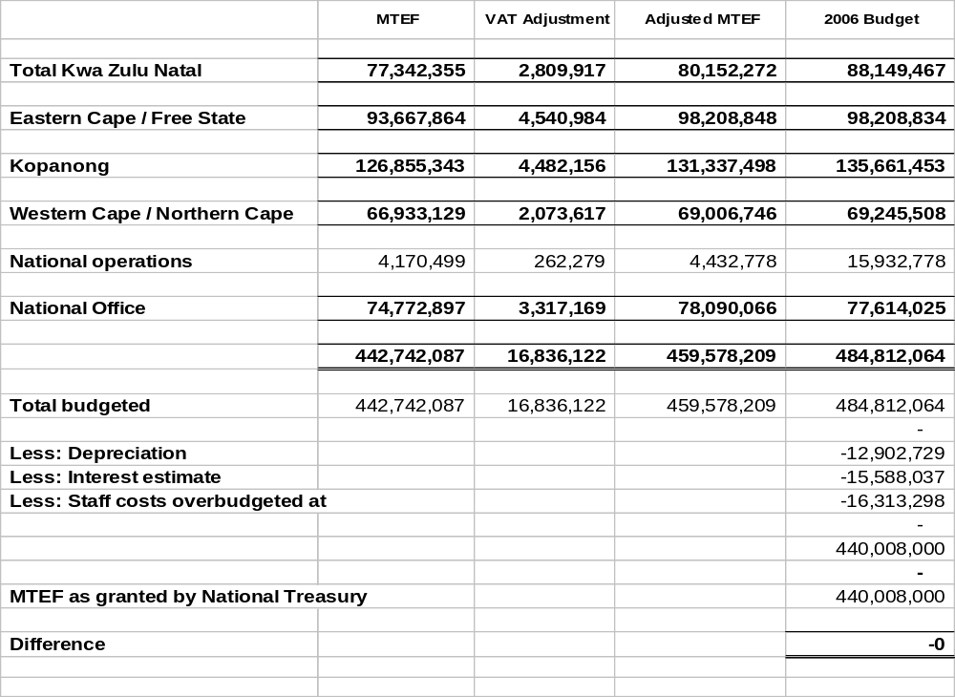
  - Audit Matters

During the financial year under review, the Legal Aid Board once again received an unqualified audit opinion. However the Auditor General emphasised the following matters:

- Fixed assets system of controls did not operate effectively throughout the financial year
  - This was as a result of a combination of ineffective systems and poor management of this function.
  - Systems have now been improved and this matter has now been addressed.
- There were weaknesses in general computer controls
  - This was as a result of us implementing a new IT system.
  - The new system has now been bedded down and the control issues have been addressed.
- The financial statements were withdrawn to effect material changes, resulting in final approved financial statements being resubmitted on 29 August 2005.
  - This was as a result of the new IT system not being able to accurately determine the accrual for Judicare.
  - This necessitated the Judicare accrual to be reflected in the annual financial statements as a contingent liability.
  - Processes have been put in place to ensure that the system is able to accurately quantify the number of instructions for which contingent liability for judicare can be determined.

  - Projected Expenditure 2005/06

In addition to the approved budget of R484m in the 2005/06 financial year, national treasury agreed to us retaining R89m which was provided for as a contingent liability in the 2004/05 annual financial statements, primarily for judicare commitments. It is projected that the current year’s budget will be spent in its entirety except for R10 million which has been allocated for the purchase of the Legal Aid House. The acquisition will be finalised during the 2006/7 financial year. An application to roll over these funds will be submitted to National Treasury.

The projected expenditure for the 2005/06 is as follows:

Summary of Expenditure

 |  |  |  | Budget to 31 March 2005 |  | Projections to 31 March 2006
 |  |  |  | Rand | % of total | Rand | % of total
Staff expenditure |  |  |  | 253,873,550 | 45% | 231,553,000 | 42%
Rental agreements |  |  |  | 16,765,941 | 3% | 19,137,600 | 3%
Capital expenditure |  |  |  | 17,707,311 | 3% | 9,029,263 | 2%
Other expenditure |  |  |  | 274,961,072 | 49% | 292,746,481 | 53%
Total expenditure |  |  |  | 563,307,874 | 100% | 552,466,344 | 100%

  - BUDGET 2006/07

The budget allocation for 2006/07 amounts to R466 408 000 compared to the 2005/06 allocation of R440 408 000 which represent an increase of 6%. It is anticipated that the organization will also receive interest amounting to R14 128 400 during the year under review, increasing the cash flow available to R480 536 400. The budget for year is made up as follows:

Operating budget 487,789,452
Capital budget 7,910,532
495,699,984
Less: Depreciation 15,163,584
480,536,400

The capital budget of R7,9m constitutes 2% of the total budget

An additional amount of R35m was allocated over an above the MTEF allocation and will be utilised as detailed below.

  - Additional allocation of R35m

During September 2005, the LAB did a detailed motivation to National Treasury for additional funding for various projects. This was included as part of Department of Justice’s submission to National Treasury’s Medium Term Expenditure Committee (MTEC). Arising out of this process, an additional amount of R35m was allocated to the MTEF amount of the LAB for the 06/07 financial year. Of this amount R10m was specifically allocated to legal representation for children whilst the rest of the money was allocated to increasing capacity of the LAB.

The budget has been allocated to the above mentioned projects as follows:

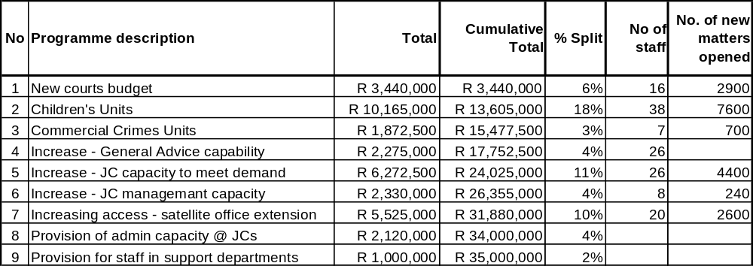

- LEGAL SERVICES DELIVERY

  - Current LAB capacity

Justice Centres/Satellite offices
The Legal Aid Board has completed its rollout of a national network of Justice Centres which serves the poor communities of South Africa. This currently includes 58 justice centres and 35 satellite offices as per the table below:

An ongoing programme of the LAB is to determine areas of need where additional offices need to be established in order to better serve our poor communities. This could also include the relocation of some of our justice centres.

No | Region | No of  Justice Centres | % of Justice Centres per province | No of Satellite offices | % of satellite offices per province
1 | Gauteng | 8 | 13.7% | 5 | 14.3%
2 | Limpopo | 5 | 8.6% | 3 | 8.6%
3 | North West | 7 | 12.0% | 0 | 0.0%
4 | KwaZulu Natal | 10 | 17.3% | 4 | 11.4%
5 | Mpumalanga | 4 | 6.9% | 4 | 11.4%
6 | Eastern Cape | 10 | 17.3% | 10 | 28.6%
7 | Free State | 4 | 6.9% | 2 | 5.7%
8 | Western Cape | 7 | 12.0% | 5 | 14.3%
9 | Northern Cape | 3 | 5.1% | 2 | 5.7%
 | Total | 58 | 100% | 35 | 100%

Staffing

The LAB has a staff budget of 1999 posts of which 1563 posts were filled as at the end of March 2005 (78%). 1441 of these budgeted posts (72%) are for legal staff. The staffing position as at the end of the 04/05 financial year was as follows:
No | Provinces | Legal staff | Non-legal staff | Temp staff | Total staff | % Staff
1 | Gauteng | 268 | 61 | 0 | 331 | 21%
2 | Limpopo | 75 | 24 | 0 | 99 | 6%
3 | North West | 77 | 26 | 0 | 103 | 7%
4 | KwaZulu Natal | 199 | 54 | 2 | 255 | 16%
5 | Mpumalanga | 54 | 14 | 0 | 68 | 5%
6 | Eastern Cape | 155 | 45 | 5 | 203 | 13%
7 | Free State | 57 | 19 | 2 | 78 | 5%
8 | Western Cape | 170 | 31 | 2 | 203 | 13%
9 | Northern Cape | 37 | 9 | 0 | 46 | 3%
10 | National office | 2 | 164 | 11 | 177 | 11%
 | Total (actual) | 1094 | 447 | 22 | 1563
 | Total (Budget) | 1441 | 558 |  | 1999
 | % Recruited | 76% | 80% |  | 78%

  - Legal Services Delivery
The LAB uses a mixed delivery system model for the rendering of legal aid. The primary delivery vehicle is through our justice centres. We also make use of Judicare ie. where we contract with private practitioners to render legal aid on our behalf. We also have co-operation agreements with NGOs/university law clinics that we fund to represent our clients.

The following are the delivery statistics per delivery system for FY 2004/05:

Delivery System | New Matters |  | Finalised Matters |  | Pending
 | Number | % | Number | % | Number | %
Justice Centres | 258,185 | 84% | 233,958 | 87% | 123,790 | 78%
Judicare | 40,238 | 13% | 26,043 | 10% | 31,682 | 20%
Co-op partners | 8,231 | 3% | 7,048 | 3% | 3,394 | 2%
Total | 306,654 | 100% | 267,049 | 100% | 158,866 | 100%

The comparative statistics for new matters with the previous years per delivery system is as follows:

Delivery System | 2003/04 |  | 2004/05
 | Number | % | Number | % | Var %
Justice Centres | 236,282 | 79% | 258,185 | 84% | 9%
Judicare | 46,613 | 15% | 40,238 | 13% | -14%
Co-op partners | 17,244 | 6% | 8,231 | 3% | -52%
Total | 300,139 | 100% | 306,654 | 100% | 2%

4.2.1 Justice Centre Delivery

We are pleased to report that our Justice Centres (JC) are meeting their delivery targets. JC new matters increased by 9% from last year whilst our finalization rate increased by 25%. The increase in new & finalized matters can primarily be attributed to additional staff being recruited and the consolidation of our practitioner per court model of service delivery.

4.2.2 Judicare

In the 2003/04 financial year, 46,613 instructions were allocated to judicare practitioners, ie 15.5% of the total number of new matters of all the LAB delivery systems. This decreased to 40,238 in the 2004/05 financial year, ie. 13%. This clearly highlights our shift away from using judicare. However, it will nevertheless remain an important part of our delivery system and it is expected that at least 10% of matters by volume will be issued to judicare on an annual basis.

4.2.3 Co-operation Agreements
The LAB presently has 6 co-operation partners that it funds. The FY 2004/05 stats for co-ops partners reflect a 52% drop in the number of matters taken on by our partners. This is primarily because of our ability to cover those areas previously done through co-op partners by our justice centres.

4.3 Positives/highlights of the 2004/05 financial year
4.3.1 Increased focus on quality
- The provision of dedicated supervisory capacity for quality management at justice centres
- The introduction of a focused training programme for candidate attorney to ensure compliance with admission requirements of the profession. This is monitored by monthly review of checklists.
- Increased training opportunities for all legal professionals.
- Formalised relationships with local JC legal justice stakeholders, resulting in increased feedback on JC delivery and quality of service, thus allowing for appropriate interventions.
- Implementation of a national judicial officer surveys to obtain independent feedback on the quality of our service.
- The implementation of our client satisfaction surveys for all clients of the LAB
- The implementation of various quality intervention and quality monitoring programmes.

4.3.2 Awaiting trial prisoner (ATP) programme
- Special project implemented to focus on ATPs who were in custody for greater than a year. All such ATPs at identified prisons were visited by LAB staff and offered legal representation. Numbers of ATPs in this category were reduced.
- Special project to reduce the number of children awaiting trial (CAT) for longer than three months. This required JC management to intervene on an individual level on behalf of such children to identify obstacles and to remove them. Numbers of such children have reduced over time.

4.3.3 Implementation of Ad-Infinitum software system
    - The Ad Infinitum computer software system went live on 5 April 2004.
    - It is an integrated finance and legal administration software package.
    - A number of problems were experienced with the system. These problems have now been for the most part resolved and the system is now stable.
- Enhancements to the system are being implemented to ensure that the Legal Aid Board obtains the best possible value from its investment.

- HUMAN CAPITAL MANAGEMENT (HCM) 2004/05 AND CURRENT

The Human Capital Management (HCM) in the Legal Aid Board (LAB) seeks to ensure that the LAB places people first because it is only through people that we can be able to deliver quality legal services to the poor and the vulnerable in accordance with the LAB mandate.

  - HCM PROJECTS AND PROGRAMS
The following HCM projects/programs are new projects which were implemented in the 2004/05 financial year and current financial year:

PROJECT/  PROGRAM | 2004/05 | 2005/06
Upgrading the LAB Performance Management System | - Performance Incentive Scheme  - Individual Development Plans | - Alignment to Balanced Score Card  - Reviewing Modifiers
Organisational Development | - Career Pathing Conceptualised  - Structured Succession Planning Process Conceptualisaton  - Staffing Plans  - Knowledge Management  - Employee Wellness Strategy including EAP and HIV/AIDS | - Career Pathing and Career Management  - Review of Organisational Structures  - Succession Planning Process Implementation  - Establishment of HR Knowledge Management Centre  - Development of a People Development Strategy  - Development of a Strategy on Physical & Psychological Safety of Employees  - Decentralisation of some HR Function  - HIV?AIDS Voluntary testing  - HIV/AIDS Prevalence testing
Employment Equity | - EE Audit  - % year EE Targets | - Approved 5 Year EE Plan with Affirmative Action measures
Education,  Training & Development | - Skills Audits  - 2 Year LAB Annual Training Program  - Training to Build Middle Management Capacity  - Mentoring & Coaching | - Legal Skills Audit  - Focus on Legal Training
HR Policies & Procedures | - Policies & Procedures Audit & Review | - Review and updates  - Separation of polices from procedures
Recruitment & Selection and  Remuneration & Benefits | - Job Evaluation & Grading Policy  - JEM System for Grading  - HR & Payroll Integrated System Acquisition | - LAB Recruitment & Retention Survey  - LAB Recruitment & Retention Strategy  - LAB Recruitment & Retention Policy  - LAB Benchmarking Process  - Acquisition of SAP and decentralisation to the regions
Labour Relations | - LR Strategy  - Case Management System  - Workplace Legislation Compliance Audit  - Internal Conciliation Process | - Acqusition of er Navigator
Organisational Culture Program | - Defining & establishing an LAB in line with Values, Vision & Mission Culture  - Organisational Culture Survey | - Organisational Culture Interventions  - Development of Client Services Charter  - Development of LAB Citizens Charter

  - PEOPLE DEVELOPMENT STRATEGY
From the financial year 2005/06, HCM within this organization is focused on a comprehensive People Development Strategy (PDS). People development is a critical area of HCM. It is about enriching employees’ lives in order to increase productivity and also to increase the capabilities of employees to develop and to lead full, productive, satisfying lives.

The LAB’s PDS aims to capture the people-centred practices that the LAB has put in place to ensure that:
- We have the right people in place
- We have the right mix of skills
- Employees display the right attitudes and behaviors
- Employees are developed in the right way
- Employees are rewarded accordingly for good performance
- Employee safety and wellness is taken seriously
- Organisational Values are entrenched in order to promote the preferred Organisational Culture

THE PEOPLE DEVELOPMENT STRATEGY

The People Development Strategy (PDS) is a comprehensive human resources system that includes:

- Strategic Planning
- Performance Management
- Career Pathing
- Workforce Planning
- Recruitment, Selection and Retention
- Compensation and Role Profiling
- Leadership Development
- Succession Planning
- People Centered Practices
- Human Resources Program Evaluation

STRATEGIC OBJECTIVES

- Strategic Planning: An Integrated Approach
- Workforce planning
- Recruitment, Selection and Retention
- Leadership Development
- Succession Planning
- Human Resources Program Evaluations
- People Centered Practices
- Physical and Psychological safety of Employees

- SUPERIOR COURTS BILL – IMPLICATIONS FOR THE LAB

The Superior Courts Bill does have resourcing implications for the Legal Aid Board in the following respects:

- The Limpopo General Division will be serviced by the Polokwane Justice Centre High Court Unit but this unit will require increased resourcing to deal with the appeals from the Magistrates Courts

- A High Court Unit will have to be established in Nelspruit to service the Mpumalanga General Division.

- The area of Jurisdiction for the North West General Division has increased to such and extent that the resourcing of the Mafikeng High Court Unit will have to be reviewed and increased.

- The Circuit Courts for the Supreme Court of Appeal to hear Civil and Criminal Appeals may have budgetary implications for the Board but this is difficult to determine without further details as to where these circuits will sit, for how long at a time and how often.

- The Circuit Courts for the General Division may also have financial implications relating to travel and subsistence for the Board, depending on whether the numbers of the Circuit Courts are increased from current levels. Additional information will be required to determine the exact impact on the Board.

- If all the Appeals from the General Divisions are to be heard by the Supreme Court of Appeal in terms of Sections 26 & 27, once proclaimed by the President in terms of Section 70, then this will impact significantly on the resourcing requirements of the High Court Unit in Bloemfontein and for the circuit courts of the SCA.

The overall impact of the legislation will only be able to be determined once more detail is known about all the above aspects.

- LAB CHALLENGES

  - Increasing client accessibility
i) Prison link – there is an increasing need for LAB to have dedicated capacity at each of our Justice centres to consult with clients at prisons and enable them to access legal representation. This will also greatly contribute to addressing the legal representation needs of trial awaiting prisoners.
ii) Accessing rural communities – The location of our justice centres and satellite offices is related to our criminal court coverage. However, access to our offices by many rural communities is difficult. Hence, there is an increasing need for us to be able to meet clients at rural areas, preferably partnering with community advice offices.

7.2 Sustainability of legal services delivery
The demand for our legal services is currently not matched to our capacity, resulting in us taking on more matters than we can effectively handle. Hence, the number of matters pending is growing at an unsustainable rate and will impact on our ability to deliver effectively in the next few years.

7.3 Quality of legal services
Despite the many interventions we have made to improve quality, the inability of our practitioners to adequately consult and prepare for their matters is a huge stumbling block to them delivering a quality service. Hence, there is a need to increase our ratio of practitioners per court to a level similar to that provided for the NPA. Currently, the NPA is gearing to have two prosecutors per court whilst we only have one practitioner per regional court and 0.5 practitioners per district court. An increased ratio of practitioner per court will enable our practitioners to set aside a day per week in order to adequately consult with clients and prepare for their cases.

7.4 Salary differential within Justice cluster impacting on the recruitment and
retention of legal professional staff
The present non-alignment of salaries across the justice cluster results in us having difficulty retaining the services of our practitioners who are attracted by better renumeration packages offered by others. We currently lose a lot of staff, especially our more junior legal practitioners, to the NPA because of their better salary scale for this level. This impacts significantly on our service delivery. The DoJ has begun an exercise to get alignment of salaries across the sector. We hope that we are fully involved in this process so that we can achieve a sustainable solution to this problem.

7.5 Supporting the paralegal sector
This sector is increasingly facing funding problems with many offices being forced to close. They however provide a valuable service in especially rural areas. Increasingly the LAB is being looked at to provide this sector with support to ensure their sustainability. However, we presently do not have the financial capability to support this sector.

7.6 Inequitable resourcing across the justice sector
The need for equitable resourcing across the justice sector is critical for the maintenance of an efficient justice system. The current trend of increasing SAPS numbers will impact on the number of people arrested and brought before court. Hence, any increase in the SAPS personnel must likewise result in an increase in the capacity of the court role-player to take on more cases. Provision has been made in the MTEF to increase the NPA capacity by 800 prosecutors over the next three years. This will enable the NPA to achieve its target of having two practitioners per court. This, whilst one prosecutor is at court, the other prosecutor would be preparing for the next case. This would result in the NPA being able to be attending to more cases at court. However, the LAB is not given additional resources that would enable our practitioners to be freed even for a day per week in order to prepare for cases. This will therefore result in delays in the court system with the LAB being seen as the main causes of these delays.

Legal Aid Board

