HYDERABAD – NIRD, 28TH FEBRUARY –31TH MARCH 2005

REPORT OF THE COMMUNITY DEVELOPMENT WORKERS DELEGATION ON THE TRAINING IN INDIA ON RURAL DEVELOPMENT, WITH EMPHASIS ON MICRO PLANNING, 28 FEBRUARY TO 30 MARCH 2005

Introduction

In September 2005 the Minister for Public Service and Administration, Geraldine Fraser-Moleketi, accompanied by her colleagues, visited India. A bilateral agreement was reached to train members of the two public services on human relations management and development.

The training programme that the above delegation embarked upon is a direct result of this agreement. The purpose of the training programme is three-fold, viz.:
- To expose the community development worker learners to the Indian community work experience amassed through the decades of implementation;
- To expose the community development worker learners to the Indian Rural development initiatives, and
- To learn about the local democratic governance system in India, with emphasis on the rural sector. Community participation in rural (and urban) self-governance is a critical aspect of effective local government.

To illustrate the central tenet of the CDW training in India, we use the following anecdote:

President ADJ Abdul Kalam visited a High School called Anandyala. He held long discussions with the students. After much discussion a question was asked, “Who is our enemy?” many answers were given. These answers were all discussed, and a consensus was reached that the one correct answer is,” Our enemy is poverty”.

Book by the President Abdul Kalam: Ignited Minds (2000).
The critical enemy among South African rural communities is poverty.

The delegation left the shores of South Africa on 28 February 2005. The delegation consisted of national, provincial and district management officials, as well as community development workers learners representing all provinces.

The visit was made possible by the India Government’s grant through the ITEC. All 30 community development workers are sponsored by the grant. The eight officials’ (national and provincial levels) costs are borne by their respective Departments, including the representative from GTZ, who was also accommodated on the visit at the GTZ’s cost.

The training was conducted by the National Institute of Rural Development (NIRD), based at Ragendranagar, Hyderabad (Andra Pradesh). The course was coordinated by Dr Thaha, Head of the Micro Planning Division at the NIRD, with assistance from the staff and senior leadership of the Institute.
The NIRD is an institution under the Ministry of Rural Development, providing training, research, action research and consultancy on rural development. It has a staff complement of over 450, all resident on its vast campus. The campus is equipped with amenities such as maintained roads, three hostels for students, banking facilities, a High School (there are several other Primary and High Schools within walking distance outside the campus), a gymnasium, a clinic, playing fields, a fully equipped administration block, lecture theatres adjacent to the library, a computer training center/ laboratory and a publishing section.

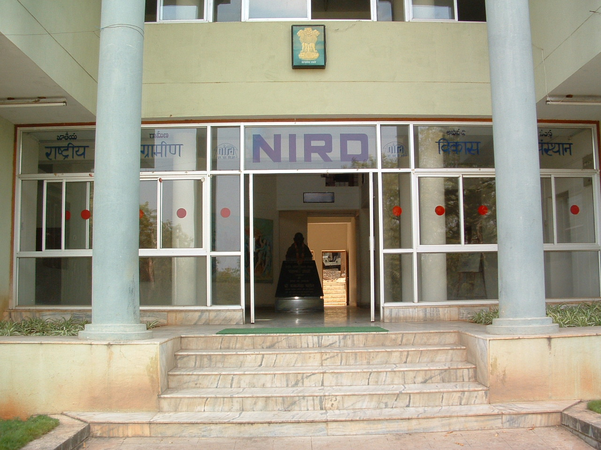
Entrance to the NIRD Administration Block. Statue of Mahatma Gandhi in the background

The Institute is led by a Director General, ably assisted by a deputy Director General and Heads of Divisions. It is an institute of international repute, and has published extensively in the field of rural development and rural community participation.

The delegation was received by the Director General, Mr Lalit Mathur, and introduced to the training by the Deputy DG, Mr Chinmay Basu and the Head of the Micro Planning Division and Director of the training programme, Dr Thaha. The training began in earnest on 29 February, a few hours after the arrival of the delegates.

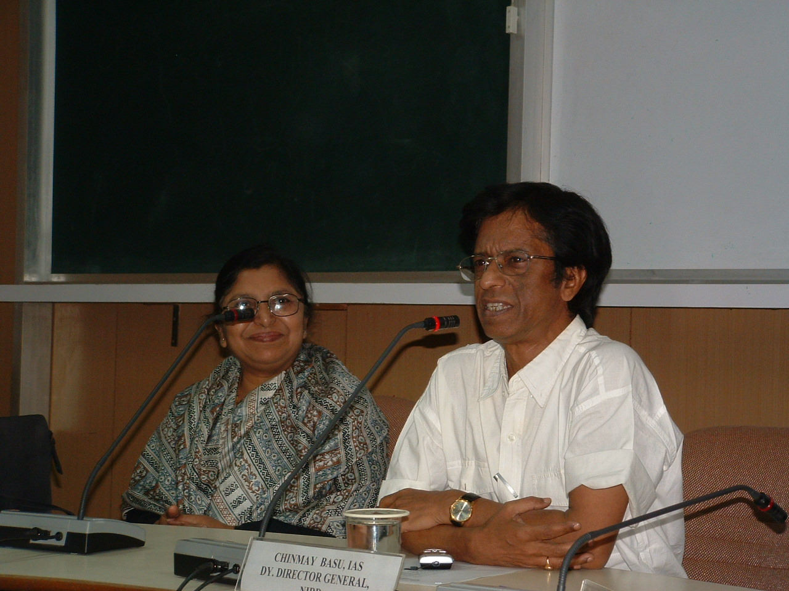
Dr Thaha (left) and Dr Chinmay Basu of NIRD, welcoming SA delegates

The training covered several areas of rural development and key resource persons facilitated the inputs. The training, in the main, covered the following areas:
- Profile of the NIRD
- Policies and programmes for rural development in India
- Approaches to sustainable development
- Policies and programmes for social development
- Local rural self governance
- Micro planning, participatory planning for development of villages
- Participatory planning, Use of PRA in planning and Planning techniques
- Self Employment schemes (SGRY) and Self help schemes (SGSY)
- Watershed Management
- Agricultural Development Programmes, and extension programmes
- Livestock programmes
- Management of Horticulture, aromatic plants
- Rural industries
- Management of primary healthcare
- Role of NABARD (Banking association) in agricultural and rural development
- Policies and Programmes of universal primary education and adult education
- Rural housing and habitat development – policies and programmes
- Principles of organizing community
- Social mobilization – skills for community development
- Micro-credit for non-farm sector
- Functions and roles of functionaries at grassroots level
- Monitoring and evaluation of projects
- IT in rural development
- Gender issues and women empowerment
- Constutional safeguards for disadvantaged sections
- Case studies:
  - Local area planning
  - Watershed management
  - Management of drinking water and sanitation
  - Participatory livelihoods – case of Andhra Pradesh
  - Social development projects

Several visits to villages to observe programmes in operation were organized, including excursions to historical and cultural sites. The key visits were to:
    - Myrada, an NGO of international repute involved in assisting the rural poor communities to establish self help schemes, aligned to the government’s SHG schemes;
    - The rural technology park (RTP) development site where research and technological innovation has led to prototype development of rural industrial development (housing, catering, food packaging, sanitary products’ manufacturing, solar power-capturing devise production, compost making schemes providing rural people with environmentally friendly income generating initiatives and wastepaper recycling);
    - Mysore where an agricultural compost producing SHG society is operating;
    - and the Hitech City – the hub of IT development, in Hyderabad.

Key lessons learnt:

Among others, the key lessons learnt are the following:

- Local rural self-governance
- Self Help Groups
- Approaches to micro planning
- Sustainability of programmes
- Govt’s passion for the development of poor communities, and the challenges thereof
- Integrated approach to community development is the best
- Historical inputs by great leaders in the form of Mahatma Gandhi and Nelson Mandela to development initiatives, both at country and international levels.

Local rural self – governance

The structural organization of local rural self-governance in India, the associated powers and functions and operationalisation thereof provided an eye-opener to the practical and pragmatic approach India has towards rural self-governance. The approach is not necessarily a panacea, but where its implementation has been according to its letter and spirit, the results have been phenomenal. In Mysore, the Zilla Panchayat (District local govt structure) has empowered local communities by assisting them to form gram sabhas, SHGs and provided the necessary financial resources. Several women are now confident enough to stand for political office.

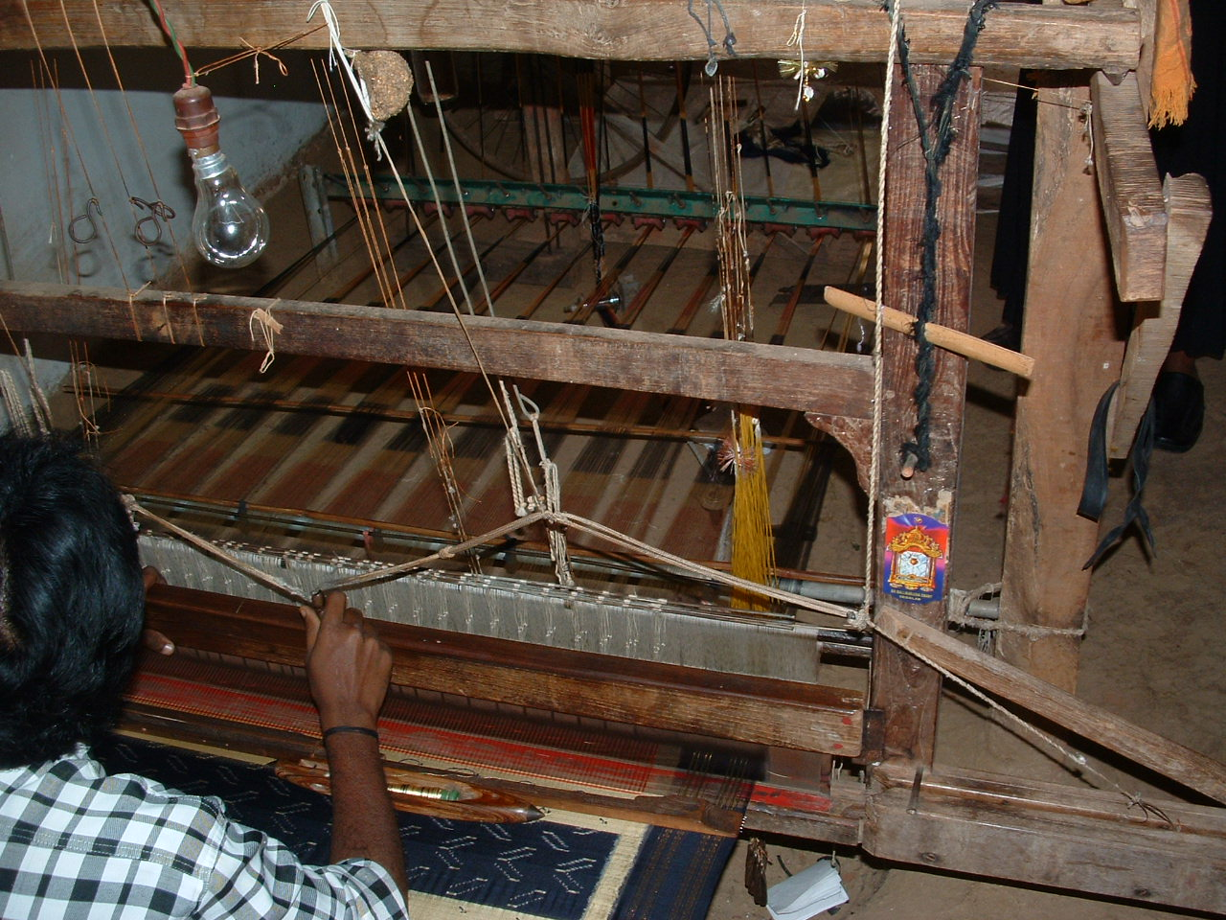
A weaver at his loom, producing cloth. The cloth is produced from cotton thread grown by the producers themselves.

Self Help Groups

These groups implement the government programmes as entailed in the SGSY and SGRY schemes, and meant to assist BPL families out of the poverty trap. The case studies in Chinayelasagiri (Mysore) and the Om Shati (Myrada) are examples of SGSY initiatives.

The government provides technical assistance, i.e. training and access to resources. In the agricultural field, land is made available from the communal basis for agricultural production. The government, at District level, facilitates access to finances. 30% of business in some of the banks is provided by these self help groups. The pictures that follow show enterprises run by local entrepreneurs and generating not only the necessary income for survival but are environmentally friendly. The cloth production business (shown above), where the producers are both cotton farmers and weavers, use organic material for enhancing the soil fertility. The paper production enterprise recycles paper for re-use in the community.

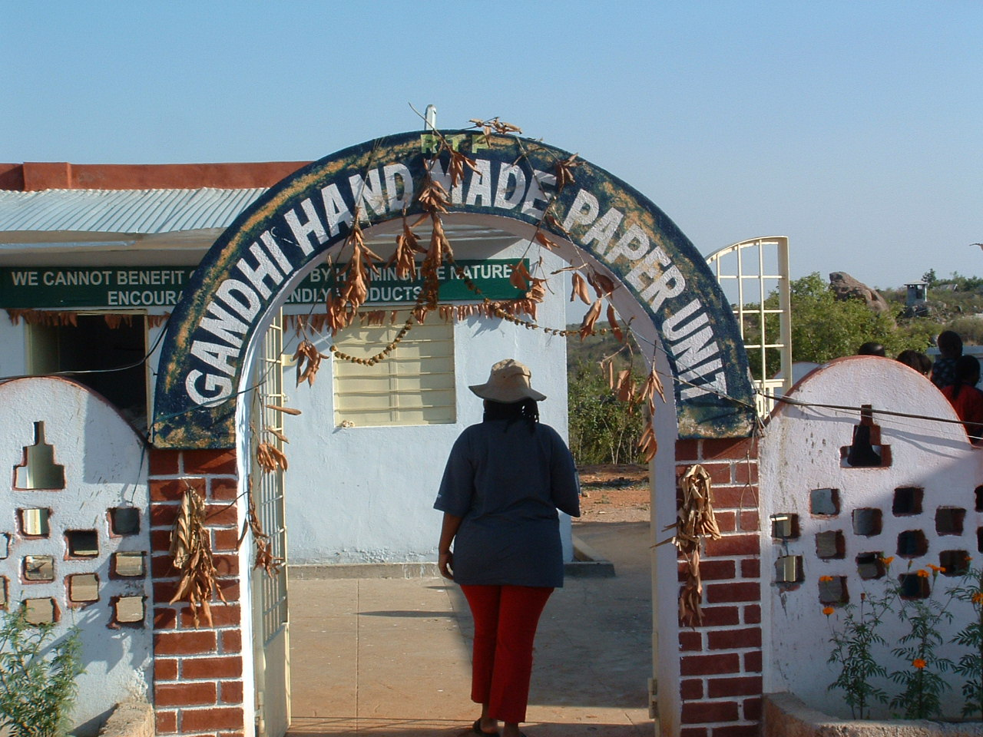

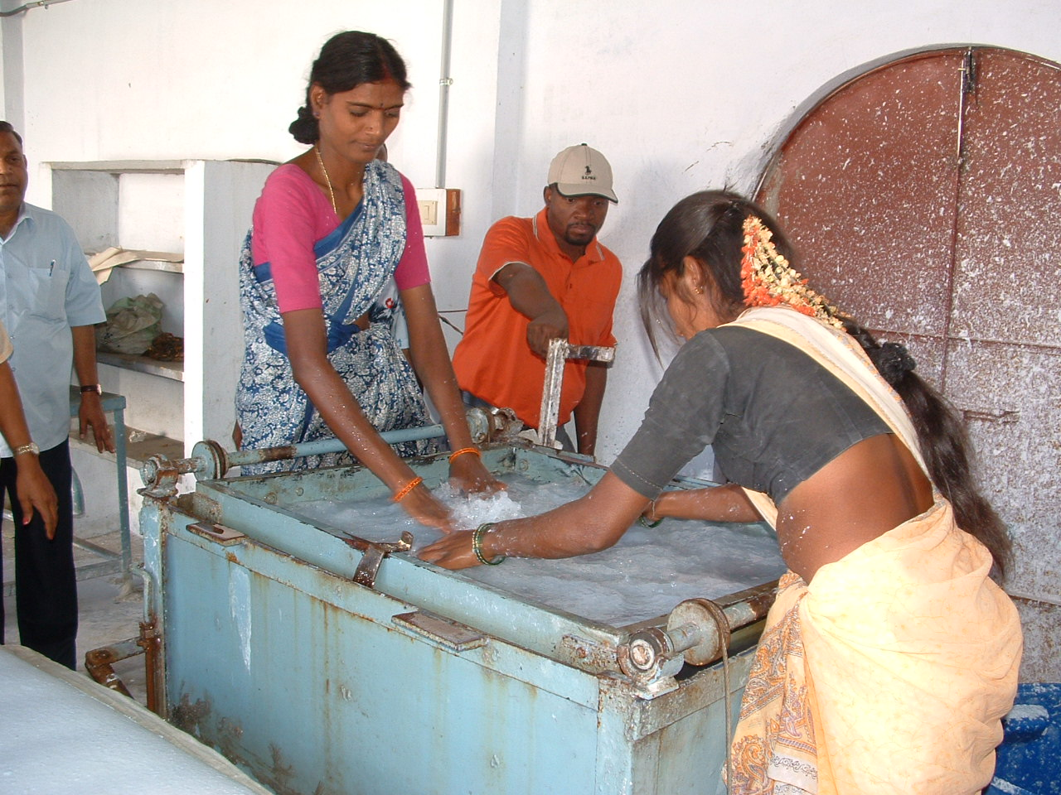

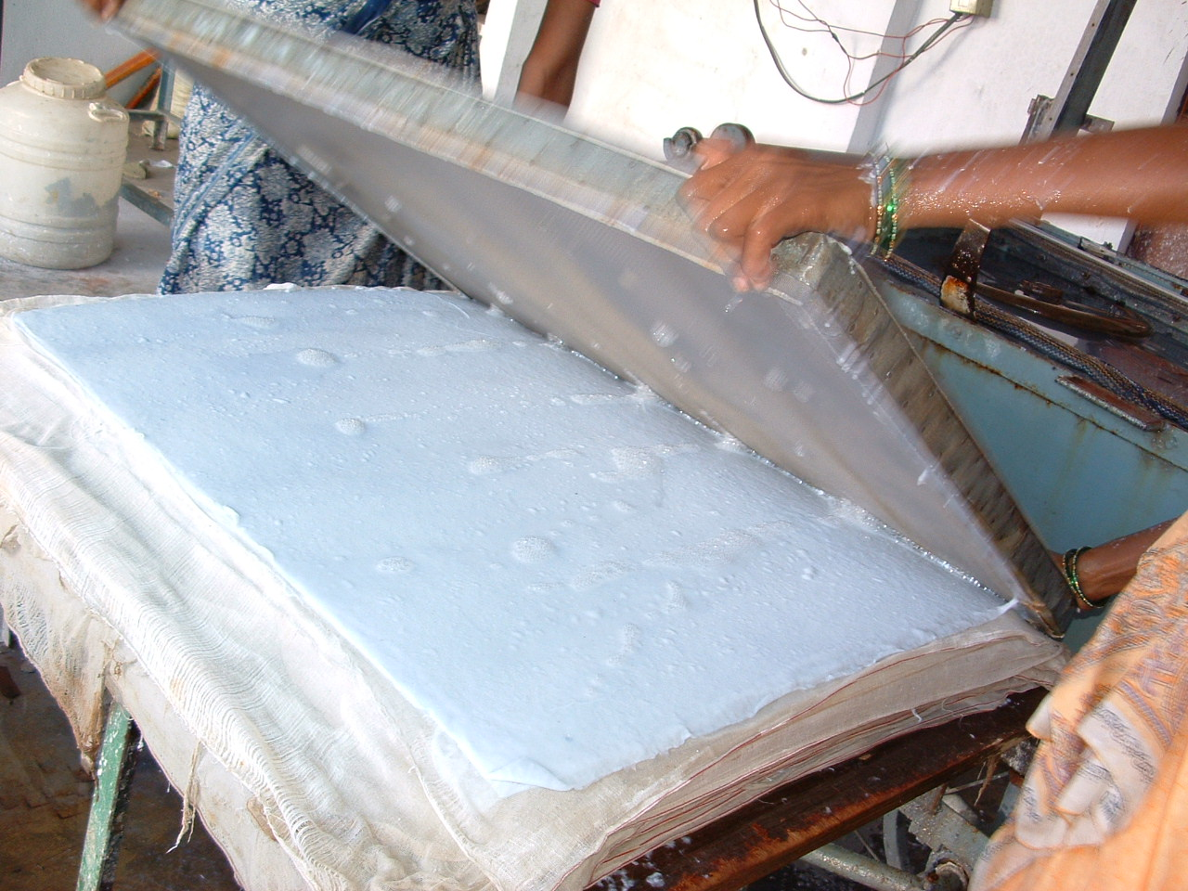

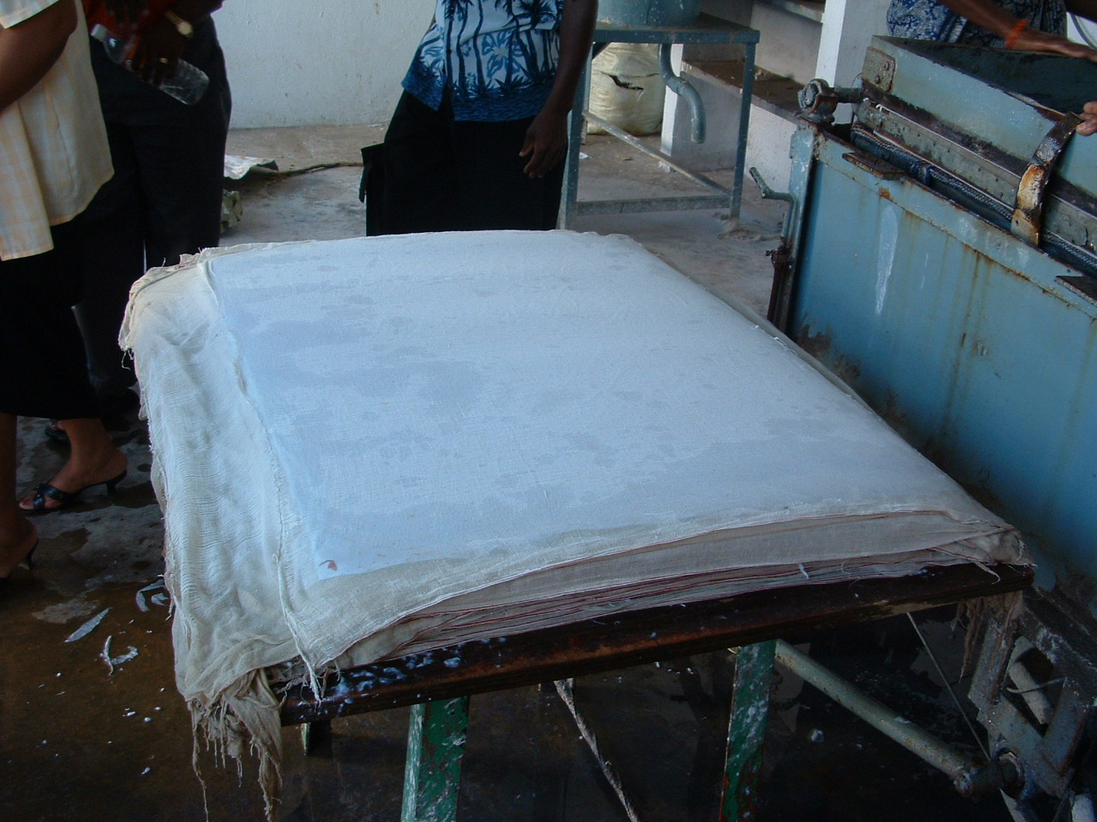

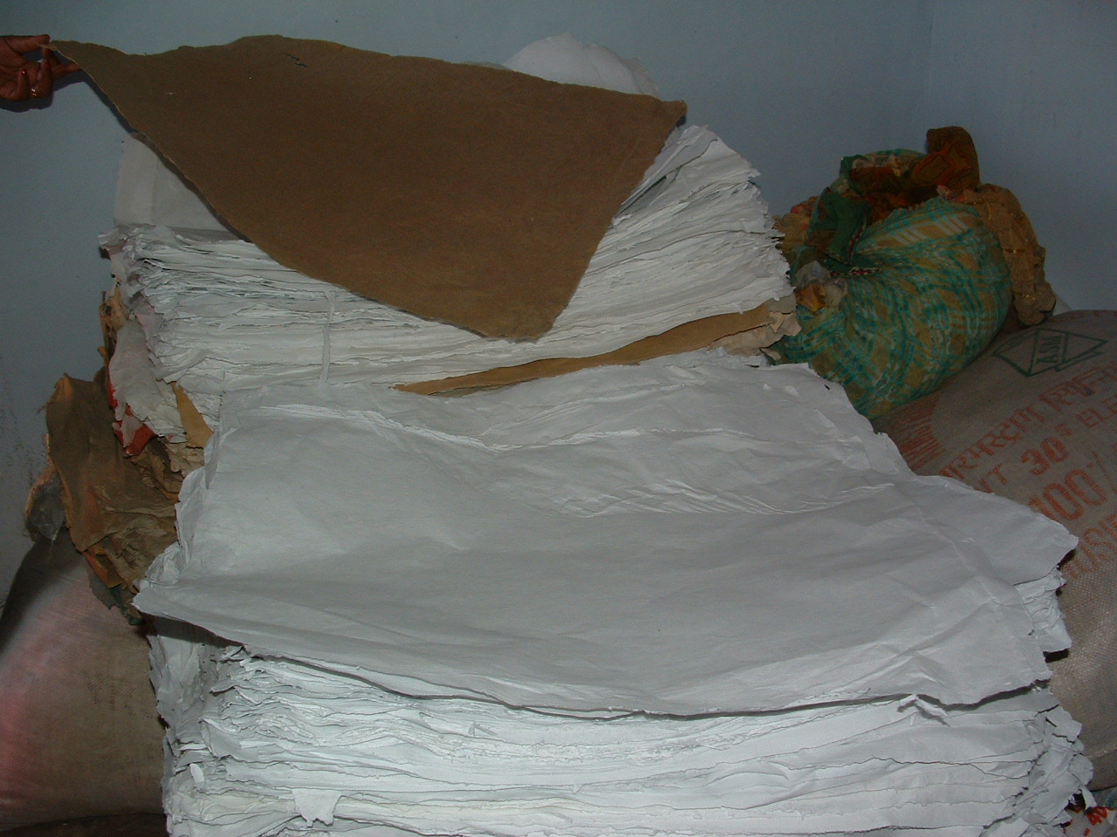

Approaches to micro planning and participatory processes and techniques

Whilst these are not new innovations, the pragmatic manner in which techniques are implemented provided a fresh outlook and experience. Rural communities are composed of mostly illiterate elderly people. For their effective participation in common decision making processes, the techniques used in India are simple and effective. For example, in assessing the effectiveness of elected representatives, a simple method of drawing on the ground circles with varying sizes and allocating each representative a circle can reveal what the villagers think about their local leading personalities.

Sustainability of programmes: case studies

Case studies

The following are case studies as experienced by the delegation:

Social stratification and social organization of the state in providing key social services to the community were observed. The report outlines the social stratification in India, gives a brief background on the educational, welfare, health, women’s development, housing and economic development. The key objective in providing these case studies is to highlight the participatory nature of the Indian system.

The educational needs of the children is not only considered a responsibility of government, but several private schools exist, run by independent welfare organizations with state assistance and community involvement. Similarly, housing approaches involve the community. A measure of significant success are the self-help schemes run by women, either as banks, loan schemes or project oriented income generating schemes. In all instances government has provided enabling legislation for smooth implementation.

Other case studies completed are on the Myrada Institute, the Mysore District Panchayat and their related projects. The Myrada Institute is a non-governmental organization that has been around for over 50 years, assisting to develop the rural areas of India. Its successes have been in the south. Several self-help schemes have been effectively established.

The Mysore District Panchayat is included to indicate the complexity of rural village administration and the attempts in India to address the challenges. The success of the Panchayat is in establishing women’s self-help groups, especially in the agricultural sector, and assisting these to obtain loans from commercial banks at low premiums and interest.

Critique on the Indian situation

The Indian government has the benefit of over 50 years of experimenting with community development models. Mahatma Gandhi pioneered the enactment of community development mechanisms, the panchayat raj institutions, rescuscitating old age traditions in India. Modern India is perfecting the system.

The approach followed in India in facilitating community involvement in policy making and service delivery is different to the approach SA is approaching the same issue. First, India has a central recruitment approach for employing public servants. Community Development Officers are employed at a District (local government) level, works with village deployees who (unless funds are available) are volunteers. The village deployees facilitate the gram sabha (“People’s Assembly” - an institution which must be in place in all villages as promulgated by law – in terms of the 73rd and 74th Constitutional Amendments). At the gram sabha, communities make known their needs and how these may be fulfilled. The District Development Officer, together with the District Commission on Finances, determine the final budgetary proposal for adoption by the District political leadership. The Development Officer is accountable for the implementation of the plans once approved.

This approach, however, is for the rural areas. The urban areas function more like in SA, with IDP-style platforms created. The system differs from state to state. While in Hyderabad the system is fairly adhered to, and the community has an active interest in the processes, the state that has perfected the system is Kerala. Community participation is more pronounced, and the final budgetary allocations and implementation plans are channeled after extensive community inputs.

The areas more affected, and showing a measure of success, are in the south. The states of Andra Pradesh, Kerala and Karnataka show a high incidence of successful community involvement in policy making and its implementation.

Recommendations to the CDW programme in SA

The following observations are derived from the exposure to India’s experiences in pro-poor policy development and demand–led service delivery systems and, from the interactions between the pioneering CDWs group and the lecturing staff at the NIRD. They have been developed with the intention to crystallise issues and develop follow up steps.

1. Potential areas for cross-learning and case study development based on India’s experiences

The modern Indian concept of “CDWs” is different from what it was in the 1950s and does not necessarily have a parallel with the RSA CDW idea. The Voluntary Development Officers (VDOs) in India today refer simply to the many Government field staff, specialising in various topics of rural development, often employed at local level in the Panchayati Raj Instituions’ (PRIs) system. However, there are a number of other areas, which are relevant for the South African context. They are, in order of importance, as follows:

- The Indian rural self-government system (PRIs) as a formalised institutional instrument for people-centred development promoting local community participation in policy development and formulation, as well as in decision making broadly affecting the livelihood of the community. These PRIs have become an institutionalised and self-governed forum for decentralised planning and implementation of rural development programmes. This area include three major components:
  - Local organisational development processes and arrangements, particularly at community/ village level (Gram Panchayat) linking micro & meso and micro & macro levels as integral part of the decentralised government service delivery systems;
  - Constitutional framework and Acts regulating the PRIs and devolving financial and administrative powers to local institutions. The Zilla Panchayat has the powers and responsibility to receive and disburse development funding from the State and Union Government, as well as to facilitate private sector contributions in the form of grants and/or loans to the local community development structures (e.g. Self help groups);
  - Decentralised planning processes and participatory planning methodologies (including participatory project cycle management (PPCMs) - marrying IDPs with CBPs in the RSA context. The inclusion of community members in the planning processes takes place at the gram sabha (ward committee level in the form of a “community people’s assembly”). The gram sabha are formally legislated bodies making community participation compulsory in key decision making processes.

- Self-help group (SHG) mobilisation and saving schemes (micro-credit and rural banking) addressing especially rural women. Targeting the most poorest section of the rural communities, the SHGs are promoted through the different self-employment (SGSY) and wage-employment (SGRY) schemes. The Indian government implements these schemes in a very pragmatic anti-poverty approach, in the same manner as it implements welfare programmes (safety nets).
- Other programmes, such as
  - Sanitation schemes (e.g. Maharashatra State case)
  - Watershed programme (to strengthen the RSA Landcare initiative)
  - All range of agricultural and non-agricultural intermediate technologies and technical innovations for SMMEs development purposes.
  - Social development initiatives targeting the poor communities in the main, without discriminating against other classes, though. A carrot and stick approach encouraging competition for amenities is utilised, e.g. in the primary and secondary education field.

2. Possible next steps to strengthen present co-operation with NIRD for competency development of CDWs and for the development of Indian case studies in RSA

Based on the above-mentioned areas, the meeting between the CDW NTT CT with the NIRD DG held on 07.03.2005 highlighted the following opportunities to take further the present Indian-South African co-operation agreement;
- To repeat a similar introductory course for another batch of 30 CDWs, which would be preceded by a course for provincial co-ordinators in September 2005 (earliest). This introductory course could be further perfected based on the present experiences to increase its relevance for CDWs;
- The possibility, to be further elaborated by the South African counterparts, of intensifying the co-operation partnership by establishing case studies in South Africa on key, jointly agreed, thematic areas;
- This process would imply a four-step approach
  - An initial exposure of selected Indian representatives to South Africa
  - An agreement on thematic areas for South African learning with relevance to the work and programmes to be facilitated by CDWs. One of the key themes to be considered is poverty alleviation mechanisms.
  - Exposure of South African representatives to specific cases in India of these selected themes
  - An “in-process support” organised by NIRD for the establishment of Indian cases in South Africa together with CDWs in pilot provinces.

It was agreed that a more specific proposal should be presented to the Indian High Commission not later than end of April for organising a possible exchange visit (by an Indian delegation) towards end of July (this process is delayed due to pressing departmental commitments. The proposal is ready, but needs to be presented to the Minister for approval and implementation).

See attached presentation on “Approach to Micro Planning”, with the Kerala example profiled, as Annexure A.
See attached case study report on “Social stratification in India …”, as Annexure B.
See Annexure C and D.

