

A NATIONAL INDUSTRIAL POLICY – DRAFT

DEPARTMENT OF TRADE AND INDUSTRY

Draft Version: 2

DATE: 15 November 2005

1. EXECUTIVE SUMMARY 3
2. THE PURPOSE AND SCOPE OF A NATIONAL INDUSTRIAL POLICY 8
3. INDUSTRIAL POLICY VISION FOR 2014 9
4. INDUSTRIAL POLICY DEVELOPMENT AND REVIEW PROCESS 9
5. SOUTH AFRICA’S INDUSTRIAL DEVELOPMENT PATH AND POST-1994 INDUSTRIAL POLICY 10
6. THREE TO FIVE YEAR OUTLOOK FOR THE INDUSTRIAL ECONOMY 17
7. LESSONS FROM INTERNATIONAL INDUSTRIAL POLICY EXPERIENCE 17
8. PRINCIPLES FOR THE DESIGN OF INDUSTRIAL POLICY INTERVENTIONS 19
9. IDENTIFYING AND UNLOCKING SOUTH AFRICA’S INDUSTRIAL GROWTH AND DEVELOPMENT: THE NEED FOR A STRONG INDUSTRIAL POLICY 21
10. CROSS-CUTTING INTERVENTIONS 26
11. SECTORAL INTERVENTIONS: CUSTOMISED SECTOR PROGRAMMES 30
12. CAPACITY AND INSTITUTION BUILDING 32
13. INDUSTRIAL POLICY PROGRAMME 33
14. APPENDIX A: SOUTH AFRICA’S INDUSTRIAL PERFORMANCE SINCE 1994 41

EXECUTIVE SUMMARY

Government has set broad economic targets of increasing economic growth to above 6 percent by 2009, and halving unemployment and poverty by 2014. This document begins to set out the contribution of a National Industrial Policy to these economy-wide objectives. Manufacturing remains the engine of our economy, as a major sector in its own right as well as with substantial linkages to primary and tertiary sectors. However, an industrial policy must increasingly be broader than manufacturing, to include particular activities in services and agriculture.

Our Industrial Policy vision for 2014 is an economy characterised by a higher value adding and broad based industrial development trajectory. The Industrial Policy document is based a three to five year outlook, which allows for planning by economic actors. Because conditions change, the Industrial Policy will be revised every second year. Implementation of the Industrial issues will be based on an Industrial Policy Programme, which will be revised on an annual basis. The Programme will inform the annual strategic and business planning, and budgeting cycle of the department and its three year Medium Term Expenditure Framework (MTEF). The Industrial Policy is aimed at synchronising with existing policy initiatives, both of the DTI as well as of government departments, such as the Customised Sector Programmes (CSPs) and Government’s Capital Expenditure (CAPEX) Programme.

The Industrial Policy is constructed in the light of Government’s response to the economic crisis it inherited in 1994 as well as the first ten years of post-apartheid industrial policy. Prior to 1994 manufacturing was characterised by declining growth and investment, and exports concentrated around minerals. Trade and industrial policy protection was uncritical and not very coherent. The immediate post-1994 policy response was aimed at reversing this situation. It entailed firstly high level macroeconomic restructuring of the economy, notably the stabilisation of the fiscal deficit and inflation in particular, as well as trade liberalisation. This was coupled with a range of functional ‘supply-side’ measures aimed at restructuring the production side of the economy to deal with higher levels of international competition. There were two major sector-specific programmes: for the Automotive, and Clothing and Textile industries. Subsequent policy development dealt with issues such as of Competition, Small Business, and Black Economic Empowerment (BEE) policies.

Economic performance since 1994 has been mixed. The manufacturing sector has grown more or less in line with Gross Domestic Product (GDP) growth, while tertiary sectors have raised their share in the economy and primary sectors have declined. The fastest growing sectors in the economy have generally been relatively skill-intensive services sectors and capital-intensive mineral-processing sectors. However, a number of more value-adding and labour-intensive sectors have also demonstrated strong growth such as automotives, furniture and plastics. There has been an overall decline in formal manufacturing employment, with some jobs shifting to services. Exports have diversified, based largely on the automotive sector success, but remain dominated by resources. Geographic disparities in economic activity continue and BEE has proceeded slowly in the manufacturing sector.

There have been a number of industrial policy successes since 1994. Most notable has been the Motor Industry Development Programme (MIDP) which effectively secured the survival of the South African automotive industry and generated significant linkages into other sectors. Various technology programmes have also functioned well and the Industrial Development Corporation has had a number of success stories, with investments in more labour intensive sectors and in the support of BEE. However, a high level review of post-apartheid supply side measures indicates a range of areas for improvement. This includes issues of scale, focus, additionality and reciprocity in the design and dispensing of industrial financing. Despite more robust competition legislation, industrial concentration and un-competitive outcomes continue to prevail in a number of strategic sectors. There has also been insufficient coordination between trade and industrial policy. Firm level evidence indicates that in medium-technology and labour intensive firms strategies to improve competitiveness also tend to result in improvements in employment levels.

These domestic changes have taken place in a rapidly changing global environment. Trade and investment liberalisation and lower transport and ICT costs, coupled with the entry of China and India into the global trading system have generated much higher levels of international competition for products, services and investment. Technological advances have increased the skill and technological intensity of production, requiring that firms master increasingly sophisticated production techniques in order to remain competitive. Growing (but unequally distributed) global income, technological advance and the splitting up of production chains across countries, has meant that high technology products have shown the fastest growth in manufactured exports, with medium technology products retaining a high but steady share and low technology and resource-based products declining in world trade. There has also been a rapid growth in services, both within economies and in world trade. Although global merchandise trade still dwarfs services trade, services trade has been growing somewhat faster than goods. Some developing countries have managed to increase their share of non-traditional services such as ICT, telecommunications and business services.

A number of domestic and international considerations condition the outlook for the design and implementation of industrial policy over the next three to five years. Higher levels of economic growth – seen recently – look set to continue. Growth over the coming years is expected to be driven by a combination of continued domestic expenditure, investment by parastatals and government, and large private sector projects. Commodity prices, including oil, are expected to remain high. This will place upward pressure on the exchange rate. Therefore firms need to plan on the basis of a relatively strong exchange rate and upgrade efficiencies accordingly in order to compete. Competition from large manufacturing economies such as China and India will also add to the need for firms to be competitive. A more accommodative macroeconomic policy would greatly support the Industrial Policy, but cannot be assumed.

A large body of international evidence is now available to assess what does and does not work with respect to industrial policy. Evidence from the ‘structural adjustment’ era of the 1980’s and 1990’s indicates that one-size-fits-all policy prescriptions have proved disappointing in a range of developing countries that have implemented adjustment policies in good faith. Conversely, it is the group of countries that have implemented well-designed and robust industrial policies, which have experienced the most rapid growth rates of per capita income. This indicates the risk of not developing a robust industrial policy. Industrial policy is necessary because the process of industrial development is beset with market and production failures. Developing productive capabilities does not occur automatically but requires a cumulative learning process. Industrial policy involves ‘getting the prices wrong’ at particular stages and in certain circumstances of development and ‘getting the prices right’ under other conditions.

Various principles emerge from both successful and relatively unsuccessful experiences of industrial policy, as well as recent theoretical work. Due to limited resources, governments are obliged to prioritise interventions. To have impact, programmes and projects must be of the minimum effective scale to induce structural change in the economy. Deciding which sectors or activities to target runs the risk of incorrect choices. However, these can be mitigated through various mechanisms. Firstly, industrial financing must be dispensed on the basis of reciprocal developmental behaviour by the recipients with credible monitoring and enforcement. Secondly, the risk of choosing the wrong activity can be mitigated by intensive research and stakeholder interaction as well as targeting quantitatively new activities. Thirdly, interventions should be designed around the strengths of existing institutions rather than setting up new institutions. An active industrial policy requires that the state socialise risks the private sector does not, but also display adaptability in recognising when certain interventions are not working. It must also take into account the constraints of global trading rules. However, there is still substantial scope for industrial policy interventions.

The global experience of high growth developing countries indicates that developing countries are not restricted to their inherited comparative advantage but can strategise to build competitive advantage, taking into account both their developmental needs and actual or potential costs and capabilities. Experience, particularly in South Africa, has indicated that three essential dimensions of industrial growth and development do not emerge automatically and require purposive interventions: a low cost production base; a sophisticated set of industrial capabilities; and increasing inclusion in the mainstream of the economy. These dimensions need to be tackled at the national, spatial, sector and firm level. In addition certain elements of the demand side must be paid attention to such as building domestic demand and economies of scale for exports.

In unlocking industrial growth and development, it is necessary to deal with a set of challenges and opportunities facing the industrial economy. South Africa has a relatively small domestic market, and is a long distance from wealthy markets. The volatility and recent appreciation of the exchange rate poses problems for both export and import competition. Both pricing and quality of transport and telecommunications infrastructure raises the costs of doing business. An historic legacy of underdevelopment in skills and technology implies a disadvantage in increasingly sophisticated global production. High levels of industrial concentration – associated with large price markups – persist in the economy, particularly with respect to intermediate products. The issue of labour costs and productivity is more complex and requires a sophisticated response: the exchange rate and investment in machinery and skills are all interlinked with the cost and productivity of labour. Fixed investment by both the public and private sector has been too low to sustain high growth and employment rates.

However, there are also a range of opportunities. South Africa has an established and relatively diversified industrial economy, based on a long history of industrialisation. Within this are pockets of technological leadership, related to our resource base and areas such as energy and aerospace. Downstream beneficiation of our natural resource base is a logical progression in a range of industries. Despite problems, our transport, ICT and financial infrastructure are relatively sophisticated. Increased public expenditure over the next decade will provide the major source of fixed investment and will unleash direct and indirect production opportunities. Growing domestic demand is an additional source of growth opportunities. South Africa also have a ‘first mover’ advantage with respect to the rest of the continent.

A range of cross-cutting interventions are necessary. Most important is a review and re-design of industrial financing based on the key principles for industrial policy interventions: minimum effective scale, focus on quantitatively new activities, and monitorable and enforced reciprocity. Industrial policy must lead trade policy more explicity and require CSPs to identify negotiating positions. Ongoing multilateral participation will focus on alliances to level the global playing field. A more strategic approach will be adopted towards bi-lateral trade negotiations considering a broader range of bi-lateral agreements types. A critical review of the tariff structure will be undertaken, focusing particularly on tariffs on intermediate inputs. Government’s capital expenditure programme will be the major source of fixed investment in coming years and requires a coordinated approach in leveraging domestic opportunities arising from it. BEE and WE need to be accelerated and tied more closely to growth and employment. Support for productivity and upgrading is essential to keep pace with global developments and will require support for world class manufacturing; process and product development; a more coherent standards, quality and assurance system; and commercialisation of domestic intellectual property. Competition policy will be strengthened to deal with un-competitive outcomes in key concentrated sectors. Small business support will focus on improving the effectiveness of small business institutions. Regional industrialisation requires a sophisticated approach based on identification of areas where high need coincides with high levels of economic potential. Finally, a robust industrial policy requires well-functioning supportive policies. Most important amongst these are: appropriate traditional and modern infrastructure; functioning skills development and technology systems; and an accommodative macro-economic policy.

Various sectors have been identified for development via the CSP process. Although the development of CSPs is already underway, this process requires more coherence. Therefore, greater prioritisation and focusing of the CSPs will be an iterative and incremental process. Increased coherence and synergies can be achieved by grouping sectoral interventions according to common challenges and opportunities. Four sectoral groupings emerge. The promotion of downstream beneficiation of raw materials is a logical progression to complete truncated value chains in the SA economy. Common issues include pricing of raw materials, skills development and technology support. The predominance of medium and high-technology products in world trade implies the need to promote advanced manufacturing. Industries such as automotives, aerospace and electronics face similar needs related to integration into global value chains, and technological upgrading. There are a range of labour intensive sectors which are more diverse and require two main types of strategies: growth strategies for those sectors which have genuine potential for competitive advantage, and restructuring strategies for key sectors which employ large numbers of people and are under competitive threat. While much of services is demand driven, certain services require intervention to realise their potential. Business process outsourcing is a new sector which has the potential to be a major employer. Project management services (engineering, construction, mining) have strong linkages into manufacturing and can be used to leverage projects on the continent. In addition there are two new areas of emphasis. The first is to investigate opportunities for greater labour intensity in existing sectors and to develop CSPs for labour intensive service sectors, particularly non-tradeable services. The second is a process of identifying new high potential sectors in terms of value addition and employment opportunities.

The development and implementation of these interventions is going to require greater capacity in both the short and medium term. Fairly immediate synergies can be gained by shifting sector strategy development and implementation, as well as incentive design under industrial policy. There significant sectoral capacity within the IDC as well as universities, which can be harnessed. It is proposed that an Industrial Policy Advisory Council (IPAC) be established to advise the Minister of Trade and Industry. In the medium term the establishment of one or more Industrial Policy Centres of Excellence will be established, focussing on research related to industrial policy issues as well as training a cadre of – predominantly black and female – post-graduate students that can be recruited into the DTI.

There is also a need for much greater intergovernmental coordiniation. Therefore quarterly fora will be established to ensure greater coherence with respect to the link between industrial policy and: infrastructure and capital expenditure programmes; skills; technology; and macroeconomic policy.

THE PURPOSE AND SCOPE OF A NATIONAL INDUSTRIAL POLICY

Government has set broad economic targets of increasing economic growth to above six per cent by 2009, and halving unemployment and poverty by 2014. This document begins to set out the contribution of a National Industrial Policy to these economy-wide objectives.

Manufacturing remains at the core of the South African economy. It accounts directly for 18 per cent of GDP and 27 per cent of employment. It stimulates backward linkages from the primary agricultural and mining sectors and forward linkages into the services sector. However, an industrial policy can no longer have an exclusive focus on the manufacturing sector. It needs to incorporate a range of services and agricultural activities which have similar desirable characteristics of manufacturing, such as the ability to catalyse employment and increased value addition.

Increasing evidence from a range of high growth developing countries, as well as South Africa’s post-apartheid industrial experience, is that the state has a decisive role to play in shaping the trajectory of the industrial economy. It is those economies which have intervened selectively and intelligently in their industrial sectors, which have experienced the highest rates of growth and employment. There is sufficient evidence from these experiences to take advantage of the opportunities that can be unleashed by an active industrial policy, while also taking into account the potential risks and pitfalls.

INDUSTRIAL POLICY VISION FOR 2014

The vision of the South African industrial economy by 2014 is built around three elements:

To diversify the economy away from its traditional reliance on minerals and mineral-processing activities and increase value-added per capita characterised by increased downstream beneficiation; participation in higher-value activities and value chain segments; and technological leadership in specific technologies.

To promote a more labour-intensive industrialisation path characterised by sustainable labour-intensive manufacturing and services sectors and economic linkages which catalyse employment creation.

To promote broad-base industrial growth characterised by greater levels of participation of historically disadvantaged people and marginalised regions in the mainstream of the industrial economy.

INDUSTRIAL POLICY DEVELOPMENT AND REVIEW PROCESS

An Industrial Policy is not set in stone but must be reviewed on an ongoing basis and reflect changes in circumstances. The Industrial Policy is based on an outlook for the next three to five years, in the context of the vision for 2014. It will be reviewed and adapted on a rolling basis every two years, except for the first review that will take place approximately 18 months after the adoption of the initial Industrial Policy document. The review schedule is as follows.

March – May 2007

March – May 2009

March – May 2011

March – May 2013

Flowing out of the Industrial Policy document will be an annual Industrial Policy Programme that will indicate the strategic programmes and projects for implementation in the current financial year. This Programme will be reviewed on an annual basis and inform the strategic planning, business planning and budgeting cycle of the DTI. The 2005/6 Industrial Policy Programme is set out in more detail in Section 13 of this document.

The Industrial Policy Programme, particularly in its first phase: 2005/6 – 2006/7 needs to both take into account and inform ongoing policy development processes both within and outside DTI. These include:

The Customised Sector programmes.

Government and parastatal capital expenditure (CAPEX) programme.

Provincial and metropolitan industrial policy and sectoral processes.

The revised Small Business Strategy.

The emerging BBEE Codes of Good Practice.

The Competition policy review.

The National Spatial Development Perspective (NSDP) and the emerging regional industrial development framework.

The National Research and Development Strategy (NRDS)

The Advanced Manufacturing Technology Strategy (AMTS)

The National Skills Development Strategy (NSDS) and programes of the Sectoral Education and Training Authorities (SETAs)

The emerging inter-governmental Services strategy.

SOUTH AFRICA’S INDUSTRIAL DEVELOPMENT PATH AND POST-1994 INDUSTRIAL POLICY

The pre-1994 industrial economy

In the early 1990’s South Africa was facing economic crisis. Gross domestic product (GDP) had shrunk from 1991 to 1993. GDP per capita was falling. Investment rates had been declining rapidly. Externally there had been a negative balance on the financial account for almost a decade. Export growth of goods and services was volatile and negative in some years. Furthermore, exports were very concentrated around mining and mineral products. There was an overvaluation of the exchange rate. The tariff regime and industrial incentive schemes were uncritically protective of domestic industry. Protection was generally not conditional upon improvements in the economic performance of firms. The legacy of apartheid – in and outside the industrial economy – resulted in widespread poverty, extreme inequalities and exclusion from economic activities. This led to chronically high unemployment on the one hand and low levels of productivity and competitiveness on the other.

Recognising these challenges there was broad agreement that South Africa needed to shift away from its inwardly focused and overly-protected domestic economy, and integrate into the global economy in a more export-oriented and diversified manner. Thus the immediate focus of post-apartheid industrial and trade policy was a ‘defensive’ set of interventions aimed at arresting and reversing industrial decline.

Industrial policy interventions since 1994

The South African economy has undergone substantial high-level restructuring since 1994, notably the stabilisation of the macroeconomy and opening up to world trade. Macroeconomic variables such as inflation and the fiscal deficit have been stabilised, with a movement to a more market-determined exchange rate regime. Trade liberalisation was undertaken through South Africa’s offer to the World Trade Organisation (WTO) in 1993, coupled with the negotiation of two major free trade agreements thereafter: with the European Union (EU) and Southern African Development Community (SADC). Subsequent trade policy activity has focussed on further rounds of WTO negotiations and other bi-lateral trade agreements.

Industrial policy over the last ten years has largely been informed by the notion of ‘supply-side measures’ to restructure the production side of the economy in order to deal with the increased global competition introduced by trade liberalisation. This was in contrast to the expensive and ineffective export support measures such as the ‘demand led’ General Export Incentive Scheme (GEIS), which tended to subsidise exports that would have occurred anyway.

Substantial sectoral support measures were put in place for two main sectors: the Motor Industry Development Programme (MIDP) for automotives and the Duty Credit Certificate Scheme (DCCS) for clothing and textiles. New incentives were introduced to raise overall levels of manufacturing investment such as the Tax Holiday Scheme (THS), and the Small and Medium Manufacturing Development Programme (SMMDP) – later extended beyond manufacturing as the Small and Medium Enterprise Development Programme (SMEDP). An incentive programme for large, strategic projects was introduced: the Strategic Industrial Projects (SIP). The National Industrial Participation Programme (NIPP) was put into place to ensure that large foreign purchases by state entities secure offsetting investment obligations in the domestic economy.

Spatial Development Initiatives (SDIs) were aimed at facilitating investment in regions of inherent economic potential, but that had been underdeveloped because of apartheid neglect. This was centred around a set of infrastructure corridors. The Critical Infrastructure Fund (CIF) was initiated to supplement the cost of project specific infrastructure. Legislation for Industrial Development Zones (IDZs) was passed to provide for purpose-built industrial estates linked to international airports or ports, which contain controlled Customs Secured Areas (CSAs). To date two IDZ’s have been legally established: in Coega and East London.

A range of support measures was put into place to support a shift to a more competitive environment. These were generally based on the logic of getting small firms to act collectively to undertake functions that they would not do individually. Programmes included the Sector Partnership Fund (SPF), Competitiveness Fund (CF), support for the establishment of Export Councils, and the Export Marketing and Investment Assistance (EMIA) programme. Increased matching grant support for research and development was introduced. The Support Programme for Industrial Innovation (SPII) provides funding for the development of manufacturing products and processes. The Technology and Human Resources for Industry Programme (THRIP) supports university level research projects undertaken for industrial purposes.

Over the period, both the policy and the agencies for the support of Small Medium and Micro Enterprises (SMME’s) were developed and refined. This has culminated in the publication of the Integrated Small Business Development Strategy and the consolidation of small business support agencies – Khula and Ntsika – into a single small and medium firm agency: the Small Enterprise Development Agency (SEDA) and the Micro-finance Apex Fund to support micro-enterprises. Legislative amendments to accommodate co-operative enterprises were also made.

In recognition of the apartheid legacy of high levels of corporate and industry concentration in the economy: a far more robust Competition Act was introduced in 1998. The objective of the new legislation was that competition policy would form a fundamental part of industrial policy, by dealing with anti-competitive behaviour flowing from concentration and facilitating entry and growth of small, and black-owned firms and foreign direct investment.

Various policies and programmes were developed to facilitate Black Economic Empowerment (BEE), including the establishment of the National Empowerment Fund, and promulgation of the BEE Act, followed by the phased release of Codes of Good Practice. The Black Business Development Supplier Programme was introduced to finance services to help black owned firms improve their core competencies.

Industrial performance since 1994

Economic performance since 1994 has been mixed. A more detailed analysis is set out in Appendix A, however the main trends are briefly described here. GDP has grown steadily at an annual average of three percent, while GDP per capita growth was one percent. However, there have been some significant changes in the structure of the South African economy since 1994. The growth trajectory has significantly shifted from a resource-based to a more diversified economy. There has been a decline in the contribution of primary sectors – agriculture and mining – to GDP; a steady growth of the manufacturing sector; and an increasing share of services in the economy (Figure A1).

The highest growth sectors since 1994 have largely been in services, upstream resource-based manufacturing and a small group of other manufacturing sectors including: furniture, leather, automotives and plastic products. Employment growth has generally not kept pace with value added growth, although some sectors have experienced good employment growth, such as business services, medical services, other manufacturing, wholesale and retail, professional/scientific equipment, finance and insurance, and plastic products. (Figures A2, A3 and A4)

While the potential for de-industrialisation that loomed in 1994 was averted and the manufacturing sector has been placed on a steady growth path, it has grown slower than a number of key developing country counterparts (Figure A5).

Total investment rates in the economy have been low, with the ratio of gross fixed capital formation to GDP in the range of 15 per cent of GDP over the period. Manufacturing investment has been heavily concentrated in the resource-based sectors. This industrial development pattern reflects that the major investments were made in capital-intensive sectors (e.g. upstream chemicals, basic iron & steel and non-ferrous industries). (Figure A6).

Both total and manufactured exports have been on an upward trend since 1994 in US$ terms, notwithstanding the strengthening of the Rand (Figure A7). There has also been a corresponding increase in imports. Manufacturing exports continue to be heavily dominated by resource-based sectors, although their share declined from over 73 percent in 1994 to 56 percent in 2003. The technological composition of manufacturing exports has thus changed. The durable goods sectors showed the most dramatic improvement, growing to one fifth of manufactured exports, driven largely by the automotive sector. Labour intensive exports grew modestly in export share, while electro-technical exports doubled from a very low base to three percent. (Figure A8). Labour productivity in manufacturing rose by 34 per cent over the ten year period, driven by a combination of performance enhancing measures and lower employment levels.

In geographic terms, economic activity remains concentrated around the three traditional metropoles: Gauteng, Durban/Pietermaritzburg and Cape Town. These more affluent provinces have an economic structure where tertiary and secondary sectors predominate, with primary sectors accounting for a relatively small proportion of gross geographic product (GGP). Conversely, the poorer provinces tend to be more reliant on the primary sector, with a relatively small manufacturing base, except for Mpumalanga and the Eastern Cape. (Figure A9).

Similarly BEE in the manufacturing sector in particular has shown slow progress, with BEE transactions being dominated by the minerals and services sectors (Table A1).

Reflections on post-apartheid industrial and trade policy

It is possible to make some high-level observations about the effectiveness of post-apartheid industrial and trade policy. Firstly, there have been a number of successes. Most notable has been the Motor Industry Development Programme (MIDP). This programme effectively secured the survival of the South African automotive industry, preserving employment in the core automotive sector and generating significant linkages into other sectors such as leather and plastics. It succeeded by creating an incentive structure that forced a range of stakeholders to collaborate to increases product specialisation and industry upgrading. This was led by the automotive Original Equipment Manufacturer (OEM) suppliers who had to help their component suppliers upgrade in order to meet the local content requirements of the MIDP. Although the MIDP is not directly replicable to other sectors, the principle of the reciprocal control mechanism through which it worked does have lessons for other interventions.

The various technology programmes have also functioned well, based on matching grant funding whereby government has taken a share of the inherent risks in industrial innovation. The Industrial Development Corporation (IDC) has also had a number of success stories, with investments in more labour intensive sectors and in the support of BEE. BEE has been mainstreamed as a fundamental factor of the business environment in South Africa.

A high level analysis of post-apartheid supply side measures, do however, indicate a range of related areas in which industrial policy in general – and financing in particular – should be strengthened, drawing on the best-practice experience of high growth developing countries. The first issue is that with the probable exception of the programmes for the automotive and clothing and textiles programmes, there were no sector specific programmes of the scale large enough to achieve substantive sectoral structural change. Related to this are the broad range of sectors that have been dealt with and the relative lack of prioritisation of these sectoral interventions.

A broader question is the extent to which the industrial financing that was dispensed induced new investment, as opposed to supporting activities that may have occurred anyway. Much industrial financing appears to have been captured by capital-intensive resource-based firms without sufficient links to their developmental impact on the economy, particularly with respect to their pricing behaviour. This implies the need for a fundamental overhaul of industrial financing principles. The design of such financing needs to be structured in such a way as to address a clearly identified market or production failure and to be based on monitorable performance requirements in exchange for industrial support.

The central relationship between growth, development and industrial structure has long been a feature of the South African economy. The 1998 Competition Act recognised the problems associated with a highly concentrated economy and introduced more robust merger regulation and measures to deal with anti-competitive behaviour. However, the new competition regime has had difficulty in dealing with pre-existing market structures that demonstrate uncompetitive outcomes. Therefore it is necessary to strengthen competition policy to deal with un-competitive market outcomes.

Firm level evidence indicates that there is a far more complex relationship between competitiveness and employment than is sometimes indicated in economic debates. In certain capital and technology intensive sectors investments in capital equipment may necessarily be labour displacing. However, in medium and more labour intensive sectors the evidence tends to indicate that firms that invest in capital equipment and skills; develop non-price based strategies; and access state financial and skills support schemes both perform better both in terms of profitability and employment.

A further area that requires attention is the relationship between trade and industrial policy. South Africa’s negotiating objectives in the WTO and bi-literals are aimed at: enhancing market access for products of export interests; eliminating industrial country subsidies and support to inefficient producers, particularly in agriculture; and re-negotiating rules that perpetuate imbalances in the international trade regime. However, there has been insufficient coordination between sector strategies and trade negotiation positions. The CSPs therefore need to be expanded to indicate sectoral trade policy positions with closer collaboration between the sector desks and negotiating teams.

Although much emphasis has been correctly placed on smaller firms in post-apartheid industrial policy, there has been a relative neglect of the role of big and larger medium sized firms. These firms are generally at the centre of industrial sectors and their strategies and behaviour fundamentally shape sectoral patterns. There is therefore a need to track more closely these firms and to identify the most dynamic large and medium firms in the industrial economy with a view to working more closely with them to unlock their potential as well as the clusters that surround them.

Changes in the global economy

These domestic industrial developments have taken place in a context of an unprecedented increased in the levels of competition in the global economy. Trade and investment liberalisation and lower transport and Information and Communication and Technology (ICT) costs, coupled with the entry of China and India into the global trading system have generated much higher levels of international competition for products, services and investment. Technological advances have increased the skill and technological intensity of production, requiring that firms master increasingly sophisticated production techniques in order to remain competitive.

Growing (but unequally distributed) global income, technological advance and the splitting up of production chains across countries, has meant that high technology products have shown the fastest growth in manufactured exports, with medium technology products retaining a high but steady share and low technology and resource-based products declining in world trade (Figure B1). South Africa has a relatively low share in the fastest growing products in world trade, which are predominantly high and medium technology manufactures. (Table A3 and A4)

There has also been a rapid growth in services, both within economies and in world trade. Although global merchandise trade still dwarfs services trade, the latter has been growing at seven per cent per annum, in contrast to five per cent growth in trade in goods. Countries like India have experienced annual growth rates in their services exports by up to 17 percent, while South Africa’s services exports have been growing by about 6 percent per annum. Developing countries have managed to increase their share of non-traditional sectors such as ICT, telecommunications and business services. Figure B2 shows that South Africa could be capturing more of the offshore service projects market.

THREE TO FIVE YEAR OUTLOOK FOR THE INDUSTRIAL ECONOMY

As stated above the timeframe for each version of the Industrial Policy document is approximately three to five years, within the context of the 2014 Vision. Therefore it is important to anticipate the major economic trends which will shape the challenges and opportunities for industrial policy over this period.

Economic growth is forecast to average over four per cent per annum until 2009, picking up to over 6 per cent between 2010 and 2014. Over the next few years, growth will be driven predominantly by domestic consumption expenditure and the CAPEX programme of government and the parastatals in the order of R200 billion, to be followed by further rounds of CAPEX expenditure on a rolling basis. The CAPEX programme will give rise to a first round investment effect and a second round competitiveness effect. The investment boost domestic production but will require substantial coordination to maximise domestic linkage effects. Ensuring that there are adequate skills to meet this demand will be a major element of the coordination effort. This installation and refurbishment of infrastructure will raise efficiencies and create a stronger platform for export growth.

Due to the rapid growth of China and India in particular, commodity prices are anticipated to remain at relatively high levels. This will give rise to a number of large resource-based investments. It will also place upward pressure on the currency. Oil prices are also anticipated to remain high. This will influence the inflation outlook as well as interest rates.

Therefore there is no guarantee that the currency will depreciate and manufacturers should plan for a relatively strong rand. This implies a focus on industrial upgrading for firms to remain competitive as well as on relatively competitive labour-intensive and non-tradeable sectors as sources of employment.

LESSONS FROM INTERNATIONAL INDUSTRIAL POLICY EXPERIENCE

The Industrial Policy Debate

Two broad schools of thought on economic development have dominated at separate times since the end of the Second World War. The period between 1945 and the end of the 1970’s can be characterised as the ‘development planning’ era. Orthodox thinking was that market failures in the industrialisation process were widespread and that governments needed to intervene extensively to remedy these failures. A number of East Asian economies did so highly effectively, but for other countries their experience was more mixed. In a number of Latin American and African economies, industrial policy was not tied strongly enough to performance requirements. The debt crisis of the 1980’s exposed the macroeconomic weaknesses of this approach, where high levels of foreign lending to support industrial investment were not matched with sufficient export earnings to service the foreign debt incurred.

This led to a backlash over the 1980’s and 1990’s, which can be characterised as the ‘structural adjustment’ era. Getting macroeconomic prices right was believed to be the appropriate ‘one-size-fits-all’ approach that would unlock rapid growth and development. Key adjustments developing countries were expected to make were: raising real interest rates, trade and capital market liberalisation, fiscal tightening and privatisation of state assets. However, the economic performance of countries that have undertaken these reforms in good faith, has proved to be disappointing, particularly in Latin America and Africa. Our post-apartheid experience, coupled with increasing international evidence that the fastest growing developing economies have adopted more interventionist industrial strategies, indicates that the policy prescriptions of the ‘structural adjustment’ era were far too simplistic. All evidence points to the need for a much stronger role for the state in promoting industrialisation.

The experience of these Newly Industrialising Countries (NIC’s) provides important evidence on best practice with respect to the design of industrial policies: the opportunities for development associated with a well-designed and robust industrial policy; the risks of not developing such a policy; as well as the potential pitfalls.

Lessons from the Newly Industrialising Countries (NIC’s)

It is well recognised that the process of industrial development is beset with market and production failures. The ability to produce does not occur automatically but is an incremental process of learning and developing cumulative capabilities. During this process a number of markets generally may not work well, or may even be missing. These are particularly markets for capital, technology and skills development.

The economic orthodoxy of the 1990’s: the Washington Consensus has maintained that countries are tied to their inherited comparative advantage, largely based on their existing set of natural resources. A simple strategy of ‘getting the prices’ right would unleash these advantages. Therefore macroeconomic stabilisation and liberalisation of trade were the main pillars of a development strategy for all countries, irrespective of their differing endowments, experiences and levels of development.

However, empirical and historic evidence has demonstrated two major contradictions with this view. Firstly, the countries that have uncritically embraced the Washington Consensus have demonstrated disappointing growth and development results. Secondly, it is precisely those countries which have not blindly followed this route that have demonstrated the highest levels of economic development. This means taking into account the specific constraints that are holding back the development of a particular country, rather than focussing on a generic ‘one-size-fits-all’ policy template. That is not to argue that all aspects of the Washington Consensus are incorrect. An important precondition for a sustainable Industrial Policy is a stable, well-run and supportive macroeconomic policy and an investor friendly business environment.

PRINCIPLES FOR THE DESIGN OF INDUSTRIAL POLICY INTERVENTIONS

Sufficient evidence has been amassed to establish what does and does not work with respect to industrial policy. At certain stages in a country’s economic development and in certain sectoral contexts it requires ‘getting the prices wrong’. During other phases and contexts it requires getting the prices right. On the basis of this evidence certain principles need to be established to guide the design of industrial policy interventions.

As noted above, the industrial development process is beset with market and production failures. Therefore the identification of the measures necessary to unlock both established and new industries must be based on the market or production failure that is holding it back. This requires more intensive interaction with stakeholders, particularly the private sector. However, it must be done in such a manner that government is not captured by special interests wishing to maintain the status quo.

In order to focus resources and achieve maximum impact, it is necessary to focus on programmes or projects that will bring about structural change at the economy, spatial or sectoral level. This implies a minimum effective scale of programmes and projects. The financial and administrative resources needed for implementation need to be weighed against the likely impact of the programme or project. Fiscal support must be premised on monitorable reciprocal performance requirements aimed at alleviating the market or production failure. The state must have the will to withdraw or even clawback subsidies where performance requirements have not been met. A similar will is required by the state in removing monopolistic or oligopolistic economic rentss where there is limited competition and which have no developmental justification.

Rather than attempting to set up a proliferation of new institutions, existing institutions which are functioning relatively well should be used as much as possible as part of the programme design. This implies for instance, that if there is a well functioning tax administration system, that it is logical to consider the use of tax-based incentives rather than e.g. set up an entirely new financial loan infrastructure.

An active industrial policy requires that the state take on risks that the private sector may be unwilling or unable to do. Failure to take such risks will result in lower levels of industrial development than would otherwise be possible. It is inherent in the nature of risk that there will be unintended consequences. This therefore also requires the ability and willingness to recognise when certain interventions are not working and abandon them in favour of improved interventions or alternative programmes.

The design of an industrial policy also needs to take into account the restrictions of global trading rules and resource and capacity constraints. Global trading rules have steadily tightened the scope of what may be done, particularly with respect to the design of subsidies. However, there is still substantial scope to develop industrial policy interventions within this framework. Budgetary and human constraints also need to be taken into account. However, in order to have a robust industrial policy it is necessary to provide for sufficient financial resources and human capabilities.

IDENTIFYING AND UNLOCKING SOUTH AFRICA’S INDUSTRIAL GROWTH AND DEVELOPMENT: THE NEED FOR A STRONG INDUSTRIAL POLICY

The global experience of the NICs, outlined above, illustrates that developing countries are not restricted to responding reactively to global forces but can strategise about their current and potential participation in the global division of labour. They can do so by taking into account a combination of:
- the specific developmental challenges that they face at particular points in their industrialisation process; and
- their existing and potential mix of cost structures and capabilities.

With respect to South Africa’s experience three key requirements for industrial growth and development have not adequately emerged since 1994. These are:
- A low cost production base;
- A sophisticated set of industrial capabilities; and
- Increasing inclusion of marginalised people in the mainstream economy through the labour market and entrepreneurship

What is required are purposive interventions to unlock these opportunities. Figure 3 provides an illustrative indication of the range of measures that could be adopted. Firstly, there are interventions related to reducing the cost structure of the economy. Secondly, there are interventions premised on upgrading industrial capabilities. Thirdly there are interventions associated with economic inclusion. These value propositions need to be developed at the country, spatial, sectoral and firm level, as well as at the broader African level.

Figure 3. Three dimensions of industrial policy: illustrative interventions
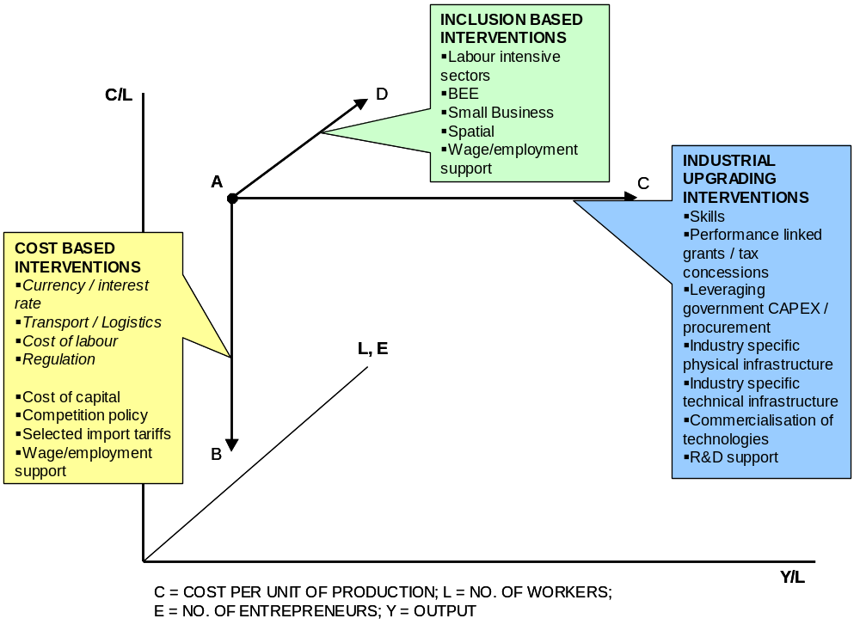
Source: Adapted from Amsden (2001): 6

These interventions, however, also need to take advantage of demand-side measures in order to build long-term sustainable markets. Domestic consumption and government capital expenditure over coming years will continue to drive growth and through direct and indirect demand-pull effects. These competitiveness effects will form the basis for building competitive advantages, which can be used by industries to penetrate lucrative and long-term sustainable export markets and achieve economies of scale.

These interventions must be rooted in our best assessment of current and potential competitive advantages in the industrial economy. Any analysis of these national or sectoral advantages requires some explanation of why they are currently not being sufficiently unlocked.

Unlocking industrial growth and development: challenges

There are a range of structural features associated with the South African economy which pose challenges for our industrial development. However, these challenges also frequently contain the roots of opportunities for development.

South African economy as a medium-size, medium-income economy is characterised by a relatively small domestic market. The historical legacy of high levels of poverty and inequality also negatively influences buying power. This is coupled with distance from a range of high income or high growth markets, such as the Triad economies and Asia. The consumer side of the economy has received a major boost from a combination of growing black participation in the economy due to employment equity and BEE, lower interest rates and the recent appreciation of the currency. However, the recent currency appreciation has also posed major problems for the production side of the economy.

Efficient interconnection with foreign markets faces some major challenges both with respect to the exchange rate as well as the actual and virtual infrastructure. Both the level and the volatility of the exchange rate has emerged as an important macroeconomic constraint to an export led growth path. Volatility negatively influences the certainty of investment decisions, while the recent appreciation of the currency poses major challenges for manufactured exports.

There have been difficulties with both the price and quality of the infrastructure necessary for trade and development. The efficiency of the basic rail and port infrastructure as well as the availability and cost of broadband telecommunications infrastructure have emerged as major cross-cutting constraints.

The strategy of the previous government of deliberately not investing in skills formation for the majority of the population is a major challenge. This poses two major sets of challenges. The first is that the global commoditisation of lower-value manufacturing places constraints on the growth of sectors that can absorb relatively unskilled labour. Conversely, availability of skilled labour becomes a constraint on the growth of more dynamic goods and services markets, which are more skill and technology and technology intensive.

There has long been a concern that high levels of concentration in the industrial economy form a systemic constraint to more labour intensive and value-adding growth path. Notwithstanding a far more robust Competition Act and the establishment of specific sector regulators, behaviour associated with high levels of industry concentration are holding back industrial development in areas such as the pricing of intermediate manufacturing inputs (Table C1) and telecommunications costs (Figure C1).

More complex is the interrelationship between relative labour costs and industrial productivity. In US$ terms average manufacturing labour costs per hour were on a downward trend between 1995 and 2002. However, the recent appreciation of the Rand has induced a rapid reversal of this trend with relative labour costs rising substantially (Figure C2). The debate around labour costs needs to be approached with sophistication because issues of labour cost and productivity are inextricably linked, particularly through investment in capital equipment and skills development.

Fixed investment rates by both the private and public sector have been low and have fallen well short of 25 per cent of GDP that is estimated to be necessary to move onto a fundamentally higher growth path. Related to the underinvestment in physical capital has been the relative underinvestment in technological capabilities. South Africa’s industrial capabilities, as measured by the UNIDO Competitive Industrial Performance Index declined between 1980 and 1990 and then improved to a par with Australia by 2000 (Figure C3).

Unlocking industrial growth and development: opportunities

The DTI places the manufacturing sector at the centre of the country’s economic development, given its ability to stimulate economic activity; catalyse employment throughout the economy; and drive economic growth through increased value-addition. However, the industrial sector extends beyond manufacturing, to a range of service and agricultural activities that have similar desirable characteristics to manufacturing.

South Africa has developed an established and diversified manufacturing base that has demonstrated resilience and the potential to compete in a global economy. Within the manufacturing sector, there are cumulative industrial capabilities built from a long history of industrialisation. The policies of the past government and particular industrial conditions have also facilitated technological developments, which have resulted in “pockets” of technological leadership: related for instance to mining, chemicals, agriculture, energy, and aerospace.

South Africa has a wide range of natural resources which can form the basis of a more labour intensive and value-adding industrial trajectory. This includes major deposits of a wide range of minerals, the ability to produce relatively cheap electricity, a wide range of agricultural possibilities, large land mass, and its inherent bio-diversity.

Notwithstanding the quality and price problems, South Africa has a relatively sophisticated infrastructure, including an extensive transport network, information and communications infrastructure and a highly advanced financial and banking system. These systems are set to be upgraded over coming years due, inter alia, to investment in ageing infrastructure and improved industry regulation.

Increased public expenditure on fixed investment over the next decade provides a huge opportunity to leverage growth. This is through a first round effect of ensuring the maximum domestic linkages from this expenditure as well as a second round competitiveness effect through improved interconnectivity with the rest of the world via an improved physical and electronic infrastructure.

A major ‘first mover’ opportunity exists with respect to the rest of Africa in various ways. South Africa is already a major exporter to the rest of Africa of a wide range of goods and services. A number of African economies are growing at a rapid rate which provides the platform to consolidate the gains of proximity to the rest of the continent. A logical extension of the capabilities built around our own capital expenditure programme would be an export-led push into the rest of continent.

Although the domestic market is relatively small, it has been growing rapidly as outlined above. This provides greater opportunities for the achievement of economies of scale with respect to servicing the domestic market.

The DTI – and post apartheid government more broadly – has over the last ten years strengthened or built a range of institutions which can form the basis of a more active industrial policy. This includes the development banking and industrial financing infrastructure; tax administration infrastructure; competition authorities, science councils; the standards, quality and accreditation infrastructure; manufacturing advisory centres; industry specific regulators; and improved intergovernmental coordination via the cluster system.

Consequently, there are three pillars to unlocking comparative and competitive advantage to catalyse a more labour intensive and value adding industrial growth path:

Cross cutting interventions to build industrial capabilities and lower costs;

Customised sector programmes to discover and unlock sectoral growth and development; and

Building sufficient and appropriate institutional capacities to implement a robust industrial policy.

CROSS-CUTTING INTERVENTIONS

There is a well-developed infrastructure for providing industrial finance in South Africa, notably through the IDC and the Enterprise Organisation (TEO) division of DTI, as well as e.g. via the National Empowerment Fund (NEF) and Small Enterprise Development Agency (SEDA). The suitability of current financing mechanisms – most of which were designed in the immediate post-1994 period – needs to be re-evaluated taking into account evidence about their effectiveness, changed conditions and global best practice. Areas of weakness which need to be addressed have been discussed above. They include the need for greater scale and more prioritisation, higher levels of reciprocity, a shift towards a more labour-intensive and value-adding emphasis and a focus on stimulating new or quantitatively higher levels of economic activity. South Africa’s incentives do not appear to be competitive in relation to our international competitors and need to be upgraded accordingly. Indicative directions for industrial financing programmes include:
- More targeted and substantial sector-specific and programmatic support based on the principles of minimum effective scale, clearer identification of the relevant market or production failure, reciprocity and monitoring.
- Support for specific industrial and technical infrastructure can address some of the coordination problems associated with industrial clustering. Appropriate underwriting of industrial infrastructure support economies of agglomeration. This can take various forms depending on the nature of the market failure, region or sector involved: Examples are industrial development zones, industrial parks, hi-tech/science parks, and catalytic project-specific infrastructure. Technological infrastructure is defined as infrastructure of a public good nature which individual firms would be unable or unwilling to invest in. These are typically activities which have technological spillovers onto an entire industry or group of activities, such as tooling, casting or standards and accreditation facilities.
- Support for world class manufacturing activities that target firm level upgrading, such as industry benchmarking clubs.
- Improved support for the commercialisation of South African technologies, through a combination of private firms or public science councils or tertiary institutions.
- Linking government procurement more strongly to industrial policy, including government’s CAPEX programme and linking BEE more closely to industrial policy

There is a need to for industrial policy to lead trade policy more explicitly. This requires a closer link between sector strategies in particular and trade negotiation positions. Ongoing interventions at the multilateral level will continue to focus on levelling the global playing field in areas such as agricultural and grandfather industries; creating a fairer set of trading rules; and pushing for more policy space for developing countries. A more strategic approach will be adopted towards bi-lateral trade negotiations. This means exploring a far broader range of possibilities than straightforward free trade agreements with economies such as India and China. Ongoing bilateral engagements will be used to address market access issues such as specific non-tariff barriers. The tariff structure needs to be reviewed particularly with respect to intermediate industrial inputs. The global trading rules will frame some of the possibilities with respect to industrial policy.

A related imperative is the development of more refined foreign direct investment (FDI) and export promotion strategies. This will entail more targeted FDI promotion driven by the opportunities identified from the sectoral strategies, as well as a more focussed export promotion strategy, based on detailed analysis of trade opportunities.

Government’s capital expenditure (CAPEX) programme will provide a massive injection into the economy over the next five to ten years. There is a need to integrate industrial policy with this initiative in order to maximise the levels of local production and to place firms on a higher growth trajectory after the CAPEX programme. This requires extensive coordination across government, the parastatals and the private sector. The CAPEX programme can be leveraged to generate longer term opportunities, particular with respect to the rest of the African continent.

BEE and women’s empowerment (WE) have proceeded slowly in the manufacturing sector in particular. This process must be acclerated. There is also a need and opportunity to link BEE and gender empowerment more directly with industrial policy. There are numerous ways of undertaking this, including linking industrial financing to BEE/WEE, strengthening government and state owned enterprise (SOE) procurement procedures and linking BEE/WEE financing more closely to developmental objectives such as employment and output growth.

Because competitiveness is fundamental to long-run sustainability, the importance of upgrading both at sectoral and firm level cannot be overlooked. Upgrading is a mechanism through which firms can enhance their competitiveness thereby combatting imports, retaining domestic market share and building export markets in a sustainable manner. Support for productivity upgrading and technology and innovation is critical in order to reduce dependence on commoditised manufacturing. Substantial work has been done with respect to tracking global technology trends and relating them to areas where South Africa could lead with respect to proprietary technologies or where it should focus on technology transfer, adoption and adaptation. The Department of Science and Technology’s National Research and Development Strategy sets the overarching framework for technological interventions, particularly on the research side of R&D. The focus of the Department of Trade and Industry’s efforts will be weighted towards the development side of R&D. Therefore technology financing needs to be expanded in order to meet our national R&D targets. There are a number of worthwhile projects identified by the AMTS that are worthy of support. This implies increased support measures for process and product innovation, and commercialisation of technologies. There is a need for greater coherence and collaboration between the Departments of Trade and Industry and Science and Technology in developing such support measures. It is important to strengthen systems to protect and develop South African intellectual property (IP) developed in and to encourage its commercialisation domestically in favour of licensing abroad. This is particularly with respect to IP that is developed through the public purse, such as the Science Councils. The national standards and accreditation technical infrastructure is extremely important to assist firms in dealing with market access, particularly related to standards and non-tariff barriers such as sanitary/phytosanitary, technical and environmental standards. This extends to the continent where a harmonised technical regulatory framework can create economies of scale for market access of African countries. The institutions responsible for technical infrastructure need to be used more strategically and integrated more closely with sectoral priorities. World Class Manufacturing support can assist firms to develop their product and process efficiencies. This is extremely important in an environment of high levels of global competitiveness, increased commoditisation of manufacturing and current currency strength. Firm level evidence indicates that firms that focus on non-price based strategies record better performance in terms of output and employment growth.

Given the unique nature of the South African economy: relative geographic isolation, coupled with concentrated market structures, there is a need for a more active competition policy and regulation. Competition policy is being reviewed with a view to strengthening it to take into account the specific market outcomes of industry structure in the South African economy. The issue of import parity pricing must be addressed in order to unlock downstream beneficiation in a range of value chains. There is a need for stronger regulation with respect to both the price and quality of industrial and modern infrastructure. This includes an efficient and cost effective transport system, much more competitive telecommunications costs and investment in broadband infrastructure, and a sufficiently capitalised and maintained electricity generation, transmission and distribution system.

Small business policy is well advanced and the institutional mechanisms for providing small business support are being overhauled and consolidated into two major agencies: SEDA and the Apex fund to focus on small- medium and micro-enterprises respectively. There is a need to link these initiatives more strongly with related interventions in areas such as competition policy, skills development, BEE/WEE and technology support.

There is a need for a coherent and sophisticated strategy for the promotion of regional industrialisation outside the three traditional metropoles, based on the principles of the National Spatial Development Perspective (NSDP). This requires identification of areas in which high economic need coincides with good economic potential. The issue of industrial infrastructure discussed under industrial financing, above, is critical. Here a broader range of possibilities need to be considered than simply industrial development zones. Consideration is being given to the development of a regional industrial fund, along European Union lines.

Although the educational and skills development framework are led by the Departments of Education and Labour respectively, there is a need for far greater integration between industrial and skills policy and implementation, particularly with respect to sector strategies. This is in areas such as ensuring that sector and SETA strategies and implementation are more aligned; development and attraction of scarce skills and related immigration issues.

SECTORAL INTERVENTIONS: CUSTOMISED SECTOR PROGRAMMES

The DTI has identified various industrial and services sectors that have the potential to substantially contribute to our national economic objectives. Strategies for these sectors are currently being developed in the form of Customised Sector Programmes (CSPs). The CSPs are aimed at identifying and unlocking the constraints to growth in each of these sectors. There are synergies to be achieved by clustering these sectors into related groupings that reflect some of the common characteristics and challenges that these sectors face. Therefore four broad sectoral groupings are identified:
- Downstream beneficiation of natural resources
- Advanced manufacturing
- Labour-intensive sectors
- Selected service sectors

South Africa has an abundance of mineral and plant resources and related comparative advantages such as relatively cheap electricity. The promotion of beneficiation of raw materials in downstream sectors is a logical progression to complete various value chains in the South African economy. These include long-established sectors such as metals fabrication; machinery and equipment; chemicals and plastics; and paper and pulp; as well as emerging sectors such as oil and gas and jewellery. Obstacles to downstream beneficiation include the pricing of raw materials, skills development, industry specific infrastructure and transport requirements. Interventions to unlock the potential of these sectors include: a regulatory framework for more internationally competitive raw material pricing inputs, leveraging domestic and continental capital expenditure coupled with targeted sector support mechanisms. There may also be potential to leverage a combination of relatively cheap labour, sophisticated infrastructure and agricultural and plant based resources to generate significant employment in high-value agricultural activities.

The predominance of medium to high-tech products in global trade signifies that more efforts should be directed to value-addition and improving efficiencies along manufacturing value chains. More importantly, new advanced manufacturing processes need to be promoted while accumulated industrial capabilities need to be enhanced in order to improve the technological composition of the export basket, and increase our share in global trade. Advanced manufacturing is generally characterised by relatively high levels of skill and technology requirements and encompasses the following sectors: automotives, aerospace, electronics and rail and marine These sectors are generally driven by foreign direct investors who own the proprietary knowledge involved and who subcontract original equipment manufacturing. However, there are areas in which South Africa has developed its own proprietary technologies, such as mining capital goods. It is in such areas that there is a very strong overlap between beneficiation and advanced manufacturing. Challenges exist with respect to deepening domestic technology linkages in automotives, building more competitive scale manufacturing capabilities in aerospace and identifying the areas in which South Africa can participate competitively in electronics value chains. This requires interventions in the areas of technology support, technological infrastructure such as tooling and more focussed FDI promotion efforts.

There is a number of sectors which are relatively labour intensive such as clothing and textiles; footwear and furniture. In recent years, the growth path of these sectors has diverged. Some of the sectors are in distress, as a result of high levels of competition from low wage countries such as China, and the strong currency. Clothing is a case in point. Certain sectors, such as furniture and leather, have, however, shown good performance and employment growth. The growth in the furniture sector is stimulated by the growth in the domestic spending while leather sector has been growing on the back of the automotive industry. The characteristics of these two groups suggest that two broad sets of interventions need to be developed. The first set of interventions relates to sectors that demonstrate good prospects for employment growth. The second relates to strategies for restructuring of sectors that are in decline.

In developing sectors, the importance of services should not be overlooked. The sector broadly constitutes over 60 percent of GDP and employment. While much services activity is driven organically by increasing per capita incomes, there are certain services sectors that display some of the desirable characteristics of manufacturing, such as the ability to absorb labour and generate substantial value addition. A number of services sectors tend to have a higher employment elasticity than manufacturing, although they also tend to be relatively skill intensive. Promising services include: business process outsourcing (BPO); ICT services; Engineering, construction and mining services, tourism and film. Challenges exist with respect to telecommunication costs and skills development in particular.

In addition to the the ongoing CSP processes identified above, there is also a need to identify new priority sectors which have the potential to substantially contribute to employment, industrial upgrading and growth. These will fall into two main categories. Firstly, non-tradable service sectors and sectors in which labour intensitivity can feasibly be increased. Secondly potentially high growth new or dynamic sectors which are capable of generating high levels of value addition and positioning South Africa in growing areas of global production.

Further the CSP processes need to be strengthened in the light of the issues arising from the industrial policy. Interventions to support CSPs must be based on the principles for industrial policy design set out above. This includes the principles of accurate identification of market/production failure, programmes of minimum effective scale targeted at the failure and reciprocity in industrial financing for the sector. CSPs need to integrate more closely with work that is underway at the provincial or local level. They also need to indicate the direction for trade policy for the sector.

CAPACITY AND INSTITUTION BUILDING

The final pillar of a strong industrial strategy is the need to build the human and organisational resources that are necessary to unlock industrial development. This spans a range of areas. It is recognised that possibly the scarcest resource in a developing country are the administrative capabilities to design and manage structural change. For this reason it is necessary to focus interventions on specific sectors and activities taking into account their ability to contribute to developmental goals, the nature and scope of the market or production failure and the prospects of success.

First and foremost is the need to strengthen the design and administration of industrial financing. This means designing programmes on the basis of minimum effective scale, which in turn implies making hard choices about prioritising some activities relative to others. These programmes need to address quite clearly the associated market or production failure that is preventing the activity from occurring. Strategies for risk minimisation include:

Focussing on quantitatively new activities rather than existing ones

Improved coordination with the private sector to establish the binding constraints to growth

Setting of monitorable reciprocal performance requirements

Benchmarking with competitor country offerings

This requires building sufficient and appropriate human capacity, particularly with respect to sectoral analysis, strategy design and programme implementation. Some institutional improvements can be achieved with minimum cost and delay: notably the consolidation of industrial policy, sectoral and industrial finance design activities. Research and information capabilities with respect to sectors can be improved through stronger networks, particularly between DTI, the IDC and selected universities that have industrial policy research related programmes. In addition, collection of more robust and reliable aggregate industrial and services data will require closer interactions with Statistics SA. Industry and Trade Policy Advisory Council will be established to review progress with industrial policy and to advise the Minister on a quarterly basis. It may also be possible to supplement capacity through technical assistance arrangements with high growth NICs. Over the medium term and longer it will be necessary to develop more detailed capacity building programmes. This will include the establishment of one or more Industrial Policy Centre(s) of Excellence to train a cadre of young – predominantly black and female – economists and to undertake ongoing research in areas related to industrial policy. This will form a recruiting ground for the DTI as well as supporting high quality ongoing research.

More strategic use needs to be made of the various state agencies in a range of ways. Firstly, their activities need to be more strategically aligned to an industrial policy based on the principles set out above. Secondly, the role of the state as entrepreneur is re-emerging in areas such as aerospace and energy.

There is need for greater intergovernmental coherence, particularly with respect to:
national, provincial and local government growth and sectoral strategies; leveraging maximum multipliers from the state’s CAPEX programme; greater coherence between sectoral strategies and skills formation; and technology support measures.

In this regard, two sets of coordination fora championed by the DTI will be convened on aregular basis to increase policy coherence and coordination across all three spheres of government and amongst related stakeholders.
- Vertical coordination aimed at integrating CSPs with provincial and local government sector strategies. The focal point of this forum is to shape sectoral interventions and dispersion of functional and customised incentives.
- Horizontal coordination aimed at alignment between existing policies and strategies and theNational Industrial Policy. This will require several platforms of engagement with other national departments and key institutions:
  - Infrastructure: CAPEX programme, transport, energy and telecommunications (DPE, DoT, DoC, DME, IDC)
  - Technology (DST, CSIR, SABS, SAQII)
  - Skills (DoL, SETA’s, DoE)
  - Macroeconomic policy (NT, SARB)

INDUSTRIAL POLICY PROGRAMME

This section summarises the key interventions that arise out of the industrial policy framework. The programme will be revised on an annual basis and feed into the annual strategy, business planning and budgeting processes of the DTI. The programme is based on the three to five year economic outlook. The Industrial Policy programme is not aimed at replacing existing policies but rather to both guide and integrate with such initiatives.

Industrial Policy Programme 2005/6

Industrial Financing
Action item | Description | Deadline
Review of Industrial Financing | Review of industrial financing since 1994, cross-country review of industrial financing and recommendations for revised incentive schemes
Development of customised incentives for priority sectors | Development of incentives aimed at achieving structural change in sectors for which CSPs have been developed
Development of revised functional incentives | Development of functional incentives such as in the areas of world class manufacturing and technology upgrading

Sectors
Action item | Description | Deadline
Finalisation of CSPs:  - Aerospace  - Agro-processing  - Automotive  - Business Process Outsourcing  - Capital Equipment  - Chemicals  - Clothing and Textiles  - Electronics/ICT  - Metals  - Tourism | CSPs to identify opportunities and challenges faced by the respective sectors and outline how the sector strategies will address the challenges and maximise the opportunities as well as taking sectors’ development path forward
Development of CSP for labour-intensive activities | Development of a ‘sector’ strategy to identify labour-intensive non-tradeable services as well as other labour-intensive opportunities in the economy
Programme for identification of new sectors | Process to identify new high value-added and employment growth areas which South Africa can potentially engage

Trade policy
Action item | Description | Deadline
WTO Negotiations | Closer link between sector strategies and trade negotiation positions

Bi-lateral negotiations with US
Bi-lateral negotiations with China and India | Strategise over broader range of possibilities (such as investment opportunities and NTB) than straightforward FTA
SACU and SADC | Deeper economic integration through establishing common policies for SACU and SADC.

Competition Policy
Action item | Description | Deadline
Finalisation of Competition Policy Review and Strengthening of Competition Act | Finalisation of Competition Policy Review and Strengthening of Competition Act to deal with un-competitive outcomes in particular sectors

Industrial upgrading and technology
Action item | Description | Deadline
Development of Framework for the commercialisation of South African technology | Framework to identify technologies required in the prioritised sectors, review international best practices for commercialising technologies, and identify strategic interventions
Development of World Class Manufacturing (WCM) framework and incentives | A framework for WCM and consideration and development of WCM incentives
Revise technology incentives | Review of technology incentives since 1994, and revision of incentive schemes to address market failures associated with developing technological competencies
Development of Framework for standards, quality and accreditation | Framework to outline critical standards, quality and accreditation facilities required

Small and Medium Enterprises
Action item | Description | Deadline
Organisational implementation framework for SMME support | Framework for maximising the effectiveness of existing institutions supporting SMME’s

Black Economic and Women’s Empowerment
Action item | Description | Deadline
Finalise Codes of Good Practice | Finalisation of BBEE Codes of Good Practice
Framework for Women Economic Empowerment (WEE) | Framework to increase participation of women in the mainstream of the economy
Framework for linking BEE and WEE to growth | Framework for linking BEE and WEE to more explicitly to government’s growth and employment objectives.

Regional Economic Development
Action item | Description | Deadline
- Finalise IDZ regulations, institutional agreements and governance | Policy review of IDZ to clarify roles and leadership responsibilities, institutional and governance arrangements
9.10.2 Framework for regional industrial development | Framework to identify industrial opportunities and challenges of the different regions, based on underlying economic potential

Large and Medium Firms
Action item | Description | Deadline
Development of a database of dynamic medium and large firms and a framework for engaging with them. | Develop database of top medium and large dynamic firms  Framework to outline the principles of engagement as well the methodology to further develop such dynamic firms

Africa
Action item | Description | Deadline

Africa trade and industry engagement strategy

Capacity and organisation
Action item | Description | Deadline
Establish Industrial Policy Advisory Council (IPAC) | Advisory council to the Minister of Trade and Industry comprising local and international experts/ academics, representatives of business and labour
Minor internal reorganisation | Movement of sector strategy and implementation, and incentive design to Enterprise and Industry Development Division
Establishment of industrial policy working group | Establishment of modalities for drawing together DTI, IDC and University-based resources on Industrial Policy
Trade and Industry Policy Centre(s) of Excellence | Establishment of centres of excellence at key universities to undertake research and train graduates in areas related to industrial and trade policy

Policy coordination
Action item | Description | Deadline
Establishment of regular inter-governmental forum on Infrastucture and Capex and Industrial Policy | DPE, DTI, DoT, IDC, DoL, business
Establishment of regular inter-governnmental forum on Skills and Industrial Policy | DoL, DTI, DoE, DHO, Setas, Labour, Business
Establishment of regular inter-governmental forum on Technology and Industrial Policy | DST, DTI, CSIR, SABS, SAQII, Business
Establishment of regular intergovernmental forum on Macroeconomic policy and Industrial Policy | NT, DTI, SARB, Labour, Business
Coordination between relevant provinces and local authorities on Customised Sector Programmes | DTI, Provinces, Metros, Munics

APPENDIX A: SOUTH AFRICA’S INDUSTRIAL PERFORMANCE SINCE 1994

Growth
Economic performance since 1994 has been mixed. GDP has grown steadily at an annual average of 3 percent, while GDP per capita growth was 1 percent. There have been some significant changes in the structure of the South African economy since 1994 (Figure A1). At the broad sectoral level, it is mostly service sectors that have show the fastest growth. This is for a range of reasons, including the realisation of pent-up demand for various services, growing consumer demand, and linkages from manufacturing. The broad sectors which have gained the greatest share have been Transport and Communication (+3.3%), Finance (+3.1%), Trade, Catering and Accommodation (+1.8%) and other services (0.3%). Construction retained a constant share. Sectors which lost share in the economy were led by Government services (-4.5%), followed by Mining (-2.2%), Agriculture (-0.9%), Manufacturing (-0.8%) and Electricity (-0.5%). However, there have been substantial differences in sectoral growth performance within manufacturing.

Figure A1: Change of broad sectors in share of GDP (%): 2004 versus 1994
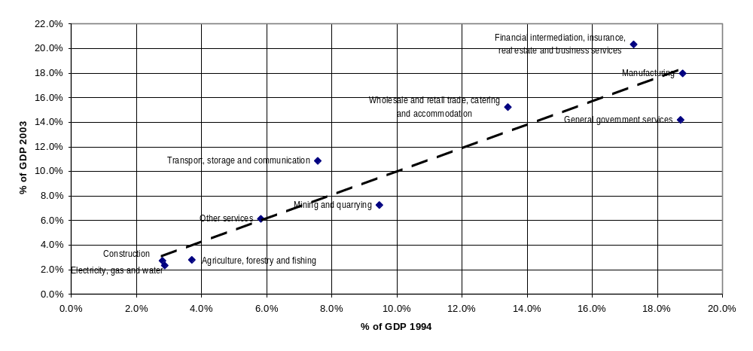Source: Quantec RSA Standardised Industry Database

Figure A2 gives a detailed breakdown of annual average sectoral growth rates of value added and employment between 1994 and 2004. The highest growth sectors have largely been services, upstream resource-based manufacturing and a small group of other manufacturing sectors including: furniture, leather, automotives and plastic products. Employment growth has generally not kept pace with value added growth, although some sectors have experienced good employment growth, such as business services, medical services, other manufacturing, wholesale and retail, professional/scientific equipment, finance and insurance, and plastic products.

Figure A2: Annual average percentage growth in sectoral gross domestic product and employment, annual average, 1994-2004
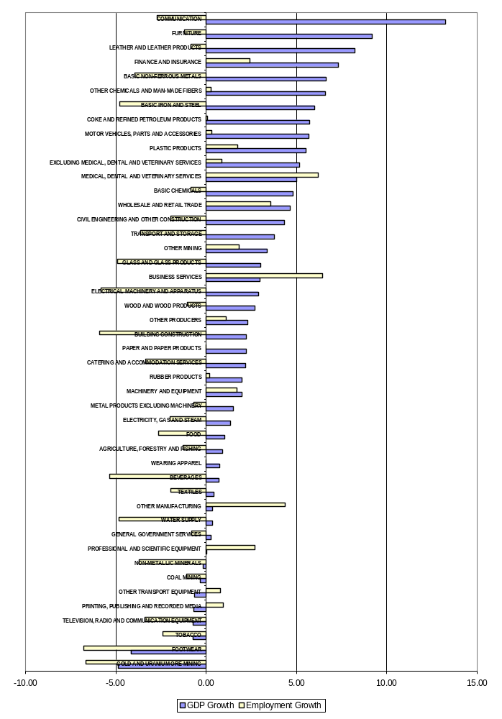
Source: Quantec RSA Standardised Industry Database

Figure A3 illustrates that this growth of manufacturing value added (MVA) – by sectoral grouping – has been uneven (Table A1 – Appendix A lists the sectors that form part of each sectoral grouping). Resource-based manufacturing grew the most over the period, from 30 to 37 percent of MVA. Labour-intensive industries declined from 46 to 39 percent share of MVA, while the Durable goods and Electro-technical industries maintained a more or less constant share at around 19 and 4.5 percent respectively.

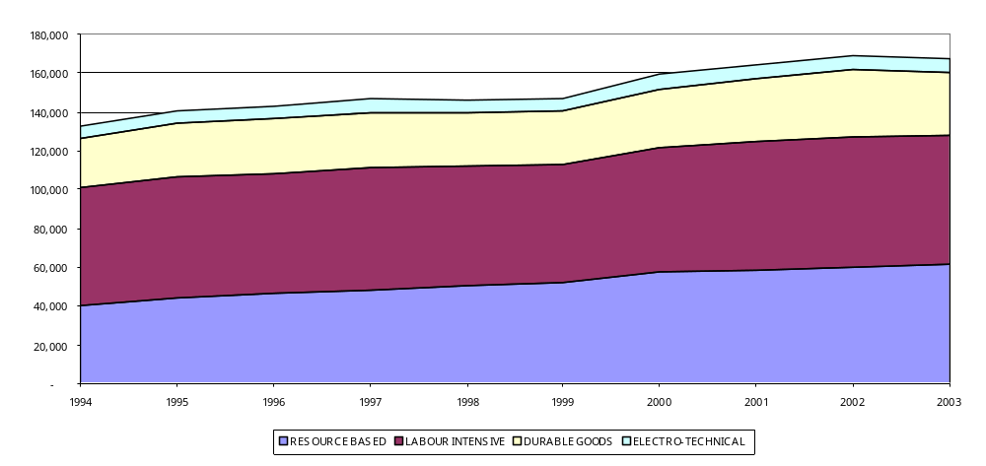Figure A3: Real growth in manufacturing value added (MVA): 1994 – 2003, Constant 2000 Rands
Source: Quantec RSA Standardised Industry Database

Figure A4 provides a more detailed breakdown of the sectoral changes in MVA. The sectors which have gained share in MVA between 1994 and 2003 have largely been capital intensive resource-based sectors: Basic iron and steel (+2.7%), Basic non-ferrous metals (+2.6%), Other chemcials (+1.1%) and Basic chemicals (+0.3%). More value-adding or labour intensive sectors which gained in share are Motor vehicles (+1.1%), Machinery and equipment (+0.3%) and Wood and wood products (0.2%).

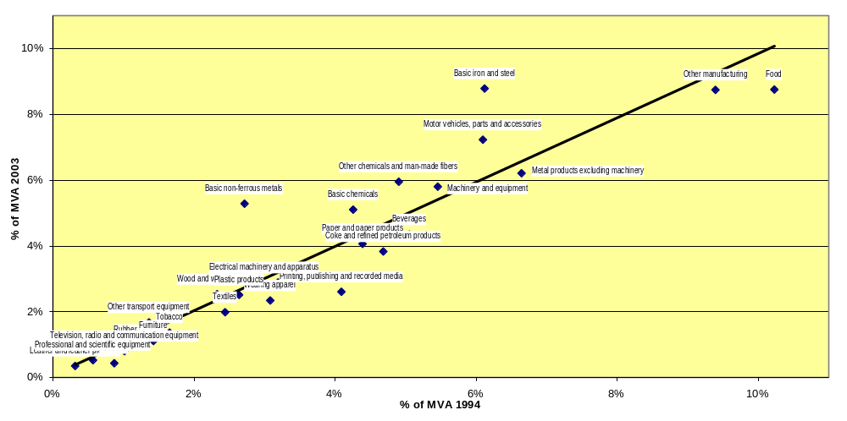
Figure A4: Sectoral share in Manufacturing Value Added (MVA): 1994 vs 2003, Constant 2000 Rands
Source: Quantec RSA Standardised Industry Database

While the threat of de-industrialisation that loomed in 1994 has been averted and the manufacturing sector has been placed on a steady growth path, it has grown slower than key developing country counterparts (Figure A5).

Figure A5: Average annual real manufacturing value added growth (%), selected developing countries, 1994-2002
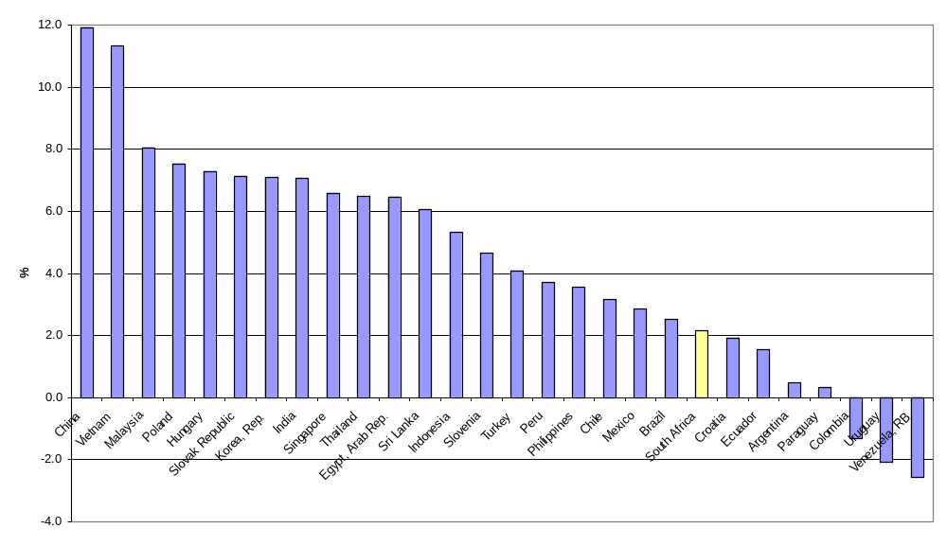
Source: World Bank Development Indicators
Note: Malaysia: MVA growth 1994-2001

Investment
Investment was even more heavily concentrated in the Resource-based sectors (Figure 6), which increased their share from 67 to 69 percent of manufacturing investment between 1994 and 2003. Labour-intensive share of investment declined from 21 to 19 percent while the Durable goods sectors increased their share from 10 to 11 percent. Electro-technical products share of manufacturing investment remained constant at around 1 percent.

Figure A6: Sectoral share in Manufacturing Investment: 1994 – 2003, Constant 2000 Rands
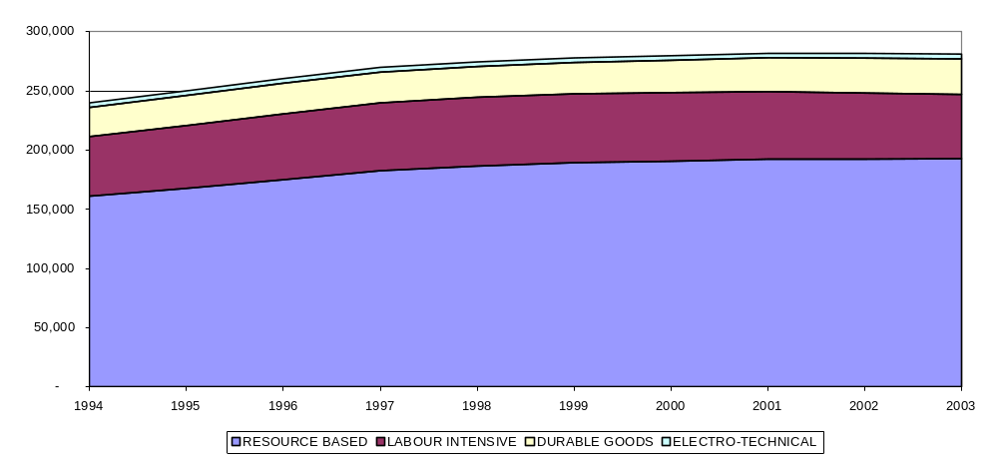
Source: Quantec RSA Standardised Industry Database

Exports
Figure 7 indicates that both total and manufacturing exports have been on an upward trend since 1994 in US$ terms, notwithstanding the strengthening of the Rand.

Figure A7: Total and manufacturing exports, 1994-2004, US$
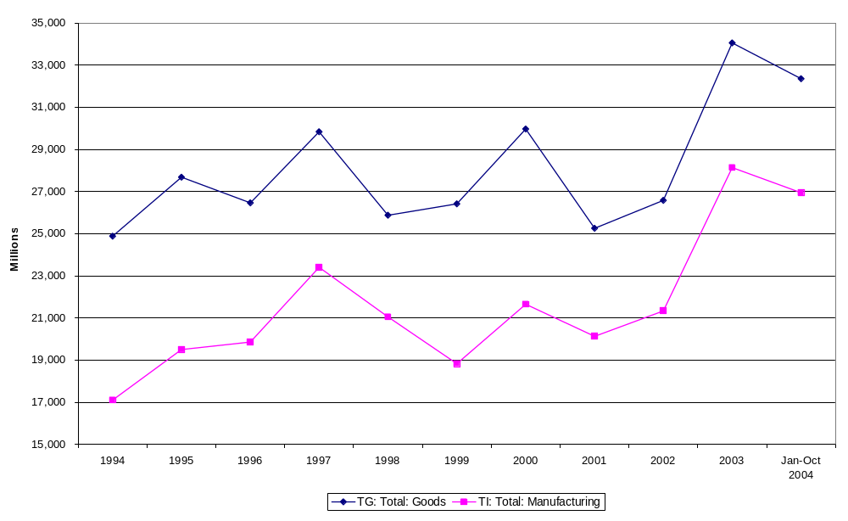
Source: Quantec RSA Standardised Industry Database

Figure 8 shows that exports have been heavily dominated by resource-based sectors, although their share declined from 73 percent to 56 percent over the period. Labour intensive sector exports grew from 17 to 19 percent of manufactured exports. The durable goods sectors showed the most dramatic improvement, growing from 9 percent to 22 percent, driven largely by automotive exports. Electro-technical exports increased from 1.5 percent to 3 percent.

Figure A8: Sectoral share in Manufacturing Exports: 1994 – 2003, US$
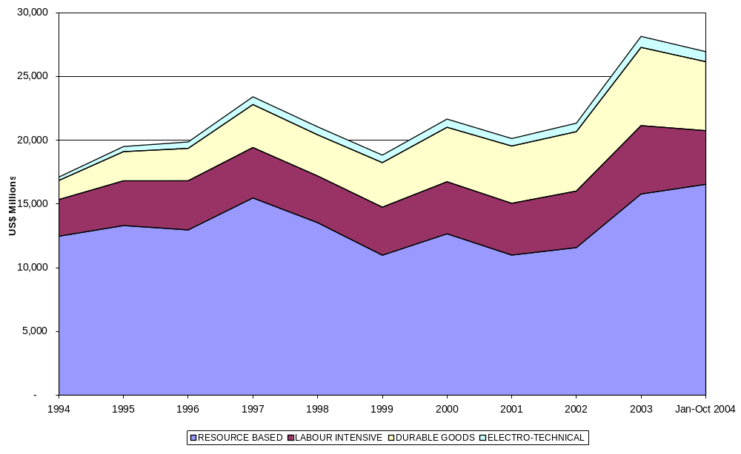
Source: Quantec RSA Standardised Industry Database

Economic participation
Economic participation has also shown inadequate change. Economic activity remains concentrated around the three traditional metropoles: the PWV area of Gauteng, Durban/Pietermaritzburg and Cape Town (Figure 9).

Figure A9: Gross geographic product by primary, secondary and tertiary sector, 2003, R’m
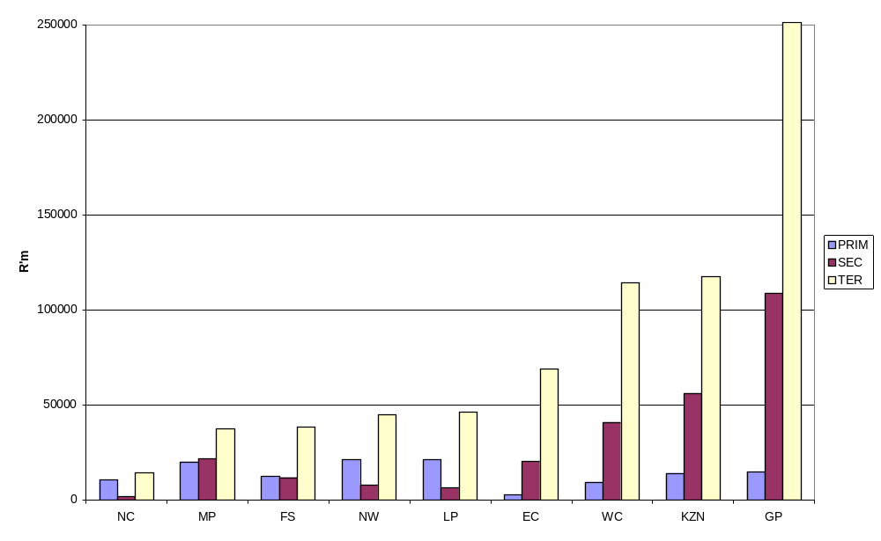
Source: Statistics South Africa

Similarly BEE in the manufacturing sector in particular has shown slow progress. In 2003, BEE transactions in manufacturing accounted for only 1.7 percent of total deal value, with deals being dominated by the minerals and services sectors (Table 1).

Table A1: BEE Transactions by sector: 2003
Sectors | Number | Transaction Value | % of Total Deal
Resources | 24 | 22827 | 58.3%
Financial Services | 25 | 3945 | 10.1%
Services | 13 | 3332 | 8.5%
Healthcare | 3 | 3194 | 8.2%
Transport | 5 | 1625 | 4.1%
Media&Entertainment | 3 | 1332 | 3.4%
ICT | 17 | 1222 | 3.1%
Manufacturing | 13 | 670 | 1.7%
Hotel&Leisure | 5 | 454 | 1.2%
Fishing/food | 3 | 451 | 1.2%
Properties | 2 | 91 | 0.2%
Retail | 1 | 22 | 0.1%
Basic Industries | 2 | 0 | 0.0%
Construction | 2 | 0 | 0.0%
Total | 118 | 39165 | 100.0%
Source: Ernst and Young as reported in Parliamentary Question 951 of 2004.

Table A2: Classification of Sectoral Groupings
RESOURCE BASED | LABOUR INTENSIVE | DURABLE GOODS | ELECTRO-TECHNICAL
Paper & paper products | Food | Metal products excluding machinery | Electrical machinery
Coke & refined petroleum products | Beverages | Machinery & equipment | Television, radio & communication equipment
Basic chemicals | Tobacco | Motor vehicles, parts & accessories | Professional & scientific equipment
Other chemicals & man-made fibres | Textiles | Other transport equipment
Non-metallic minerals | Wearing apparel
Basic iron & steel | Leather & leather products
Basic non-ferrous metals | Footwear
 | Wood & wood products
 | Printing, publishing & recorded media
 | Rubber products
 | Plastic products
 | Glass & glass products
 | Furniture
 | Other industries

Table A3. Fastest growing products in world trade, 1990-2000
 | Exports (billion dollars)
Product | 1990 | 2000 | Average annual growth (percent) 1990–2000
Ores and concentrates of uranium | 22 | 352.6 | 32.0
Optical instruments and apparatus | 3 809.7 | 22 096.3 | 19.2
Thermionic valves (semiconductors) | 59 098.6 | 284 417.0 | 17.0
Telecommunications equipment and parts | 56 766.0 | 206 333.3 | 13.8
Gas, natural and manufactured | 22 329.4 | 80 008.2 | 13.6
Parts of and accessories of computers | 47 956.7 | 150 491.3 | 12.1
Electric power machinery and parts | 10 540.9 | 31 662.9 | 11.6
Medicinal and pharmaceutical products | 36 276.6 | 106 455.4 | 11.4
Automatic data processing machines | 67 418.0 | 188 641.0 | 10.8
Equipment for distributing electric | 13 284.7 | 37 110.1 | 10.8
Ores and concentrates of precious met | 1 222.9 | 3 319.7 | 10.5
Electrical machinery and apparatus | 36 738.8 | 97 259.5 | 10.2
Organo-inorganic and heterocyclic compounds | 11 597.7 | 30 532.7 | 10.2
Elect. Apparatus such as switches relays etc | 35 297.0 | 90 569.0 | 9.9
Under garments knitted or crocheted | 11 814.2 | 30 188.5 | 9.8
Nickel | 2 870.8 | 7 243.2 | 9.7
Road motor vehicles n.e.s. | 6 570.2 | 16 070.7 | 9.4
Medical instruments and appliances | 9 944.4 | 23 281.8 | 8.9
Articles of rubber n.e.s. | 4 798.1 | 11 058.8 | 8.7
Silver, platinum and similar metals | 5 050.7 | 11 517.1 | 8.6
Photographic apparatus and equipment | 7 259.5 | 16 539.4 | 8.6
Perfumery cosmetics and toilet prep | 10 069.0 | 22 686.4 | 8.5
Non alcoholic beverages n.e.s. | 2 297.6 | 5 119.1 | 8.3
Knitted or crocheted fabrics | 6 023.7 | 13 383.3 | 8.3
Rotating electric plant and parts | 13 205.5 | 28 533.3 | 8.0
Articles of materials described in division 58 | 28 728.7 | 62 055.0 | 8.0
Engines and motors. non-electrical | 22 013.4 | 47 353.5 | 8.0
Misc. non-ferrous base metals | 1 606.5 | 3 454.6 | 8.0
Glass | 9 352.2 | 20 036.5 | 7.9
Furniture and parts thereof | 29 066.6 | 61 736.6 | 7.8
Essential oils perfume and flavouring | 3 571.4 | 7 558.0 | 7.8
Residual petroleum products n.e.s. | 5 183.4 | 10 918.7 | 7.7
Motorcycles, motor scooters | 9 833.9 | 20 478.5 | 7.6
Pearls precious and semi-precious stones | 24 132.3 | 49 827.5 | 7.5
Spices | 1 185.6 | 2 430.8 | 7.4
Edible products and preparations n.e.s. | 7 337.6 | 15 021.9 | 7.4
Wood manufactures n.e.s. | 8 057.1 | 16 447.8 | 7.4
Manufactures of base metal n.e.s. | 23 796.9 | 48 525.9 | 7.4
Nitrogen-function compounds | 17 113.5 | 34 659.1 | 7.3
Made-up textile articles | 8 087.2 | 16 302.7 | 7.3
Optical goods n.e.s. | 4 636.0 | 9 337.6 | 7.3
Miscellaneous chemical products n.e.s. | 21 154.2 | 42 479.8 | 7.2
Other organic chemicals | 6 871.7 | 13 724.7 | 7.2
Other miscellaneous manufactured articles | 10 463.1 | 20 871.8 | 7.2
Cork natural raw and waste | 122 | 243.3 | 7.1
Pigments paints varnishes | 11 761.2 | 23 448.3 | 7.1
Petroleum products refined | 78 781.0 | 156 343.5 | 7.1
Measuring checking analysing instruments | 36 365.6 | 72 086.9 | 7.1
Pumps & compressors fans & blowers | 19 716.6 | 38 920.5 | 7.0
Meters and counters n.e.s. | 1 352.6 | 2 659.2 | 7.0

Source: UNIDO (2004)

Table A4. Dynamic product exports per capita, US$, 2000

Country | Dynamic Products Exports per capita, US$, 2000
Singapore (1) | 21.138
Ireland | 13.772
Belgium | 6.262
Luxembourg | 4.723
Netherlands | 3.842
Switzerland | 3.429
Sweden | 3.366
Taiwan, China (2) | 3.352
Israel | 3.271
Finland | 2.911
Canada | 2.889
Botswana (3) | 2.669
Germany | 2.598
Austria | 2.306
Denmark | 2.282
Malaysia (4) | 2.182
United Kingdom | 2.037
France | 2.014
Japan | 1.843
Korea, Rep. (5) | 1.617
Hungary (6) | 1.445
Hong Kong, China (7) | 1.398
Slovenia (8) | 1.379
Italy | 1.188
United States | 1.065
Estonia (9) | 1.035
Spain | 1.012
Czech Rep. (10) | 0.937
Mexico (11) | 0.862
Portugal | 0.786
Norway | 0.780
Slovak Rep. (12) | 0.732
Costa Rica (13) | 0.658
Mauritius (14) | 0.498
Thailand (15) | 0.396
Philippines (16) | 0.369
Australia | 0.346
Oman (17) | 0.311
Namibia (18) | 0.309
Poland (19) | 0.250
New Zealand | 0.192
Greece | 0.178
Lithuania (20) | 0.178
Croatia | 0.163
Tunisia | 0.141
Turkey | 0.117
South Africa (24) | 0.112
Latvia | 0.110
Swaziland | 0.109
Romania | 0.105

Source: UNComtrade, based on the 40 fastest growing (SITC 4 digit) products in world trade, 1985 – 2000. Shaded rows = developing countries. Brackets = developing country rankings

APPENDIX B: GLOBAL ECONOMIC DEVELOPMENTS

Figure B1. Shares of manufactured products in world exports by technology levels from 1976 to 2000 (%)
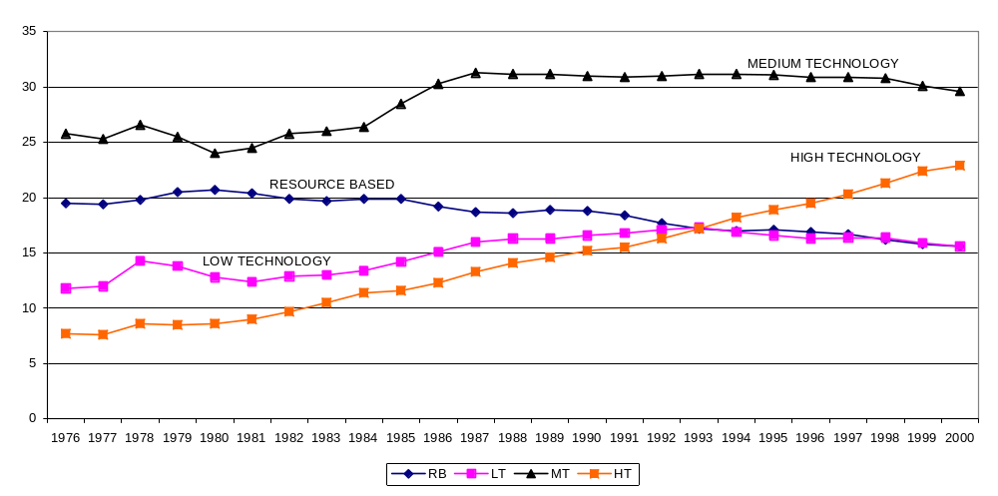
Source: Lall

Figure B2. Leaders in number of offshore service projects in developing countries (2002-3)

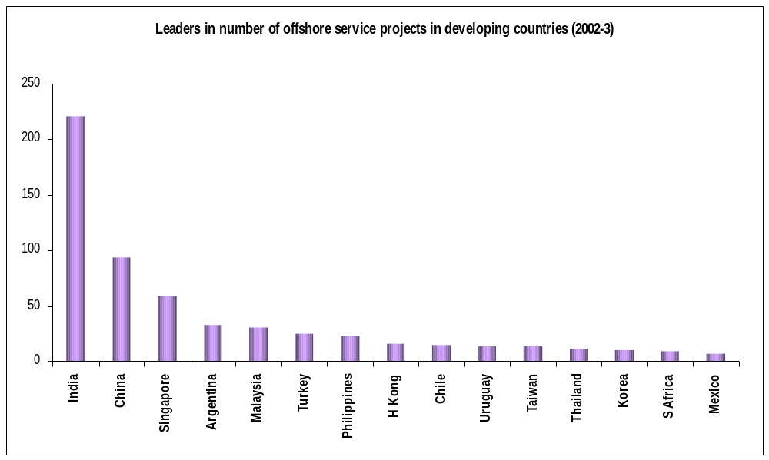
Source: Lall

APPENDIX C: UNLOCKING INDUSTRIAL GROWTH AND DEVELOPMENT: CHALLENGES

Table C1. Estimated maximum margin between import and export parity prices in selected sectors
Sector | Primary producer margins | Margins by traders / intermediaries | Estimated margin faced by SME producers
Carbon steel | 25 – 40 % | 10 – 20% | 35% – 60%
Polymers | 25% – 40% | – | 25% – 40%
Stainless steel | 15 – 20% | 10 – 20% | 25% – 40%
Aluminium | 5 – 10% | N/A | N/A
Sources: Corporate Strategy and Industrial Development Research Project, University of the Witwatersrand; Trade and Investment South Africa
Notes:
- Estimates exclude rebates for secondary exports and industry specific arrangements.
- N/A indicates information is not available

Figure C1. International leased lines, annual fee for 2mbps
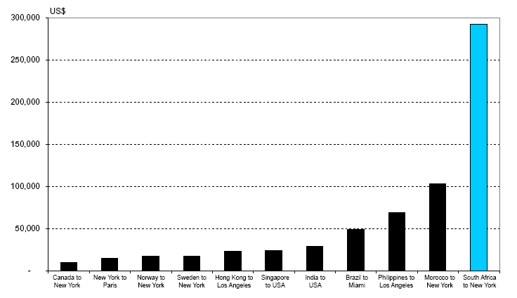
Source: South Africa Foundation (2005), Telecommunications prices in South Africa: An international peer group comparison, Occasional Paper No. 1

Figure C2. Manufacturing labour costs per hour US$, selected economies, 1994 – 2003
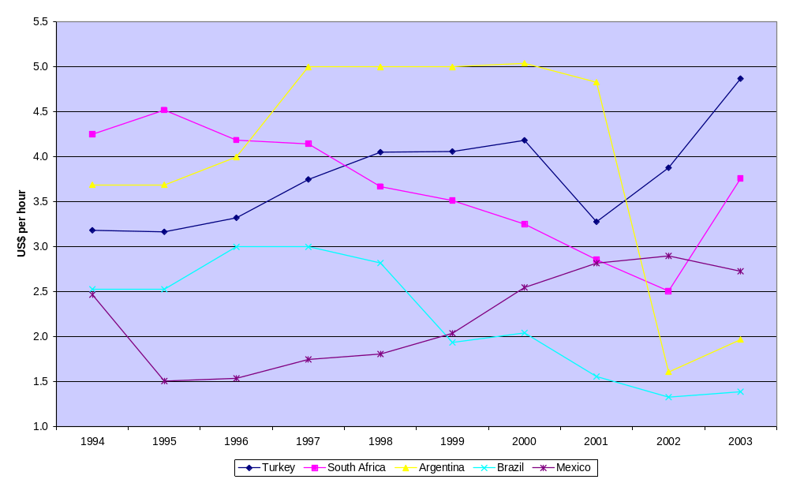
Source: Economist Intelligence Unit

Figure C3. Industrial upgrading of selected countries: UNIDO CIPI index, 1980, 1990 and 2000
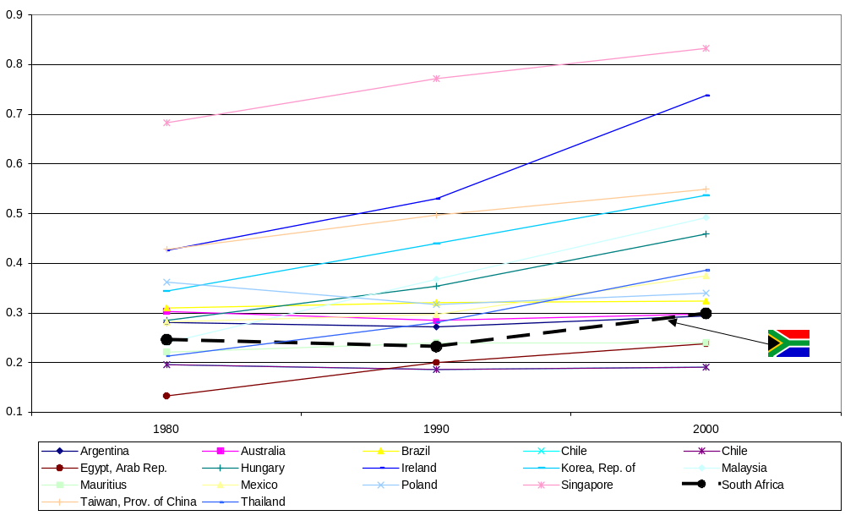
Source: UNIDO, 2004
Selected Bibliography

Amsden, A. (2004) The Rise of “The Rest”: Challenges to the West From Late-Industrialising Economies, New York, Oxford University Press
Chang. H-J.. The Political Economy of Industrial Policy. London, Macmillan.
——— (2002). Kicking Away the Ladder. London, Anthem Press.
Department of Trade and Industry (2005) The Developmental State and the real economy, internal discussion document
Fine. B. and Z. Rustomjee (1996). The Political Economy of South Africa: From Minerals-Energy Complex to Industrialisation. London, Hurst & Company.
GCIS (2004), Towards a Ten Year Review: Synthesis Report on Implementation of Government Programmes
Hausmann, R. Rodrick, D and S. Velasco. (2005) Growth Diagnostics, John F. Kennedy School of Government
Joffe, A. Kaplan D., Kaplinsky, R., and D. Lewis (1995) Improving Manufacturing Performance in South Africa: The Report of the Industrial Strategy Project, Cape Town, UCT Press
Lall, S. (2003) Reinventing industrial strategy: The role of government policy in building industrial competitiveness, The Intergovernmental Group on Monetary Affairs and Development (G-24).
Mathews, J. (2004) World Industrial Development in the 21st Century: Catch-up Strategies and the Latecomer Effect, MGSM Working Papers in Management
National Treasury (2005) A Partnership for Growth and Empowerment: accelerating economic development, 2005-2014, internal government discussion document
Rodrik, D. (2004) Industrial Policy For The Twenty-First Century, John F. Kennedy School of Government
United Nations Industrial Development Organization (UNIDO) (2002), Industrial Development Report 2002/3: Competing through innovation and learning, Vienna
Wade, R. (1990) Governing the Market: Economic Theory and the Role of Government in East Asian Industrialisation, Princeton University Press

Ekurhuleni/CSID Cluster Studies
The accuracy of some of the employment data must be questioned. For instance it is difficult to believe that professional and scientific equipment employment could have grown by close to 3 percent per annum when MVA growth in this sector was virtually non-existent.

