NATIONAL HEALTH LABORATORY SERVICE
STRATEGIC PLAN 2004 – 2007
ROADMAP TO THE FUTURE

TABLE OF CONTENTS

1 EXECUTIVE SUMMARY 3
2 Statement of the business 3
3 Vision 3
4 Strategic Intent 3
5 Business Drivers 3
6 Key Outcomes 3
7 Key Initiatives 3
8 Financial Projections 3
9 Conclusion 3
10 Annexure A – Financial Statements 3
11 Annexure B – Executive Summary [Finance] 3
12 Annexure C – Executive Summary [Information Technology] 3
13 Annexure D – Executive Summary [Human Resources] 3
14 Annexure E – Executive Summary [QA, Research & University Relations] 3
15 Annexure F – Executive Summary [Central Region] 3
16 Annexure G – Executive Summary [Coastal Region] 3
17 Annexure H – Executive Summary [Northern Region] 3
18 Annexure I – KwaZulu-Natal Laboratory Services 3
19 Annexure J – Executive Summary [National Institute of Communicable Diseases] 3
20 Annexure K – Executive Summary [National Institute of Occupational Health] 3
21 Annexure L – High-level Organogram 3

EXECUTIVE SUMMARY
The National Health Laboratory Service is a health care organisation established by an Act of Parliament to improve the health of the people of South Africa through diagnostic and advisory services.
The core business of the NHLS is the improvement of the health of the nation by the provision of cost effective and professional diagnostic expertise to patients, clinicians and the public health sector.
The products of the company are diagnostic pathology services; knowledge and information through research; training and teaching of health care professionals for tertiary institutions; disease and environmental surveillance, health information; and advocacy to Government and other health authorities.
At present the NHLS derives 92% of its income from “fee for service” for diagnostic pathology services. The vast majority of these operations take place within the public sector with lesser direct engagement of other health care professionals, NGO’s, medical aids, tertiary institutions and private patients in this regard. The pharmaceutical industry and other research funders form a minority sector of the current market of the NHLS.
There exist opportunities for expansion of services to the public sector as well as to become designated providers for “low option” medical aids. Partnerships could be formed with NGO’s, elements of the private sector, research funders as well as the SADC countries. Further potential avenues for expansion of the business are to be found in the areas of data accumulation and management and clinical care.
Whilst the main emphasis of the NHLS will be the ethos of public health, the organisation will be managed upon sound commercial principles. This exists as an urgent need in order to keep the NHLS in the position of market leader in the industry.
The NHLS will improve the benefit it currently provides to the government as well as expanding the benefit it provides to the private sector by means of a consistent focus in the areas of service provision, accessibility and market utilisation with particular emphasis on the following four items which will form the strategic intent of the organisation:

  - Increase market share through the improvement of logistical structures which will result in increased accessibility

  - Improve health skills in the country through the active recruiting, training and retention of key skills

  - Improve the quality of service and efficiency of the organisation through the improvement of internal support structures, a focused program of laboratory accreditation, active participation in national and international quality assurance programmes and the creation of an increased knowledge base

  - Active programmes to improve information technology as well as to enhance the effectiveness of technology in general within the organisation

A strategic programme of intervention in the four areas above will ensure that the vision of the organisation will be achieved within the stated time frame. This strategy forms the basis for all the business of the National Health Laboratory Service and the strategies and business plans of all regions and departments of the organisation will be aligned with this one.

Statement of the business
The National Health Laboratory Service is a health care organisation established by an Act of Parliament to improve the health of the people of South Africa through diagnostic and advisory services.
The core business of the NHLS is the improvement of the health of the nation by the provision of cost effective and professional diagnostic expertise to patients, clinicians and the public health sector.
The products of the company are diagnostic pathology services; knowledge and information through research; training and teaching of health care professionals for tertiary institutions; disease and environmental surveillance, health information; and advocacy to Government and other health authorities.
At present the NHLS derives 92% of its income from “fee for service” for diagnostic pathology services. The vast majority of these operations take place within the public sector with lesser direct engagement of other health care professionals, NGO’s, medical aids, tertiary institutions and private patients in this regard. The pharmaceutical industry and other research funders form a minority sector of the current market of the NHLS.
There exist opportunities for expansion of services to the public sector as well as to become designated providers for “low option” medical aids. Partnerships could be formed with NGO’s, elements of the private sector, research funders as well as the SADC countries. Further potential avenues for expansion of the business are to be found in the areas of data accumulation and management and clinical care.

Vision

The vision for the organisation is as follows:

By 2007 the National Health Laboratory Service will have improved health skills in the country, expanded service delivery and established itself as the national centre of excellence for relevant high quality services, rapidly adapting to market and technological changes as measured by international recognition.

Strategic Intent
The following four areas form the strategic intent of the organisation. These areas will form the basis for the business focus of the organisation in order to facilitate the achievement of the vision.

- To increase market share through the improvement of logistical structures, which will result in increased accessibility

- Improve health skills in the country through the active recruiting, training and retention of key skills

- Improve the quality of service and efficiency of the company through the improvement of internal support structures, a focused program of accreditation, active participation in national and international quality assurance programmes and the creation of an increased knowledge base

- Active programmes to improve information technology as well as to enhance the effectiveness of such technology in general within the organisation

Business Drivers
Certain issues have been identified by the executive team of the organisation as having influence on the ability of the NHLS to do business. Some of these issues have a positive influence, whilst others are seen as obstacles to be overcome. All of them are, however, to be considered in the tactical plans for the organisation. These issues are as follows:

  - Government position on matters affecting the NHLS
  - Information technology
  - Interface with hospital information systems
  - Pace of technology developments
  - Infrastructure
  - Structure of the organisation
  - Availability of suitably qualified skilled people
  - The role of Clinical Pathology
  - Performance management system
  - Quality assurance programmes
  - Legal and policy issues
  - Department of Health budgets, funding and cash flow
  - Internal and external perception of the NHLS
  - Diversity of the NHLS
  - Markets

Key Outcomes
The following is a list of key outcomes required by the organisation in order to facilitate the delivery of the strategic intent and thus the vision:

  - An important area for market growth is the area of communicable diseases and screening for common malignancies and genetic conditions. Improvement in these areas is relatively easy to measure by means of customer surveys, tracking of epidemiological information and increasing test volumes. In order to fully utilise this growth area it will be necessary to analyse current delivery capacity, compare this with anticipated prevalence rates, establish and influence partnerships with provincial structures and establish national vertical programmes for specific focus areas (e.g. tuberculosis). This initiative will be further facilitated by the appointment of national and regional coordinators and by the initiation of a drive to expand the capacity of current staff through in-service training. Logistical issues such as transport availability, laboratory capacity and communication technology will need to be addressed. The business managers are the persons best placed to facilitate this initiative.

  - In order to further expand market penetration of the NHLS, it will be necessary to investigate low cost options of medical aids, as well as the insurance industry. The effectiveness of this initiative will be measured by the tracking of test volumes, customer surveys and the increase in the profitability of the organisation. This initiative will be facilitated by approaching medical aids to place the organisation in the position of being the preferred provider of service and regulating this relationship by means of a service level agreement. It will be necessary to finely examine the IT infrastructure as well as the physical infrastructure to ensure that the organisation is capable of meeting the requirements of such a service level agreement.

  - The most critical shortage of skills within the NHLS is that of qualified Anatomical Pathologists. An issue of this nature requires a great deal of examination and due diligence before the ideal solution is decided upon. It is clear, however, that this area needs urgent attention. The solution cannot simply be to boost the salaries of this group of professionals, as operating funds of the company are insufficient to sustain this. In order to develop a workable solution to this critical matter, it will be necessary to establish current workloads as well as to investigate the efficiency of the current system of work. Scarce skills allowances should be added to the mix, but only within the framework of a comprehensive analysis of the problem. Retention of skills is often an issue best addressed by taking action to make the company an employer of choice. This will always involve the combination of a number of solutions.

  - In order to improve the quality of service and efficiency of the company it will be necessary to improve the quality and effectiveness of the support structures of the NHLS. This includes management support, logistical support as well as communication and technological support. Each of these areas will need to be examined individually to determine where improvements can be made.
  - A focused programme of laboratory accreditation needs to be embarked upon in the regions as well as a commitment to effective quality assurance.

  - In order to increase the knowledge base of the organisation it will be necessary to increase the number of registrars, increase the number of clinical pathology registered medical technologists, address the ratio of medical technologists to technicians and increase the number of research publications attained by the scientists within the organisation.

  - There exists an urgent need to perform training for employees on all IT systems used within the NHLS. A training needs analysis is required, trainers equipped and venues and equipment sourced. Regular training sessions will be set up to address this area.

  - A project team needs to be established to investigate the development and implementation of interfaces of the NHLS laboratory information system with the various hospital information systems. The two areas that will need attention are the areas of hardware and infrastructure as well as the establishment of a system of cooperation with provincial structures.

Key Initiatives
The following three areas have been identified as urgent areas of focus to facilitate the achievement of the vision for the organisation:

  - Create a culture of growth and accountability through a fully integrated performance management system to be designed specifically for the National Health Laboratory Service and implemented as a matter of urgency. The system will cater for both rewards and development and will be linked to the strategy of the organisation.

  - The organogram of the organisation will be finalised as a matter of some urgency, especially for the senior levels of the organisation. Clear individual and departmental goals will flow from this as well as a clear definition of roles and boundaries. This will result in a well-empowered organisation with full responsibility and accountability being evident throughout.

  - Clear individual development plans for the executives of the company reflecting growth objectives and a consistent ability to stretch individual and company objectives will be formulated based on the principles of the performance management system.

Financial Projections
Financial projections are difficult due to the fact that there is little or no expectation of a return on investment from the organisation. Given the nature of this strategy, however, it is necessary to develop a culture of business according to standard constraints of income, expenditure, profit and loss.
The attached annexure A illustrates the current income and expenditure performance and budgets of the organisation.

Conclusion
It should be evident from this strategy document that the focus of the executive team of the NHLS has evolved to one of business according to business rules and accountabilities. The targets and goals as set out in this document are readily achievable if the executive team of the organisation is allowed to do so. The achievement of these targets and goals will ensure the achievement of the vision for the organisation and thus ensure a vastly improved and substantially more accessible organisation.

- Annexure A – Financial Statements

  - Group Balance Sheet at 31 March 2004

 | 2004  R’000 | 18 months  2003  R’000
ASSETS
Non-current assets
Property, plant and equipment | 147 215 | 35 278
Intangible assets | 142 | 107
Interest in subsidiary | - | -
Other investments | - | 4
 | 147 357 | 35 389

Current assets
Trade and other receivables | 193 385 | 158 420
Inventories | 14 585 | 24 836
Cash and cash equivalents | 89 471 | 40 277
 | 297 441 | 223 533
Total assets | 444,798 | 258 922
EQUITY AND LIABILITIES
Capital and reserves
Reserves | 157 038 | 56 329
Accumulated deficit | (226 430) | (218 214)
 | (69 392) | (161 885)
Non-current liabilities
Post retirement medical benefits | 251 923 | 253 526
Finance Leases | 1 842 | -
Deferred Income | 40 308 | 36 940
 | 294 073 | 290 466
Current liabilities
Current potion of finance lease obligation | 740 | -
Trade and other payables | 118 641 | 79 649
Provisions | 83 423 | 47 819
Current portion-Deferred income | 17 313 | 2 873
 | 220 117 | 130 341
Total equity and liabilities | 444 798 | 258 922

  - Group Income statement for the year ended 31st March 2004

 | 2004  R’000 | 18 months  2003  R’000
Revenue | 891 056 | 949 168
Cost of sales | (592 719) | (527 115)
Gross surplus | 298 337 | 422 053
Other operating income | 58 177 | 32 385
Administrative and other operating expenditure | (364 800) | (680 018)
Deficit from operations | (8 286) | (225 581)
Investment income | 70 | 7 367
NET DEFICIT FOR THE PERIOD | (8 216) | (218 214)

  - Income Statement for the year ended March 2004
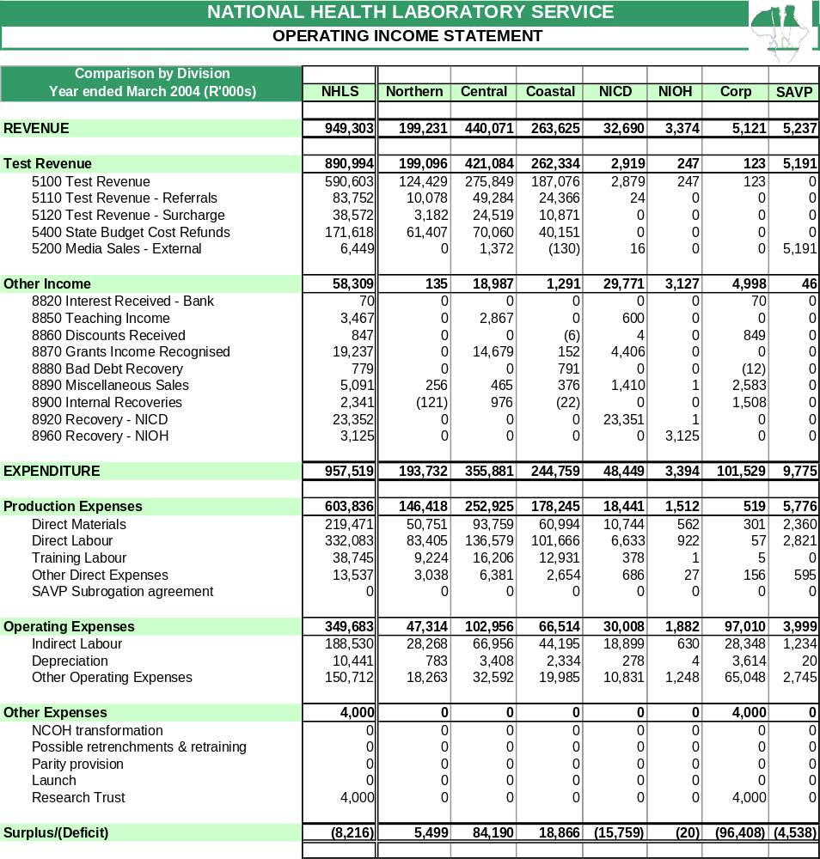

  - Budgeted Income Statement for the year ended March 2005

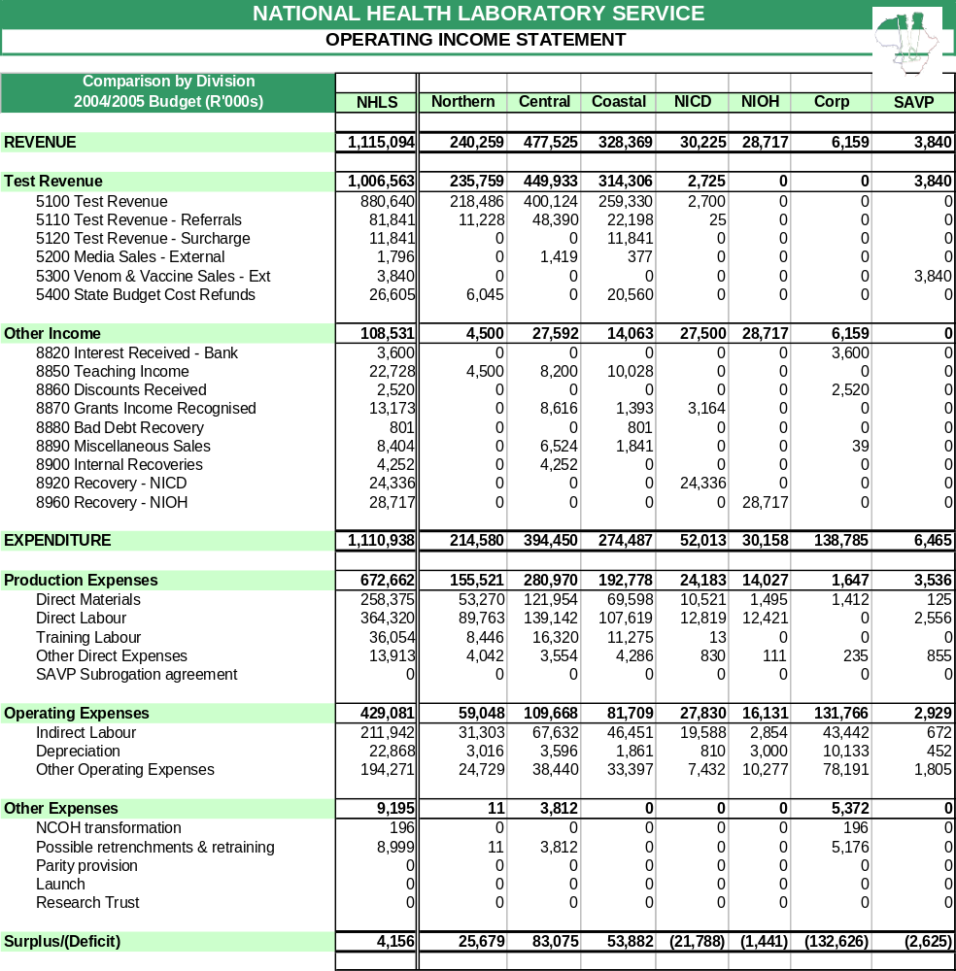

  - Medium-term expenditure framework
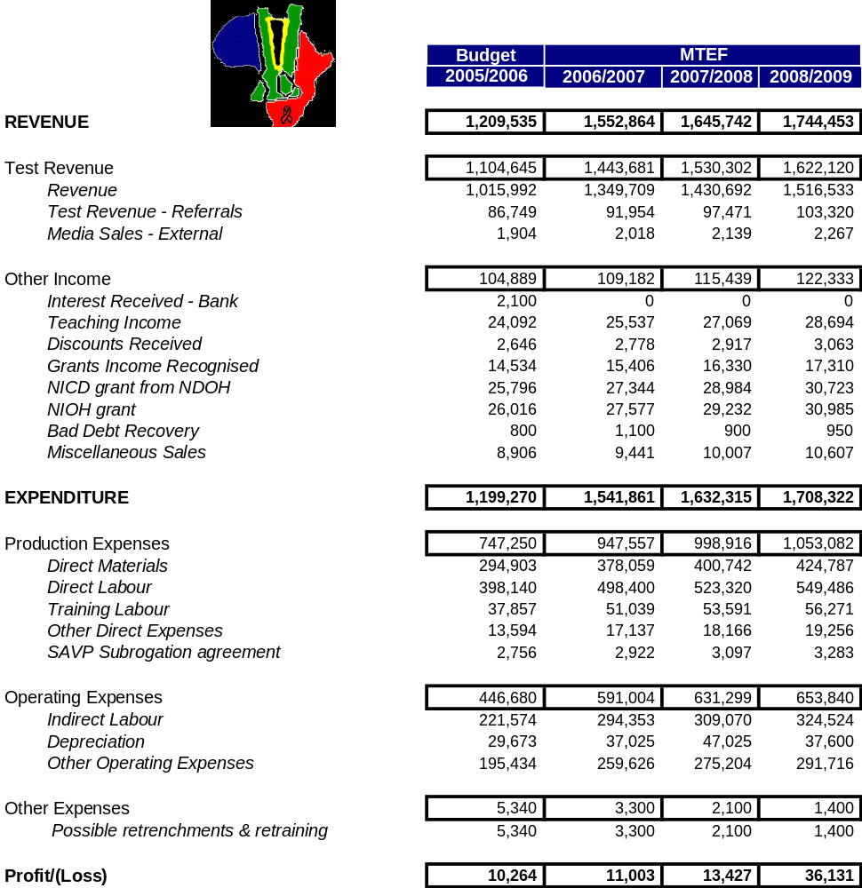

Annexure B – Executive Summary [Finance]

  - INTRODUCTION
The Finance and Administration division aims to:
- Provide an effective management and administrative support service to the core business divisions
- Provide transparent reporting and an internal control framework to provide assurance to the Accounting Authority of the NHLS
- Through continuous refinement of the financial strategy and structure, to maximise compliance with all relevant financial statutes and regulations, the most important of which is the Public Finance Management Act (PFMA) [Act 1 of 1999]
- Ensure excellent service to its customers, both internally and externally
- Provide a Corporate Governance framework that is formally concerned with the organisational arrangements that have been put in place to provide an appropriate set of checks and balances within which the stewards of the NHLS operate
- Provide the environment within which the NHLS can advance the quality of its service
- Accurately determine Revenue, Expenditure, Assets and Liabilities

The division has made considerable progress to date in complying with PFMA and Generally Accepted Accounting Practice (GAAP) requirements, which is evidenced by an unqualified audit report for the year 2003/4.

We value teamwork, sound planning, innovation, loyalty and enthusiasm and always strive to improve our performance. Respect for, and investment in, our staff is an important part of our values. We will act transparently with integrity, respect, fairness and objectivity and we honour the faith of all South Africans.

  - Key competencies
- Financial management
- Procurement and contractual management
- Remuneration management and personal tax expertise
- Grant administration management
- Market intelligence and analysis and interpretation of financial and business information
- Treasury management
- Risk and internal control expertise
- Supply chain management
- Credit control management
- Budgetary controls
- Asset and liability management
- Inventory management
- Financial and business systems development and control
- Cost and price determination
- Information systems skills
- Marketing and communication skills
- Infrastructure management
- Knowledge management
- Financial reporting
- Knowledge of statutory regulations
- Financial relationships

  - Programme 1: Grant Administration

    - Strategic Intent
To improve, develop and devolve a grant management system:
- For the identification and tracking of grant income;
- For reporting to grantors to ensure compliance with grant agreements;
- For reporting to grantees the ongoing status of grants;
- For recording activities and outputs resulting from grants [royalties, publications, papers, conferences, etc];
to ensure the effective, efficient, economical and transparent management of grant activities in accordance with the PFMA. The existence of a sound grant management system would be attractive to potential funders and hence assist in securing research funds, which in turn would facilitate enhancement of research output in line with the NHLS strategy.

    - Key Initiatives
- Develop a module in consultation with Oracle SA by March 2005 to track grant income, track grant status and history;
- Develop and implement policies and procedures by March 2005 for the communication, monitoring and deployment of the NHLS Grants Management System;
- Develop the NHLS Grants database to record investment, return, activities and results of all research projects from protocol to publication by March 2006.

  - Programme 2: Cash Flow Management

    - Strategic Intent
To improve cash flow management thereby make cash available in order for the NHLS to meet its strategic capital expenditure objectives effectively, efficiently, economically and with transparency.

    - Key Initiatives
The NHLS’ cash flow position will be improved by:
- Reducing total debtors days to 55 days by March 2006 by levering of interest for late payments or offering of settlement discounts to encourage early settlement;
- Unless determined otherwise in a contract or other agreement, all payments due to creditors must be settled within 30 days from receipt of an invoice;
- Implement an effective EDI system for private accounts thereby reducing potential bad debts by October 2004;
- Track and analyse the recording of source information on the Laboratory Information Management System [LIMS] to ensure accurate and complete billing data within a specified period.

  - Programme 3: Assets

    - Strategic Intent
To put in place:
- Proper control systems for assets;
- Preventative mechanisms to eliminate theft, losses, wastage and misuse;
- Processes and procedures for the effective, efficient, economical and transparent use of the NHLS’ assets;
- a system to properly evaluate all major capital expenditure prior to a final decision on the project;
to ensure that the NHLS is adequately equipped with all assets necessary to extend the delivery of its core services throughout the country.
    - Key Initiatives
- Implement, train and communicate approved asset policies and procedures to all staff by March 2005 to ensure compliance of the NHLS Asset Policy;
- By March 2005, perform a nationwide physical verification of assets; to update barcodes on assets and the asset register to ensure the asset register reflects all assets owned by the NHLS ;
- Identify assets for write-off, sale or redeployment;
- Appoint and constitute a Capital Expenditure [CapEx] committee to approve the capital budget expenditure by October 2004;
- Perform a risk assessment of NHLS assets and ensure that assets are adequately insured by November 2004.

  - Programme 4: Risk Management

    - Strategic Intent
A risk management strategy must be implemented to identify emerging risks, to determine the skills required of managers, to improve controls and to manage these risks to safeguard the financial resources of the NHLS. The latter is necessary to ensure asset availability for the effective accomplishment of the global NHLS strategy.
    - Key Initiatives
- Communication to all staff is essential to ensure that the risk management strategy is incorporated into the language and culture of the NHLS;
- Perform a risk assessment by understanding the business objectives and identifying and communicating the associated risks by September 2004 and reviewing on an annual basis;
- Design a plan to respond to the risks identified and communicate this plan to the business by April 2005;
- Develop and implement a monitoring system to record and monitor risks by April 2005;
- Design and implement a fraud prevention plan by December 2004.

  - Programme 5: Business Performance Management

    - Strategic Intent
To design and implement a business performance management solution for the recording, detection, measurement, reporting and analysis of business drivers to effectively, efficiently and economically execute the NHLS’ strategy.

    - Key Initiatives
- Conduct interviews with business role-players in order to identify the NHLS’ needs by September 2004;
- Investigate proofs of concept to ensure the best technology fit for the NHLS by December 2004;
- Identify an appropriate solution(s) to deliver the NHLS strategy by January 2005;
- Implement and rollout to business role-players by March 2005.

  - Programme 6: Costing & Pricing Strategy

    - Strategic Intent
To ensure that the NHLS’ tariffs fairly reflect the true cost of delivering a service to customers and to become the price-setters in the pathology market. The purpose of this is to safeguard the NHLS against the financial risk of dependency on cross-subsidisation of tests and to eliminate undue external influence on tariff setting.

    - Key Initiatives
- Appoint a cost accountant by October 2004 to systematically determine the true costs of all services rendered by the NHLS;
- Identify and develop a costing methodology to best calculate and represent the services rendered by the NHLS by October 2004;
- Identify a Costing Committee representing all interests of the business by December 2004;
- Determine the actual cost of laboratory tests that represent 80% of the total annual revenue of the NHLS by January 2005;
- Deliver the NHLS tariffs for the period 2005/6 in accordance with the parameters prescribed by the Department of Health by January 2005.

  - Programme 7: Procurement

    - Strategic Intent
To identify equipment, services and consumables required to deliver the strategy of the NHLS and obtain these by a predetermined authorisation and approval hierarchy, through a transparent process at the best prices and quality, ensuring optimal stock levels in an effective, efficient and economical manner.

    - Key Initiatives
- By June 2005, all goods and services by the NHLS would have been evaluated under a tender process or a market review;
- Set approval limits and implement approval hierarchies into Oracle and communicate to business by November 2004 to ensure compliance within the delegation of authority guideline;
- Train procurement officers, requisitioners and management on how to obtain goods and services by February 2005 to ensure alignment with procurement policies;
- Continuous monitoring of procurement activities by using system reports, communication and physical inspections to establish performance and non-compliance of procurement policies.

Annexure C – Executive Summary [Information Technology]

  - Introduction

Information Technology is vital to the success of the National Health Laboratory Service (NHLS) and its subsidiaries. This technology plays an enabling role in the incorporation of the various entities in the formation of the NHLS.

The NHLS IT strategy is to standardise on two mission critical IT systems, the Oracle Enterprise Resource Planning (ERP) System and the Disa*Lab Laboratory Information Management System (LIMS). This standardisation will ensure faster and easier implementation of these key systems into the business units and laboratories of the NHLS.

In order to effectively manage policy and reduce the cost of IT to the NHLS, the IT department will mainly be centralised at the NHLS head office in Sandringham. There are five sections: IT Operations, Information Security Management, ERP Management, LIMS Management and Help Desk Management. The day to day management of IT in the coastal region will be the responsibility of the Corporate Services Manager who has a line function to the IT Executive Manager.

  - Key Initiatives

The IT Operations section will be responsible for providing the IT operational services to the organisation. These services will include:

- Planning, designing, deploying, administering and managing server operating systems and network services;
- Managing the centralised and remote facilities, including configuration, change management and storage capacity;
- Formulating, implementing and monitoring of operational policies and procedures;
- Project management;
- Implementing information security measures to protect the data integrity;
- Managing e-mail services, Internet/Intranet services and application hosting;
- Planning and implementing business continuity measures;
- Installing, maintaining and supporting IT Hardware, operating systems and back office applications;
- Maintaining and supporting IT operational facilities, i.e. computer rooms, computer cabinets, server farms;
- Providing first level desktop application and operating system support.

The Help Desk section will be responsible for providing the centralised Help Desk services to the organisation. This includes:

- Providing a help desk facility to the business and partners by logging, assigning and dispatching appropriate support personnel as necessary;
- Provide help desk statistical reporting;
- Monitoring and managing service level agreements for outsourced IT hardware and desktop software support;
- Provide first line technical telephonic support.

The Oracle ERP and LIMS sections will be responsible for providing support for the Oracle ERP and Disa*Lab Laboratory Information Management Systems respectively. These include:

- Providing technical and functional support and administering their respective applications and data dictionaries;
- Manage user requirements and user training;
- Project management;
- Software version control and release management;
- Provide system and database reporting particularly using appropriate report writers;
- IT application quality assurance and monitoring compliance to quality standards;
- Implementing information security measures to protect the data integrity;
- Database administration and management.

The Information Security Management will be responsible for ensuring the security of the IT systems. These include:

- Setting policy on information security measures to protect unauthorised data access to the systems of the NHLS;
- Audit the levels of security of the various systems within the NHLS and recommend corrective action to management.

  - Strategic Focus Areas

- The IT department’s main focus over the next few years will be the incorporation of KwaZulu Natal into the NHLS. This project will require a substantial capital investment as the majority of laboratories have no computer systems. Implementation of IT Infrastructure, the Disa*Lab LIMS, Oracle ERP and e-mail systems will be required in this province.

- Substantial effort needs to be placed on training and ongoing re-training of staff to improve efficiencies, especially on the Disa*Lab LIMS and Oracle ERP systems.

- In order to improve patient healthcare, interfaces will be investigated and developed between the NHLS Laboratory Information Management System and the various Hospital Information Systems in the provinces.

- The IT strategy will include investigation into other Oracle modules, in particular the Human Resources and Payroll systems. Electronic Data Interchange (EDI) of billing data will be extended to additional medical aids.

- Additionally, other projects will include extending the Wide Area Network, the continued replacement of 25% - 30% of hardware each year and the roll out of new versions of Oracle ERP and Disa*Lab LIMS.

Annexure D – Executive Summary [Human Resources]

  - Introduction

Effective and evolutionary human resources management forms an integral part of the strategic direction of the NHLS. Since its inception in October 2001, the NHLS embarked on a focused strategy to develop a people management framework that will attract and retain highly talented people and in which they will thrive and contribute to the organisation’s continued growth.
The strategic human resources plan strives to promote a work environment in which skills development and performance contribution is recognised, human values and relationships are respected and where innovative problem solving is encouraged.

  - Strategic initiatives

During 2004/05 the NHLS human resources department will drive the following key strategic initiatives in line with the broader NHLS strategic plan:

    - Change Management

It is anticipated that a number of change management initiatives will be implemented during 2004/05 to further enhance the integration and development of a new organisational culture. This aspect includes the finalisation of the NHLS Employment Equity and Workplace Skills Plans, the finalisation of the NHLS organogram, the implementation of a new job grading system (Hay Chart Profile) and career-pathing and performance measurement systems for the core occupations, the piloting of a new performance management system for executive and senior managers as well as other support staff and facilitating management development interventions. It is furthermore envisaged that a comprehensive internal survey be conducted in order to obtain feedback regarding progress with regard to the implementation and impact of the NHLS strategic plan as well as to measure performance of executive and business managers.

    - Restructuring

This involves the national restructuring of laboratories and redeployment of affected staff following an analysis of overall NHLS staffing requirements. Through an assessment of operational and service delivery requirements, the macro structure as approved by the NHLS Board in 2003/04, will be refined during 2004/05. This process will ensure the development of a more suitable and relevant structure for the NHLS. It is furthermore anticipated that the planning process regarding the integration of laboratories in Kwazulu Natal, which is due to take place in 2005/06, will commence during 2004/05.

The NHLS also plans to sign an agreement with collective labour to facilitate broad restructuring processes and to comply with the requirements of the National Framework Agreement of NEDLAC.

    - Attraction and Retention of Scarce Skills

It is anticipated that during 2004/05 a comprehensive investigation will be undertaken with regard to the attraction and retention of scarce skills positions in the core occupations. This will be done within the context of current and future skills demands by the broader South African public health environment.

The NHLS will also participate in an external remuneration survey during 2004/05 in order to benchmark its remuneration and employee benefit practices against other organisations (private and public) in South Africa.

    - Productivity

In 2004/05, the NHLS will continue to develop and implement strategies aimed at improving productivity. Specific attention will be placed on flexibility of working hours to support operational requirements, remuneration broad banding, increasing the retirement age, management of sick leave, assessment of workplace safety provisions and an actuarial assessment of the impact of HIV/ Aids on the current and future workforce of the NHLS.

    - Human Resources Policy Framework

The human resources department intends to finalise the new human resources policy and procedures framework of the NHLS by the end of the 2004/05 financial year. This includes internal policies on HIV/ Aids management, performance management, training and development, remuneration, job evaluation, code of ethics and organisational rights for unions.

Annexure E – Executive Summary [QA, Research & University Relations]

The objective of the portfolio is to provide an integrated approach to the practice of Pathology that results in a strong scientific and academic base that will serve as a foundation for the core functions of the National Health Laboratory Service compared against accepted international standards.

  - Quality Assurance
This department is a small unit that will be responsible for the policy, direction and monitoring of all matters relating to the quality assurance of the NHLS. This will not be limited to pathology investigations (inclusive of methodology, accuracy, reproducibility, turnaround times and standard operating procedures), but will extend to Support Service Departments who by definition must also bear responsibility for the NHLS to “stay in business”.

The foundation of the departmental activities will be the provision of a sound Information Technology infrastructure that will include a departmental server. The prime software loaded onto the server will be the “Q-Pulse” document management system. This will provide a paperless system of document management and version control with laboratories and support units accessing and modifying documentation as and when required on the central server via the intranet. All laboratories and support departments will be required to have the documentation resident on this server so that the information is accessible to all parties within the NHLS. This will result in standardised documentation that will be current and valid. The departments will be responsible for the maintenance of their documentation, with the Quality Assurance Department providing the facilitation thereof.

All laboratories will be expected to partake in a Quality Assurance programme, of either an internal or external origin. All NHLS laboratories will be expected to enlist in the NHLS QA programmes, which will be coordinated by the Quality Assurance Department. Current programmes are being run for Haematology, Chemistry and Microbiology, the latter by the NICD.

All Tertiary laboratories will be expected to participate in an international quality assurance programme.

  - Accreditation
The Quality Assurance Department will be responsible for the review of national and international accreditation systems and will provide guidance and advice to all laboratories in the NHLS so that national and international accreditation standards can be achieved. This will also apply to Support Service Departments. The implementation and Quality Assurance Procedures will be directed through the Regional Managers and Regional Quality Assurance Managers who will be responsible for overseeing adherence to policy in their subordinate laboratories.

The QA Department will be strengthened by the addition of 5 more staff (technical and clerical) with the specific responsibility to coordinate and assist with the accreditation of NHLS laboratories. Initially, this will be focussed on the Academic Centres and then extended to the peripheral laboratories.

  - Safety
The existing small Safety Department, headed by a National Safety Manager, will be expanded to include Deputy Safety Managers. Their key responsibility is the generation and maintenance of documentation for distribution to the NHLS. They will also be responsible for keeping abreast of national legislation and amending and distributing NHLS Policy accordingly. The department will be responsible for tracking applicable international trends and amending policy within the NHLS, even though this may not be a legislated requirement. The Safety Officer will be responsible for the delegation of safety responsibility as legislated.

A number of gaps in the adherence to safety legislation have been identified in many NHLS laboratories and steps will be taken to address this in the form of safety inspections and distribution of applicable documentation.

The activities of the Safety Department are centred on five main areas these being workplace safety, methodology, standard operating procedures (including specimen handling), safe use of reagents and their storage, waste disposal and injuries on duty.

  - University and Technikon Relations
With the creation of the NHLS and the incorporation of all Academic Departments of Pathology into one organisation, it has assumed responsibility for all pathology training at Undergraduate and Postgraduate level in South Africa. This includes the training of registrars to become specialist pathologists and the development of a strong cohort of medical scientists. Schools of Pathology need to be implemented in all Academic Centres to ensure that these needs are coordinated and met. In addition, Expert Committees have been established for all major specialties to ensure that there is professional excellence in Anatomical Pathology, Haematology, Chemical Pathology, Microbiology, Virology and Immunology. Training of technologists and technicians is also vital for an assured supply of competent and professional staff for the NHLS laboratories.

Relationships with the Universities and Technikons will be established through structured Umbrella and Bilateral Agreements with each institution. These agreements will be managed through the National Academic Pathology Committee, this being an NHLS Board Committee.

  - Research
A Research support unit will be established for providing Corporate Management and information on research activities in the NHLS. This will include the development and support of staff models for employees involved in research, a database of researchers and research activities, research grant administration, research incentive fund administration, travel grant administration and a register of all publications by employees of the NHLS. The unit will also provide corporate support for the NHLS MRC Trust. Collaboration and interaction will also be required between the NHLS and national policy making bodies such as the HSRC, Department of Science and Technology, Cohort, the MRC and the NRF.

An Intellectual Property Policy is also to be developed for the NHLS.

Annexure F – Executive Summary [Central Region]

  - Introduction

The Central Region of the NHLS serves the Northern Cape, Free State Provinces and the southern part of Gauteng and the North West Province. The area covered is over 620 000 sq km (51% of the country) with 15,5 million people (36% of population). Services are provided from two tertiary facilities associated with medical faculties in Johannesburg and Bloemfontein, and a network of 58 laboratories. Revenue for the region during 2004-5 is estimated to be R450m, with net income of R80m.

  - Focus Areas
- Provision of pathology services will remain the backbone of the region with emphasis on quality client services to the public sector. The already wide range of services will be further expanded, but emphasis will be on the provision of quality laboratory services in support of national tuberculosis and ARV rollout programmes. To attain these improvements further infrastructural development, inside and outside of laboratories, particularly in peripheral areas and IT is required.
- Teaching, training and research that was marginalised during the formative stages of the NHLS will be improved to ensure that teaching and research are maintained as the unique selling features of the NHLS.
- An important strategic imperative will be the expansion and retention of the knowledge base of the NHLS. Retention of highly skilled and dedicated staff has become a problem. The upgrading of technical quality in general, and the accreditation of laboratories specifically is dependent on this. Mechanisms to retain and expand our knowledge base must be refined within the environment of learning, but also researching organisation. This is a strategic focus area of the Human Resources Department.
- Specific threats to revenue generation within the Region include:-
  - Inadequate peripheral services (especially for tuberculosis) – this will be addressed through improvement in the quality and accessibility of laboratory services throughout the region.
  - The introduction into public hospitals of modern Point-of-Care equipment operated by professional nurses – this has been partially addressed through tariff restructuring so as to lessen the dependency of the NHLS on tests that are capable of being applied in a Point-of-Care setting. The NHLS will engage with hospital administrators to offer assistance with cost and quality control assessments. It is envisaged that if managed with sensitivity, that control of such testing is likely to revert back to the NHLS in most instances.
  - PPP contracts between provinces and private health providers – the NHLS will engage with provincial departments of health to contribute to these partnerships.
- Service laboratories (high throughput discipline integrated optimally automated facilities) are planned at Pelonomi, Universitas, Tshepong and Chris Hani Baragwanath this year. Due to the high initial costs the introduction of further service laboratories will be staged over at least 3 financial years. These will greatly enhance productivity but require careful management as productivity is gained through redundancies. A staged introduction will allow for natural attrition to prevent large-scale retrenchments.
- Due to the under-capitilisation of the NHLS during the first few years, the fabric and physical maintenance of many laboratories was neglected. Renovations of affected laboratories will be undertaken in order to improve working conditions and to enhance the image of the NHLS. This includes the Braamfontein campus, where a facility investigation of these valuable properties will be undertaken. The latter is necessary as the complex is now seriously under-utilised and alternate uses will be explored.
- Service level agreements will be concluded with all provinces this year, and all flat rate arrangements phased out. This creates further management opportunity due to better management information and single platform referral systems.
- The Central Region is well placed to expand, improve and rationalise services during the 2004-5 financial year. Although access to services is less of a problem than in the other regions, there is a dire need to extend services to a greater population, especially in the North West Province. Adequate budgetary provision will be made for a phased recapitalisation programme, modernising laboratory services and facilitating better teaching and research.

Annexure G – Executive Summary [Coastal Region]

  - INTRODUCTION

The Coastal region of the National Health Laboratory Service is an integral part of the organisation that strives to achieve the three basic objectives i.e. provision of quality and cost-effective health laboratory services, provision of training in pathology education and to support health research, as stated in the NHLS act of 2000. In order for the NHLS to make meaningful impact on the provision of health services to all South Africans, it has to ensure that laboratory services are provided in an equitable manner by improving accessibility, especially to those areas that currently have no access.

  - STRATEGIC INTENT

- Promotion of good customer relations through a client-driven laboratory service
- Building trust and creating confidence
- Expansion of the skills-base through training
in order to secure sustainability for the future.

  - KEY INITIATIVES

Service delivery will be improved through attainment of the following strategic goals:

- Development of a sound and realistic organisational structure that will ensure optimal utilisation and retention of available human capital.

- Improvement of accessibility, quality and cost-effectiveness of laboratory services to communities that were previously underserved.

- Extension of SANAS accreditation, active participation in national and international quality assurance programmes and commitment to the principles of good laboratory practice.

- Establishment of client-driven laboratory service through co-operation and partnership with NHLS customers.

- Establishing academic training and research in the Eastern Cape, and strengthening and expanding these activities in the Western Cape.

The region intends to improve its services in the next three years through the following strategic initiatives:

- Restructuring of laboratory service

  - The region will ensure efficiency in service provision that will translate into a cost benefit for both the NHLS and its clients. This efficiency will be achieved through the establishment of core-service laboratories, especially within tertiary centres. This strategy rationalises space, staff and equipment requirements whilst improving automation and turn-around-times. A further benefit of the revised laboratory structure is the simultaneous improvement of the IT infrastructure.

  - The Department of Public Works in the Western Cape has also taken a decision to commercialise the precinct where the Greenpoint laboratory is situated. This will necessitate the relocation of the laboratory to a site where the NHLS has security of tenancy. This will provide an opportunity for restructuring of the laboratory with the aim of creating a centre of excellence for clinical trial work.

- Transport

The NHLS plays a pivotal role in assuring the success of the primary health care programmes (such as TB, cervical cancer screening, sexually transmitted diseases and HIV/AIDS), which are priority programmes for the Department of Health. Constraints to service delivery in this regard are the poor road infrastructure and transport systems in the Eastern Cape. The region aims to overcome these limitations by seeking alternative transportation and logistical solutions.

- Development of training and research programme in Umtata

The University of Transkei Medical School and Nelson Mandela Tertiary Laboratory are limited to undergraduate training programmes. A comprehensive plan, to be implemented in phases, will be developed to ensure that this institution is able to provide equal opportunity of academic development to the Eastern Cape community.

- Service Level Agreement

Service level agreements with both provinces have already been signed. The next three years will focus on strategies to educate Department of Health officials to facilitate better understanding and more meaningful analysis of electronically delivered NHLS statements of accounts as well as to develop interfaces between the hospitals and laboratories to eliminate the potential for capturing of incorrect patient demographic information and hence minimise payment rejections, especially by medical aids. Good understanding of NHLS statement of accounts and invoices should facilitate timeous payment by health institutions, which in turn will improve the cash flow of the NHLS. This will also focus on improving electronic access to results by clinicians and nurses as part of strategy to improve turnaround times. Partnership and collaboration between NHLS and the department will be enhanced through these service level agreements.

- Change Management

The region will participate in the corporate change management strategy to sensitise its employees to the importance of customer care and the need to adapt to the sound business principles necessary to ensure effectiveness, efficiency and sustainability of the NHLS. Management of transformation within the organisation regarding employment equity is an essential investment for the NHLS.

Annexure H – Executive Summary [Northern Region]

  - Background and Introduction

The Northern region is one of the three National Health Laboratory Service regions in the country, established to provide pathology services to Limpopo, Mpumalanga, northern Gauteng and the northern part of the North West.

  - Strategic focus for the period 2004 – 2007

    - Strategic Intent

The Northern region is committed to provide quality pathology services, in the most efficient, effective and economical manner, in collaboration with the DOH & Welfare, to all communities in Limpopo, Mpumalanga, Northern Gauteng and North West. These services are underscored by continuous improvement and supported by leadership and academic expertise utilising modern technology and best practices.

    - Key Initiatives
- Optimising usage of NHLS by existing and potential clients

NHLS services are not optimally utilised by existing clients, and as a result activities, which include continuous communication with the provincial departments of Health and Welfare amongst others, are to be put in place to ensure optimisation of service provision to both existing and new clients.

- Provision of quality pathology services

The Northern region, in line with the organisation’s vision, is committed to provide quality service to all its clients. This is a continuous process envisaged to promote client satisfaction as well as quality care to patients. The process includes extension of SANAS accredited facilities within the region, active participation in national and international quality assurance programmes and a commitment by all laboratories to adhere to the principles of good laboratory practice.

- Provide effective, efficient and economical pathology services

The region, in line with the Public Finance Management Act, is committed to promote accountability for the efficient use of scarce resources through sound management of both operations and finances.

- Extend services delivery to rural communities within the Region

The Northern region consists of urban, semi-urban and remote rural areas. It is thus imperative to extend services to all communities.

- Upgrading of laboratory facilities

Disparities still prevail regarding laboratory facilities. The region will upgrade these facilities to acceptable standards by 2006.

- Improve corporate image

Focus will be directed towards attaining and maintaining professionalism at all levels within the region. Activities will include the establishment of dress codes and training of staff on proper telephone etiquette by 2005. These efforts are envisaged to promote user-friendly services.

- Effective communication

Efforts will continue to be made towards promoting effective communication with both internal and external clients. These plans include the appointment of regional Public Relations Officers by 2006 to assist in fast tracking effective communication with our clients.

Annexure I – KwaZulu-Natal Laboratory Services

The incorporation of the KwaZulu-Natal laboratory services into the NHLS will be accomplished within the period of this strategic plan. The details and timelines of this process are under discussion between the parties. The interim arrangement will continue under an agency agreement.

Annexure J – Executive Summary [National Institute of Communicable Diseases]

  - STRATEGIC INTENT
- The NICD will be a national and international centre of excellence for communicable diseases of regional importance and function as a resource of knowledge and expertise to the South African government, the SADC countries and the African continent, in order to advise and assist in the planning of policies and programmes and to support appropriate interventions and responses to communicable diseases problems and outbreaks.

- To achieve this goal the NICD will aim to establish itself as a world-class public health institution and a major global player in the field of international health.

  - STRATEGIC FUNCTIONS OF NICD
The essential function of the NICD is to be a resource to the NHLS, to the National Department of Health, the Provincial Departments of Health, local authorities and the health professions in South Africa as well as the global health community, for intelligence on communicable diseases in the region. In addition it is to be a resource for reference investigations and capacity building in communicable diseases of public health importance.

Accordingly its functions can be divided into 8 categories: -

- Surveillance – passive and active, at population and at organism levels;
- Communications – publication of materials, consultancy and regular advisories;
- Outbreak response and management together with the affected regional or local authority;
- International responsibilities by representing the region in global health for a;
- Planning responsibilities through expert representation on advisory bodies, including assistance in policy designs for interventions, biological disaster management, both natural and intentional [bio defence];
- Academic affiliations relating to teaching/training;
- Appropriate research focused on communicable diseases problems of public health concern;
- Quality assurance and reference including the establishment of local type cultures, standards and management of QA for NHLS and outside laboratories;

  - Key Initiatives

- Once the building of the new laboratory complex at Sandringham has been completed, the viral gastroenteritis unit, together with staff, will be relocated in part from MEDUNSA to fill a vital gap in the existing repertoire of services offered by the NICD.

- The DOH will be supported in their existing primary health care initiatives through the establishment of a vertical TB programme and a national TB reference laboratory to reduce the burden of disease.

- The epidemiology division will be strengthened particularly in the areas of bio statistics, data mining, web-based data publication and in networking with field epidemiologists. A bio statistician has been appointed, to commence in January 2005, who will be responsible for data analysis and decision support to communicable disease management.

- A specialist bio informatics node will be established for NICD to facilitate meaningful analysis of data generated from laboratories using computational tools to assist with planning of interventions, such as immunisation strategies, as well as to identify key areas requiring further research.

- Multi-university affiliations will be established to fulfil the national academic responsibilities of the NICD. This will be accomplished through the Umbrella Agreement with universities as well as through direct interaction with individual tertiary institutions.

- Upgrading of training facilities for national and international visiting students and scientists including provision of adequate accommodation to enable the NICD to fulfil its mandate to provide training and engage in collaborative research in laboratory and epidemiological sciences related to communicable diseases.

Annexure K – Executive Summary [National Institute of Occupational Health]

  - STRATEGIC INTENT

The NIOH will be a nationally and internationally recognised centre of excellence for occupational health, functioning as a national and regional resource of knowledge and expertise to the South African government, Industry and Labour; the Southern African Development Community (SADC) countries; and the African continent; providing advice and assistance, conducting research and developing capacity through teaching and training for the purpose of promoting healthy conditions in the workplace and improving occupational health.

  - STRATEGIC FUNCTIONS OF NIOH

The essential function of the NIOH is to be a resource within the NHLS, in collaboration with the National Department of Health, to the various stakeholders involved in occupational health including the State in its broader context of government departments and academic institutions, Labour and Industry within South Africa as well as in the SADC region. The strategic functions fall into 8 broad categories:

- Statutory autopsy service – is provided under the Occupational Diseases in Mines and Works Act to diagnose compensable occupational cardio-respiratory disease in deceased miners and data are analysed and reported annually.

- Information services - the NIOH houses South Africa’s national reference library in occupational health, serves as the national ILO-CIS Centre (International Labour Organisation International Occupational Health and Safety Information Centre) and the SADC Clearing House and provides a national resource center with regular disease surveillance reporting and consultancy.

- Development of professionals and training - a major role of the NIOH is multidisciplinary teaching and training in occupational health.

- Reference and specialised laboratories – function for analytical chemistry, toxicology, electron microscopy, immunology, microbiology and occupational hygiene, providing a wide range of analytic, measurement and national quality assurance capacity.

- Health hazard evaluations – focused on priority exposures through application of occupational hygiene expertise to assess risks.

- Surveillance and Occupational Health indicators – ongoing sentinel occupational risk and disease surveillance and development of reliable occupational health indicators.

- Research – focused on priority occupational health problems, about 30 concurrent research projects contribute to the development of effective occupational health services and prevention of occupational disease.

- Advisory services - range from expert representation on national and international advisory and technical committees to consultations to individual workers and practitioners or professional groupings to promote knowledge and develop occupational health services.

  - KEY INITIATIVES

- Establish a new national occupational disease surveillance system by 2005 and develop and refine occupational health indicators for South Africa to publish biennial reports in 2005 and 2007.

- Establish, develop and/or expand the postgraduate FFOM, MPH, DOH and research programmes to 75 students; expand the variety and number of short courses / seminars e.g. occupational toxicology; expand and develop expertise and publication output through research and in-service training programmes for and with NIOH staff and professionals sourced through development of academic and funding affiliations with South African and international institutions.

- Develop the Ergonomics unit and the Bioaerosols unit; ensure that the X-ray diffraction (XRD) laboratory will function as a regional reference laboratory by end 2005; establish the NIOH as the national reference centre for silica dust analysis by 2007.

- Involvement in special programmes will include the Global Elimination of Silicosis Programme in the SADC region; the Sida (Swedish International Development and Co-operation Agency)-sponsored Work and Health Programme in Southern Africa, the WHO/ILO Joint Effort on Occupational Health and Safety in Africa.

- Expand and improve the library service emphasising the book and journal holdings on “modern” occupational health issues; maintain a quality national ILO-CIS centre; develop the SADC Clearing House and expand the use of the Resource Centre by trade unions and worker groups with the development of appropriate promotional materials.

  - CONCLUSION

The NIOH will be an internationally recognised, national and regional reference centre, which, through networking with complementary national resources, provides leadership in occupational health data surveillance, research, national standards and capacity development.

- Annexure L – High-level Organogram



CEO
John Robertson
Operations
Corporate
Central Region
Gerrit Coetzee
Coastal Region
Sipho Mahlati
Northern Region
Joyce Mogale
Finance & Administration
Suliman Minty
Human Resources
Elsjé Greyling
Information Technology
Stelios Michas
Quality Assurance
Martin Hale
Communication
NICD
Barry Schoub
NIOH
Mary Ross
Surveillance

