Programme 4: Financial Management and Systems

A. % Share of the total vote
Years | 2004/05 | 2005/06 | 2006/07 | 2007/08
Billion
MTEF Allocations | 13801916 | 13990708 | 15069011 | 16812876
 | 13801916 | 13990708 | 15069011 | 16812876
Financial Management and Systems | 352455 | 354284 | 370723 | 389661
Share | 2.5536672 | 2.532280711 | 2.460168089 | 2.317634413
Progress |  | 0.518931495 | 4.640062774 | 5.108396296

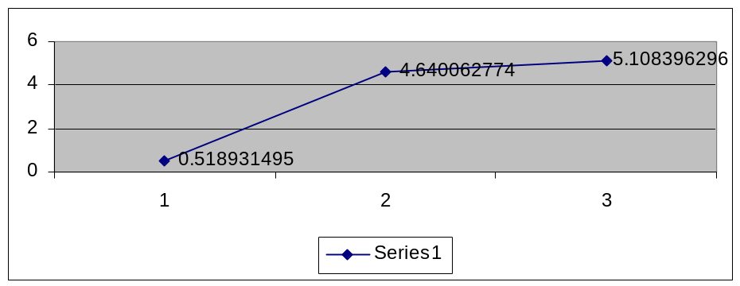
Nominal % progress (Vertical left) and years (medium term, (Horizontal right)

B. Subprogrammes:

1. Management

Years | 2004/04 | 2005/06 | 2006/07 | 2007/08
Financial Management and Systems | 352455 | 354284 | 370723 | 389661
Suprogrammes:
1. Management | 1233 | 1251 | 1359 | 1427
Share | 0.349832 | 0.353106547 | 0.366580978 | 0.366215762
Progress |  | 1.459854015 | 8.633093525 | 5.003679176

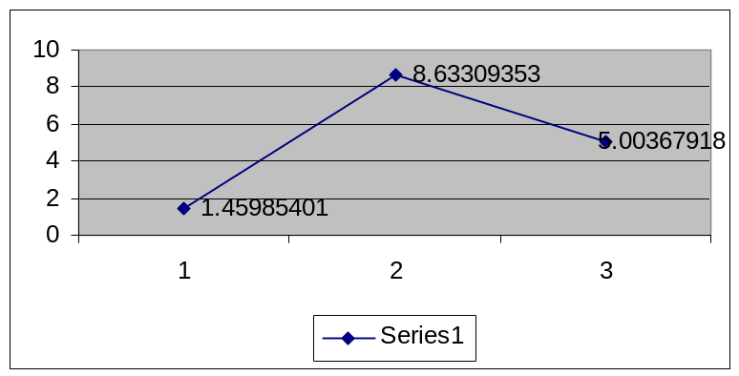
Nominal % progress (Vertical left) and years (medium term, (Horizontal right)

What are the challenges on management towards the financial year 2006/07? The expenditure allocation increases by 7% and declines by -4% over the medium term.

2. Supply Chain Management
Years | 2004/05 | 2005/06 | 2006/07 | 2007/08
Financial Management and Systems | 352455 | 354284 | 370723 | 389661
Suprogrammes:
2. Supply Chain Management | 38016 | 30531 | 32453 | 34449
Share | 10.786058 | 8.617662666 | 8.75397534 | 8.840761585
Progress |  | -19.68907828 | 6.295240903 | 6.150432934

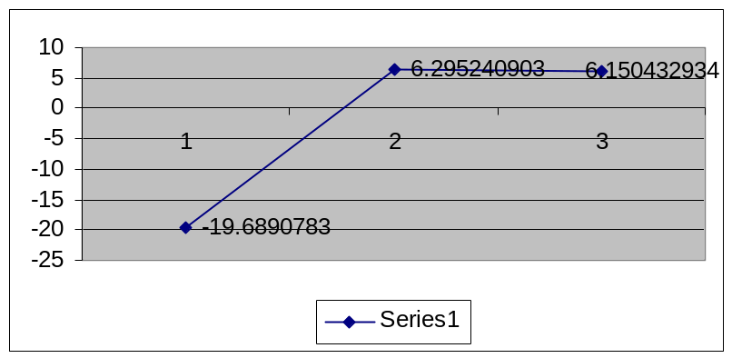
Nominal % progress (Vertical left) and years (medium term, (Horizontal right)

The allocation for the Supply Chain Management increases over the short term by approximately 26% and stabilise over the medium term. The subprogramme replaces the State Tender Board Procedures and most of the activities will be managed at individual department’s level.

In the recent meeting with the Standing Committee on Public Accounts (SCOPA), the Department indicated that there were only two deportments that were still using State Tender Board Procedures mainly because of skills capacity.

- What is the situation so far with the two departments and how are they being assisted?

- What is the quality of progress with the departments already implementing Supply Chain Management?

- What informs the drastic increase only over the short term (approximately 26%)?

- Could the Department provide specific details on the implementation of the suprogramme including building and developing internal capacity within government departments?

This will certainly impact on Parliament oversight expectations.

- Does the implementation of the subprogramme necessarily raise different financial management compliance issues?

- What would be those different compliance issues?

- Could the Department give examples in relation to Unauthorised expenditure, Irregular wasteful and Fruitless Expenditure?

3. PFMA implementation and Coordination.
Years | 2004/05 | 2005/06 | 2006/07 | 2007/08
Financial Management and Systems | 352455 | 354284 | 370723 | 389661
Suprogrammes:
3. PFMA Implementation and Co-ordination | 15781 | 14327 | 15228 | 16056
Share | 4.477451 | 4.043930858 | 4.107649107 | 4.120504746
Progress |  | -9.213611305 | 6.288825295 | 5.437352246

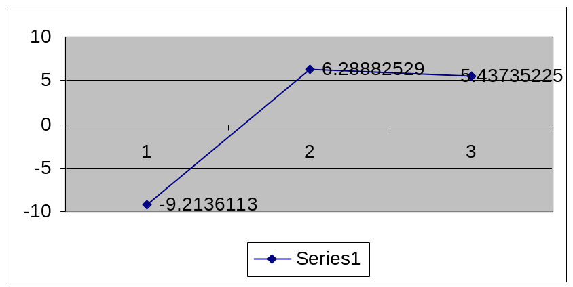
Nominal % progress (Vertical left) and years (medium term, (Horizontal right)

The Public Finance Management Act (Act 29 of 1999, PFMA) implementation within departments and public entities is almost five years so far. Challenges are also based on the best way to report on progress in the implementation of the legislation. The recent survey by the Department including normative values as developed by the Department has yielded positive results on basic compliance issues such the establishment of audit committees etc.

- What is the way forward?

What is the role of the subcommittee in the facilitation of the process?

The need for progress is critical as effective, efficient and economic use of public resources and service delivery in general is beginning to be linked with progress in the impact of the legislation.
- Is the drastic increase of 16% in the short term (2006/07), necessarily a reflection of this challenge?

- How will the resources be employed or utilised?

4. Financial Systems
Years | 2004/05 | 2005/06 | 2006/07 | 2007/08
Financial | 352455 | 354284 | 370723 | 389661
Suprogrammes:
4. Financial Systems: | 297425 | 235890 | 321683 | 337729
Share | 84.386659 | 66.58217701 | 86.77179457 | 86.67251791
Progress |  | -20.68924939 | 36.36991818 | 4.988140499

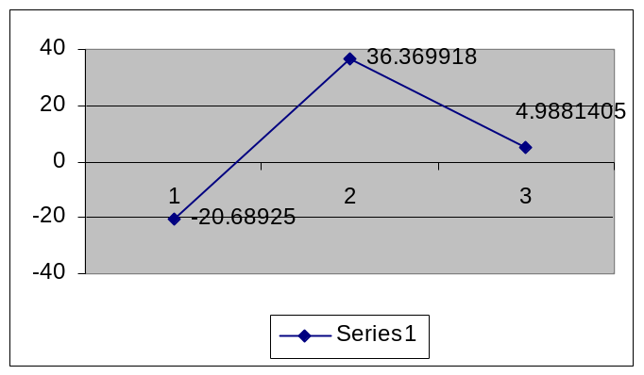
Nominal % progress (Vertical left) and years (medium term, (Horizontal right)

As compared to other subprogrammes, the financial system has the largest share (almost 67%) of the programme. The situation is sustained over the medium term, with the share at 87%. However, in the financial year 2005/06, the allocation declines to -21%. It however, increases drastically over the short term 2006/07 by almost 57%, with decline of -37% over the medium term (2007/08).

4.1 Items:

a. Operational Costs
Years | 2004/05 | 2005/06 | 2006/07 | 2007/08
4. Financial Systems: | 297425 | 235890 | 321683 | 337729
a. Operational Costs | 49363 | 50733 | 55672 | 59352
Share | 16.596789 | 21.50705837 | 17.30647874 | 17.57385359
Progress |  | 2.775358062 | 9.735280784 | 6.610145136

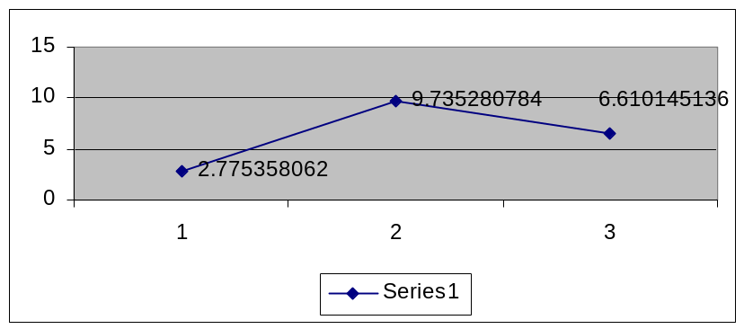
Nominal % progress (Vertical left) and years (medium term, (Horizontal right)

b. Basic Accounting Systems (BAS)
Years | 2004/05 | 2005/06 | 2006/07 | 2007/08
4. Financial Systems: | 297425 | 235890 | 321683 | 337729
(b) Basic Accounting Systems (BAS) | 90478 | 91017 | 97146 | 103691
Share | 30.420442 | 38.58450973 | 30.19929558 | 30.70242709
Progress |  | 0.595724928 | 6.733906853 | 6.737282029

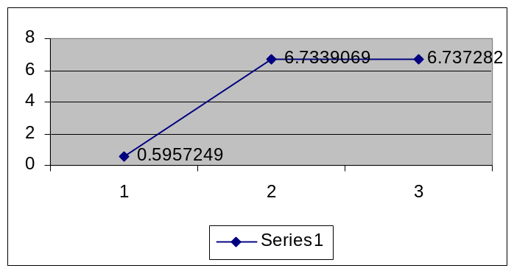
Nominal % progress (Vertical left) and years (medium term, (Horizontal right)

C. Persal
Years | 2004/05 | 2005/06 | 2006/07 | : 2007/08
Financial Management and Systems | 352455 | 354284 | 370723 | 389661
Suprogrammes:
c. Persal | 44527 | 48029 | 51391 | 54334
Share | 14.970833 | 20.36076137 | 15.97566548 | 16.08804693
Progress |  | 7.864890965 | 6.999937538 | 5.726683661

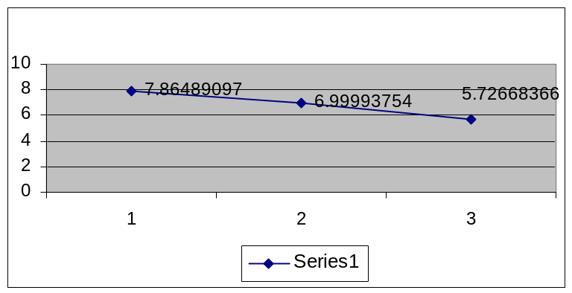
Nominal % progress (Vertical left) and years (medium term, (Horizontal right)

D. Logis
Years | 2004/05 | 2005/06 | 2006/07 | : 2007/08
4. Financial Systems: | 297425 | 235890 | 321683 | 337729
(d) Logis | 35257 | 39810 | 41642 | 43725
Share | 11.854081 | 16.87651024 | 12.94504217 | 12.94677093
Progress |  | 12.91374762 | 4.601858829 | 5.002161279

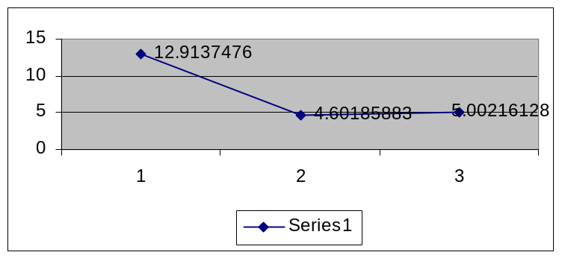
Nominal % progress (Vertical left) and years (medium term, (Horizontal right)

E. Vulindlela
Years | 2004/05 | 2005/06 | 2006/07 | 2007/08
4. Financial Systems: | 297425 | 235890 | 321683 | 337729
e. Vulindlela | 18903 | 21118 | 22507 | 23629
Share | 6.355552 | 8.95247785 | 6.996639549 | 6.996437972
Progress |  | 11.71771676 | 6.577327398 | 4.985115742

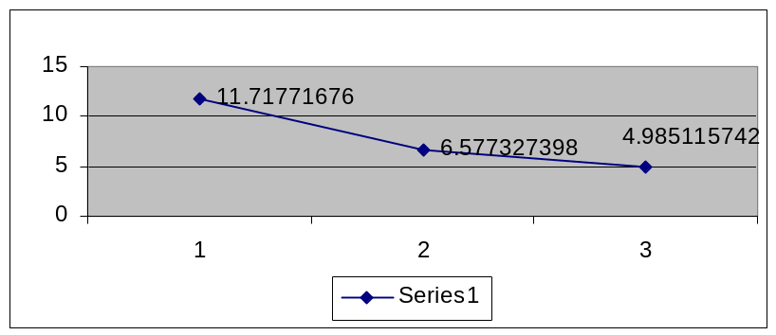
Nominal % progress (Vertical left) and years (medium term, (Horizontal right)

F. Integrated Financial Management Systems (IFMS)

Years | 2004/05 | 2005/06 | 2006/07 | 2007/08
Financial Management and Systems | 352455 | 354284 | 370723 | 389661
4. Financial Systems: | 297425 | 235890 | 321683 | 337729
f. IFMS | 42990 | 57468 | 53325 | 52998
Share | 14.4541 | 24.3622 | 16.57687848 | 15.69246348
Progress |  | 33.6776 | -7.209229484 | -0.613220816

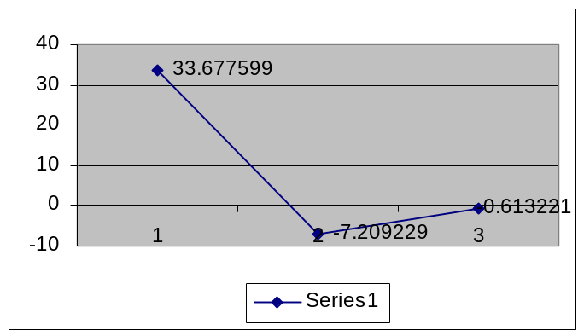
Nominal % progress (Vertical left) and years (medium term, (Horizontal right)

The item takes the largest share (24%) for the financial year 2005/06. The larger share continues over the medium term, although at a lower level.
The overall trend of the allocation reflects drastic decline for the short term (2006/07/ and 2007/08), with a slight increase in 2007/08.

- What is the progress with analysis to determine the suitability of the traditional and existing financial systems, i.e. The Financial Management Systems (FMS), The Human Resource Management System (Persal), the Logistic Management System (Logis), and the Basic Accounting System (BAS)? What is the target over the medium term for the implementation of the New Integrated financial management solutions (IFMS)?

- What form of capacity is being developed within the Department and other departments especially in terms of user ’support and training’?

The 2005-2005 Strategic Plan indicates (p55) that a Master System Plan (MSP) to implement the IFMS is to be submitted to Cabinet in the first semester of 2005. The MSP provides proposals for the replacement of Government’s current financial systems, together with the proposed budget and implementation time frames.

- What is the progress so far?

