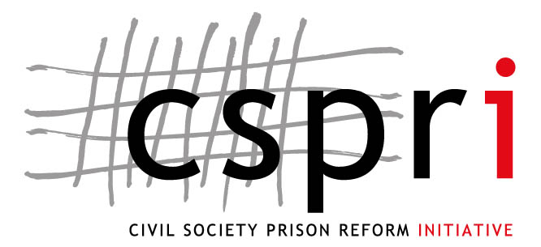

REPORT ON THE EVALUATION OF THE
INDEPENDENT PRISON VISITORS (IPV) SYSTEM

by

Jacqui Gallinetti

CSPRI Research Paper Series No 5, May 2004
This publication was funded by the Open Society Foundation (OSF) and the Ford Foundation
© NICRO and the Community Law Centre, May 2004.

Copyright in this article is vested with NICRO and the Community Law Centre, University of
Western Cape. No part of this article may be reproduced in whole or in part without the express
permission, in writing, of NICRO and the Community Law Centre.

It should be noted that the content and/or any opinions expressed in this article are that of the
author and not necessarily of NICRO, CLC, CSPRI, its Advisory Board or any funder or sponsor of the aforementioned.

Civil Society Prison Reform Initiative (CSPRI)
P O Box 10005
Caledon Square
7905
SOUTH AFRICA
Tel: + 27- 21- 462 0017
Fax: +27- 21- 462 2447
email: lukas@nicro.co.za
1 Harrington Street,
Cape Town, 8001
SOUTH AFRICA
http://www.nicro.org.za/cspri

The Civil Society Prison Reform Initiative is a joint project of NICRO (National Institute
for Crime Prevention and the Reintegration of Offenders) and the Community Law Centre (CLC)
of the University of Western Cape.

The aim of CSPRI is to improve the human rights of prisoners through research-based lobbying and advocacy and collaborative efforts with civil society structures. The key areas that CSPRI examines are developing and strengthening the capacity of civil society and civilian institutions related to corrections; promoting improved prison governance; promoting the greater use of non-custodial sentencing as a mechanism for reducing overcrowding in prisons; and reducing the rate of recidivism through improved reintegration programmes. CSPRI supports these objectives by undertaking independent critical research; raising awareness of decision makers and the public; disseminating information and capacity building.

LM Muntingh, NICRO J Sloth-Nielsen, CLC

Contents

Acknowledgements 2
Glossary 5
1. Introduction 6
2. Purpose of research 9
3. Methodology of research 11
3.1 Application of questionnaires 11
3.2 Profile of the participants to the study 12
Findings 14
4. The interpretation and execution of the establishment of
the IPV system by the Judicial Inspectorate of Prisons 14
4.1 The definition of community 16
5. The performance of the IPVs measured against the
procedures and policies as described in the IPV manual 17
5.1 Powers, functions and duties of IPVs 18
5.2 Prisoners’ rights to lodge complaints 19
5.3 Guidelines for dealing with prisoners’ complaints and requests 20
5.4 Urgent complaints 20
5.5 Performance management systems 22
5.6 Reporting systems 22
5.7 Payment of IPVs 23
6. The effectiveness and efficiency of the IPVs in resolving
complaints 25
6.1 Site visits 25
6.2 Recording prisoner complaints 27
6.3 Interaction between IPVs and prisoners who have
lodged complaints 35
6.4 The impact of IPVs at local prisons in resolving
complaints 38
6.5 The involvement of IPVs in prison matters unrelated to
their mandated tasks and the resolution of matters falling
outside their mandated tasks 44
7. Co-operation between IPVs, Institutional Committees
and the Heads of Prisons 45
7.1 Administrative arrangements 45
7.2 Security arrangements 46
7.3 G365 Register 48
7.4 Relationship between IPVs and prison staff 49
7.5 Co-operation between IPVs and other organisations and
government departments 55
8. The relationship between IPVs and the personnel and other
units in the Judicial Inspectorate of Prisons 55
8.1 Training 56
9. The efficiency and effectiveness of Visitors’ Committees 57
10. The selection and recruitment of IPVs 59
11. The out-puts of IPVs 62
12. Obstacles and impediments that IPVs encounter 63
13. International comparisons with similar institutions,
particularly the United Kingdom 64
  - Her Majesty’s Chief Inspector of Prisons for England and
Wales 64
14. Recommendations 66
14.1 Appointment of IPVs 66
14.2 Performance Management System 67
14.3 Feedback to prisoners 68
14.4 Training of IPVs 69
14.5 Interaction between IPVs and DCS officials 69
14.6 Additional IPVs or more time allocated 70
14.7 Interaction with prisoners and work outside mandated duties 70
14.8 Political oversight 71
Annexures: Questionnaires 72

Glossary

DCS – Department of Correctional Services
HOP – Head of Prison
IPV – Independent Prison Visitor
OIJ – Office of the Inspecting Judge
VC – Visitors’ Committees
NIS – National Integrity System

The author would like to express her appreciation to all of the respondents who willingly and generously gave up their time to participate in this study. They include officials from the OIJ, IPVs, Regional Co-ordinators, DCS officials, members of civil society and prisoners. Gian Parker assisted with the field research in relation to civil society organisations. Raygaanah Barday designed the graphs appearing in this report. Julia Sloth-Nielsen and Lukas Muntingh for their comments on the draft version of this report.
REPORT ON THE EVALUATION OF THE INDEPENDENT PRISON VISITORS (IPV) SYSTEM
by

Jacqui Gallinetti

1. Introduction

This report on the IPV system forms part of a larger study into civilian oversight of the correctional system. Saras Jagwanth has completed an evaluation of the Office of the Inspecting Judge, which should be read in conjunction with this report.

Oversight of public functions, duties, and institutions can take many forms. In South Africa, the executive branch of government has great power and this must be held in check in order to make it accountable to the citizens of the country. Our Constitution provides a clear mandate to Parliament, specifically the National Assembly, to oversee the executive. There are also other bodies that play an oversight and monitoring function, namely, the so-called Chapter Nine institutions such as the South African Human Rights Commission and the Gender Commission. In addition, civil society can play an important role in monitoring the actions of the executive and the legislature and in holding both organs of state accountable.

There have been some important attempts to ensure accountability and transparency through the introduction of oversight mechanisms in certain important government departments. The Department of Safety and Security, for example, by the establishment of community policing forums, which initially emphasised oversight of the police as well as liaison, communication and co-operation, and the Independent Complaints Directorate, which provides independent civilian oversight of police actions.

South Africa’s correctional services system has been plagued by various problems over the years, which were specifically highlighted by the recent Jali Commission. As stated by Pope, corruption (which is one of the focuses of the Jali Commission) undermines democratic development, inhibits the performance of public institutions and optimal use of resources. Accordingly, the promotion of national integrity is critical to any process of sustainable reform.

Transparency International (TI) has developed an overview of the concept and practice of National Integrity Systems. TI argues that corruption and recent processes of democratisation require transparency and accountability from those in public office, and proposes that a National Integrity System (NIS) is a comprehensive method or fighting corruption. The NIS has two goals – to fight corruption and create an efficient and effective government that operates in the public interest. The System is a set of objectives supported by supported by fundamental strategies delivered through key institutions (pillars). Of relevance to this study are certain NIS objectives, strategies, and institutions. The most relevant objectives are:

- Mechanisms supporting accountability and transparency in the democratic process;
- Building a creative partnership between government and civil society organisations, and
- Appropriate mechanisms that provide public officials with channels for reporting acts of alleged corruption and ensure independent monitoring of procedures and systems.

The most relevant strategy is the creation of a partnership between government and civil society and the most relevant pillars are:

- Civil society, public awareness, public participation, and
- ‘Watchdog’ agencies.

TI also notes that states that are undergoing a process of transition have particular problems that may require different approaches to a NIS. After ten years of democracy, South Africa is a developing country that is still setting democratic structures in place, therefore some of these concerns have resonance for us:

- states that are in transition are weak, and often inherit bureaucracies that not only lack many of the regulatory institutions that are necessary for a modern state and economy to function, but also many of the conditions necessary for mechanisms of accountability to function
- in states that are in transition, civil societies are weak in transition and might not function in such a way that they underpin constructive reforms (although this is not necessarily true for South Africa).

While it must be noted that in 2000 the Office of the Inspecting Judge requested that the task of investigating corruption within the DCS be removed from its mandate, the goal of the NIS in relation to creating an efficient and effective government working in the public interest continues to be of relevance to any study pertaining to the OIJ. In terms of the correctional system in South Africa, steps have been taken to attempt to ensure transparency, accountability and civilian oversight in and of prisons. Although a number of the objectives and pillars of the NIS, as stated above, are being put into place, it remains imperative that civil society play an integral role in ensuring that this occurs. Civil society must form part of the NIS.

In 1998, the Correctional Services Act (the Act) provided for the establishment of the Office of Judicial Inspectorate of Prisons, the object of which is to facilitate the inspection of prisons in order to report on issues such as the treatment of prisoners, prison conditions and any dishonest or corrupt practices in prisons. This office and its functions fall in line with the purposes of the correctional system in South Africa, as set out in the Act.

The powers, functions, and duties of the Inspecting Judge of Prisons include arranging for and inspecting prisons in order to report on the aforementioned objects of the office. In accordance with this, the Inspecting Judge can appoint Independent Prison Visitors to deal with the complaints of prisoners and allow for community involvement in the correctional system. This allows for an independent mechanism through which the treatment of prisoners can be monitored and promoted.

It is therefore important to ensure that the system of Independent Prison Visitors functions in accordance with its purpose and mandate as set out in the Act. This can only be achieved by evaluating the functions, interaction and effectiveness of the Independent Prison Visitors system. This research will be of value to a number of stakeholders. Civil society can be appraised of the effectiveness of the system in order for the situation in South Africa regarding human rights to be monitored and for donors to be informed of possible issues that need to be investigated further, monitored and for which resources should be allocated. As for the Department of Correctional Services and government in general, this research could indicate the extent to which the aims and goals of the Act have been achieved. Successful practices could be identified, and therefore replicated in other areas, and potential obstacles and problems could be highlighted and recommendations made regarding their resolution.

This research may be seen as a mechanism for co-operation between government and civil society in order to ensure that the constitutional principles that underpin the Act are adhered to and that the minimum standards that Correctional Services strives to achieve are examined and assessed.

2. Purpose of the research

This research was commissioned by the Civil Society Prison Reform Initiative, which is a collaboration between NICRO and the Community Law Centre, of the University of the Western Cape. The goals of this initiative are to promote civilian oversight of prisons, and public participation in the management of prisons with the aim of improving the human rights enjoyed by people being held in prisons in South Africa.

The research into the Independent Prison Visitors (IPV) system aims to evaluate, inter alia, the following:

- The interpretation and execution of the establishment of the IPV system by the Judicial Inspectorate of Prisons
- The relationship between IPVs and the personnel and other units in the Judicial Inspectorate of Prisons
- The performance of the IPVs measured against the procedures and policies as described in the IPV manual
- The out-puts of the IPVs
- The effectiveness and efficiency of the IPVs in resolving complaints
- The co-operation between IPVs, Institutional Committees and the Heads of Prisons
- The involvement of IPVs in prison matters that are unrelated to their mandated tasks
- The efficiency and effectiveness of Visitors’ Committees
- The selection and recruitment of IPVs
- Co-operation between IPVs and other organisations and government departments
- The impact of IPVs at local prisons in resolving complaints
- The resolution of matters falling outside of their mandated tasks
- The resolution of complaints referred to the Chief Inspector: Prisons
- Interaction between IPVs and prisoners who have lodged complaints
- Obstacles and impediments that IPVs encounter
- International comparisons with similar institutions, particularly with the United Kingdom

It should be noted that the purpose of the research is not to evaluate individual IPVs or the performance of IPVs at a particular prison. The study aims to evaluate the system of Independent Prison Visitors generally. Therefore pains were taken to ensure that the findings do not reflect the situation at a particular prison but rather provide a view of the generic situation of Independent Prison Visitors from selected geographical sites. In this respect, the study is limited as it does not extend to all prisons and did not involve all IPVs. However, it is hoped that the sample of participants to the study is wide enough to ensure that the results could be applied generally across South Africa.

3. Methodology of the research

Initial meetings with senior staff of the Judicial Inspectorate of Prisons were held in order to explain the research methodology and incorporate any requests from the Office.

A research proposal and draft questionnaires were then compiled and forwarded to the Research Ethics Committee of the Department of Correctional Services in order to obtain permission to conduct the research in selected prisons. This permission was granted in October 2003.
The research then involved the following:

- Desktop review of comparable institutions internationally
- Administration of the questionnaires, through personal interviews with the staff of the Judicial Inspectorate of Prisons, prison staff including Heads of Prisons, IPVs, prisoners and civil society organisations. A total of 97 persons were interviewed for this study.
- Obtaining information and statistical information from the electronic reporting systems of the Judicial Inspectorate of Prisons
- Analysis of the information obtained through the records, interviews and completed questionnaires, using, amongst others, the Act; the User Manual for IPVs and the IPV Manual as control documents

3.1 Data collection by means of the questionnaires:

This involved personal interviews with members of civil society, IPVs, OIJ staff, prisoners, and prison staff. In addition, certain respondents were interviewed telephonically and certain civil society members completed self-administered questionnaires.

The locality of the prisons where prison staff and prisoners were interviewed was determined in consultation with the Judicial Inspectorate of Prisons and officials from the Department of Correctional Services.

3.2 Profile of the participants to the study:

A total of 97 individuals participated in the study. In order to maintain confidentiality, any references to specific prisons that may reveal the identity of IPVs and prison staff have been removed and only the areas and generic prisons in which they operate are indicated.

- IPVs

A total of 20 IPVs, that were made up as follows, were interviewed:

- Western Cape – 2 IPVs including one from Pollsmoor Prison
- Gauteng – 17 IPVs from Johannesburg Prison, Pretoria Prison, Baviaanspoort Prison, Modderbee Prison and Krugersdorp Prison
- Free State – 1 IPV from Groenpunt Prison

The IPVs who were interviewed were selected from a range of prisons, including maximum, medium, juvenile and female prisons. Two Regional Co-ordinators were interviewed and one chairperson of a Visitors Committee.

Two former IPVs were also interviewed about their experiences and perceptions of the system

- Prison staff

A total of 32 prison staff members, made up as follows, were interviewed:

- Gauteng – 22 members from Pretoria Prison, Baviaanspoort Prison and Leeukop Prison
- KwaZulu-Natal – 10 members from the Pietermaritzburg and Durban-Westville Prisons

The prison staff are stationed at a range of prisons including maximum, medium, juvenile and female prisons. In addition, the members interviewed included a Head of Prison, Assistant Head of Prisons, Centre Co-ordinators, Section Heads and Unit Managers, Senior Correctional Officers, Section Supervisors and Correctional Officers. All members were informed of the purpose of the research and participated of their own volition.

- Prisoners

A total of 35 prisoners were interviewed. They were selected by requesting that the Office of the Inspecting Judge randomly select names of prisoners from certain prisons who had lodged complaints that were either pending or had been resolved. Furthermore, when visiting the prisons, if a particular prisoner was no longer at the prison, then the IPV at that prison suggested alternative prisoners. All prisoners were informed of the purpose of the research and participated of their own volition.

The prisoners were selected from the following prisons:

- Gauteng – 4 prisoners from Pretoria C Maximum Prison, 6 prisoners from Leeukop Maximum Prison, 8 prisoners from Pretoria Central Prison and 7 from Baviaanspoort Medium Prison
- Kwa-Zulu-Natal – 3 prisoners from Durban-Westville Female Prison, 6 prisoners from Durban-Westville Medium B Prison and 4 from Pietermaritzburg Medium B Prison.

All of the prisoners who were interviewed had been sentenced. It was originally intended that some awaiting-trial prisoners would be interviewed, however, most had been released or moved or sentenced at the time that the interviews were conducted. An attempt was made to interview one awaiting trial prisoner from Durban-Westville Medium A Prison, however, he wanted permission from his legal representative before he spoke with the researcher, therefore it was decided to terminate the interview.

- Civil society members

A total of 5 members of civil society were interviewed. One was interviewed personally and the remainder completed a self-administered questionnaire. The participants were made up as follows:

  - Western Cape – 2 participants from different NGOs
  - Gauteng – 1 participant from an NGO
  - Eastern Cape – 2 participants from the same NGO

All the participants were from organisations that have some knowledge of or connection to prisons or the Department of Correctional Services. Likewise a further 28 individuals from NGOs, CBOs or Chapter 9 institutions, that have knowledge of, or a connection to prisons of the Department of Correctional Services, were sent the self-administered questionnaire, but no responses were forthcoming.

- Office of the Inspecting Judge

Three officials from the Office of the Inspecting Judge were interviewed.

4. The interpretation and execution of the establishment of the IPV system by the Judicial Inspectorate of Prisons

The history of the establishment of the Judicial Inspectorate is grounded in civil society action relating to correctional services. It appears that in 1994 the Penal Reform Lobby group drafted a number of documents relating to correctional services policy reform. These included a recommendation for the establishment of a lay visitors scheme. Then followed the publication of a DCS White Paper and a civil society “alternative White Paper”, as well as a conference in 1995, which led to the establishment of the Transformation Forum on Correctional Services. Ultimately, this led to the Correctional Services Act, which introduced the IPV system.

As stated above, Section 92 of the Act makes provision for the appointment of Independent Prison Visitors. This provision has resulted in the OIJ adopting a vision regarding who they consider appropriate to be appointed to these posts, namely, public spirited persons of integrity who are interested in the promotion of the social responsibility of human development of prisoners. The IPV system, as it operates today, has evolved through continuous planning, implementation and revision.

In 1999, a pilot project for Independent Prison Visitors was introduced. This project involved the appointment of 15 IPVs at selected prisons in the Western Cape for a period of three months. The objectives of the project were to establish a uniform system and rules of procedure relating to the appointment of IPVs, contractual conditions for IPVs, the monitoring of IPVs, the payment of IPVs, reporting by IPVs and the functioning of VC’s. The results of this pilot project led to various recommendations being made regarding the above.

In 2000, further work procedures were developed to deal with prisoners’ complaints in order to provide guidelines to the OIJ itself, the administrative system of the OIJ, to establish a complaints committee and to provide a work procedure according to which complaints would be dealt with by administrative support staff.

These types of developments have been ongoing since the establishment of the IPV system. The IPV system is now electronically automated, a customised nomination form for IPVs has been developed, former IPVs have been appointed as case managers in the legal unit, special assistants have been appointed as IPVs, public meetings are arranged regarding calls for nominations for IPVs and eight Regional Co-ordinators have been appointed.

The Regional Co-ordinators’ work was initially performed by the Judicial Inspectors, however, there was no ongoing support for the IPVs as the Judicial Inspectors were performing two functions and could not provide the necessary support to IPVs. This problem was identified from a survey conducted with IPVs who indicated the need for support from the OIJ. As a result, former IPVs were appointed as Regional Co-ordinators on a full-time contractual basis. Their purpose is to provide logistical support, attend VC meetings as the representatives of the OIJ and capture all outstanding and unresolved complaints flowing from the VC meeting on the electronic system.

IPVs are appointed for 2 years on a contractual basis. The reasoning behind this is that the IOJ does not envisage an IPV appointment as being a career choice because of the independent nature of the position. The appointment is seen as a learnership programme whereby individuals are taught skills with which they can contribute to civil society. In addition, the OIJ does not want an IPV to become too entrenched in the system as this may compromise his or her independence.

The 2002/2003 Annual Report of the OIJ indicates that there 186 IPVs have been appointed countrywide, with 8 regional co-ordinators and 36 Visitors’ Committees. During 2002, IPVs paid 7 147 visits to prisons, interviewed 58 907 prisoners and recorded 190 167 complaints. An additional 4992 written complaints from prisoners were received directly by the OIJ.

4.1 The definition of community

Because of the independent nature of IPVs and their selection and recruitment from communities, the issue of what a community is was raised by a senior official of the OIJ. Accordingly, this study included a question relating to the definition of community that was posed to the IPVs and participants from civil society. A wide range of responses were received; some of the more insightful ones are listed below:

“Not politically motivated, religious community participation also important.”

“People who have their freedom, residential areas, family structures, business, school structures.”

“The immediate citizens of that specific area. All the community-spirited organisations.”

“It is a body forming social or political unity.”

“The smaller constituency where I live or work, or organisational involvement.”

“It is a group of people leaving together and upholding the same interests and needs.”

It appears that there is no consensus as to what constitutes a community and the OIJ would be advised to apply as broad a definition as possible and be inclusive of a whole variety of individuals and organisations when dealing with the concept of a community in its work.

5. The performance of the IPVs measured against the procedures and policies as described in the IPV manual

The Office of the Inspecting Judge has a performance evaluation system that is aimed at evaluating the performance of the individual IPVs. The study therefore concentrated on the performance of IPVs measured against the procedures and policies of the IPV manual in general. This inquiry therefore involved questioning IPVs and prison staff on aspects of the IPVs’ work in relation to the resolution of the different types of prisoner complaints.

5.1 Powers, functions and duties of IPVs

According to the IPV manual, the primary function of the IPVs is to deal with prisoners’ complaints. Their duties are set out in section 93(1) of the Act and these entail dealing with prisoners’ complaints by:

- Paying regular visits
- Conducting private interviews with prisoners
- Recording complaints and monitoring their progress
- Liaising with Correctional Service officials to attempt the resolution of complaints internally within the prison

Furthermore, the IPV manual sets out the underlying purpose of dealing with complaints is. This involves:

- Serving as a mechanism to promote the humane treatment of prisoners;
- Monitoring the manner in which the HOP deals with prisoners’ complaints in order to resolve them;
- Promoting a peaceful prison environment, and
- Reporting unresolved or urgent complaints to the Inspecting Judge.

The IPVs were asked directly what their powers, functions and duties are. The majority of the responses indicated a clear understanding of their mandate in terms of the Act and the manual. Most knew their duties as set out in Section 93 of the Act and specified these. However, a number merely stated that they knew what their duties were without elaborating and giving any detail as to what they entailed. A few responses concentrated on the substance of what their monitoring should entail in respect of site visits, i.e. living conditions, hygiene, and food.

Also, none of the IPVs showed an insight into the underlying purpose of dealing with complaints, though some identified the monitoring of prisoners’ living conditions and treatment as the rationale behind their tasks. Out of the 20 IPVs interviewed, only 2 mentioned this aspect of their work. However, a number did stress their monitoring function. No mention was made of the promotion of a peaceful prison environment. However, judging from their over-all responses to the study, the researcher noted that IPVs have a general understanding of the purpose of their work.

5.2 Prisoners’ rights to lodge complaints

The responses of the IPVs unanimously indicated a clear understanding of what prisoners’ rights are concerning the lodging of complaints. This included the understanding that prisoners have the right to lodge a complaint at any time and that these complaints must be investigated according to proper procedure.

This, however, needs to be contrasted with the responses of the prison staff to the question whether they are know what prisoners’ rights to lodge complaints are. Of the 32 DCS members interviewed, 15 stated that they knew what prisoners’ rights are, but failed to elaborate despite being asked for details. One DCS member indicated that he was unaware what prisoners’ rights are and 16 stated that they knew and provided details of their understanding of prisoners’ rights to lodge complaints. While some of these answers indicated a rudimentary knowledge of prisoners’ rights to complain, the following statements indicate a severe lack of insight and understanding on the part of DCS members:

“No minor complaints or requests.”

“To serve their sentence in the proper way.”

“The complaint must be finalised in 21 days.”

“They are informed of their rights on admission.”

“Yes, I know, but sometimes prisoners abuse them on several occasions because they don’t want to abide with the system.”

These comments, from a sizeable proportion of the sample, indicate an inherent and institutional failure on the part of some DCS members to appreciate the need to adhere to certain minimum standards concerning the treatment of prisoners. It is in this environment that the IPVs have to operate and perform their functions and duties and it is therefore not surprising to note some of the difficulties that IPVs encounter, which are discussed below.

5.3 Guidelines for dealing with prisoners’ complaints and requests

The responses from the IPVs indicated that they have a general understanding of the procedure for lodging complaints. This understanding of the procedure indicated the steps set out in the manual, namely, registering the complaint with a DCS official, use of the G365 Register, monitoring the resolution of the complaint, and intervening when the complaint is not resolved or the prisoner is not satisfied. There is some confusion as to the time-frame involved in the resolution of complaints. Some IPVs mentioned a period of 7 days, whilst others mentioned a period of 21 days.

  - Urgent complaints

Urgent complaints are those that need immediate attention and cannot wait the usual 14 days for resolution, for example hunger strikes or assaults. As far as urgent complaints are concerned, the manual states that not every urgent complaint should necessarily be referred to the Office of the Inspecting Judge. The first port of call should be the HOP with a view to resolving the issue at prison level. It appears that in making referrals to OIJ, the IPV has some discretion concerning sending the urgent complaint to the office or not. From the responses to the question regarding what the procedure is that should be undertaken in relation to urgent complaints, it appears that there is some lack of understanding about the stipulations in the manual. Seventeen out of 20 responses indicated that they immediately referred urgent complaints to the OIJ. These responses did not indicate any attempt to discuss the relevant matter with the DCS officials and in particular the HOP.

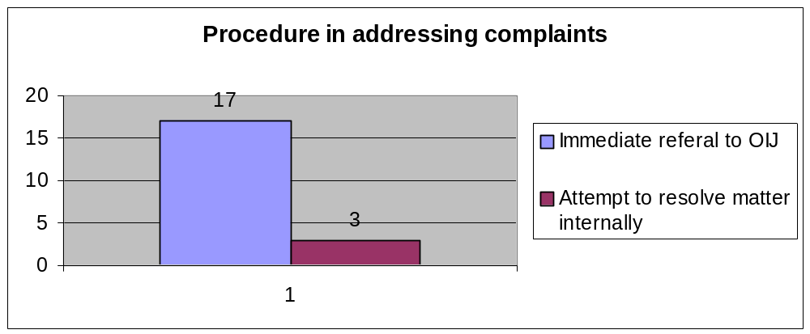

However, the remainder of the responses indicated that the procedure of first referring the matter to DCS officials was followed. Most of the IPVs expressed satisfaction with the procedures in relation to the resolution of urgent complaints. Nine out of 20 IPVs indicated satisfaction with procedures involving urgent complaints. The reasons given include a shortage of staff at their prison, inaction or overreaction on the part the OIJ, the length of time taken to resolve urgent matters and the geographical distance of the OIJ from prisons outside the Western Cape. One IPV explained it as follows:

“No, especially with regard to complaints of assault after they are referred to OIJ they are referred back to DCS who cover each other and manipulate inmates if inmate was assaulted by official member. With the result and factor of inmates withdraw and cancelling complaint.” [ in other words assault complaints against DCS members are referred back to DCS by the OIJ and result in inmates ultimately withdrawing the complaint]

Despite this dissatisfaction, none of the IPVs made any suggestions for changes to be made to the urgent procedure and they do not appear to have a problem with the procedure itself, but rather with the factors affecting the procedure, as set out above.

5.5 Performance management systems

Of the IPVs that responded to the questions pertaining to this issue, the majority were of the opinion that the system was fair. One IPV stated that it was very helpful and successful, however another, noting that she had heard of it (thereby indicating that she was not absolutely clear on what it entailed) was not sure how happy she was with the system. While some IPVs reported having received feedback from the performance management system, others notably stated that they had received no comments pertaining to the system and their performance. This seems to indicate an inconsistency of practice in communication with IPVs relating to their performance. However, a number of issues were raised during the course of the study that indicate a revision of the performance management system would be warranted. This will be discussed in more detail in the recommendation section below.

5.6 Reporting systems

All of the IPVs indicated that they knew how to operate the electronic reporting systems of the Office of the Inspecting Judge. In addition, they were of the opinion that the system was helpful and most found it easy to operate. Two IPVs noted that initially they found the system difficult as they were computer illiterate and had to spend much time getting to know the system. However, they then stated that they now experienced no difficulty in operating the system, since receiving training in its use.

While most reported having experienced no problems with the operation of the system, one IPV stated that he experienced problems with the use of DCS computers, for example, when the system was down he was unable to access the reporting system. He stated that this usually occurred in the evenings and on weekends.

Most had no suggestions for improvements, however a point that should be taken into consideration is the issuing of passwords to IPVs that allow them to access the DCS computers at the prison without having to use DCS officials for this purpose. At the prisons visited during the study, none of the IPVs had access to a computer that was exclusively for their use. Having noted the optimal use and expenditure of the Judicial Inspectorate’s budget, it would perhaps be expedient to factor in an amount for computers for use by IPVs as this might facilitate easier and more efficient reporting, although the cost implications for such a suggestion are significant and would necessarily entail budget adjustments and increases.

5.7 Payment of IPVs

IPVs receive R38.65 per hour and their allocated hours range between 14 – 67 hours per month depending on the size of the prison to which they are assigned. Most of the IPVs interviewed stated that they felt that the payment system for IPVs was fair. However, one IPV refused to comment on the issue, one indicated that it was not fair and another stated that while it worked initially, it was now “falling to pieces”.

The complaints that were noted were elaborated on. It appears that the main problem relates to the efficiency of payment and that in some respects the payment of IPVs is delayed.

Related to the issue of payment of IPVs is the amount of work hours allocated to IPVs in their contracts. Only a minority of the IPVs who were interviewed were of the opinion that the hours allocated were sufficient. Most felt that the hours for payment stipulated in their contracts were insufficient. All the respondents indicated that the hours allocated did not correspond to the amount of work that there was in their prisons. Some of the comments that were made include the following:

“In our prison we are 2x IPVs and there are 2666 inmates currently. Inmates fluctuate, complaints differ in nature and as such need more time as the allocated to deal with.”

“The prison we are working in is very overcrowded.”

“The problem is the perception that IPVs must now handle all complaints, whereas the official DCS complaints procedure is overlooked.”

“The amount of work, because sometimes we work as social workers and psychologists.”

“[…] Prison has approximately 12 000 to 13 000 prisoners with only 10 IPVs. The plea bargaining process at […] should be allocated more hours.”

Having reported this, it is noteworthy that one of the IPVs that indicated that the time allocation was sufficient works in a small prison with relatively few prisoners compared to other IPVs interviewed.

It is therefore perhaps opportune to review the hour allocation according to the prison assigned to the particular IPV. In conducting the interviews with IPVs it became apparent that many work extra hours for which they receive no remuneration. There does not appear to be any negativity about this on the part of the IPVs, however, it is this researcher’s impression that a balance must be struck between limiting the hours that an IPV should be spending in the prison so as to prevent unnecessary generation of work and the dealing with the actual amount of work that needs to be attended to.

Furthermore, it appears that the extra hours that the IPVs work and the nature of the work they perform is related to DCS officials misunderstanding their functions or unfairly using IPVs to attend to issues that they should actually deal with . This problem relates to management issues between the Office of the Inspecting Judge and those particular prisons. This indicates that there is a breakdown in communication between the IPVs stationed at those prisons and the Office of the Inspecting Judge. It is argued that the OIJ should be more aware of the difficulties facing particular IPVs at particular prisons. The reasons for the OIJ being unaware of the difficulties that IPVs face should be investigated further to determine whether the cause of this lies with the regional co-ordinator, the Visitor’s Committee or the OIJ itself.

6. The effectiveness and efficiency of the IPVs in resolving complaints

The main function of IPVs is to resolve complaints, but there are a number of factors and issues that impact on their ability to perform this mandate. These involve the procedures set by the OIJ, their manner of undertaking this function, their interaction with prisoners and their interaction with the OIJ. This section of the report will outline the functioning and efficiency of the IPVs according to their own assessment of their work and the impressions and experiences of prison staff and prisoners.

6.1 Site visits

According to the IPV manual, IPVs must undertake a full site visit to the prison at least twice a month during which time the IPV must visit all the cells where the prisoners are incarcerated. Judging from the participants’ responses to the questionnaires, it would appear that approximately half of the IPVs interviewed take this guideline literally and only conduct full site visits twice a month – usually at the beginning and end of a month. The remaining participants to the study indicated that they either conducted site visits at least twice a month, three times a month, and four times a month, while one of the participants responded as follows:

“Thrice a week when I don’t have many consultations and 2 when I have consultations.”

These differing practices seem to correspond with the prisoners’ experiences. While a good number of prisoners stated that the IPVs visit them either once or twice a month, the majority stated that they were visited once a month. A small amount indicated a bi-monthly visit and three prisoners stated that they only see the IPV when they request a meeting.

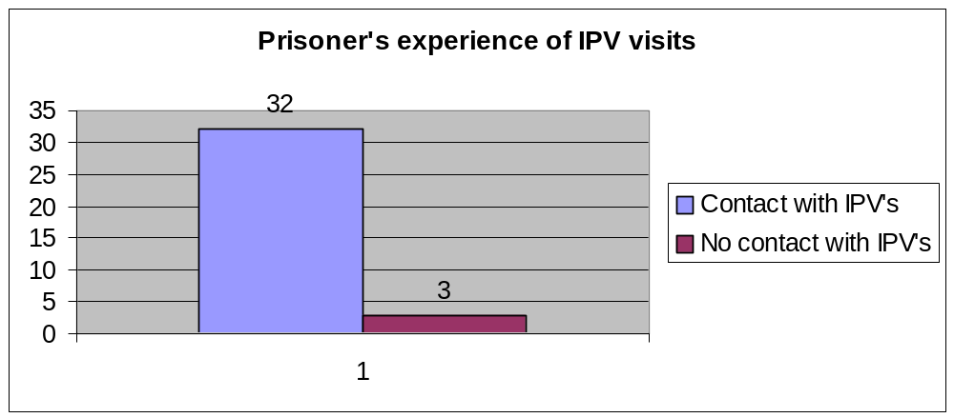

This seems to indicate that the general practice of IPVs is to undertake regular site visits. In those cases where the visits are irregular and infrequent, this should be identified by the performance management system of the OIJ and dealt with accordingly. If it is not, this aspect of the performance management system needs to be reviewed so that the OIJ can assess more effectively whether IPVs are complying with their duties.

Furthermore, the two IPVs in the Western Cape indicated that the purpose of their site visits was to check on the living conditions, the state of the kitchen and the prison hospital. Most IPVs who were spoken to indicated that they used the site visits to inform the prisoners who they were and how they could assist and to advise the prisoners that if they wanted to lodge a complaint they should see them.

Most of the IPVs indicated that the site visits entailed visiting each cell in their prison and that a member of the DCS accompanied them. They make mention of the fact that the prison official is within view during the visit, but out of earshot. Some make mention of the fact that they carry out the visits unaccompanied. Two IPVs stated that during their site visits they spoke to each and every prisoner to determine whether any had complaints. This, however, does not appear to be standard practice and could depend on the size of the prison they serve.

It is encouraging that the majority of the prisoners interviewed were aware of the IPV system. Their knowledge of it stems from various sources including pamphlets, radio and visits from IPVs themselves. It should be noted, however, that a number of the prisoners interviewed had been transferred to their current prison from other prisons and that three of the prisoner respondents had indicated that they had not had any contact with an IPV since being moved to their current prison. The fact that an IPV has not had contact with all the prisoners in his or her prison is contrary to the specific duties set out in the IPV manual and the information obtained from the IPVs who all maintain that they have had access to all of the prisoners in their prisons.

A potential explanation for this is that the prisoners in question laid their complaints at their former prisons and had received no feedback since their transfer to their current prison. This seems to indicate a breakdown in communication between the OIJ and the IPVs regarding prisoners who have lodged complaints in their prisons. The method of ensuring that such information is communicated to the relevant IPVs should be reviewed; if there is no such system in place, one should be developed.

It is also encouraging to note that of the 32 prison staff members interviewed, only one indicated that he was not aware of the IPV system.

Furthermore, research undertaken amongst various officials from the South African Human Rights Commission and NGOs by Saras Jagwanth prompted her to note in her report that as far as accessibility of IPVs is concerned, most respondents rated this as fairly high. With the successful expansion of the IPV system to cover the whole country, the general opinion appeared to be that it was the exception rather than the rule that a prisoner would not gain access to an IPV.

6.2 Recording of prisoner complaints

A number of questions in the questionnaire were aimed at eliciting information on how the IPVs interpreted their independence and how they gained the prisoners’ confidence.

As far as their independence was concerned, most IPVs stated that they ensured this by not taking sides with either prisoners or prison staff, by being impartial and neutral. However, one IPV expressed the inherent tension between having a function that required dealing with prisoners’ complaints independently and working in a prison environment that required the co-operation of the prison staff:

“I must admit this is a very difficult position for IPVs as we are encouraged to maintain a healthy working relationship with DCS officials as we depend upon them to attend and resolve inmates complaints. But nevertheless I greet official members, sometime make small talk but I spend time with inmates as I believe my role is to attend to inmates plight though sometimes one find herself attached to inmates through identifying with them, self-disclosure which is hoped at instilling hope in their lives and encouraging behaviour modification.”

Some responses were cause for a bit more concern as they, in and of themselves, show a natural bias towards the DCS officials despite being aimed at indicating independence:

“Mustn’t be too committed to a prisoner, must be at a distance. Must monitor the problem and facilitate it. Mustn’t get too involved otherwise they expect too much.”

“By having your

- Schedule of visit
- Having your own plan and programme
- Sticking to the minimum standard of service delivery
- Indicating/speaking to HOP”

These responses seem to indicate that certain IPVs are not sure about how they ought to maintain independence once they have been integrated into the system at the prison. This may require additional or follow-up training after performance management assessments have been done.

In response to a question put to prisoners as to whether they regard IPVs as being independent, 18 were of the opinion that they were independent, 16 were of the opinion that they were not independent and one respondent was undecided.

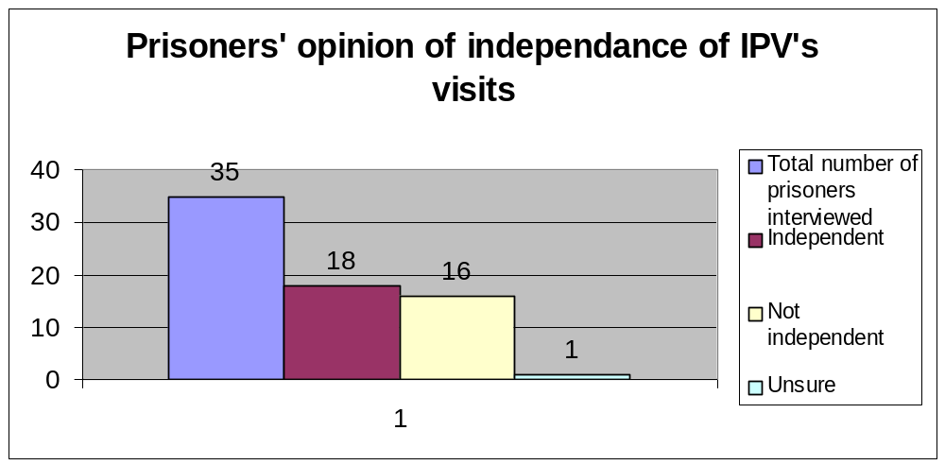

This is particularly worrisome as the IPVs’ independence goes to the very heart of the establishment of the system. For such a large portion of the research sample to be of the opinion that they are not independent indicates that the IPVs and OIJ must develop further strategies and techniques for proving their independence to prisoners.

Of the five civil society organisations that were consulted, four considered IPVs to be independent from prison staff. The fifth respondent was undecided and could not commit to an answer either way. It is noteworthy that this respondent belonged to the only organisation that had been consulted that did no direct work in prisons, whereas respondents from other organisations had knowledge of the correctional system and worked in that sector. The civil society organisations were also asked whether, in their opinion, IPVs were considered independent in the eyes of the prison population. In this regard, all five were of the opinion that prisoners regarded them as independent.

Research undertaken by Saras Jagwanth gave some further insight into the independence of IPVs. An official from the South African Human Rights Commission, while expressing the opinion that the OIJ was ‘formally independent’, reported a significant number of complaints received by the SAHRC relating to the perceived lack of independence on the part of IPVs. The perception reported by prisoners was that IPVs were co-opted by prison officials and that the relationship between IPVs and prison officials was too close to allow for independence. Another respondent interviewed for the research undertaken by Saras Jagwanth reported on the impressions gained from female inmates of Worcester Prison. She noted that as the IPV grew more familiar with prison officials, her efficacy had decreased.

As far as gaining a prisoner’s trust is concerned, the manual does not give much guidance and the IPVs have to use their discretion. Most IPVs mention the fact that they explain their functions regarding the recording of complaints and make the point that they are independent from prison staff. However, in general, all seem to have developed their own manner of accomplishing this. Some of the comments received include the following:

“Your approach must be calm and reassuring. You can’t be aggressive or rude. The trust you develop between you and him and you must be calm and collected. You must also show them you are trying to help. Don’t give them the impression you are a friend with DCS, but explain that you need information from them.”

“Prisoners should know you are a brother or sister to them. Give them your full attention. Sometimes have a chat with them.”

“I ensure the prisoners trust by being open, honest and consistent and by giving timeous updates and feedback to their complaints or request dealt with. i.e. be reliable.”

“Word goes around with inmates. If you helped one then word goes around that I can help. […] We don’t force anything out of them. For example sodomy. An inmate will come to you and look down and scared. You tell him what his rights are about complaints.”

“I don’t normally start by taking complaints. I would discuss normal life topics, e.g. football, rugby or certain academic courses.”

“Not portraying myself as an authority figure but maintaining my professionalism. Ensuring them of my belief that they have a potential to make the best out of their lives.”

These experiences are valuable as they can provide insight and training for new IPVs. Different methodologies can assist in different cases and it would appear that the past experiences of IPVs could heighten their colleagues’ insights as well as help new appointments. There should perhaps be a greater opportunity for information sharing between all IPVs – not only on a regional level, but countrywide.

Likewise, comments received from some of the prisoners indicate the initiative and skills used by the IPVs in gaining the prisoners’ confidence:

“She introduced herself and outlined the nature of her job and knowing she is sent by the Judge made me feel comfortable.”

“She was so kindly to me, whereby I take her like our heroin for solving our problems.”

“They manage the three ‘C’s calm cool and collected. Very understanding and listening and comfortable to be with and makes it possible that your complain is attended to as to even come into consensus, compromise.”

“They are so kind and patient when talking to you.”

“She speak to me with respect [,] it was good.”

“She treats us and talks to us nice and gives us hope.”

“She talked to me like she was my mother. Asked me what was in my heart. I must talk about what I am doing right or wrong like my mother.”

“The way she explained where she is from and nature of the problems she needs to know made me feel comfortable.”

“She explained where she is from and told me if I come to her it will only be the two of us so I shouldn’t be scared.”

These comments indicate that the manner in which an IPV addresses a prisoner can garner him or her that prisoner’s trust and respect. The respondents also seem to imply that the way in which IPVs treat prisoners is different to the treatment received at the hands of members of the DCS. Perhaps members of the DCS could adopt the techniques employed by IPVs in an effort to resolve prisoners’ complaints. It is recommended that DCS officials receive more training and sensitisation regarding prisoners’ rights to lodge complaints and that the OIJ should attempt to engage with the DCS regarding this issue.

Very few negative comments were received from prisoners regarding the manner in which IPVs put them at ease, but those that were received included the following:

“Not really because in cell and lots of people around including warders.”

“They tell me the same thing which I’ve been tell by management.”

“Sometimes they come with the police and you can’t complain about the police in front of the police.”

“No sometimes stressful aggressive.”

“My opinion is the IPV has little or no authorization concerning the complaints. Lack of confidence in the authorization of the IPV.”

“IPV didn’t do anything in particular to make me feel at ease.”

These responses indicate that it is problematic to have officials from the DCS present at the consultations and that a balance between security issues and issues of confidentiality needs to be found. In addition, the second and second-last comments show that certain prisoners question the actual ability and powers of the IPVs in the correctional system, and as the enforceability of decisions reached by the OIJ is still open to for interpretation, this is a valid concern.

The actual recording of complaints seems to follow the general procedure as set out in the manual. Having noted this, however, it does appear that day-to-day practice varies from prison to prison. The procedure always involves an interview, but some IPVs use an appointment schedule while others go to the cells and invite complaints and conduct consultations immediately thereafter. Some of the IPVs mentioned an approximate period of 20 minutes for an interview with a prisoner. After such an interview, the DCS officials and the HOP are approached in an effort to find a resolution to the prisoner’s complaints. Most of the IPVs seem to be sensitive to the fact that they have to treat the complaints as confidential, with them emphasising that their interviews are conducted out of earshot of DCS officials, despite them sometimes being present for reasons of security. Some IPVs conduct their interviews without there being any DCS members present. However, this seems to be slightly problematic as one participating IPV explained:

“In interview an inmate in the presence of a member that is eyesight but [not] earshot. But sometimes is difficult because the DCS member want to listen to what we are saying. If you explain to them the procedure they tell you about your safety.”

An IPV related the following as the format that he or she employs in recording complaints:

“Private consultations are only conducted in relation to inmates who have unresolved complaints after a period of at least 14 days. A list of inmates with unresolved complaints is usually drawn up by the IPV. This list is then discussed with the HOP with a view to ascertain the reasons for the delay in resolving such complaints and to request the HOP to arrange for these prisoners to be called to a secure (private) area to conduct a private consultation with the prisoner. During the consultation I:-

- Determine the nature of the complaint
- Record a summary of the complaint, date, time, etc.
- Ascertain the merits and urgency of the complaint
- Obtain a ‘proposed solution’ from the prisoner.”

Not all responses were this detailed and although this seems to be a logical procedure to follow, it raises the question of why individual, private consultations are not used at the initial recording of the complaint and only once the complaint remains unresolved for 14 days.

The majority of the prisoners who were interviewed stated that the duration of their consultations with the IPVs ranged from 10 minutes to 30 minutes. Only two prisoners mentioned a consultation time of 5 minutes. A small percentage even stated that the consultation took up to an hour or longer. In addition, some of the prisoners acknowledged that the time spent with them in consultation depended on how many prisoners the IPV had to consult with and the nature of the complaints.

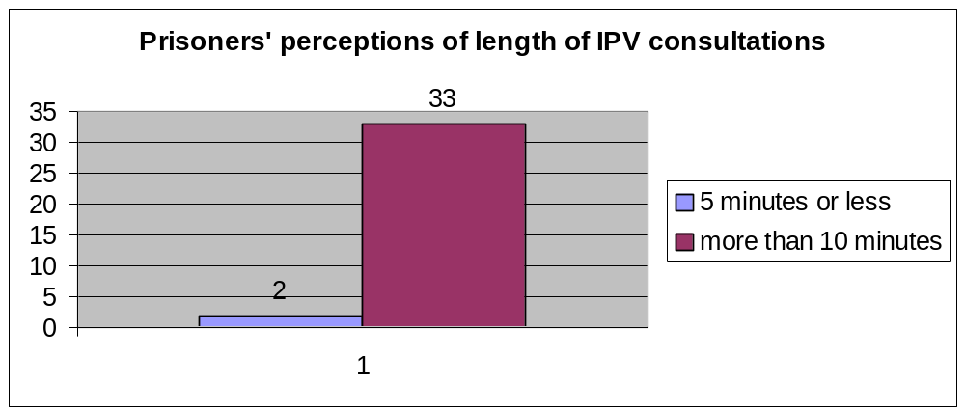

In addition, the majority of the prisoners seemed satisfied with the manner in which the complaints were recorded. Generally, it would appear that a discussion takes place during which time the prisoner relates his or her problem and the IPV asks questions for the purpose of clarification.

However, the prisoners’ responses in relation to the issue of confidentiality (as also noted above) is a matter of concern. While some stated that their consultations took place in private without the presence of a DCS member or other prisoners, others confirmed that a DCS member was usually present and that they were, in the opinion of the prisoner, able to hear the content of the consultation. Most of those who were interviewed in the presence of prison staff stated that they were uncomfortable during the interview precisely because of the presence of a member of the DCS. Judging from the responses received, it would appear that the fact that it is necessary for a member of the DCS to be present because of safety concerns has either not been explained properly to prisoners or not at all. It is recommended that steps be taken to address the issue of striking a balance between the safety of the IPV and the confidentiality of the consultation.

6.3 Interaction between IPVs and prisoners who have lodged complaints

The most important aspect of the interaction between IPVs and prisoners who have lodged complaints relates to the feedback that the prisoners receive in respect of their complaints.

Based on the responses to the questionnaires, it appears that the IPVs use a range of different means to provide feedback. Two IPVs stated that their only manner of providing feedback involved printing out the electronic response from the OIJ and furnishing this to the prisoner. It is the researcher’s opinion that this is not the most optimal means of providing feedback. Another IPV stated that the usual method was to provide written confirmation of the outcome, but that this was also sometimes done verbally. This IPV indicated that the nature of the complaint dictated the manner used to provide feedback.

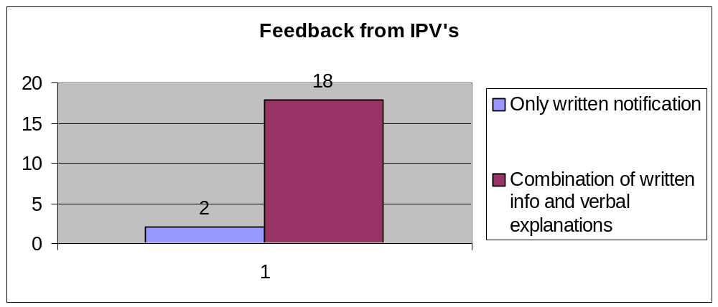

A number of IPVs arrange for a private consultation with the prisoner who has lodged a complaint and then inform him or her of the outcome of the complaint face-to-face. According to some of the replies received, it would appear that a member of the DCS is present for purposes of security even during such a private consultation.

Some IPVs provided more comprehensive detail about the procedure that they followed:

“I go from cell to cell. Let them read the answer. Discuss the way forward, or I send a list with a cell rep or floor rep and they come to my office where I give them feedback.”

“Feedback is provided by going back yourself to the inmate and tell them the outcome or how the complaint is being resolved, even if you are still waiting for an answer to back to the inmate and tell them that you are still waiting for the response from the Head of Prison.”

“I normally call them to the office for feedback, because at times you find that he is still not satisfied and becomes furious and then I explained to them that there are other things which are also out of our mandate.”

The aforementioned responses indicate a more balanced and reasoned approach to dealing with prisoners who feel aggrieved. However, this aspect of dealing with prisoners too is left somewhat to the discretion of the IPVs; it is suggested that the experiences of the IPVs employed in fine-tuning future training initiatives.

However, the prisoners’ responses paint a different picture. Thirteen out of the 35 prisoners who were interviewed stated that they had received no feedback whatsoever regarding their complaints. The remainder of the prisoners who participated indicated that they had received feedback. This seems to be at odds with what is reported by the IPVs. These different responses can be interpreted to mean that the IPVs are not performing as they are mandated to do or that they are providing feedback, but not in a manner that is understandable to the prisoners. This aspect of providing feedback therefore either needs to be addressed by carrying out an assessment means of the performance management system or by improving the training given to IPVs.

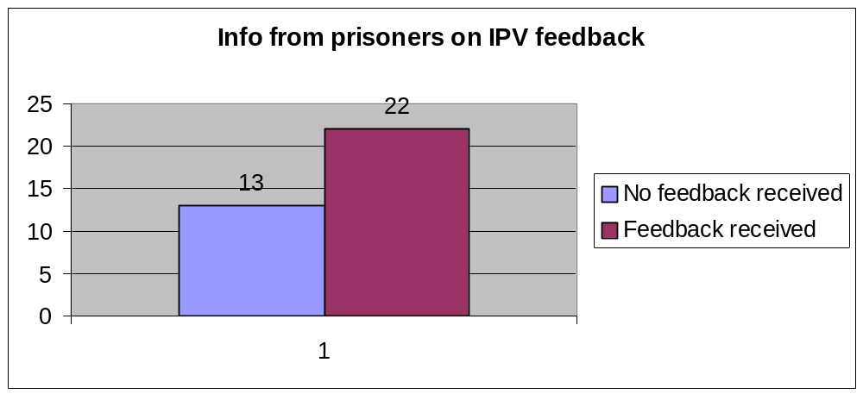

A further consideration that needs to be taken into account is the quality of feedback that is provided to prisoners. Of those prisoners who stated that they had received feedback, nine were not satisfied with the feedback they had received. This could be for the simple reason that the feedback was not to their liking and did not accord with what they had expected the outcome of the case to be. However, the following statements made by dissatisfied prisoners are reason for concern:

“IPVs are not doing their work-job right.”

“Because my problem had not being solve. The job is too hard for them. I even phone the Jali Commission, but the respond say the prison is not under restrictions.”

“The power of the IPV is too restrict and there are always cover ups from CS side and excuses.”

“Dit vat baie lank vir terugvoering. Ek se dit weer dit is ‘n gemors. Hier is nie samewerking met die IPV en lede van DK dienste.” [It takes very long to get feedback. I say it again, it is a mess. There is no co-operation between the IPV and members of DCS.]

Although these statements came from a small number of people in the sample, they indicate that there is a perception that IPVs are ineffectual and are unable to effectively attend to prisoners’ complaints. This could ultimately have a negative impact on the work being done in prisons by IPVs and could affect their credibility within the prison population. One way to avoid this is by ensuring the prisoners are aware of their right to appeal against decisions made regarding complaints. However, of those prisoners who indicated that they were dissatisfied with the feedback they had received, six stated that they were not informed of their right to appeal.

It is suggested that in order to counter this, training that specifically equips IPVs with the skills needed to communicate difficult decisions to prisoners is needed. This would possibly help avoid having a prisoner feel that the IPV is not performing his or her mandate efficiently.

6.4 The impact of IPVs in resolving complaints at local prisons

In order to determine the impact of IPVs in resolving complaints at prisons, IPVs were asked to comment not on their own effectiveness, but that of “their” prison in resolving complaints. The question of their effectiveness was reserved for the prisoners and prison staff in order for this study to obtain a more objective assessment.

Most of the comments received from the IPVs concerning the effectiveness of their prison in addressing complaints indicated that they felt it was less than efficient and even poor in a number of cases. A recurring comment was that the prisons tend to be too slow about resolving prisoner complaints. In addition, a number of IPVs were of the opinion that prison staff do not realise the importance of attending to prisoners’ complaints as evidenced by this comment:

“The prison’s effectiveness in dealing with prisoners’ complaints vary (sic) – most prison staff always suspect pre-conceived motives in prisoners before dealing with their complaints – therefore not very effective- resulting in a loss of trust by prisoners in staff.”

Various IPVs provided an actual rating of the prisons’ effectiveness in dealing with complaints, with this ranging from 5% to 50%, 60% and 70%.

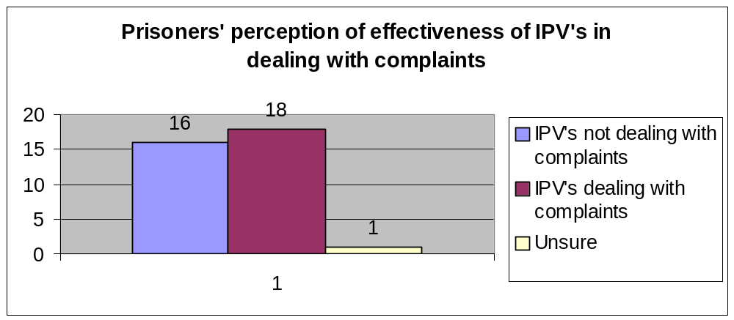

As far as the impact of IPVs is concerned, 18 prisoners felt that the IPVs were dealing with complaints effectively, 16 felt that they were not and one indicated that he did not know if they were or not. The reasons given by the prisoners who felt that IPVs were not attending to complaints included:

“Firstly the book goes to the wardens and secondly IPVs are local people – so they are used by wardens because they are from the same area.”

“Because they do not make a follow up – they always take complaints and nothing happens after.”

“Because they are unreliable.”

“Not exactly, because the co-operation from the CS side when the IPV is not present is negatively.”

“They don’t follow the right procedures and steps.”

“Hulle word rond gedonder v/d lede van DK Dienste.” [They are messed around especially by members of the DC Services.]

These responses indicate two main problems. Firstly, there is a perception that the IPVs are not performing their functions correctly. This needs to be addressed through the performance management system, there should be greater control from the regional co-ordinators, and there must be ongoing communication with the OIJ. Secondly, there is the usual suspicion and distrust of members of the DCS, with IPVs not being regarded as being independent from prison staff. This is difficult to solve, as IPVs have to operate within the constraints of the DCS system. A potential solution is for there to be more careful communication between IPVs and prisoners relating to issues of independence.

Prison staff were also questioned about their perceptions regarding the effectiveness of the IPVs’ abilities to resolve complaints. Of the 32 members of the DCS who were interviewed, 22 believe that the IPVs are effective. The remainder expressed varying opinions on this issue.

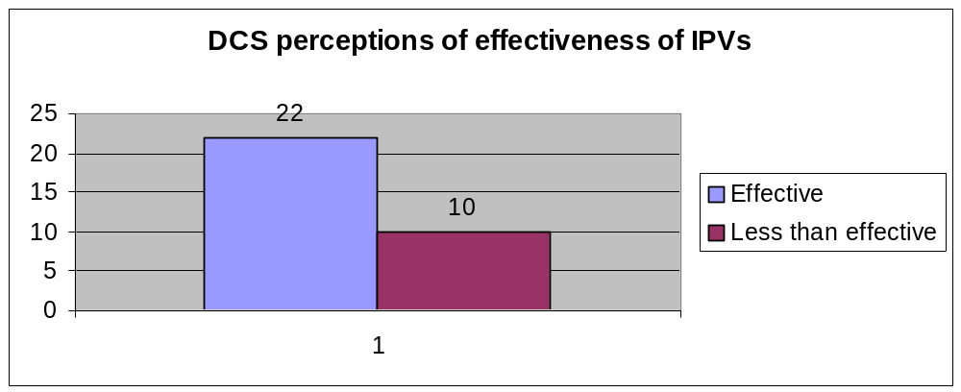

Some stated that the effectiveness was “average”, “poor” or “20%”. However, some of the more telling comments were:

“Very poor in that they normally do not consult with the section members when registering complaints from prisoners. Sometimes a resolved problem is registered again with them.”

“They take problems they cannot solve.”

“IPVs need someone like a strong supervisor who can monitor them not to do as they like. They come for duty in the morning sign the book G365 to report that they are on duty and they disappear.”

“The system is useless as she does not solve any problems but refer all the list to unit managers. She also jots down stupid complaints.”

Some of these observations indicate that officials of the DCS fail to understand the nature of the work performed by the IPVs. However, some indicate serious problems with the performance and management of the IPV system that need to be addressed.

Furthermore, some general comments on the IPV system that were elicited from the prisoners ought to be taken into account and addressed in the development of future training programmes and guidelines for operating prisons. There should also be some combined efforts between the OIJ and DCS to inform members of the DCS about the function and purpose of IPVs. These include the following:

“Die IPV se hande is afgekap. Die lede hulle maak IPVs dom/stupid. IPVs is beperk op sekere goed. Daar is nie plek waar ons kan praat en lede luister en maak gek van ons. Hulle moet hulle weg vat. Staat mors geld. Bewaarders lag hulle uit oor IPVs.” [The IPV’s hands are tied. The members they make IPV stupid. IPV are limited with certain things. There is nowhere that we can talk and members listen and make fun of us. They must take them away. State is wasting money. Warders have a good laugh over IPVs.]

“The IPV hasn’t got enough power, because when you laid a complain, the member will do as they are co-operating but in the end there will be no progress. The big problem is within the member of DCS not with the IPV because the member are not scared of the IPV.”

“The IPV need lot of assistance from other institution like SAPS. So that if a complain need to be taken to court so that SAPS can be there to charge a perpetrator.”

“I like the system. I compliment them on the work they are doing but must do it faster.”

“In my understanding the IPV’s in prison has brought transparency and are in the edge of developing the justice system while DCS are still reluctant I giving their side of such development and that no DCS directorate is responsible for a serious attendance into the unresolved matters directed to DCS and that the DCS’s feel threatened by the independence of the Inspector of Prison Visitors (IPV). It’s my submission that the IPV be employed with more power in resolving conflicts and complains as […] DCS bodies are conservative to the rights of the Department. Correctional clients are not given an alternative avenue for other bodies in dealing wit complaints.”

The impact of the IPV system can also be gauged from the following general comments made by certain members of the DCS:

“I think it is a good thing, that people can see that we are human to and we with the IPV try hard to improve prison live for the inmates and take care of there problems and help where we can to make a better South Africa for all of us.”

“We need that our managers to listen to us on Operational Level when we voiced out our tongue. Sometimes we have some suggestion about the problems encountered in the Section where we are working. I suggest that the IPV member to come down inside the section office escorted by a correctional official so that he/she can be able to see the prisoners nearby.”

“Inmates should not consider IPV as their lawyers in a sense that they should misbehave and the IPV should come in and try to take the correctional officers duties on their own hands. Same applies to correctional officers, they should not be threatened by the presence of IPVs rather consider them as a mirror of prison admin to the outside community (transparency).”

“Their presence is not welcome because they do not resolve complaints. Minor complaints are registered e.g. prisoner wants paper to write to his family and they register this as a complaint instead of resolving it. Can be a waste of time and money.”

“IPVs must first find out if the complaint has been registered with section head to prevent duplication which may one way or another lead to conflict. Complaints that can be solved on the spot may not be recorded e.g. if an inmate asks for an envelop or wants to see the social worker.”

“I think the IPV is good, and would like to see them getting even more involved in maybe getting programs for rehabilitation on the way. And not just be a watchdog. (They must make people more aware that prisons must be there to uplift people rather than break people down.”

“If the IPVs members can be given an extra opportunity to visit prison on a daily basis on five working days just to work with us in prison in order to help inmates to solve their problems.”

One DCS official offered some suggestions for improvement:

“Any new IPV should introduce him/herself. Officials should be updated about their (IPVs) duties. The new IPV and his/her duties should be announced to the inmates. There should be specific time at which the IPVs will come to see the inmates. This will help both the officials and the IPV with security arrangements.”

Other suggestions for improvement were furnished by a civil society organisation:

“A more effective system communication system, which enhances interaction and anonymity. The IPV system should be more realistic with more stakeholder input. Expanded to have more IPV per prisoners. There should be adequate training. Improved response time.”

Civil society organisations were also invited to comment on whether, in their opinion, IPVs are contributing to the efficient handling of prisoners’ complaints. Three respondents answered in the affirmative, while two were not of the opinion that IPVs were contributing to greater efficiency. The reasons given related to the length of time it took to resolve a complaint once it had been referred to the VC or the OIJ and the fact that the OIJ had no power to force the DCS to take action in certain circumstances as they were merely in a position to make recommendations.

6.5 The involvement of IPVs in prison matters that are unrelated to their mandated tasks and the resolution of matters falling outside their mandated tasks

A number of IPVs indicated that they undertake work that falls outside their designated functions. The context in which this arose was in relation to the resolution of complaints. It appears that problems are often minor and require only a telephone call to achieve a resolution. A number of the IPVs stated that although it was not required of them they would assist the prisoner in this regard as they believed that it enhanced their credibility with the prisoners and was a way of “going the extra mile”.

In addition, there being a shortage of prison staff to deal with matters of a particular nature appears to be a problem. One IPV stated that she acts as a social worker and psychologist on occasion in order to assist the prisoners. There are also accounts of IPVs following up on certain issues that ultimately amount to them circumventing the formal complaints process and rapid resolving problems raised by prisoners. Furthermore, a number of IPVs spend more than the allocated amount of hours on their work in order to ensure the efficient resolution of complaints.

However, this “extra” work undertaken by certain IPVs seems to depend on the individual IPV and does not appear to be a general trend amongst all IPVs. This is a phenomenon that one will find in a range of work situations, and not only in the context of the IPV system. Ultimately, it is the researcher’s opinion that the IPVs that undertake this additional work are those that are dedicated to the spirit of the system and that believe in the purpose of the work that they have chosen to undertake. This is especially praiseworthy considering that there is no guarantee of re-appointment for the IPVs as they are employed on a fixed-term contract. Unfortunately, the appointment process (discussed below), however well refined, will never be able to determine with certainty whether a particular IPV demonstrates these characteristics and subscribes to this work ethic.

Regarding any innovations that the IPVs may have introduced at their prisons, none of the civil society organisations interviewed were aware of any practices initiated by the IPVs themselves. The introduction of new practices in prisons should perhaps be encouraged by the OIJ, however, the fact that IPVs have limited work hours and a heavy case-load needs to be borne in mind when considering their potential in this regard.

7. The co-operation between IPVs, Institutional Committees and the Heads of Prisons

There are a number of aspects to the work of IPVs that provide insight into the co-operation between them and DCS officials. These include the monitoring of the G365 register, security arrangements and administrative arrangements regarding their work in prisons. These will be discussed below in addition to the perceptions of the parties concerned regarding their relationship.

7.1 Administrative arrangements

The IPVs have not noted any problems with the administrative arrangements that are made regarding their work in prisons. They generally all agree that these are quite routine and involve:

- Submitting their schedule of visits to the HOP,
- Requesting escorts for their site visits and interviews with prisoners, and
- Access to computers, telephones and fax machines.

The majority of IPVs indicated that they experienced no problems with the scheduling of IPV visits. However, a few IPVs noted that they had experienced some difficulties in managing to hold follow-up discussions with the HOP because of the incumbent not being available despite an appointment having been made; in addition, gaining access to prisoners is a problem when roll call takes place as this takes a considerable amount of time and effectively denies the IPV access to the prisoners and when special events are scheduled by the prison the IPVs are sometimes not informed accordingly, which results in them having to reschedule. Although the responses included few comments such as these, it is clear that in some prisons the prison staff do not factor the work of the IPVs into their activities. This creates the impression that the work of the IPV is expendable.

Likewise, most prison staff noted that they had experienced no problems in scheduling IPV visits. Only two comments were received that indicated some difficulties, namely, a shortage of DCS staff to escort IPVs on occasion and instances where the IPV wished to visit the cells during the day instead of the morning, thereby interfering with section activities scheduled to take place at those times.

These observations of the difficulties encountered, both on the part of the IPVs and members of the DCS members indicate that while there might be problems, they are not insurmountable. Addressing them could lead to the IPVs and members of the DCS ensuring that the communication between them is more effective so as to prevent such incidents in future.

An important administrative aspect involves access to and removal of documents from the prison. Those IPVs who commented on the matter of ensuring that the proper procedure is followed, indicated that they complied with the prison requirements. Other comments indicated that instead of removing the necessary documents from the prison, copies were made.

7.2 Security Arrangements

The IPV manual states that it is the responsibility of the HOP to provide security arrangements for IPVs during their site visits.

In discussing this aspect of their work, less than half of the IPVs interviewed indicated that they had no problems with security arrangements. Therefore, it would appear that security is a common problem experienced amongst IPVs.

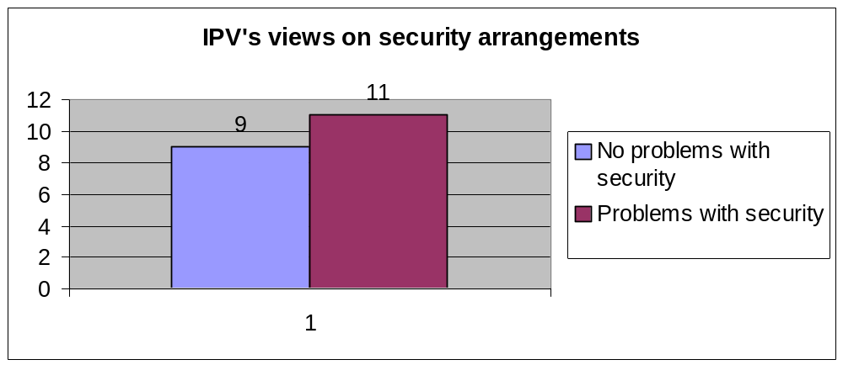

Some of the experiences of the IPVs who have had difficulties in this regard include:

- Members of the DCS not allowing IPVs access to the cells by not unlocking the doors;
- Members of the DCS leaving the cells in order to escort prisoners to other areas such as the hospital whilst a visit is taking place, and
- Members of the DCS “disappearing” whilst IPVs are recording prisoners’ complaints. One of the IPVs explained that this is a problem because if the IPV leaves the cell once they realise that they have been left alone, it creates the impression that he or she distrusts the prisoners. This dilutes their credibility with the prisoners
- Being locked in cells with awaiting trial prisoners
- Unwillingness on the part of members of the DCS to escort IPVs to single cells

The matter of problems with security arrangements was echoed by the two former IPVs who were interviewed, who also mentioned the hostility of members of the DCS who have to escort IPVs on site visits.

Two IPVs expressed dissatisfaction with the fact that they did not receive safety allowances because, as one noted, although he had not been injured, this had happened to other IPVs.

A further two IPVs suggested a reason for the problems with security arrangements, namely, the shortage of prison staff in relation to overcrowding in prisons. This is perhaps a good point, nevertheless IPVs are entitled to security and failing to ensure this is provided has a negative impact on the relationship between IPVs and prison staff. Failing to provide IPV with adequate an appropriate security serves to create the impression that prison staff do not hold in high regard the work undertaken by IPVs.

Of the prison staff interviewed, most were of the opinion that the security of IPVs was the responsibility of, amongst others, the members in charge of internal security, the section supervisors or the centre co-ordinators (operational). This would require that the HOP delegate this function to those officials. They also mentioned that the main aspect of security arrangements involves escorting the IPVs into the cells and units.

7.3 G365 Register

The G365 register is the official complaints register that is operated by the prisons, and in which all of the prisoners’ complaints must be recorded in order for them to be attended to by DCS officials.

The majority of the IPVs experienced no problems with the monitoring of the G365 register. They check the register, provide their index register if necessary and have regular discussions with the HOP regarding unresolved complaints. However, some problems were noted. These include:

- Not all prisoners’ complaints are recorded in the G365 register
- IPVs experience difficulty in finding the register as it moves around various offices, therefore the IPV has to track it down
- Members of the DCS updating the G365 register irregularly
- Only requests to see the social worker and HOP are recorded in the G365 register

Most of the prison staff indicated that the IPVs had full access to the G365 register and that they checked it regularly. However, there were four responses that indicated practices to the contrary - two members of the DCS stated that they did not allow the IPVs access to the register; one stated that the IPV in his section simply did not check it (the respondent is a section supervisor), and one failed to answer the question.

Although the monitoring function of the IPVs is aimed at ensuring greater efficiency in the management of prisoners’ complaints, as one IPV states:

“…it is difficult to convince the Correctional Officials otherwise – to the practice they have been following up till now – very rigid to change.”

This comment indicates that something more than IPVs is needed to change the mindset of some members of the DCS regarding the management of prisoners’ complaints. This would necessarily involve specific training and policy directives from the DCS itself.

However, judging from the observations of the prison staff, it appears that the IPVs do indeed follow procedure and furnish them with their Index Register should prisoners’ complaints not have been recorded in the G365 register immediately. The Index Register is the official register of the IPVs’ complaints in which the IPVs must record all complaints that are reported to them by prisoners. Of the prison staff interviewed, 28 indicated that this procedure was adhered to, while two stated that they were not provided with the Register. Of the remaining members of the DCS who were questioned, one did not answer the question and the other stated that IPVs did not visit his section. This last comment is somewhat puzzling and of concern, as IPVs are expected to serve all areas in their designated prison.

7.4 Relationship between IPVs and prison staff

The study revealed almost equally polarised opinions on the part of IPVs in relation to this issue.

Those IPVs who were of the opinion that they have a good relationship with prison staff used terms such as “professional”, satisfactory”, “co-operative” and “helpful” to describe it.

The comments of IPVs who have experienced problems with the relationship are more telling, however. These comments are generally self-explanatory and include:

“Less satisfactory, members feel IPVs are in prisons to spy on them.”

“Prison staff still has a misinterpretation of my presence in prison. They think I am there for witchhunting. They might loose their jobs. They have a problem of trusting any role as an IPV.”

“In most cases tense, because sometimes they think we are ‘targeting’ them, but in most because we discuss with them it becomes better.”

“That is good but sometimes they do not see us a to complement them they feel we are taking their jobs.”

“I consider it to be fair. Some DCS official have attempted to propose invite for lunch and use other manipulative tactics in an attempt to steer us from serving inmates interest. Non-compromising from myself constantly result to indifferent attitude by DCS. I believe I am not in prison to be loved by DCS I am happy if they co-operate with me of which I demand.”

“DCS have negative attitude towards IPV because you always have to beg them to solve your complain[t]. Even on their respond to consultations you can see that they have a bad attitude.”

Of the prison staff interviewed, 28 participants stated that they had good and professional working relationships with IPVs. One stated that they were “friends” and that they got on like “bread and butter”. This latter statement tends to cause concern as it would appear that the IPV in question might be identified as having compromised some or all of his or her independence. This indicates the difficulties faced by IPVs in working in close proximity to officials of the DCS who they are mandated to monitor through prisoners’ complaints.

Furthermore, four members of the DCS indicated that there were problems in the relationship between IPVs and prison staff. These included observations that the prison staff were not happy with them, they were not trusted and that their relationship was limited just to greeting one another.

Of the five civil society organisations that were consulted, four expressed opinions on the relationship between IPVs and officials of the DCS. These are as follows:

“They are a threat because without IPV there is no threat in the system.”

“The IPVs are seen as spies. DCS staff are not very happy with them since they are neutral and it can damage their jobs.”

“Initially there was scepticism and fear of the unknown on the part of DCS. Now they use the IPV to exonerate themselves as the IPVs view regarding any matter is more credible than their view in the event of a dispute with them and a prisoner.”

“It differs from prison to prison.”

The relationship between the DCS and IPVs seems to be a problem that needs immediate attention from both the DCS and the OIJ. It would appear that both IPVs and members of the DCS need to be sensitised with regard to their respective functions and work. Both parties need to be prepared to acknowledge one another’s duties and responsibilities and both must recognise the value of the other’s obligations.

One IPV made the following suggestion:

“Prisoner staff to me need to attend workshops, they are mostly still using the old methods when treating prisoners, I feel they need counselling once in a while. To them prisoners are not human beings.”

Only about a quarter of the IPVs interviewed noted any disputes that occurred between them and officials of the DCS. Generally, these related to the following:

- Access to medical files and information on the health of the prisoners
- The IPVs’ duties
- Security
- Types of complaints registered by the IPVs
- Prisoners’ complaints
- Co-operation

However it appears that all these problems were resolved either through discussions with the HOP, use of the IPV manual, the Act or “quiet diplomacy”.

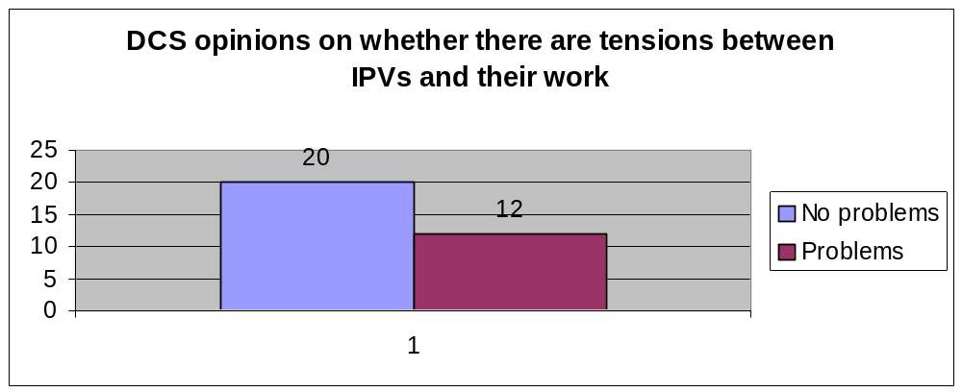

Likewise, the prison staff were questioned on whether there were any tensions between the work that IPVs are mandated to perform and their work. Twenty of the members of the DCS stated that no problems had been encountered. However, a sizeable proportion of the sample, namely 12 members, mentioned certain difficulties that needed specific attention, as these would seem to impact on the effectiveness of the IPV system. These comments included:

“The IPVs seem to be in prison to tell the officials what they should do. They act as superiors to officials. They act as if we are not doing our utmost to help the inmates.”

“They [IPVs] could add other staff.”

“IPVs take complaints from inmates which are not registered to the complaints and requests book. Secondly they are not familiar with DCS acts and regulations.”

“The entering of complaints into the IPV index book and the G365 register. The IPV count every interview as a complaint while on the G365 only the complaints are entered.”

“The offenders does not register complaints [any more].”

“It causes inconvenience.”

“They listen to the prisoners and thereafter they do not consult with section manager to clarify, because some of this complaints and requests should have been attended to effectively by the section head, and this kind of things are sometimes confusing, and some of them does not have good relationship with the member they act very special.”

“Especially when dealing with disciplinary measures. Offenders […] to consult IPVs when they feel they have been charged or misbehaving. Therefore they (inmates) put IPV on crossfire between members and inmates.”

“Complaints are sometimes very minor. We at the prison is also capable to resolve that.”

Some of these comments merely indicate a lack of understanding on the part of members of the DCS about the function and duties of IPVs and vice versa. However, some of the observations reflect on the procedures and effectiveness of the IPV system and should be seen as motivation for IPV training procedures to be revised or the institution of further mechanisms for monitoring their work.

One of the questions put to the IPVs was whether their relationship with prison staff impacts on their relationship with the prisoners. Some of their answers include the following:

“The prisoners have trust in me as an IPV because my relationship with the DCS is purely professional and does not raise any sceptics from the prisoners.”

“Have a big effect, effective dealing with complaints are hampered by some members not attending to it in 14 days rule and then inmates lose interest.”

“Strongly, because prisoners are humans, they watch how you deal with challenges. They also tell you their views the prisoners about you as an IPV.”

“The relations must not be more than work relationship because the prisoners will start losing faith in IPVs.”

These few responses show insight on the part of some IPVs into the fact that they must be seen to be independent and be able to balance their reliance on the DCS with their monitoring and complaints resolution function. However, many IPVs did not respond to this question; this raises the concern that despite their training and general acknowledgement of their independent function in prisons, their day-to-day experiences may detract from this. It is in this regard that the Visitor’s Committee and the regional co-ordinator are important as these two systems can be used as a means to provide continuous positive reinforcement for the IPVs particularly in respect of how they balance the nature of their work and the work environment.

The DCS officials were asked whether any IPVs had acted in an unauthorised manner. Of the responses, 24 indicated that there had been no such incidents while eight mentioned some difficulties. With the exception of one, it appears that all of these problems were resolved internally through discussions and that none of the difficulties had a negative impact on the prison staff’s opinion of the system. However, one of the members of the DCS stated that the problem had led to the IPV being transferred and this had had a negative impact on his perception of the IPV system, although he refrained from providing details about the incident.

7.5 Co-operation between IPVs and other organisations and government departments

Generally, it appears that contact between IPVs and other government departments occurs mainly in the context of the VC. This is discussed in more detail under the Visitors’ Committee section below.

However, it is notable that while the five civil society organisations that were interviewed were aware of the IPV system, they did not have any formal linkages with IPVs despite all being active in correctional work. This would seem to indicate that there is a definite need for concerted efforts on the part of the regional co-ordinators and VCs to increase their outreach to NGOs, CBOs and the community at large.

8. The relationship between IPVs and the personnel and other units in the Judicial Inspectorate of Prisons

Of the IPVs that were interviewed, most seemed to have a good impression of the Office of the Inspecting Judge. Three of the participants said that they had lodged grievances against the OIJ, but this did not seem to impact on their work or level of co-operation with the Visitor’s Committee, regional co-ordinator or any other aspect of the OIJ. All of the IPVs had a high regard for the Inspecting Judge of Prisons.

The most insight came from the two regional co-ordinators who were interviewed, as well as the chairperson of a Visitors’ Committee. The chairperson of the Visitors’ Committee indicated that there was a good communication system within the IPV unit at the OIJ.

While one regional co-ordinator stated that the communication between himself and the OIJ was excellent and that he had experienced no problems with the OIJ, the other indicated that in his opinion there was a lack of co-ordination at the OIJ. Furthermore, he had experienced problems with the OIJ in the form of a lack of co-ordination at the level of “line management function”.

Therefore, although the study was limited in the number of regional co-ordinators who were consulted, it would appear that a review of the process of co-ordination and communication between the OIJ and regional co-ordinators is required. This would be valuable in any event and would assist future operations and management.

8.1 Training

The performance of the IPVs initially depends on the training that they received from the OIJ. It is therefore important to determine the effectiveness of the OIJ in training the IPVs and preparing them for their work in prisons.

Of the IPVs that commented on the training only three felt it was helpful and sufficient. The most common comments related to the fact that the training provided was too short and intensive and that it was not practical enough and that it required more information relating to the day-to-day duties of IPVs. Two former IPV who were interviewed also expressed dissatisfaction over their training. They noted that training provided an idea of what happens in prison, but that the reality was totally different. One observation is that the procedures devised for IPVs are not completely compatible with prison administration and operation.

Some of the comments received indicate suggestions for improvement:

“The training was good but they should not mix old IPVs and new IPVs. They should take the IPVs to prison and show them the premises.”

“The training was a lot to absorb. Saying one thing and really being there is different. Need on the job training. We have given insight to new recruits and that helps them….you go beyond what is expected of you.”

Notably, one of the IPVs who was interviewed had been re-appointed. The comment received indicated that the revision of the training syllabus by the OIJ had resulted in improvements:

“The first time was not a hard training and I feel not that relevant to our work. Second training was fine, relevant, helpful.”

Despite this apparent improvement, many of the critical comments about the training provided by the OIJ were made by recent appointments, indicating that there continued to be a need for revising and upgrading the training that was provided.

9. The efficiency and effectiveness of Visitors’ Committees

Visitors Committees are established in terms of section 94(1) of the Act, which provides that the Inspecting Judge may establish a VC for a particular area. A VC comprises all the IPVs appointed in that area and meets monthly to discuss matters contained in the IPV manual. The functions of the VC include:

- Considering unresolved complaints;
- Submitting to the OIJ those complaints that the VC is unable to resolve;
- Organising a schedule of visits;
- Extending and promoting the community’s interest and involvement in correctional matters, and
- Submitting minutes of its meetings to the Inspecting Judge.

Only one of the IPVs who were interviewed expressed any dissatisfaction with the operation of the VC and then did not elaborate further. The remaining comments all indicated that the IPVs were of the opinion that the VC is an excellent means of sharing information and discussing unresolved complaints.

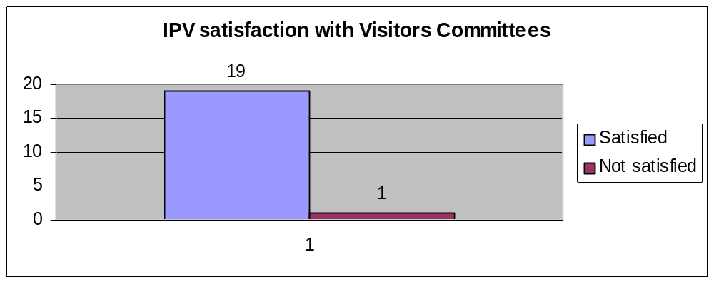

Some of the more noteworthy comments include:

“The Visitors’ Committee only experienced problems with regard to attendance and participation in the Criminal Justice Cluster for contribution, since we believe we form part of the C.J. Cluster and the response for this request from the OIJ was not very satisfactory. The performance and functioning of the Visitors’ Committee in my prison is very vital since we have made allot of recommendations with regard to prisoner’s complaints i.e. with regard to issues of Bail, Appeal, Plea Bargaining and other Social Welfare related matters.”

“The performance is excellent, it is [at] a level where we are able to learn and discuss problems and a level where we can make decisions.”

As far as prison staff are concerned, of those who had some form of interaction with the VCs, no problems were noted and their effectiveness was rated as between average and good, with one respondent saying that the Committee is “excellent”.

According to the IPV manual, an important function of the VC is to encourage community participation in prisons by extending invitations to community leaders and representatives as well as other departmental stakeholders.

The study revealed that the VCs are carrying out this function and receiving good co-operation from their communities. Three separate VCs indicated that they held meetings and enjoyed excellent attendance by representatives from Legal Aid, OIJ area managers, the Commissioner of the Parole Board, DCS officials including HOPs, religious leaders, taxi associations, legal representatives and other community organisations.

An example of the initiative shown by VCs is that of the Pretoria VC. They have invited representatives from a secondary school to visit a juvenile prison and have invited members of the legal profession to Pretoria Local Prison. In addition, a Woman’s Day breakfast was organised at Pretoria Female Prison which women who had been identified as being active in their communities were invited to attend. The breakfast was held in the prison and a tour of the prison was organised as well as a gathering with the female prisoners for discussions. As a result of this initiative one of the guests at the breakfast was appointed as an IPV.

It would appear that the VC is an important and beneficial aspect of the IPV system that receives support from the community, other departments and IPVs themselves.

10. The selection and recruitment of IPVs

It appears that much effort has gone into finalising the appointment procedure for IPVs.

A policy document has been developed that deals with the following:

- Determining the establishment of posts
- Establishing VCs
- Calling for nominations
- Selecting candidates
- Interviewing candidates
- Appointing IPVs
- Induction of IPVs
- Re-appointing IPVs
- Transferring IPVs
- Increased hours for IPVs
- Monitoring and reviewing IPVs

In addition, the OIJ developed a customised nomination form. Applicants complete the form, which requires the following information:

- Personal particulars
- Language proficiency
- School qualifications
- Post-school qualifications
- Computer literacy
- Work experience
- Community involvement
- Criminal offences
- Motivation for becoming an IPV

These details ultimately allow for a rating of the applicant. The details are processed by the electronic system operated by the OIJ, which generates a shortlist of preferred candidates. Interviews are conducted next. The guideline for a shortlist is four candidates for one post. Therefore, the candidates with the four highest scores will be shortlisted. The electronic scoring system was developed partly by a psychometrist. The OIJ has also developed a document entitled “Suggestions and Guidelines for Interviewing Prospective Independent Prison Visitors”. All of these efforts appear to have ensured that the appointment and recruitment process is as transparent, unbiased and objective as possible.

This is reflected by the comments of the IPVs on the appointment procedure. The majority of the IPVs were of the opinion that the procedure was fair, however a few felt that it was slow and delayed. The latter comments relate to the application of the procedure itself and do not seem to detract from its credibility, only its efficiency.

Civil society organisations that were asked for their views on the procedure for appointing IPVs volunteered the following comments:

“There is a large amount of political nepotism.”

“Appointment is done on the basis of qualification alone and this results in many community activists not qualifying in terms of the automated short listing computer programme.”

“I think they are fair as it is necessary to ensure that reliable people are appointed to carry [out] the relevant functions.”

“They [procedures] should be made available and published in all communities so that community members are aware of them.”

These comments indicate that while most IPVs considered their appointments to have been fair, certain civil society organisations had identified problems in this regard. These problems, however, seem to be grounded in a misunderstanding or misperception concerning the procedure for appointing IPVs as implemented by the OIJ. Therefore, it might be expedient for the OIJ to create greater awareness of the mechanics and reasoning behind their appointment and selection procedures.

In addition, the IPVs were asked whether community involvement was important to the appointment procedure on account of the procedure being geared towards a certain degree of community involvement. Almost all the responses indicated that community involvement was an important aspect for the appointment of IPVs. This sentiment was echoed by all five civil society organisations that were interviewed. However, there were two dissenting opinions from IPVs that should be noted:

“Yes, but should not exclude people who would otherwise be an asset.”

“Not important because this have nothing to do with community but with whom you are.”

Despite these two comments, it appears that the OIJ has devised a sound and reasonable appointment and recruitment procedure.

11. The out-puts of the IPVs

Judging from the information discussed thus far, it would appear that a number of obvious outputs are expected of IPVs. These relate to:

- The resolution of prisoners’ complaints;
- Assisting prisoners with problems that the DCS is not attending to, and
- Involving the community and other Departments in prison life through consultations and the dissemination of information.

However, the study also revealed further information about the impact and outputs of the IPV system.

In response to a question on whether the OIJ has established an independent complaints and request procedure for prisoners that is accessible, effective and reliable and that seeks to result in a calm and satisfied prison population, a range of replies were received.

IPVs were generally ambivalent about whether this had been achieved or not. Most responses indicated that there was a move in this direction, but that there was still much that needed to be done in order to attain this goal.

In response to a question as to whether IPVs are contributing to greater transparency in prisons the reply from the IPVs was resoundingly positive.

12. Obstacles and impediments that IPVs encounter

It would appear that IPVs face a number of obstacles from day to day. These either stem from three sources - the OIJ, DCS or the prisoners themselves. Overall, it would appear that there is consensus that the IPVs are performing their work fairly well and in terms of their mandated duties. However, where there is dissatisfaction with the IPV system, it would appear, it is caused by the obstacles to their work.

One of the main impediments that IPVs encounter relates to the DCS. This manifests itself in many forms:

- The hostility or distrust that members of the DCS feel towards IPVs, which is particularly evident regarding the issue of security arrangements;
- Prison administration rules that interfere with the scheduling of visits;
- Lack of understanding on the part of members of the DCS about the functions of IPVs;
- Lack of awareness of prisoners’ rights;
- Resentment of IPVs amongst prison staff, and
- IPVs apparently not being accommodated in the day-to-day management of prisons

It would appear that these obstacles need to be addressed by proper channels of communication at prison, regional and departmental level.

Another impediment that was observed is distrust of IPVs by prisoners occasioned by them not always liking the responses that they get to their complaints. In this regard, the inability of IPVs to explain that they are not the ultimate solution to all problems, but merely facilitators and monitors leads to the erosion of confidence in the IPV system amongst the prison population. Another reason for prisoners to distrust IPVs is the fact that interviews are conducted in the presence of a member of the DCS who is there to provide security. Although security is an essential part of IPV visits, there is obviously a problem in this regard, which needs immediate attention.

While IPVs do not seem to experience any real problems with the OIJ, this study does highlight certain issues. These include the question of whether the performance management system is operating properly. This is because prison staff and prisoners have noted irregularities, such as complaints being duplicated, reporting for duty and then leaving and recording complaints that do not qualify as such. Furthermore, there is the issue of whether the training provided for IPVs is sufficient to equip them to manage the prison environment. It would appear that the IPVs are not aware of all prison regulations and that practical training, or at least constant supervision for an initial period, would be warranted.

These are just some of the problems that have been noted in the text of the report. Although they are not in the majority, some, such as security and performance management, are raised in different sections of the report and therefore require closer examination and attention.

13. International comparisons with similar institutions, particularly with the United Kingdom

13.1 Her Majesty’s Chief Inspector of Prisons for England and Wales

Like South Africa, the United Kingdom has an independent prisons inspectorate whose functions and powers are set out in section 5A of the Prison Act 1952 as amended by section 57 of the Criminal Justice Act. These functions include the inspections of prisons in order to report on the treatment of prisoners and conditions in prisons.

The Chief Inspector has a staff of approximately 32 people to carry out inspections and provide support services.

The Independent Monitoring Boards for Prisons and Immigration Removal Centres may be likened somewhat to our IPV system. These boards provide a monitoring function in order to ensure lay and independent oversight on behalf of ministers and the general public. Until 8 April 2003, Independent Monitoring Boards were referred to as Boards of Visitors (In Prisons) and Visiting Committees (in Immigration Centres). They were established under the Prison Rules 1964, Young Offender Rules 1968 and the Immigration and Asylum Act 1999 as well as the Detention Centre Rules 2001. There are 1 800 volunteers attached to 137 prisons and 9 immigration removal centres throughout England and Wales. Each board is independent and submits an annual report to the home secretary.

As with the IPV system, board members can access the establishments at any time. While board members are appointed to monitor the concerns of inmates or detainees, unlike the IPVs in South Africa their function is also to talk to staff and check on their working conditions. Again, unlike South Africa, board members can visit establishments unannounced and do not have to schedule their visits.

As stated, board members are volunteers and no special qualifications are required for one to become a member. Instead, there is a focus on individual qualities such as fairness, commitment to human rights and an ability to communicate effectively with people. The Home Secretary appoints board members.

Time spent fulfilling their functions averages out at around four-and-a-half days per month. As board members can be employed elsewhere, they are entitled to reasonable time off to perform their duties under the Employment Rights Act. Application to become a board member is achieved by requesting an application pack online. There is no formal remuneration for board members, but board members may claim expenses, such as those for travelling.

Training for board members takes the form of induction training for approximately six months, which is aimed at familiarising members with the layout and management system of the establishment to which they are assigned. Furthermore, members also attend a New Member’s Course between six and twelve months after their appointment.

Although the functions and aims of this system are similar to the IPV system, there are significant differences. These include the fact that IPVs are employed in terms of a contract of employment, time spent monitoring by IPVs is longer than that undertaken by board members, the training received by IPVs (three days) is considerably less than that received by board members and the appointment criteria and procedure differ significantly.

It is arguable that both systems have merit, however, it would appear that the IPV system is more credible and consistent, because IPVs are essentially dedicated monitoring persons and not volunteers. This results in more accountability and certainty regarding their appointment to prisons. It has been noted that Independent Monitoring Boards have a high turnover of volunteer members. However, the IPV system could benefit from the example set regarding training of board members.

14. Cost-effectiveness of IPVs

IPVs cost the OIJ on average R2400.00 per month per IPV. This includes all costs including traveling and administrative costs, as well as their actual payment. Based on these figures, it appears that the IPV system is therefore extremely cost effective. This is motivated by the fact that for this amount of money, there is an independent community observer at almost every prison in South Africa to monitor the human rights conditions of prisoners. As has been noted above, their presence has contributed to the more efficient handling of prisoner complaints and has led to a vast improvement of the complaints procedure as operated in South African prisons by DCS. In addition, their work has resulted in greater transparency and accountability, and ultimately reinforces the State’s objective of ensuring a human rights culture throughout all levels of government. The achievements of the IPV system must not be obscured by some of the findings in this report. Overall, the system functions very well and it is only certain aspects that require revisiting and revision.

Against this backdrop, the objectively minimal amount of R2400.00 per month per IPV can be seen as optimal expenditure. However, as has been noted in this report and in the recommendations below, perhaps some of the problems that have been encountered can be addressed by increasing expenditure for the system. These aspects include, more hours for IPVs or additional appointments, a study into the IT needs of IPVs and increasing the regional management system of IPVs.

15. Recommendations

At the outset, it must be stated that the IPV system is one that appears to be an overwhelming success in that a monitoring presence has been established in prisons that lends to the more efficient management of complaints. Moreover, community involvement has been achieved in an environment that has traditionally been “closed”. These achievements add value to an NIS as described in the Introduction to this report, by establishing a watchdog mechanism, independent monitoring of correctional procedures and systems, supporting accountability and transparency and ensuring public participation in South African prisons. Overall, it is argued that the IPV system has made a positive impact in respect of the human rights of people held in prisons in South Africa. However, this does not mean that human rights problems in prisons are over. There are certain improvements that need to be explored and these are discussed below. The IPV system has particularly highlighted the inadequacies in the DCS system in dealing with prisoners' complaints. This could be seen as a manner in which the OIJ has succeeded in providing civilian oversight of correctional practice and policy. In and of themselves, the recommendations suggested in this section do not propose a solution to any of the shortcomings identified by this report. Instead they offer the OIJ guidelines for improving the system so that the correctional system in South Africa might better uphold human rights.

14.1 Appointment of IPVs

While the majority of comments made by IPVs indicated that they were of the opinion that the appointment process was fair, this is not in and of itself an objective indicator as they were appointed to the position and would therefore consider the procedure fair. Nevertheless, an objective view of the appointment procedure developed by the OIJ would be that it is indeed fair as the bulk, short listing, selection process is assigned to an electronic rating procedure. Only the final stage involves personal selection, which is carried out by interview panels that have been furnished with guidelines to selection criteria.

However, some of the comments elicited from civil society organisations, which are connected to the correctional system in one way or another, tended to indicate that there was a perception that the appointment process was biased in favour of “political” appointments. While particular respondents did not further define this view, it does call for reflection on the part of the OIJ on how it manages its appointment procedure.

At the very least, it may be expedient, when calling for nominations and holding public meetings, to develop a more understandable explanation of the appointment procedure and the objectivity that is desired. It is also not sufficient to attempt to achieve this through the official web site, as the organisations interviewed had internet access and were still under the impression that the procedure was somewhat biased. In addition, the majority of community-based organisations and religious organizations that comprise civil society do not have internet access.

14.2 Performance Management System

Some of the comments received from prisoners and prison staff indicate that there should be some monitoring of IPVs in prisons that goes beyond the performance management system operated by the OIJ through the regional co-ordinators. Furthermore, the scope of management at regional level may be too wide and this may result in not enough attention being paid to certain aspects of the IPVs’ work.
It would appear that some of the difficulties encountered by the prison population and staff cannot be brought to the attention of the OIJ purely by means of the performance management system, therefore the OIJ ought to implement further monitoring mechanisms. This could entail more substantive checks and balances. For example, the following tools could be used to verify the performance management system:

- G366 entries – a random examination of these entries against work that was said to have been done by the IPV by questioning either prisoners or prison staff.
- A check of a particular prison’s statistics regarding complaints resolved by IPVs where the OIJ receives written complaints directly from prisoners in that prison.
- A survey of the nature of the complaints that are resolved by IPVs at a particular prison to ensure that IPVs do not use minor complaints as a means to boost their statistics
- Random questioning of prison staff by regional co-ordinators to verify IPVs’ activities and procedures
- Analysing the number of and nature of complaints withdrawn by prisoners at a particular prison

However, these methods should not interfere with the duties of the already burdened IPVs and should be shared between the regional co-ordinators and the OIJ.

14.3 Feedback to prisoners

As indicated by the responses from prisoners regarding this issue, a more effective system for providing feedback to prisoners concerning the progress and outcome of their complaints needs to be developed. There are two aspects that need to be addressed in this regard. Firstly, the length of time that it takes for a complaint to be resolved. A regular report-back period needs to be added to the IPVs’ duties to ensure ongoing feedback is provided even when it takes a while to resolve certain complaints. This would also require that the OIJ give IPVs ongoing feedback that Office is charged with resolving a particular complaint. In addition, IPVs need to be aware of the need to properly explain what the delay in resolving a complaint entails.

Secondly, it would appear that some prisoners do not understand why their complaint was resolved or takes a long time to be resolved. This implies that certain IPVs are not able to communicate this effectively to the prisoners. Effective communication skills could be incorporated into a training component for IPVs.

14.4 Training of IPVs

It would appear that the training required for IPVs should be revised. Such training could draw on the experiences of previous IPVs, prison staff and some prisoners. The training should also provide a practical component and could perhaps rely on case studies. Furthermore, it would be useful to include the subject of inter–personal skills in the training programme as IPVs seem to have to maintain a balance between two sets of competing interests.

Training, however, is not only recommended for IPVs. It would appear that a large effort must be made to increase awareness within the DCS of the IPV system, the operation thereof, the obligations of IPVs and the ethos behind the system. This could go a long way towards improving relations between staff of the DCS and IPVs, as well as preventing the misunderstandings that seem to occur from time to time.

14.5 Interaction between IPVs and DCS officials

It would seem that in this regard there are certain issues that need to be addressed. As stated in the above paragraph, there ought to be greater awareness amongst prison staff regarding the IPV system. This would go a long way towards dispelling much of the hostility and suspicion that is evident on the part of members of the DCS towards IPVs. Although this is not a general problem in all prisons, a sizeable portion of the DCS sample of respondents indicated wariness and distrust towards the system. This must to be addressed by strategies developed by the OIJ that reach the majority of prison staff and not just senior officials.

Secondly, the relationship between prison staff and IPVs needs to be clearly defined and translated into practice to ensure that prisoners are more confident about the independence of IPVs. The single factor that seems to negate their independence is the way that IPVs are provided with security measures by the DCS. While it is essential that IPVs’ safety be ensured, a more effective method of escorting IPVs on site visits and interviews must be formulated so as to remove any indication that officials of the DCS are able to hear discussions.

Finally, one of the comments in section 5.7 of the report seems to indicate that the IPVs handle all of the prisoners’ complaints. This runs contrary to the purpose of IPVs. They are not appointed to replace the DCS’s complaints procedure, but are there merely to monitor the management of complaints and facilitate the resolution of unresolved complaints, in addition to providing civilian oversight of the treatment of prisoners and their complaints. However, some of the comments made by members of the DCS indicate that they still regard it as one of their functions to handle prisoners’ complaints. Once more, there seems to be a discrepancy between the practices followed in different prisons. However, in so far as some prisons may have abdicated their role in managing prisoner complaints, this needs to be addressed, by raising awareness of the role and function of IPVs within the correctional system.

14.6 Additional IPVs or the allocation of more time

It is clear from some of the responses received that some of the IPVs are overworked and spending more than their allotted time on resolving complaints. The OIJ must review this situation, especially in view of problems with overcrowding and review time-sheets with a view to possibly increasing the time allocation for certain prisons, or appointing additional IPVs.

14.7 Interaction with prisoners and work outside mandated duties

While there is some need for IPVs to be a confidant in order to gain a prisoner’s trust, some of the comments in section 6.2 indicate that on occasion they adopt the role of counsellor, lay therapist or social worker. One IPV noted that she saw herself acting as a psychologist or social worker at times. This raises serious questions regarding the ability of the IPVs to remain independent, because assuming these roles would create the impression that they were sympathetic to a particular prisoner’s cause. It could also create the impression that they are mandated to ensure that the prisoner’s complaint is resolved to his or her satisfaction, which this is not the role or function of IPVs. This issue has to be addressed through the training provided to IPVs, which must offer guidance as to how IPVs must set boundaries and limit their interaction with prisoners.

14.8 Political oversight

While not specifically addressed in the study, political oversight remains the ultimate means of ensuring that the civilian oversight provided by the IPVs achieves its desired effect. The results of this study and the information on the IPV system thus gleaned must be communicated to the DCS. The DCS, in turn, has to report to Parliament on its efforts at ensuring that the problems identified by the IPV system are addressed effectively.

Furthermore, the OIJ must enjoy complete independence. This might be achieved by rethinking the linkages between the OIJ and the DCS, particularly the fact that the OIJ’s budget is administered by DCS. If IPVs are to be truly independent and transparent, the fact that they are paid from a DCS budget undermines that independence and transparency.

Finally, the importance of effective communication systems and skills is a common thread in this study. These must be developed and implemented at local, regional and national level to improve the efficiency and credibility of the IPV system.

* * *

Act 108 of 1996
Lue-Dugmore, Melanie,”South Africa: An examination of institutional models and mechanisms responsible for: the administration of justice and policing, the promotion of accountability and oversight; and a review of transformation strategies and initiatives developed in relation to the administration of justice and safety and security”, a paper commissioned by the Committee on the Administration of Justice, Northern Ireland, Institute of Criminology, UCT, 2003, p.44.
See also Julia Sloth-Nielsen, “Overview of Policy Developments in South African Correctional Services 1994-2002”, CSPRI Research Paper Series No. 1, July 2003.
Pope, J. “The National Integrity System”, Confronting Corruption – The Elements of a National Integrity System, TI Sourcebook, Transparency International, accessed from http://transparency.org/sourcebook/index.html, Accessed 1/5/2004.
“The National Integrity System: Concept and Practice: Country Studies: Overview Report”, Transparency International (hereinafter referred to as the TI Report).
TI Report, p. 6.
TI Report, p. 13
Act 111 of 1998. It should be noted that to date only certain parts of the Act have been promulgated.
Section 2 and 4
Section 90
Section 92
The CSPRI website is accessible through www.nicro.co.za
Information contained in a letter from Amanda Dissel, CSVR, to the Inspecting Judge dated 7 August 2000.
Briefing document of the OIJ, undated (a copy can be obtained from the author).
“Pilot Project : Appointment of Independent Prison Visitors : Judicial Inspectorate” JI 3/3.
Special assistants are persons who have been appointed for a particular purpose. For example, a dentist was appointed who then provided orthodontic services in a particular prison.
Information obtained from interviews with three senior officials at the OIJ on 25 August 2003.
Interview with senior official from the OIJ on 30 April 2003.
In an interview on 30 April 2003.
Numerous quotes appear in this research report and they have been transcribed with the grammatical and spelling errors intact. Where additions to the text of the quotes are required for clarification purposes, these are inserted in bracket form –[…].
As noted by senior officials at the Office of the Inspecting Judge.
Information obtained from http://judicialinsp.pwv.gov.za
Information that could reveal the identity of this participant to the study has been excised.
In this context, it would appear “police” means DCS officials.
Although this may be a limitation of the study in that the participant might not have understood the question or did not fully elaborate by stating his or her initial procedure, a literal reading of the answer does seem to indicate that while a reasonable and efficient procedure is being employed, the use of private consultations is not being used by this IPV at the initial stages of recording a complaint. This therefore questions the IPV’s insight into what the steps that he or she should follow actually are.
Potentially, this comment could be seen as a suggestion that more IPVs ought to be appointed.
The VC’s work and functions are explained in section 9 below.
JI 6/2
JI 104
IPVs with criminal convictions have been appointed by the OIJ and so a criminal record is not obstacle to appointment.
Interview with senior official from OIJ on 28 August 2003.
Interview with senior official from OIJ on 28 August 2003.
Information obtained from http://www.homeoffice.gov.uk/justice/prisons/inspprisons/index.html
Information obtained from a senior official at the OIJ.
This is the register that has to be completed to gain access to the prison.

